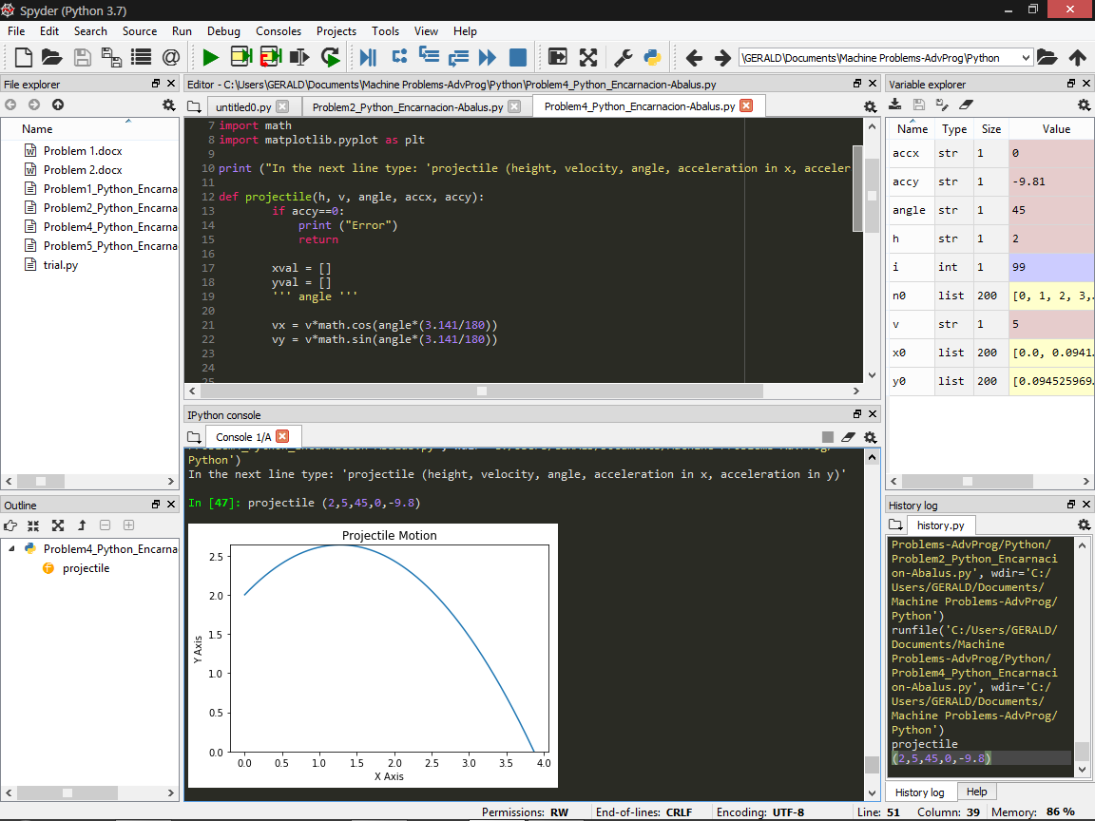

Problem 4 (Python)

import math

import matplotlib.pyplot as plt

print ("In the next line type: 'projectile (height, velocity, angle, acceleration in x, acceleration in y)'")

def projectile(h, v, angle, accx, accy):

if accy==0:

print ("Error")

return

xval = []

yval = []

vx = v*math.cos(angle*(3.141/180))

vy = v*math.sin(angle*(3.141/180))

t = 0

x = 0

y = h

d = 0.0001

xval.append(x)

yval.append(y)

while(True):

t = t+d

x = vx*t +(0.5)*accx*(t*t)

y = vy*t +(0.5)*accy*(t*t) + h

xval.append(x)

yval.append(y)

if y < d:

break

plt.plot(xval, yval)

ax = plt.gca()

ax.set_ylim([0, max(yval)])

plt.xlabel('X Axis')

plt.ylabel('Y Axis')

plt.title('Projectile Motion')

plt.grid

plt.show

*Screenshot of an example*