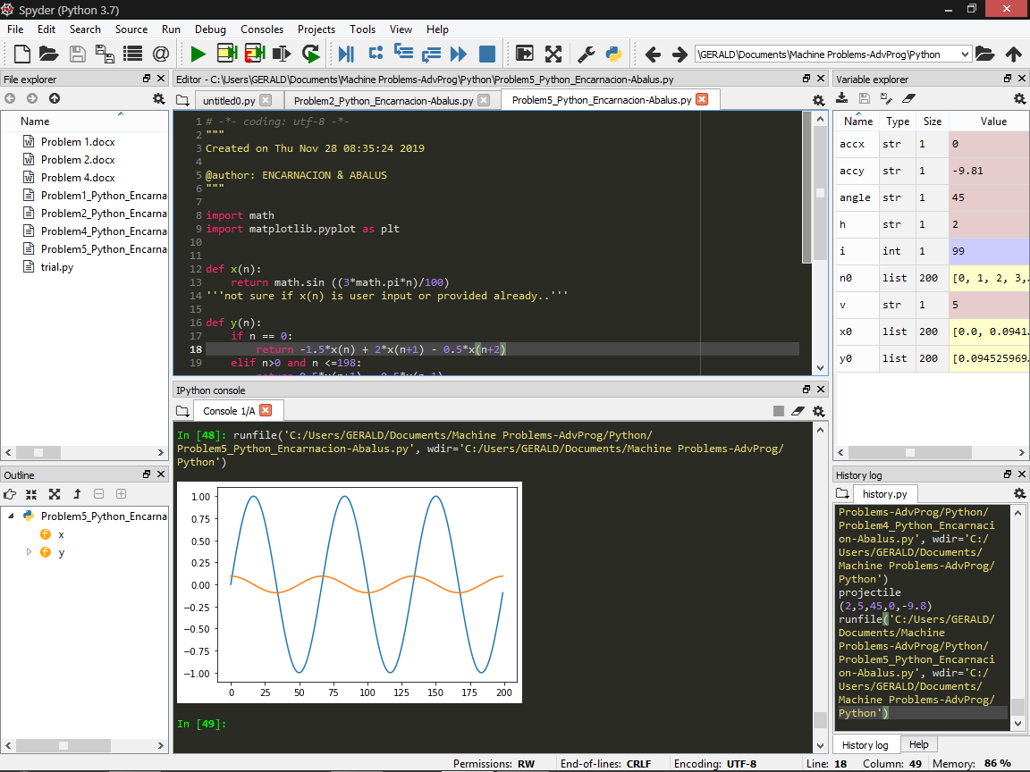

Problem 5 (Python)

import math

import matplotlib.pyplot as plt

def x(n):

return math.sin ((3\*math.pi\*n)/100)

'''not sure if x(n) is user input or provided already..'''

def y(n):

if n == 0:

return -1.5\*x(n) + 2\*x(n+1) - 0.5\*x(n+2)

elif n>0 and n <=198:

return 0.5\*x(n+1) - 0.5\*x(n-1)

elif n == 199:

return 1.5 \*x(n) - 2\*x(n-1) + 0.5\*x(n-2)

n0 = list(range(200))

x0 = [x(n) for n in n0]

y0 = [y(n) for n in n0]

plt.plot (n0, x0, label = 'x(n)')

plt.plot (n0, y0, label = 'y(n)')

plt.legend

plt.show

*Screenshot of the graph*