A Project Report on
MetroTransit Fleet Demand Forecasting
Submitted in partial fulfillment of the requirements for
Bachelor of Computer Applications (Data Analytics)
MACHINE LEARNING LAB
Paper Code: BCADA 5P 126
Submitted by
Student 1: Varshitha K R Register No.: 241BCADA60
Student 2: Greshmaa Rajesh Register No.: 241BCADA46
Student 3: A Merlin Levia Register No.: 241BCADA15
Student 4: Shiny Matilda K Register No.: 241BCADA10
Student 5: V Mounisha Register No.: 241BCADA28
Student 6: Angel Precilla A Register No.: 241BCADA40

ST. JOSEPH'S UNIVERSITY, BENGALURU - 27
DEPARTMENT OF ADVANCED COMPUTING
ACADEMIC YEAR: 2026-2027

CERTIFICATE
This is to certify that the project titled
“MetroTransit Fleet Demand Forecasting”
has been successfully completed as part of the Machine Learning Lab (Paper Code: BCADA 5P 126) prescribed by ST. JOSEPH'S UNIVERSITY, under the Department of Advanced Computing, Bachelor of Computer Applications (Data Analytics) programme during the academic year 2026-2027.

Signature of the Teacher in-charge | Head of the Department
____________________________ | ____________________________

DECLARATION
We hereby declare that the project report titled “MetroTransit Fleet Demand Forecasting” submitted for the Machine Learning Lab (BCADA 5P 126), Bachelor of Computer Applications (Data Analytics), is a record of the work carried out by our group. The work presented in this report has not been submitted elsewhere for any other academic award.
We further declare that all datasets, libraries, external references, code resources and AI-assisted tools used during the project have been appropriately acknowledged wherever applicable.

Place: Bengaluru
Date: 01 October 2026
Signatures of Students:
1. ______________________________ Varshitha K R (241BCADA60)
2. ______________________________ Greshmaa Rajesh (241BCADA46)
3. ______________________________ A Merlin Levia (241BCADA15)
4. ______________________________ Shiny Matilda K (241BCADA10)
5. ______________________________ V Mounisha (241BCADA28)
6. ______________________________ Angel Precilla A (241BCADA40)

ACKNOWLEDGEMENT
We express our sincere gratitude to St. Joseph's University, Bengaluru, and the Department of Advanced Computing for giving us the opportunity to carry out this project as part of the Machine Learning Lab (BCADA 5P 126) in the Bachelor of Computer Applications (Data Analytics) programme.
We thank the Head of the Department, our Teacher in-charge and our project guide for their guidance, timely feedback and encouragement throughout the project. Their suggestions on time-aware validation, data leakage and the interpretation of results helped us improve the quality of our work.
We are grateful to the creators of the UCI Bike Sharing Dataset, Hadi Fanaee-T and Joao Gama, and to the UCI Machine Learning Repository for making the data publicly available. We also acknowledge the open-source Python community (pandas, NumPy, scikit-learn, Matplotlib, Seaborn, SciPy and joblib), Google Colab and Microsoft Power BI, whose tools made this work possible.
Finally, we thank all six members of Group 11 for their cooperation. Each member took ownership of a distinct role (data engineering, data analysis, data science, analytics engineering, ML engineering and BI development), and the project was completed through steady teamwork and regular discussion.

ABSTRACT
Bike-sharing operators must keep bicycles available where and when riders need them. Too few bikes cause lost rides, while too many leave idle bikes and increase holding and redistribution costs. This project builds a machine learning solution for the MetroTransit Fleet Management team that forecasts hourly bike-rental demand and converts the forecasts into fleet-stocking decisions. The UCI Bike Sharing (hourly) dataset was used, with 17,379 hourly records from January 2011 to December 2012. The data was validated (no missing values or duplicates), sorted chronologically, and the leakage columns casual and registered were removed. Sine-cosine features were created for hour and month, and the target was log-transformed. Exploratory analysis showed commuting peaks at 08:00 and 17:00 on working days, leisure-driven midday demand on non-working days, and lower demand in poor weather. A Random Forest Regressor was tuned using GridSearchCV with time-series cross-validation. On a chronological hold-out of the last 20% of the data (7 August to 31 December 2012, 3,476 hours) the model achieved an RMSE of 88.76 bikes, MAE of 56.84, MAPE of 32.85%, R² of 0.838 and a peak-hour error of 149.76 bikes. An earlier random-split test gave a much more optimistic RMSE of 42.04, showing why time-aware validation is necessary. The forecasts were converted into recommended fleet levels using a safety margin; under assumed cost parameters, a 35% margin gave the lowest modeled cost ($358,217.50 against $612,332.25 with no margin). The results are presented through a Power BI dashboard and a reusable prediction script. The project shows that the hour of the day is the strongest driver of demand and that forecast-driven stocking can support fleet rebalancing decisions.
Keywords: Bike-Sharing Demand Forecasting, Random Forest Regression, Time-Series Validation, Fleet Rebalancing, Power BI

CONTENTS
1. INTRODUCTION
1.1 Overview of the Project
1.2 Problem Statement
1.3 Objectives of the Project
1.4 Scope of the Project
1.5 End User / Stakeholder and Project Value
2. DATASET AND DATA UNDERSTANDING
2.1 Dataset Description
2.2 Dataset Source
2.3 Features / Variables and Target
2.4 Class Distribution / Data Distribution
2.5 Dataset Limitations
3. DATA PREPARATION AND EXPLORATORY DATA ANALYSIS
3.1 Data Cleaning
3.2 Preprocessing
3.3 Feature Extraction / Feature Engineering
3.4 Exploratory Data Analysis
3.5 Key Insights from EDA
4. MACHINE LEARNING METHODOLOGY
4.1 ML Problem Type
4.2 Train-Test / Validation Strategy
4.3 Algorithms / Models Used
4.4 Model Training
4.5 Hyperparameter Tuning
4.6 Mathematical / Statistical Concepts Used
5. MODEL EVALUATION AND RESULTS
5.1 Evaluation Metrics
5.2 Model Comparison
5.3 Final Model Selection
5.4 Error Analysis / Confusion Matrix / Residual Analysis
5.5 Interpretation of Results
6. DASHBOARD / VISUALISATION AND IMPLEMENTATION
6.1 Dashboard / Visualisation
6.2 Important KPIs / Insights
6.3 Prediction / Application Workflow
6.4 Sample Input and Output
7. CHALLENGES, LIMITATIONS AND IMPROVEMENTS
7.1 Challenges Faced
7.2 Approaches That Did Not Work
7.3 Current Limitations
7.4 Future Improvements
8. TEAM CONTRIBUTION AND LEARNING
8.1 Team Roles and Contributions
8.2 Skills / Learning Outcomes
9. CONCLUSION
10. REFERENCES / BIBLIOGRAPHY
11. APPENDICES

1. INTRODUCTION

1.1 Overview of the Project
Bike-sharing systems allow people to rent a bicycle at one location and return it at another, and they have become an important part of urban transport. Their success depends on availability: a rider who cannot find a bike is lost revenue, while a bike that sits unused is a wasted asset. Demand changes sharply with the hour of the day, the season, the weather and whether the day is a working day, so fleet managers need to anticipate it rather than react to it.
This project was carried out for the MetroTransit Fleet Management team, a bike-sharing fleet management client described in the project brief. Using the UCI Bike Sharing dataset, our group of six students, each with a defined role, built a complete workflow: data cleaning, exploratory analysis, demand forecasting, fleet rebalancing logic, a Power BI dashboard and a reusable prediction script.
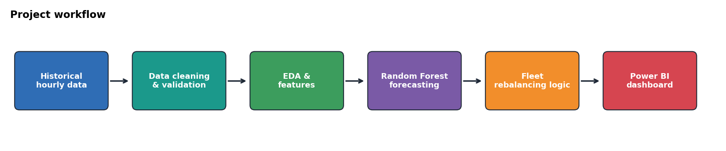
Figure 1.1: Overall project workflow

1.2 Problem Statement
The problem is to forecast the hourly demand for bike rentals and use the forecast to support fleet rebalancing. The input is a set of calendar and weather conditions for an hour (season, year, month, hour, holiday, weekday, working day, weather situation, temperature, feels-like temperature, humidity and windspeed). The expected output is the predicted number of bike rentals (cnt) for that hour, and a recommended fleet level derived from it.
The problem matters because without reliable forecasts, operators face bike shortages in high-demand hours, excess bikes in low-demand hours, inefficient redistribution and poor utilisation of the fleet.

1.3 Objectives of the Project
- Analyse historical bike-sharing demand patterns.
- Identify the important factors that affect hourly bike demand (time, season, weather and day type).
- Forecast hourly bike-sharing demand using a machine learning regression model.
- Evaluate forecasting performance using RMSE (primary metric), MAE, MAPE and hourly peak error, with a time-aware validation strategy.
- Identify peak-demand periods and convert predicted demand into recommended fleet levels for rebalancing.
- Present the analysis and results through an interactive Power BI dashboard and a reusable prediction script.

1.4 Scope of the Project
Included: analysis and forecasting of system-wide hourly demand (cnt) using the UCI hourly dataset; data validation and preprocessing; exploratory and statistical analysis; a Random Forest forecasting model with time-series cross-validation; a rebalancing decision layer (safety margin, understock/overstock classification and modeled costs); a Power BI dashboard; and a prediction script with input validation and logging.
Excluded: station-level or route-level forecasting, live data feeds, deployment as a web service or API, real operating cost data from a bike-sharing company, and external factors such as events or public transport disruptions. The financial figures in this report come from assumed scenario parameters and are not real company data.

1.5 End User / Stakeholder and Project Value
The primary users are the fleet management and operations team of a bike-sharing service: planners who decide how many bikes should be available in each hour, and dispatch staff who schedule redistribution trucks. The solution supports decisions such as when demand is expected to rise or fall, when shortages may occur, and when bikes should be redistributed. Hours with very low demand (for example, the early morning) can also be used to schedule maintenance.
The value of the project is mainly analytical and academic: it shows how a demand forecast can be turned into a stocking decision. The cost figures are modeled under stated assumptions and should not be read as real savings.

2. DATASET AND DATA UNDERSTANDING

2.1 Dataset Description
The project uses the UCI Bike Sharing Dataset (hourly file, hour.csv). It contains 17,379 hourly records and 17 columns in CSV format, covering the period from 1 January 2011 to 31 December 2012. Each row describes one hour and includes calendar information, weather conditions and the number of bike rentals. The data comes from the Capital Bikeshare system in Washington, D.C., USA.
The target variable is cnt, the total number of rentals in that hour (minimum 1, maximum 977, mean 189.46). It is the sum of casual (unregistered) and registered rentals. Because the target is a continuous count, the task is a regression problem.

2.2 Dataset Source
Dataset Name: UCI Bike Sharing Dataset (hourly data file, hour.csv)
Source / URL: UCI Machine Learning Repository, https://archive.ics.uci.edu/dataset/275/bike+sharing+dataset
Access Date: 17 September 2026

2.3 Features / Variables and Target
Table 2.1 lists the variables in the dataset. Temperature, feels-like temperature, humidity and windspeed are stored as normalised values between 0 and 1 (the validation step confirmed that no value fell outside this range).
Variable | Description | Role in the project
instant, dteday | Record index and date | Used for sorting; dropped before modelling
season | 1 = winter, 2 = spring, 3 = summer, 4 = fall | Input feature
yr, mnth, hr | Year (0 = 2011, 1 = 2012), month (1-12), hour (0-23) | Input features; hr and mnth also encoded as sin/cos
holiday, weekday, workingday | Holiday flag, day of week (0-6), working-day flag | Input features
weathersit | 1 = clear, 2 = mist/cloudy, 3 = light rain/snow, 4 = heavy rain/snow | Input feature
temp, atemp | Normalised temperature and feels-like temperature | Input features
hum, windspeed | Normalised humidity and windspeed | Input features
casual, registered | Rentals by unregistered and registered users | Dropped (they add up to cnt, so they leak the target)
cnt | Total hourly bike rentals | Target variable
Table 2.1: Variables in the UCI Bike Sharing (hourly) dataset

2.4 Class Distribution / Data Distribution
Bike demand is right-skewed: most hours have moderate or low demand, and a smaller number of hours have very high demand (skewness of cnt = 1.28, casual = 2.50, registered = 1.56). Temperature, humidity and feels-like temperature are approximately symmetric (skewness between -0.11 and -0.01), and windspeed is mildly right-skewed (0.57). Figure 2.1 shows the distribution of total demand and Figure 2.2 compares skewness across the numerical variables.
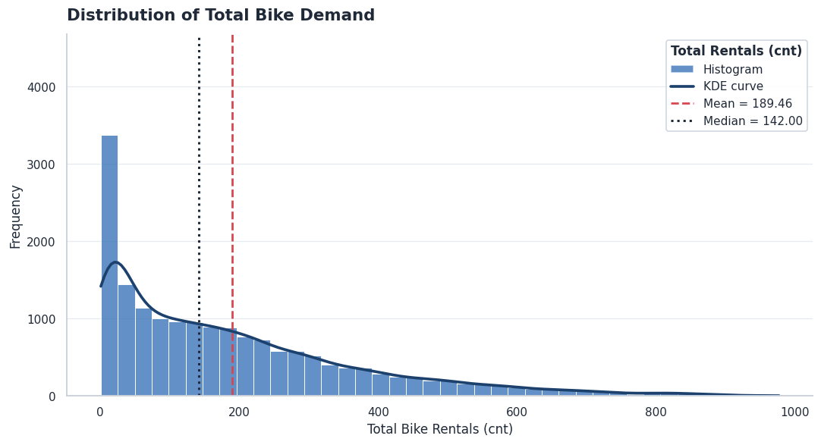
Figure 2.1: Distribution of total hourly bike demand (cnt)
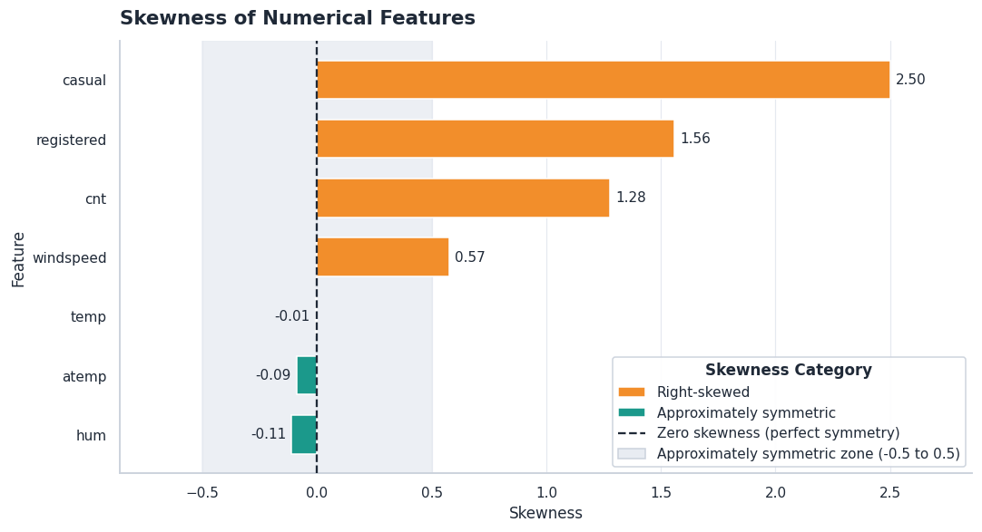
Figure 2.2: Skewness of the numerical features
The weather situation is highly imbalanced (Table 2.2). Clear weather accounts for about two-thirds of all hours, while heavy rain or snow has only three records, so conclusions about the heaviest weather category are unreliable.
Weather situation | Records | Share of hours | Average demand (cnt)
1 - Clear | 11,413 | 65.67% | 205
2 - Mist / Cloudy | 4,544 | 26.15% | 175
3 - Light Rain / Snow | 1,419 | 8.17% | 112
4 - Heavy Rain / Snow | 3 | 0.02% | 74
Table 2.2: Distribution of the weather situation and average demand in each category

2.5 Dataset Limitations
The dataset covers only two years and one city, so it cannot show longer-term trends or behaviour in other places. Demand in 2012 was generally higher than in 2011, which means later periods differ from earlier ones. The severe-weather category has only three records. The data is at system level (no station information), has no information about events, and contains a small number of extreme values (505 hours flagged by the IQR rule, 2.9% of the data) that represent genuine peak demand. The weather values are recorded observations, so a real forecasting system would need weather forecasts as input.

3. DATA PREPARATION AND EXPLORATORY DATA ANALYSIS

3.1 Data Cleaning
Data cleaning was carried out by the Data Engineer. The dataset was checked for structure, missing values, duplicates, data types and invalid values before any modelling.
- Missing values and duplicates: none were found (0 missing values, 0 duplicate rows in 17,379 rows and 17 columns).
- Data types: the date column (dteday) was converted to datetime format; all other columns already had suitable numeric types.
- Validity checks: hour (0-23), season (1-4), month (1-12), temperature, humidity and windspeed (0-1) were checked, and no invalid values were found.
- Outliers: 505 hours (2.9%) were flagged as potential outliers in cnt using the 1.5 x IQR rule. They were detected but not removed, because they represent genuine peak-demand periods rather than errors.
- Ordering: the data was sorted by date and hour so that time order is preserved for the validation strategy. The cleaned file was saved as cleaned_bike_sharing.csv.
A small data-quality log was also saved for audit purposes (Table 3.1).
Rows | Columns | Missing values | Duplicate rows | Potential outliers (cnt) | Invalid hour values
17,379 | 17 | 0 | 0 | 505 | 0
Table 3.1: Data quality log

3.2 Preprocessing
A preprocessing pipeline was built with scikit-learn and saved by the Data Engineer. The data was first split chronologically into 80% training (13,903 hours) and 20% testing (3,476 hours), so that the test set always lies after the training period. The target (cnt) and the leakage or identifier columns (casual, registered, instant, dteday) were removed from the features.
- Numerical features (temp, atemp, hum, windspeed): median imputation followed by standard scaling.
- Categorical features (season, yr, mnth, hr, holiday, weekday, workingday, weathersit): most-frequent imputation followed by one-hot encoding (unknown categories ignored).
- The preprocessor was fitted on the training data only and then applied to the test data, which prevents information from the test period leaking into training. The processed feature matrix has 61 columns.
The forecasting notebook used the cleaned data directly with the engineered features described in Section 3.3. Tree-based models such as Random Forest do not need scaled inputs, so scaling was not required for the final model.

3.3 Feature Extraction / Feature Engineering
Two kinds of feature engineering were applied by the Data Scientist.
- Cyclic encoding of time: hour and month are circular (hour 23 is next to hour 0). They were converted using sine and cosine: sin_hr = sin(2π x hr / 24), cos_hr = cos(2π x hr / 24), sin_mnth = sin(2π x mnth / 12) and cos_mnth = cos(2π x mnth / 12). This gives four new features.
- Log transformation of the target: because demand is right-skewed, the model was trained on log(1 + cnt) and its predictions were converted back with exp(x) - 1.
- Leakage prevention: casual and registered were dropped because they add up to cnt. The final model uses 16 input features (12 original and 4 cyclic).

3.4 Exploratory Data Analysis
The Data Analyst carried out visual and statistical exploratory analysis on the cleaned data. Unusual observations were kept, not removed, because they represent genuine peak demand. The most useful plots are shown below.
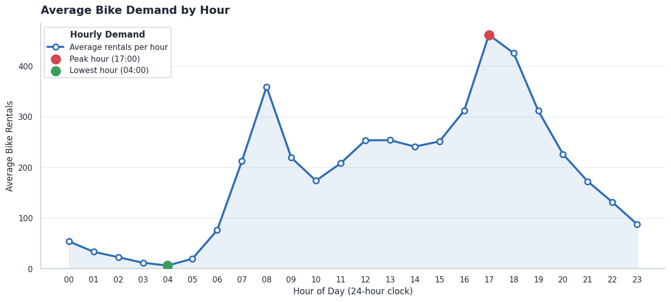
Figure 3.1: Average bike demand by hour of the day
Demand is far from uniform across the day. The highest average demand occurs around 17:00 and the lowest around 04:00, with a second peak in the morning at about 08:00. This is useful for planning fleet availability and rebalancing.
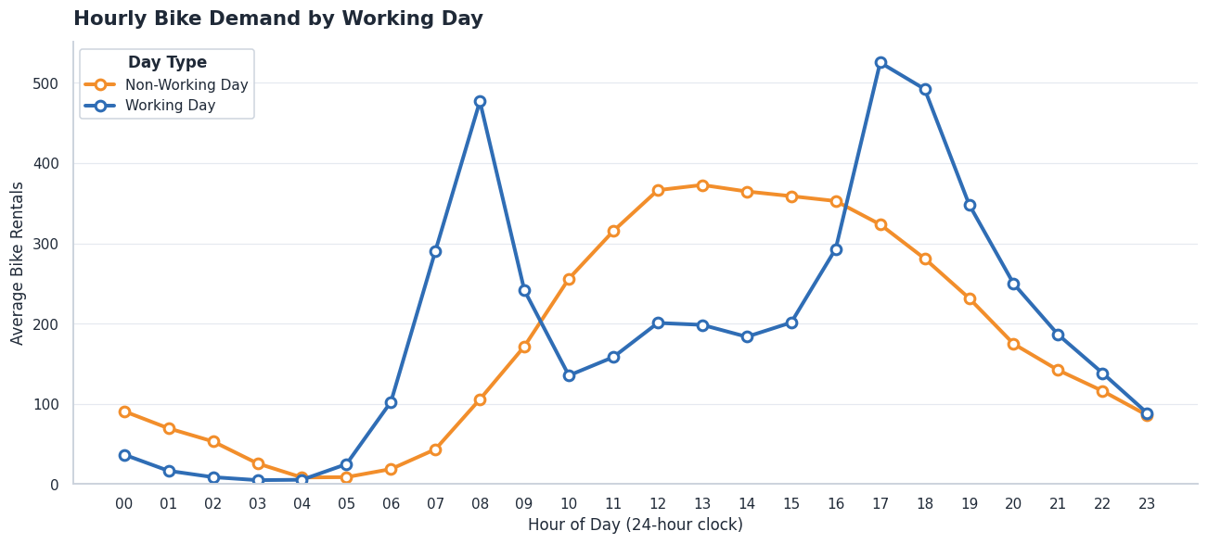
Figure 3.2: Average demand by hour and working-day status (heatmap)
On working days demand is concentrated in the morning and evening commuting periods, while on non-working days it is spread more smoothly around the middle of the day. Hour and day type therefore interact, and one fixed hourly pattern is not enough for planning.
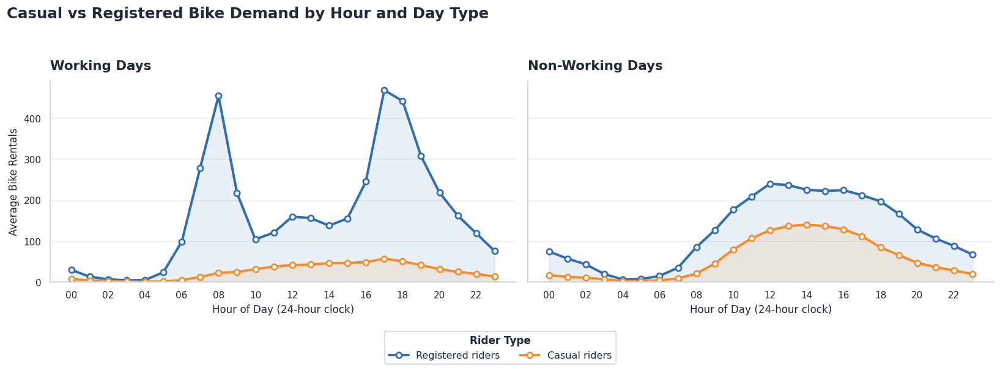
Figure 3.3: Casual and registered rentals by hour and day type
Day type | Casual peak hour | Registered peak hour | Avg casual / hour | Avg registered / hour | Casual share
Non-working day | 14:00 | 12:00 | 57.44 | 123.96 | 31.7%
Working day | 17:00 | 17:00 | 25.56 | 167.65 | 13.2%
Table 3.2: Casual versus registered riders by day type
Registered riders follow commuting peaks, while casual riders are more leisure-oriented and make up a larger share of rentals on non-working days. Total demand therefore hides two different usage purposes.
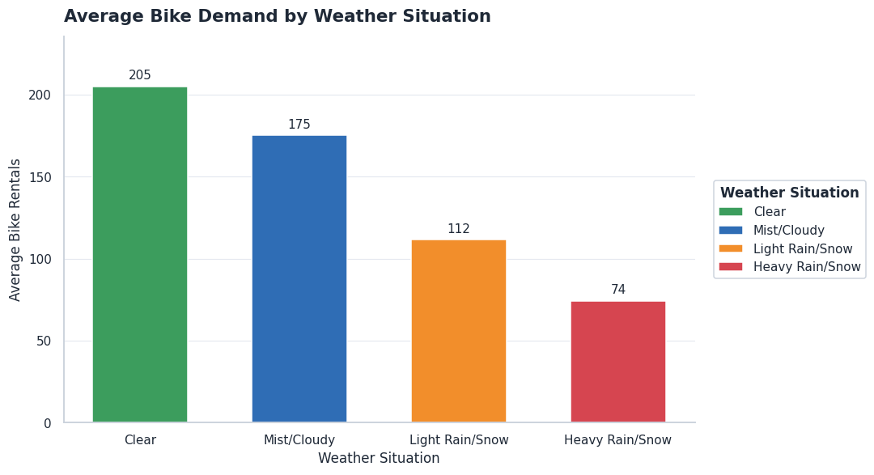
Figure 3.4: Average bike demand by weather situation
Average demand falls as weather gets worse: 205 rentals per hour in clear weather, 175 in mist or cloud, 112 in light rain or snow and 74 in heavy rain or snow (based on only three records, so this last value is unreliable).
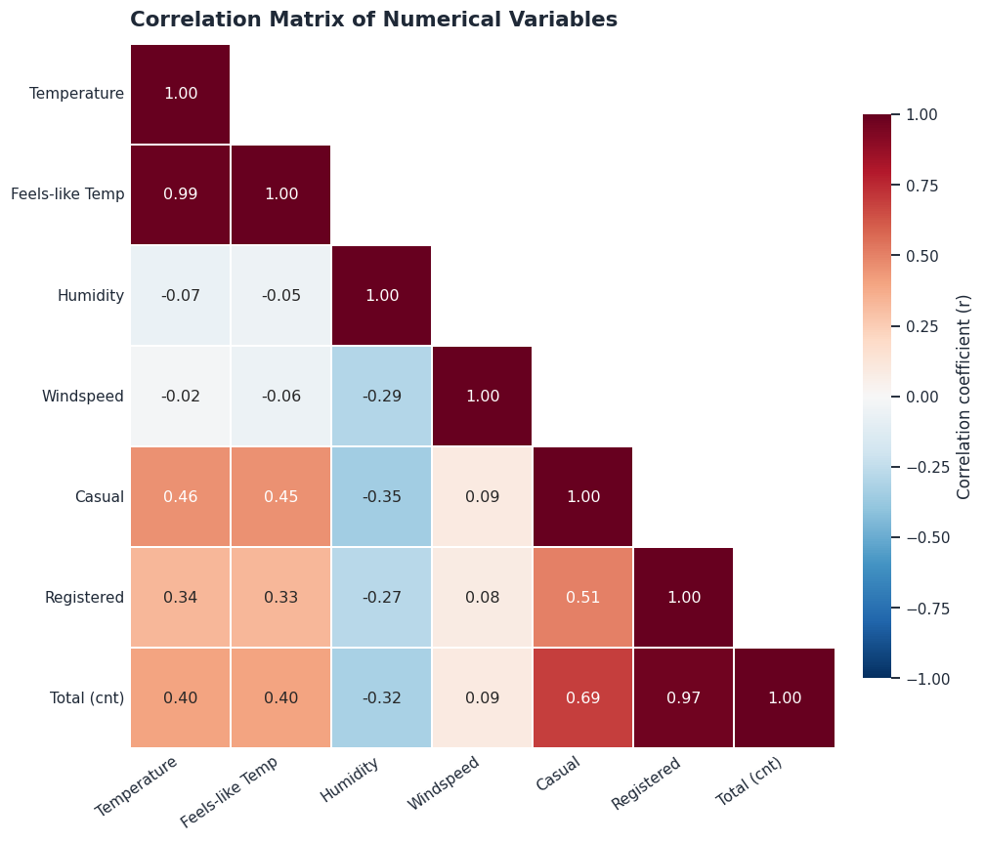
Figure 3.5: Correlation matrix of the numerical variables
Registered (r = 0.97) and casual (r = 0.69) rentals are strongly related to total demand, as expected since they make up cnt. Among the weather variables, temperature (r = 0.40) and feels-like temperature (r = 0.40) have a moderate positive association, humidity has a negative association (r = -0.32) and windspeed has a very weak one (r = 0.09). These are associations, not proof of causation.
A Welch independent-samples t-test was used to compare average demand on working and non-working days. The result (t = 4.10, p = 4.25 x 10^-5) shows a statistically significant difference at the 5% level.
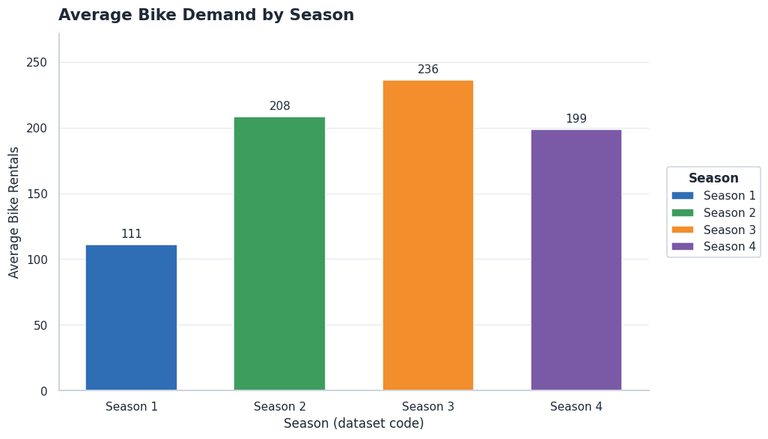
Figure 3.6: Average bike demand by season (1 = winter, 2 = spring, 3 = summer, 4 = fall)
Average demand is lowest in winter (111 rentals per hour) and highest in summer (236), with spring (208) and fall (199) in between. The monthly view shows demand rising from January to a plateau between June and September and falling again towards December (Appendix B).

3.5 Key Insights from EDA
- Hour of the day is the strongest pattern: demand peaks near 17:00 (and around 08:00 on working days) and is lowest around 04:00, so fleet levels should follow the clock.
- Hour and day type interact: working days show commuting peaks driven by registered riders, while non-working days show a midday leisure pattern with a larger casual share (31.7% against 13.2%).
- Season and weather matter: demand is lowest in winter and falls steadily in poorer weather; temperature is positively associated with demand and humidity negatively.
- Demand is right-skewed, and its high values are genuine peak hours, so they were kept in the data.
- The weather categories are very imbalanced (only three heavy rain or snow hours), so severe-weather results must be read with care.

4. MACHINE LEARNING METHODOLOGY

4.1 ML Problem Type
This is a supervised regression problem: the goal is to predict a continuous numerical value, the number of bike rentals in a given hour (cnt), from calendar and weather features. Because the data is ordered in time, it is also treated as a time-aware forecasting task.

4.2 Train-Test / Validation Strategy
Bike demand in one hour is strongly related to demand in nearby hours. If rows are split randomly, the model can see hours right before and after each test hour during training, which makes the score look better than it would in real use. The team therefore used a time-aware strategy.
- Chronological hold-out: the first 80% of the sorted data (13,903 hours) was used for training and the last 20% (3,476 hours, from 7 August 2012 to 31 December 2012) was kept as an unseen future test period.
- Time-series cross-validation: hyperparameter tuning used TimeSeriesSplit with 5 splits, where each validation fold comes after its training fold.
- Leakage control: casual and registered were removed; the preprocessing pipeline was fitted on training data only; and no future observation was used to predict an earlier one.
- Early experiment: the first version of the Random Forest was evaluated on a random 80/20 split (random_state = 42). It gave an RMSE of 42.04, which is much better than the chronological result and is discussed in Sections 5.2 and 7.2.

4.3 Algorithms / Models Used
The main model is a Random Forest Regressor. A Random Forest builds many decision trees on random samples of the data and averages their predictions. It was chosen because it (i) captures non-linear effects and interactions such as hour x working day without manual feature design, (ii) is robust to skewed data and extreme values, (iii) does not need scaled inputs, and (iv) provides feature importances that help explain the results. To have a reference point for the model, a simple persistence baseline (the demand of the previous hour is used as the forecast) was also calculated from the held-out data for Section 5.2.

4.4 Model Training
The training workflow was: (1) load the cleaned dataset and sort it by date and hour; (2) create the sin/cos features and drop leakage and identifier columns; (3) apply log(1 + cnt) to the target; (4) train the Random Forest and tune it with GridSearchCV; (5) convert predictions back to bike counts with exp(x) - 1; (6) evaluate on the chronological hold-out and save the predictions (Holdout_Predictions.csv); and (7) save the trained model with joblib. The work was done in Python using pandas, NumPy, scikit-learn, Matplotlib, Seaborn, SciPy and joblib on Google Colab.

4.5 Hyperparameter Tuning
Hyperparameters were tuned with GridSearchCV using 5-fold TimeSeriesSplit and negative root mean squared error as the scoring rule. The grid (Table 4.1) contained 12 combinations, giving 60 model fits. The best combination was n_estimators = 200, max_depth = None and min_samples_split = 2. Before the grid search, a manually chosen configuration (n_estimators = 200, max_depth = 20, min_samples_split = 3) had been used for the first experiment.
Hyperparameter | Values tested | Best value
n_estimators | 100, 200 | 200
max_depth | 15, 20, None | None
min_samples_split | 2, 5 | 2
Table 4.1: GridSearchCV search space (5-fold TimeSeriesSplit)

4.6 Mathematical / Statistical Concepts Used
The key concepts and formulas used in the project are given below (y = actual demand, ŷ = predicted demand, n = number of hours).
- RMSE (primary metric) = √( (1/n) Σ (y - ŷ)² ). It is in the same unit as demand (bikes per hour) and penalises large errors more.
- MAE = (1/n) Σ |y - ŷ|. It is the average size of the error in bikes.
- MAPE = (100/n) Σ |y - ŷ| / y. It expresses the error as a percentage of actual demand; it becomes large when actual demand is small.
- R² = 1 - Σ (y - ŷ)² / Σ (y - ȳ)². It is the share of the variation in demand explained by the model.
- Hourly peak error: the mean absolute error over the busiest 10% of hours (actual demand at or above the 90th percentile, 576.5 bikes in the hold-out set).
- Log transformation: z = log(1 + y) reduces skewness; predictions are converted back with y = exp(z) - 1.
- Sine/cosine encoding: sin(2πh/24) and cos(2πh/24) place the hours on a circle so that 23:00 and 00:00 are close together.
- Skewness measures the asymmetry of a distribution (values above 0.5 mean right-skewed). Correlation (r) measures the strength of a linear relationship between two variables.
- Welch t-test: tests whether the mean demand of two groups differs without assuming equal variances.
- Rebalancing logic: Recommended fleet = ceil( ŷ x (1 + m) ), where m is the safety margin. Lost rides = max(0, y - stock); idle bikes = max(0, stock - y); lost revenue = lost rides x revenue per ride; holding cost = idle bikes x holding cost per bike.

5. MODEL EVALUATION AND RESULTS

5.1 Evaluation Metrics
Four metrics were used: RMSE (primary), MAE, MAPE and the hourly peak error, together with R² for overall fit. RMSE was chosen as the primary metric because large forecasting mistakes are the most harmful for a fleet: a big under-forecast in a rush hour leads directly to shortages. MAE gives the typical error in bikes, MAPE gives the error as a percentage, and the peak error shows how well the model handles the busiest 10% of hours. Accuracy is not used because this is a regression problem.

5.2 Model Comparison
Table 5.1 compares the evaluations carried out. The most realistic estimate of future performance is the chronological hold-out result.
Model / evaluation setting | RMSE | MAE | R² | MAPE (%) | Peak error
Persistence reference: previous-hour demand, chronological hold-out | 129.67 | 85.19 | 0.654 | 54.54 | 188.08
Random Forest (200 trees, depth 20, min split 3), log target, random 80/20 split | 42.04 | - | 0.944 | 27.07 | 53.96
Random Forest, tuned with time-series CV, chronological hold-out (final) | 88.76 | 56.84 | 0.838 | 32.85 | 149.76
Table 5.1: Model comparison (RMSE, MAE and peak error in bikes per hour). "-" means the value was not recorded in the notebook.
The persistence reference was calculated from the hold-out file for this report to give a simple benchmark. The random-split result looks better, but it is not comparable with the chronological results because the random split lets the model learn from hours next to the test hours.

5.3 Final Model Selection
The selected model is the tuned Random Forest Regressor with a log-transformed target (n_estimators = 200, max_depth = None, min_samples_split = 2), saved for use in the prediction script. It was selected on the following evidence: on the chronological hold-out it clearly improves on the persistence reference (RMSE 88.76 against about 129.7 bikes); it handles the non-linear hour x day-type pattern found in the EDA; and it gives interpretable feature importances. The team uses the chronological hold-out figures as the final results, because they match how the model would be used (forecasting the future from the past) and are the same predictions used for the fleet decision analysis.

5.4 Error Analysis / Confusion Matrix / Residual Analysis
Residuals (actual minus predicted) were analysed on the 3,476 held-out hours. Figure 5.1 shows the first week of the hold-out period, Figure 5.2 shows the hourly demand profile and error, and Figure 5.3 shows the distribution of errors.
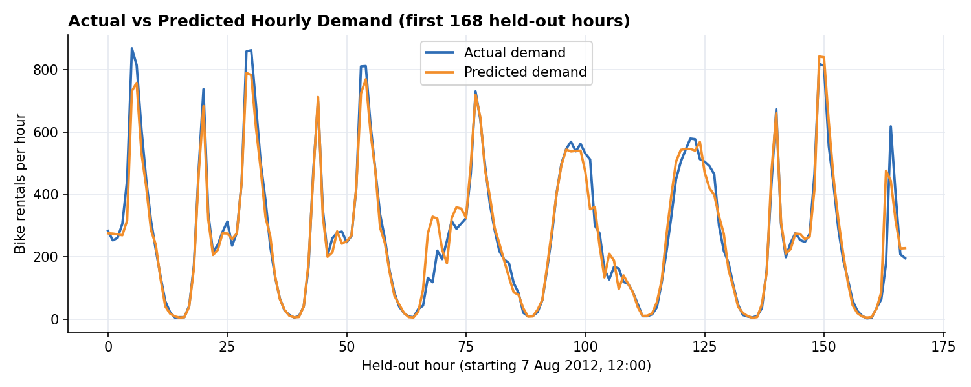
Figure 5.1: Actual and predicted hourly demand for the first 168 held-out hours
The predicted curve follows the daily rise and fall of demand closely, but in many rush hours it stays below the actual peak.
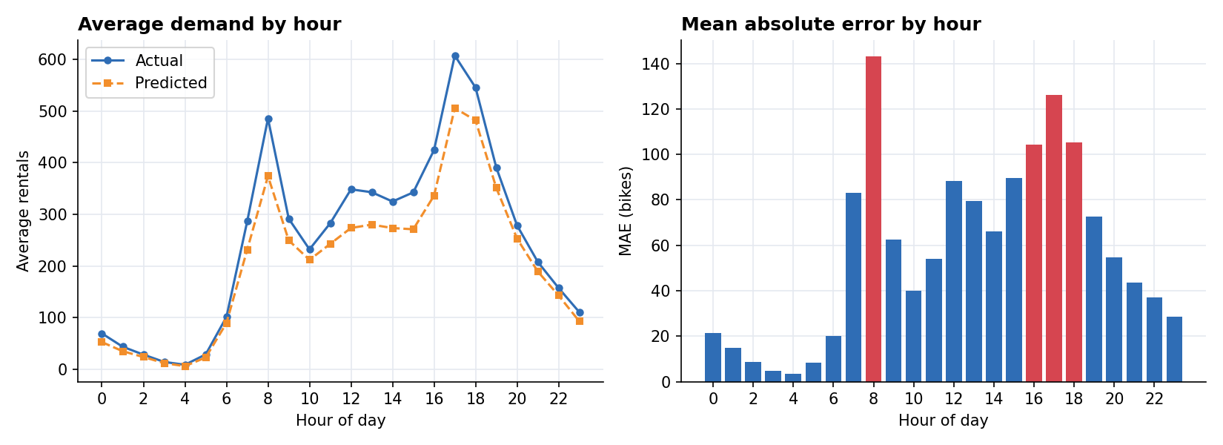
Figure 5.2: Average actual and predicted demand by hour (left) and mean absolute error by hour (right; red bars = MAE of 100 or more)
- The model under-predicts on average: the mean error is +39.7 bikes and 74.0% of hours were under-predicted. A likely reason is that the hold-out period (August to December 2012) has higher demand than most of the training period, and a Random Forest cannot predict values much beyond those it has seen.
- Errors are largest in the rush hours: MAE is 143.1 bikes at 08:00, 126.1 at 17:00, 105.1 at 18:00 and 104.2 at 16:00, while it is only 3 to 5 bikes between 03:00 and 05:00.
- Errors are higher in poor weather: MAE is 53.9 bikes in clear weather, 57.1 in mist or cloud and 82.1 in light rain or snow (238 hours). Heavy rain or snow did not occur in the hold-out period.
- Errors by season: MAE is 42.2 bikes in summer hours, 65.6 in fall hours and 49.3 in winter hours (the hold-out contains only 262 winter hours).
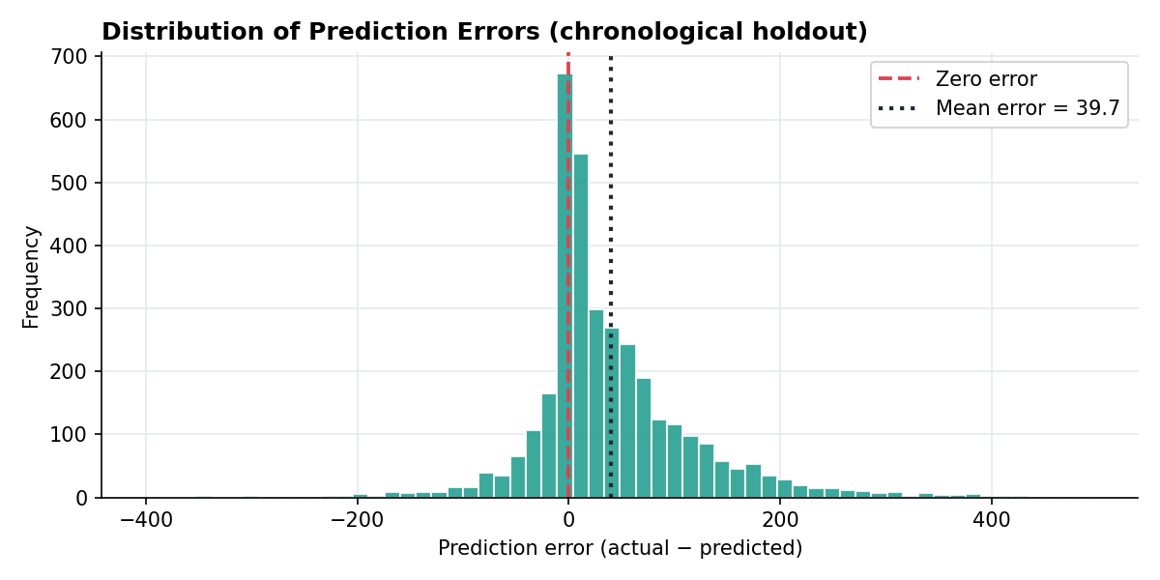
Figure 5.3: Distribution of prediction errors on the chronological hold-out
The error distribution is centred to the right of zero (under-prediction) and has a long right tail, which corresponds to the underestimated peak hours.

5.5 Interpretation of Results
In simple terms, the model is good at knowing when demand is high or low during the day, but it tends to be too cautious in the busiest hours. On average it is wrong by about 57 bikes per hour (MAE), and the error is larger in rush hours. The MAPE of 32.85% looks high mainly because percentage errors become large in the early-morning hours when only a few bikes are rented; the RMSE and MAE are more meaningful for fleet decisions.
Figure 5.4 shows which inputs the Random Forest relied on. Hour of the day is by far the most important feature (importance 0.627), and the sine and cosine hour features add to it, followed by temperature and working day. This agrees with the EDA, where the hour of the day was the strongest pattern. Note that these importances were printed in the Data Scientist's notebook.
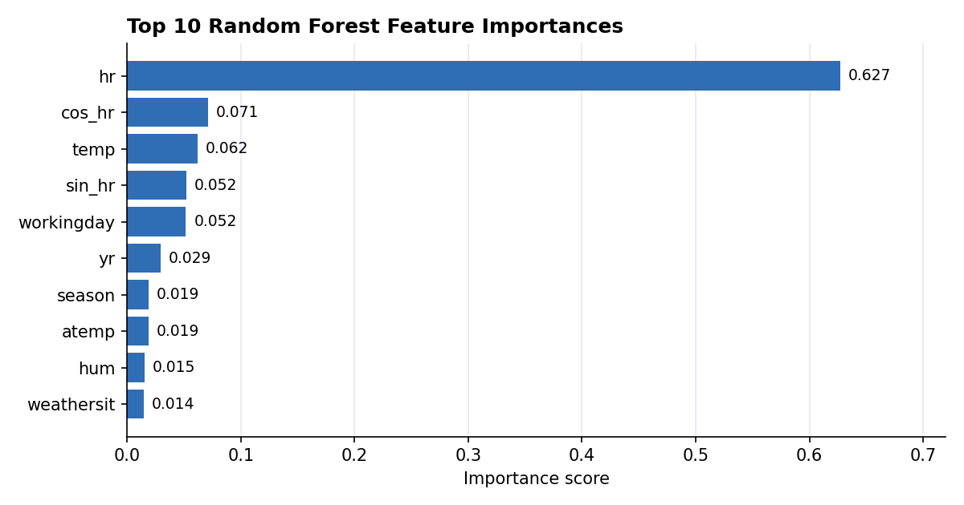
Figure 5.4: Top 10 feature importances of the Random Forest
Strengths: captures the daily and weekly pattern, uses simple inputs, and is fast to run. Weaknesses: under-forecasts peak hours, and its accuracy on future data is lower than the random-split test suggested. The safety margin in the decision layer (Section 6.2) was added partly to reduce the effect of this under-forecasting.

6. DASHBOARD / VISUALISATION AND IMPLEMENTATION

6.1 Dashboard / Visualisation

The dashboard provides an overview of bike-sharing demand metrics across the 17,379 hourly records. Top card visuals display total rides (3,292,679), registered rides (2,672,662), and casual rides (620,017). Line charts highlight commuting peaks at 08:00 and 17:00, while rider segmentation shows registered users account for 81.17% of total volume. Seasonal bar charts and temperature scatter plots illustrate higher demand during warmer periods

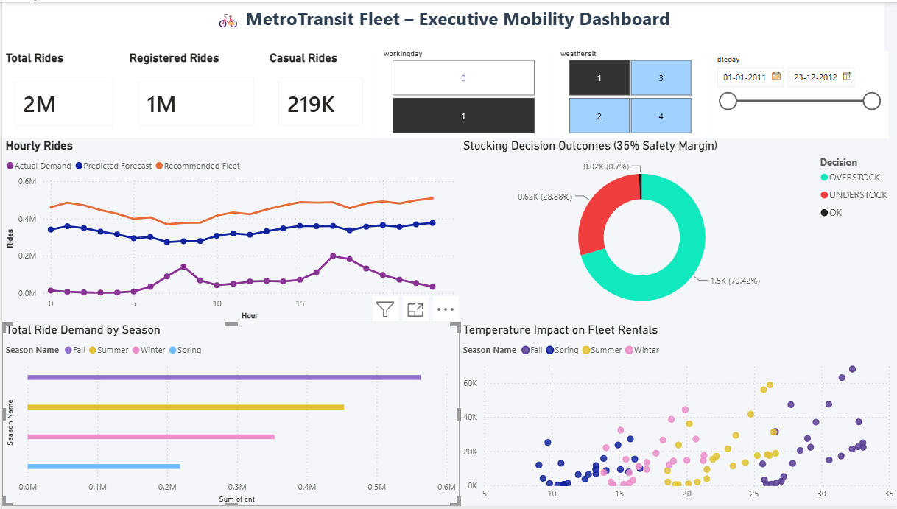

6.2 Important KPIs / Insights
Decision layer. The Analytics Engineer turned forecasts into stocking decisions (Rebalancing_Logic.py). For each hour, the recommended fleet is the predicted demand increased by a safety margin. Each hour is then classified as UNDERSTOCK (recommended fleet below actual demand), OVERSTOCK (above actual demand) or OK, and the cost of the mistake is calculated. The UCI data does not contain any cost information, so the following scenario values were assumed and are not real company data.
Assumed parameter | Value
Revenue per ride (lost revenue when demand is not met) | $3.50
Holding cost per idle bike per hour | $0.75
Cost of one rebalancing truck run | $45.00
Truck capacity | 150 bikes per run
Table 6.1: Assumed scenario parameters
Safety margins from 0% to 40% (in steps of 5%) were tested on the hold-out predictions (Table 6.2 and Figure 6.1). The lowest total modeled cost occurred at a 35% margin.
Safety margin | Understock hours | Overstock hours | Lost revenue ($) | Holding cost ($) | Truck cost ($) | Total net cost ($)
0% | 2,525 | 919 | 583,075.50 | 22,641.75 | 6,615.00 | 612,332.25
5% | 2,321 | 1,130 | 488,411.00 | 29,627.25 | 15,075.00 | 533,113.25
10% | 2,077 | 1,369 | 405,216.00 | 39,027.00 | 25,515.00 | 469,758.00
15% | 1,813 | 1,628 | 333,868.50 | 51,002.25 | 36,495.00 | 421,365.75
20% | 1,592 | 1,851 | 275,887.50 | 65,814.75 | 47,610.00 | 389,312.25
25% | 1,393 | 2,057 | 227,738.00 | 82,761.75 | 58,365.00 | 368,864.75
30% | 1,198 | 2,247 | 188,314.00 | 101,552.25 | 69,345.00 | 359,211.25
35% | 1,016 | 2,437 | 156,362.50 | 121,935.00 | 79,920.00 | 358,217.50
40% | 876 | 2,575 | 130,413.50 | 143,637.00 | 91,035.00 | 365,085.50
Table 6.2: Safety-margin tuning on the chronological hold-out (modeled costs under assumed parameters)
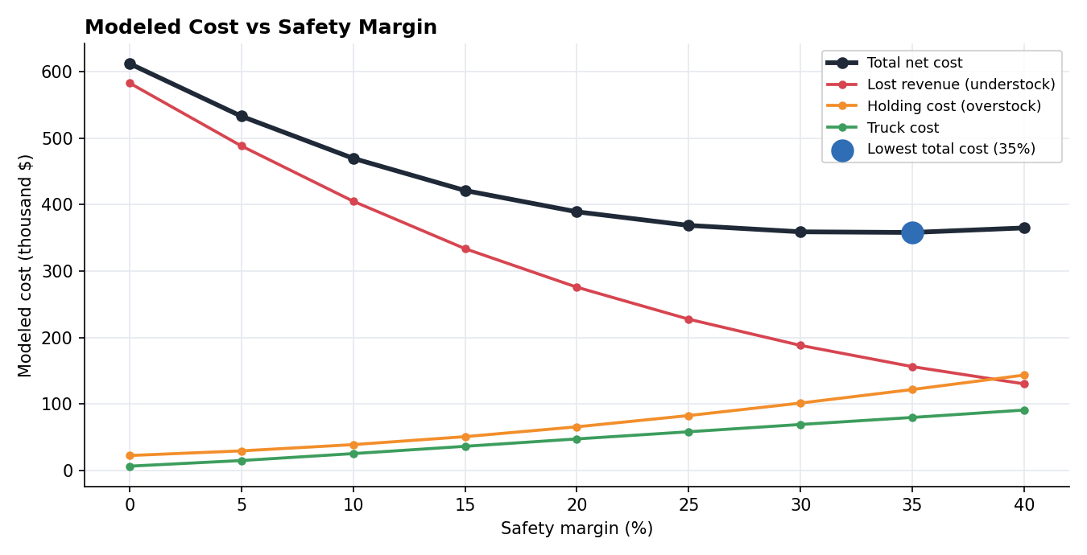
Figure 6.1: Modeled cost against safety margin
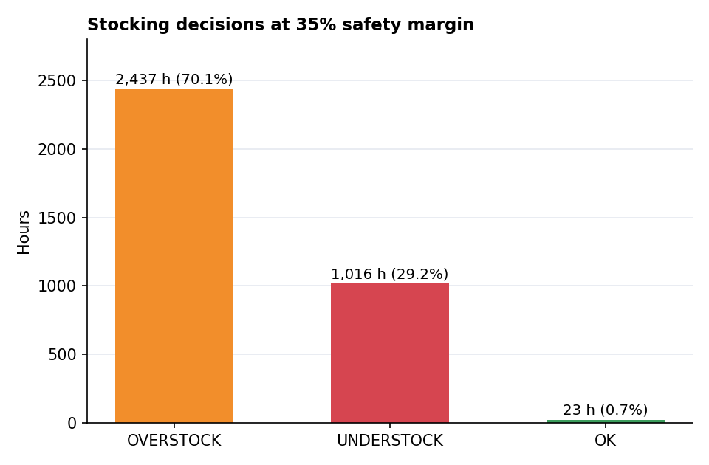
Figure 6.2: Stocking decisions at the 35% safety margin
Key KPIs and insights (chronological hold-out, 35% safety margin):
- Total modeled net cost is $358,217.50 at a 35% margin, compared with $612,332.25 with no safety margin, a modeled reduction of $254,114.75 (about 41.5%) under the assumed costs.
- Understock hours: 1,016 (29.2% of hours), with 44,675 lost rides and $156,362.50 of modeled lost revenue. Overstock hours: 2,437 (70.1%), with 162,580 idle bike-hours and $121,935.00 of holding cost. Only 23 hours (0.7%) matched demand exactly.
- Modeled cost is concentrated in the fall period ($178,949.00), ahead of summer ($81,328.25) and winter ($18,020.25), before truck costs; truck costs add $79,920.00 over the 147 days. This partly reflects the number of hours from each season in the hold-out (fall 2,098 hours, summer 1,116, winter 262).
- The safety margin trades one kind of error for another: raising it reduces lost rides but increases idle bikes and truck runs. The lowest cost is at 35%, and costs at 30% ($359,211.25) are almost the same.

6.3 Prediction / Application Workflow
Figure 6.3 shows how a new input is processed by the prediction script written by the ML Engineer (predict.py). The function predict_demand() takes a dictionary of 12 raw fields (season, yr, mnth, hr, holiday, weekday, workingday, weathersit, temp, atemp, hum, windspeed).
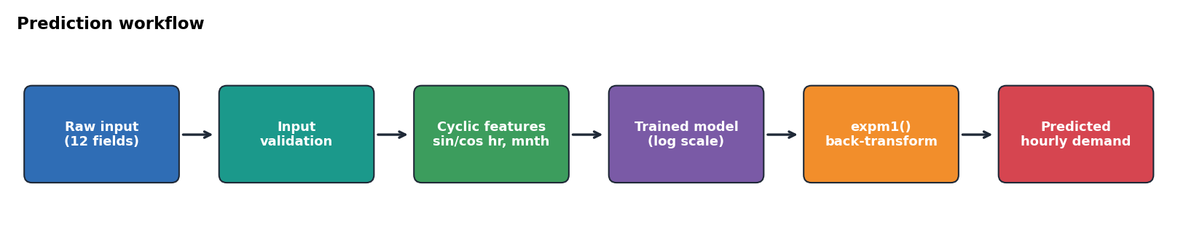
Figure 6.3: Prediction workflow for a new input
- Input validation: the function checks that all 12 required fields are present and raises a clear error message if any are missing.
- Feature creation: the sine and cosine features for hour and month are added, and the columns are arranged in the same order as during training.
- Prediction: the trained Random Forest (loaded from bike_demand_model.pkl with joblib) predicts log(1 + demand), which is converted back to bikes with exp(x) - 1.
- Logging and testing: each input and prediction is written to a log file, and the script includes a latency check and a test showing that incomplete input is rejected correctly.

6.4 Sample Input and Output
Example 1: prediction for a single new input (taken from the validation test in the prediction script), for a January winter evening at 18:00 on a working day with clear weather.
season | yr | mnth | hr | holiday | weekday | workingday | weathersit | temp | atemp | hum | windspeed
1 | 0 | 1 | 18 | 0 | 3 | 1 | 1 | 0.24 | 0.29 | 0.81 | 0.0
Table 6.3: Sample input to predict_demand()
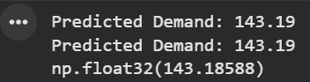Example 2: model output and fleet decision for two hours of the hold-out period (35% safety margin).
Date | Hour | Actual demand | Predicted demand | Recommended fleet | Decision | Lost rides / idle bikes
2012-08-07 | 12:00 | 283 | 275.4 | 372 | OVERSTOCK | 89 idle
2012-08-07 | 16:00 | 445 | 316.5 | 428 | UNDERSTOCK | 17
Table 6.4: Sample outputs from Decision_Metrics.csv

7. CHALLENGES, LIMITATIONS AND IMPROVEMENTS

7.1 Challenges Faced
The main challenges were:
- Skewed demand with sharp peaks: the busiest hours are several times higher than the average, and they are the hardest to predict (peak error 149.76 bikes).
- Data leakage: casual and registered add up to the target, so they had to be removed, and the split had to respect time order.
- A large gap between random-split and chronological results (RMSE 42.04 against 88.76), which meant the early results could not be trusted as a forecast of future performance.
- Rare weather category: only three heavy rain or snow hours exist, so conclusions about severe weather are weak.
- Missing business information: the dataset has no cost data, so revenue, holding and truck costs had to be assumed.
- Coordinating six roles: the cleaned data, model predictions, decision metrics and dashboard depended on each other, so file formats and column names had to be agreed between team members.

7.2 Approaches That Did Not Work
Two things did not work as expected:
- Random-split evaluation: evaluating on a random 20% of the rows gave an RMSE of 42.04 and R² of 0.944, but this was overly optimistic because neighbouring hours appeared in both training and test data. Switching to a chronological hold-out gave the more honest RMSE of 88.76. The lesson was that validation for time-ordered data must respect time.
- Stocking exactly the predicted demand: with a 0% safety margin, the model would understock in 2,525 of 3,476 hours and give the highest modeled cost ($612,332.25). Because the model tends to under-predict peaks, a buffer was needed.

7.3 Current Limitations
The current solution cannot reliably do the following:
- Predict peak hours accurately: it under-predicts on average (by about 40 bikes per hour in the hold-out) and the rush-hour errors are large.
- Generalise to a full year: the hold-out covers only August to December 2012, so spring and the first half of the year were not tested in the final evaluation.
- Forecast station by station: the model works on system-wide totals only.
- Work in real time: it uses recorded weather values for the hour, so a live system would need weather forecasts, and the model has not been deployed or monitored.
- Give real financial impact: cost results depend on assumed parameters.
- Be fully time-consistent in tuning: the hyperparameter search in the notebook was run on the training part of the earlier random split, so re-running it on the chronological training data only would be cleaner.

7.4 Future Improvements
With more time and data, the project could be improved as follows:
- Add lag and rolling features (for example demand in the previous hours or the same hour last week), which are very informative for hourly forecasting.
- Compare more models, such as gradient boosting (HistGradientBoosting, XGBoost) and time-series models, with a proper baseline table.
- Use more years of data and refit the model regularly so that it can follow growth in demand.
- Predict upper quantiles or add a peak-focused model to reduce under-forecasting in rush hours.
- Build station-level forecasts and use real cost data to tune the safety margin by time of day.
- Deploy the prediction function as a web service or dashboard-connected API with logging and monitoring for model drift, and feed it weather forecasts.

8. TEAM CONTRIBUTION AND LEARNING

8.1 Team Roles and Contributions
Student Name / Register No. | Assigned Role | Major Contribution | Tools / Skills Used
Varshitha K R  241BCADA60 | Data Engineer | Data acquisition, validation and cleaning; outlier detection; chronological train-test split; leakage prevention; preprocessing pipeline; data quality log; cleaned dataset. | Python, pandas, scikit-learn (Pipeline, ColumnTransformer), Google Colab
Greshmaa Rajesh  241BCADA46 | Data Analyst | Visual and statistical EDA: distributions, skewness, boxplots, correlation, feature interactions, casual versus registered analysis, Welch t-test and actionable insights. | pandas, NumPy, Matplotlib, Seaborn, SciPy
A Merlin Levia  241BCADA15 | Data Scientist | Feature engineering (sine/cosine, log target); Random Forest model; GridSearchCV with time-series cross-validation; metrics (RMSE, MAE, MAPE, peak error); feature importance; saved model. | scikit-learn, pandas, NumPy, joblib, Matplotlib
Shiny Matilda K  241BCADA10 | Analytics Engineer | Connected model predictions to business KPIs; rebalancing logic (safety margin, understock/overstock decisions, cost matrix, margin tuning); Decision_Metrics output. | Python, pandas, NumPy, Matplotlib
V Mounisha  241BCADA28 | ML Engineer | Reproducible prediction script: model loading, input validation, feature creation, log back-transform, logging, latency check and testing. | Python, joblib, pandas, logging
Angel Precilla A  241BCADA40 | BI / Power BI Developer | Built the interactive Power BI dashboard: KPI cards, demand trend and hourly charts, rider-type split, season and temperature views, and working-day and weather slicers. | Microsoft Power BI

8.2 Skills / Learning Outcomes
Technical skills: we learned to build an end-to-end machine learning workflow, from data validation and preprocessing to feature engineering, model tuning and evaluation. We understood in practice why time-ordered data needs time-aware validation and how data leakage can inflate scores. We also learned to turn model output into a business decision with a safety margin and modeled costs.
Analytical skills: we practised reading distributions, skewness, correlations and interactions, and interpreting error metrics such as RMSE, MAE, MAPE and peak error honestly, including the weaknesses of the model.
Teamwork and communication: working in six defined roles taught us to share files and results, agree on formats, and document assumptions clearly. We also practised presenting technical results through a dashboard and this report for a business audience.

9. CONCLUSION
This project addressed the problem of forecasting hourly bike-sharing demand to support fleet rebalancing for the MetroTransit Fleet Management client. Using the UCI Bike Sharing dataset, we cleaned and validated the data, explored demand patterns and built a tuned Random Forest model with cyclic time features and a log-transformed target. The exploratory analysis showed that hour of the day, day type, season and weather strongly shape demand.
On a chronological hold-out of 3,476 hours (7 August to 31 December 2012) the final model achieved an RMSE of 88.76 bikes, MAE of 56.84, MAPE of 32.85%, R² of 0.838 and a peak error of 149.76 bikes. An earlier random-split test looked much better (RMSE 42.04), but it was over-optimistic, and the chronological result is the honest estimate. The model tends to under-predict the busiest hours.
Using the forecasts, a 35% safety margin gave the lowest modeled cost in our tests ($358,217.50 against $612,332.25 with no margin), under assumed cost parameters. The results were delivered through a Power BI dashboard and a validated prediction script. The most important learning for the team was that a good score only matters if the validation matches real use. Future work should add lag features, compare more models, use more data and deploy the model with monitoring.

10. REFERENCES / BIBLIOGRAPHY
The following sources were used in this project:
[1] Fanaee-T, H. and Gama, J. (2013). Event labeling combining ensemble detectors and background knowledge. Progress in Artificial Intelligence, Springer, pp. 1-15.
[2] UCI Machine Learning Repository. Bike Sharing Dataset. https://archive.ics.uci.edu/dataset/275/bike+sharing+dataset
[3] Pedregosa, F. et al. (2011). Scikit-learn: Machine Learning in Python. Journal of Machine Learning Research, 12, pp. 2825-2830.
[4] Breiman, L. (2001). Random Forests. Machine Learning, 45(1), pp. 5-32.
[5] Official documentation: pandas (https://pandas.pydata.org/docs/), NumPy (https://numpy.org/doc/), Matplotlib (https://matplotlib.org/), Seaborn (https://seaborn.pydata.org/) and SciPy (https://docs.scipy.org/).
[6] Microsoft Power BI documentation. https://learn.microsoft.com/power-bi/
[7] Group 11 project repository. https://github.com/greshmaarajesh/ML-Final-Lab-Group-11
[8] AI assistance: Claude (Anthropic) was used to help draft and format this report from the group's notebooks, datasets and results. The results and figures reported come from the group's own outputs.

11. APPENDICES

Appendix A - GitHub Repository
Repository Link: https://github.com/greshmaarajesh/ML-Final-Lab-Group-11
The repository contains the notebooks, the cleaned dataset, Holdout_Predictions.csv, Decision_Metrics.csv, the source files, the Power BI dashboard, the presentation and the weekly project update documents.

Appendix B - Additional Screenshots / Outputs
The following additional outputs support the main report.
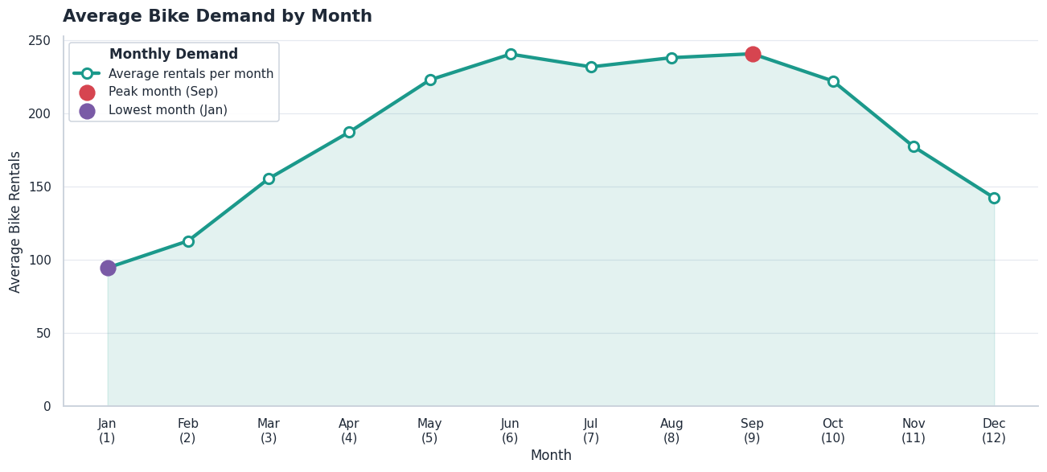
Figure B.1: Average bike demand by month (lowest in January, highest in September)
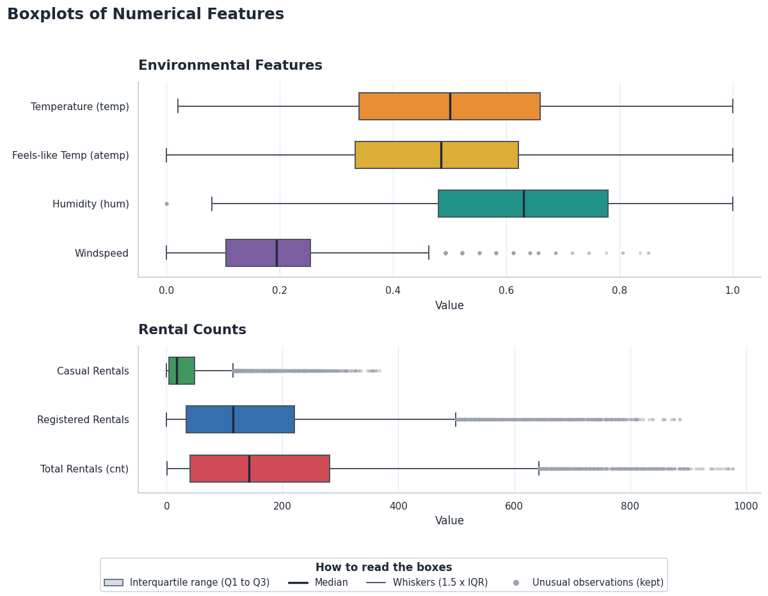
Figure B.2: Boxplots of the numerical features (unusual observations retained)
Table B.1 gives the average actual and predicted demand and the mean absolute error for each hour of the day on the chronological hold-out.
Hour | Avg actual | Avg predicted | MAE
00:00 | 69.3 | 52.5 | 21.3
01:00 | 43.6 | 34.9 | 14.9
02:00 | 28.3 | 23.7 | 8.7
03:00 | 14.1 | 11.8 | 4.8
04:00 | 8.6 | 6.0 | 3.4
05:00 | 28.6 | 22.8 | 8.3
06:00 | 101.2 | 89.3 | 20.2
07:00 | 286.4 | 231.4 | 83.1
08:00 | 485.3 | 373.8 | 143.1
09:00 | 291.4 | 249.4 | 62.5
10:00 | 232.0 | 211.7 | 39.9
11:00 | 282.7 | 242.7 | 54.0
12:00 | 348.2 | 273.5 | 88.4
13:00 | 342.6 | 279.9 | 79.6
14:00 | 324.6 | 273.3 | 66.1
15:00 | 342.4 | 270.9 | 89.7
16:00 | 424.3 | 336.0 | 104.2
17:00 | 607.1 | 505.6 | 126.1
18:00 | 545.2 | 481.6 | 105.1
19:00 | 390.4 | 350.9 | 72.5
20:00 | 278.3 | 252.9 | 54.8
21:00 | 207.7 | 189.2 | 43.6
22:00 | 157.3 | 142.8 | 37.1
23:00 | 110.5 | 92.7 | 28.6
Table B.1: Hourly average of actual and predicted demand on the hold-out set

Appendix C - Important Code Snippets (Optional)
Short code excerpts from the project are shown below.
1. Cyclic features and log-transformed target (Data Scientist):
df['sin_hr'] = np.sin(2 * np.pi * df['hr'] / 24.0)
df['cos_hr'] = np.cos(2 * np.pi * df['hr'] / 24.0)
df['sin_mnth'] = np.sin(2 * np.pi * df['mnth'] / 12.0)
df['cos_mnth'] = np.cos(2 * np.pi * df['mnth'] / 12.0)
X = df.drop(columns=['instant', 'dteday', 'casual', 'registered', 'cnt'])
y_log = np.log1p(df['cnt'])

2. Time-series cross-validation and tuning (Data Scientist):
tscv = TimeSeriesSplit(n_splits=5)
param_grid = {'n_estimators': [100, 200], 'max_depth': [15, 20, None],
'min_samples_split': [2, 5]}
grid_search = GridSearchCV(RandomForestRegressor(random_state=42, n_jobs=-1),
param_grid, cv=tscv, scoring='neg_root_mean_squared_error', n_jobs=-1)

3. Recommended fleet and stocking decision (Analytics Engineer):
def recommended_fleet(predicted_demand, safety_margin):
return np.ceil(predicted_demand * (1 + safety_margin))

diff = stocked - actual_demand # < 0 UNDERSTOCK, > 0 OVERSTOCK, else OK

4. Prediction function with input validation (ML Engineer):
def predict_demand(raw_input: dict) -> float:
missing = [c for c in REQUIRED_COLUMNS if c not in raw_input]
if missing:
raise ValueError(f'Missing required input fields: {missing}')
df = add_cyclic_features(pd.DataFrame([raw_input]))[MODEL_COLUMNS]
return np.expm1(model.predict(df)[0])

