COMPUTER PROGRAMMING PROJECT – GRETA DELL’AMICO 3197417
TASK 1- Implementation of the class
To optimize the function using simulated annealing, I implemented the class “Probl”. The problem is structured as an nxn table, and the objective of the optimization is to find the minimum of the function. In the class I implemented the move proposal that consists in steps of length 1 and allows border jumping. To have a better understanding of the problem, I plotted the function in two dimensions, using the function “visualize”.
Then I used the simulated annealing function and the function “accept_with_prob” to optimize the problem, this function returns the optimal cost and problem.
TASK 2 – modulo operations
The modulo operation allows the algorithm to jump over borders, in fact if the current coordinate is on one of the borders of the matrix, the move proposal could move the point to the opposite side of the grid.
Allowing border jumping is necessary to make sure that the local search process is uniform: with border jumping, every element on the grid has the same number of neighbors, otherwise, edge elements would have fewer neighbors, and this might lead to different behaviors of the algorithm in these areas. In fact, when we allow border jumping and we are in an edge position, let’s say j=0, the probability for the move proposal to have j = 1 or j = n-1 is the same, however if we don’t allow border jumping the move proposal will have j = 1, and the distribution of the proposals would not be uniform among all the elements of the grid.
Furthermore, allowing border jumping is particularly useful as it makes the proposal matrix symmetric, making it possible to use the simplified acceptance rule from the Metropolis- Hastings algorithm. Having to use the standard acceptance probability formula from the Metropolis Hastings algorithm, would be less efficient and increase the computational cost.
Without the modulo operation, the “propose_move” method of the “Probl” class should be changed, and conditional statements may be needed to check if the initial configuration is on a border and in this case some appropriate changes to the code would be needed, this would increase the length of the code and its computational cost.
TASK 3 – performance and different temperatures
To study the performance of the algorithm as the temperature changes, we can store the best cost found in each temperature(1/beta). This information can be stored in a matrix, the matrix has as rows the repetitions of the algorithm and as columns the betas, in this way we can take the mean of all the columns to result in an array of average best costs in each temperature of the algorithm.
To get my results I used three functions:
- A modified version of the simann function, that returns an array of all the betas (1/temperature), and an array of the best costs found by each beta
- To have a statistically significant result, I ran the modified simann function 20 times and got the average best cost obtained for each beta. This operation is implemented with the “get_mean_results” function
- The function “plot_task3” is used to display the results obtained with the two previous functions
This is the graph obtained:
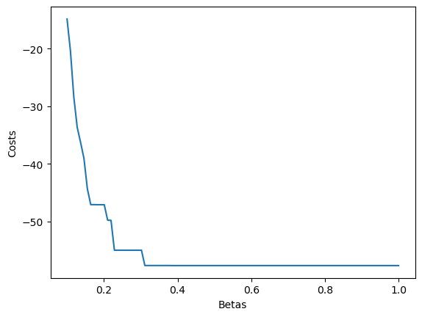
As the obtained graph shows, the higher the value of beta, and the lowest the value of the temperature (since beta is the inverse of the temperature), the lower is the value of the best_cost found by the algorithm. Furthermore, the cost drastically falls in the first part of the x-axis (betas) and then it remains pretty constant. After having explored different beta ranges, we can conclude that with a suitable beta range (for example(0.1,2)) the annealing scheme helps us in finding the lowest cost, and to some extent avoids local minima. In fact with this range at lower beta, the algorithm is able to explore broadly the matrix (like a random-walk algorithm), to identify areas with global minima, and as the beta increases, the acceptance rate reduces, focusing the search around these identified areas in subsequent steps to pinpoint the minimum (greedy behavior).
In conclusion, we can say that at lower beta values within an appropriate range, the algorithm efficiently explores the grid to identify the global minimum area. As beta increases, the acceptance rate decreases, enabling more focused search around this area in subsequent annealing steps to precisely locate the minimum.
TASK 4 - Performance for different dimensions
To study these variables, I provided a simulated annealing code that will return the convergence speed and convergence success.
To study the convergence speed I used the time measure, while to study the convergence success, I will stop algorithm when the acceptance rate is zero, in fact at this stage the possibility of the point to change its position is very low. In my analysis, I consider a successful convergence when the point resulting from the algorithm is in a neighbor of the actual minimum. During the trials, I kept beta0, beta1, anneal_steps, mcmc_steps constant. Some data that I retrieved is reported in the notebook file.
To run these tests I used three functions:
- A modified version of the simulated annealing function, that returns the best cost found, a variable “t” that is an indicator for the convergence speed and “convergence _success” that is a Boolean variable
- To have significant results, with the function “mean_results” I run the new version of simann 20 times, and got the mean of the time spent by the algorithm to converge and of the success rate
- Through the function “info_performance”, I ran the “mean_results” function for the different dimensions of the problem and stored the results in two arrays.
From the results obtained, the convergence time increases as the size of the matrix increases, and the success rate decreases as n grows.
The decrease in the success rate highlights the fact that as the dimension of the matrix increases the dimensions of local and global minima do not change proportionally, making convergence more difficult. Moreover, since the move length is fixed at 1 regardless of problem size, the algorithm covers a smaller fraction of the grid's space as the problem increases, and faces more problems in finding the actual minimum
The lower speed that characterizes the problems with higher dimensions is due to the necessity of exploring a greater space, in fact as n grows, the matrix becomes larger resulting in a longer search for the minimum.
TASK 5 - Acceptance Probabilities
To study the behavior of the acceptance probability, I used the acceptance frequency = (number of accepted moves/ mcmc_steps). To get the data about acceptance probability I modified the simulated annealing code, in a way that it returns an array with the acceptance frequency and the array of the values of beta.
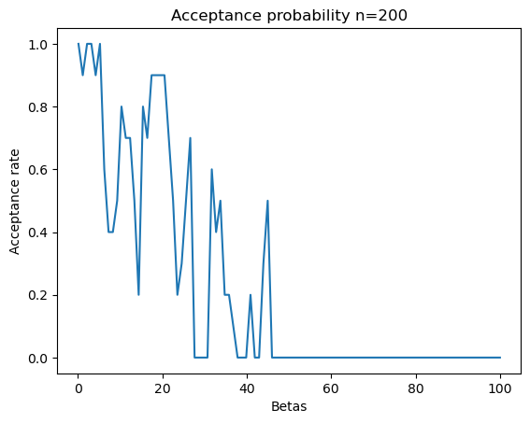
Finally I plotted the results obtained with the function “plot_task5”.
As we notice from the graph, as beta increases, the acceptance probability decreases, and the simulated annealing process is more and more similar to the greedy approach: less moves are accepted, and a smaller portion of the matrix is explored. This result is consistent with how simulated annealing operates. After each step, the best configuration is kept for the next step. Since this configuration is already highly effective, finding moves with reduced costs becomes increasingly difficult, leading to a consistent decrease in the acceptance rate. Similar behaviors are observed with different sizes of the problem.
Analyzing acceptance rates offers insights into the optimization landscape. Initially, especially for larger values of n, the acceptance rate is very high, indicating that most moves are approved as they either improve or slightly worsen the cost, this suggests a landscape with a surface characterized by minor variations. As beta increases, certain local areas show a significant drop in acceptance rates, sometimes barely above 0. This gradual decline to zero can signify reaching a minimum area. However, it's unclear how many such areas are there and whether these areas represent a local or global optima.
TASK 6 – optimization for a fixed n
To visualize the optimization I used two functions:
- A “visualize” function that I used also in the first task, that was useful to visualize the general landscape and how the function behaves
- The “show_opt” function that plots the best coordinates found by the simulated annealing algorithm
The image that we obtain is:
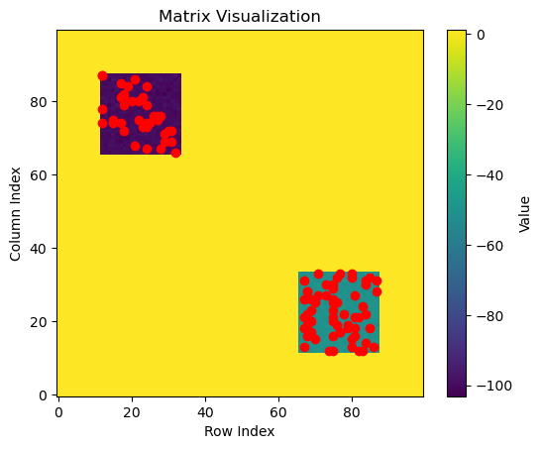
The differences in the landscape's levels are clearly visible due to the range of colors used in the visualization function. The majority of the area appears in a consistent shade of yellow, indicating uniformity, while specific regions stand out in shades green and purple, marking the locations of local and global minima, respectively.
Furthermore, the contour of the function's surface often leads to the optimization procedure becoming trapped in local minima. Escaping these minima would entail a significant deterioration in the cost, making it a less favorable option. Consequently, whenever the optimizer falls near to these local minima, it settles the solution to that local minimum.
The graphical results align with the acceptance rates, in fact, after visualizing the optimization with different beta ranges, I concluded, as expected, that choosing the right 'beta0' and 'beta1' values is crucial for an effective algorithm. Low initial and final beta values result in behavior like a random walk, accepting almost all moves and frequently jumping between areas. On the other hand, high 'beta0' and 'beta1' values, lead to a greedy-like approach, reducing acceptance rates and relying heavily on the starting configuration for success. Finally the right range for beta makes sure that, at first the algorithm explores a great part of the matrix, this indicates that we are moving on a quasi-flat area where cost differences can be easily overcome thanks to high temperature . However, as soon as the optimal region is found, the setting of betas do not allow the algorithm to escape out of this area and this leads to an extensive search in such areas: thus the algorithm has good chances to find the optimal minimum.
Task 7
Simulated annealing demonstrates efficiency with smaller grids but struggles to achieve a high success rate in convergence with larger grid sizes. For vast and complex optimization tasks, this algorithm may not be the best fit due to its diminishing effectiveness on broader scales. Furthermore, the previous analysis, narrowly tailored to a specific issue, might not apply well to different scenarios.
In addition, it is worth mentioning that a greedy strategy (that is resembled by the simulated annealing function with high values for beta) in this context not only fails to address our challenges but could potentially complicate our computations. The problem's landscape predominantly consists of a vast, quasi-flat area lacking a definitive gradient for value decrease, making it non-monotonic. Additionally, there are smaller regions of minima with closely clustered values. Such a setup makes it harder for a purely greedy approach to reach an optimal solution.
An improved approach might involve starting with a random walk (that is similar to a simulated annealing approach with low value for beta) to analyze the landscape broadly, knowing the best cost found by the random walk, we could then apply simulated annealing starting to pinpoint the global optimum based on the most promising areas identified. This two-phased method could enhance the search for the optimal solution by initially covering a wide range of possibilities before refining the focus.
Adjustments to simulated annealing, such as making the step size proportional with the grid size could ensure a more exhaustive exploration of the grid. This could potentially increase the algorithm's capacity to find the global minimum, especially in large-scale problems, leading to a more effective optimization process.

