- Introduction

In the ever-growing world of cryptocurrencies, the market has also evolved into many different directions at several points in time. Miners – and also appliances for cloud-mining contracts – usually have to specify the financial goals they want to pursue, i.e., mainly which coins to mine.
The fixedness of their choices often results in a “What If I’d Chosen Another Currency” when their mined coin dips and since a lot of coins get lost in the shuffle and perish, it seems like a rational idea to make these mining contracts tradeable against each other and currency units, too.
The products of our competition involve such fixed contracts. When customers buy hashpower for a coin that vanishes, they effectively suffer a 100% loss on the rest of their contract.

[ODEON Logo]

ODEON Mining was developed as the solution to the problem of the rapidly growing mining market. We aim to satisfy the needs of the blockchain by providing an integrated multi-altcoin-mining platform being based on a $ 15m ICO.
ODEON aims to provide a platform to equally supply miners and cloud-mining contractees with an intuitive UI that allows easy purchase of said contracts as well as the trading of the same with flexibility and transparency. Whilst users can trade a portion of the contracts (2-year contracts), a second mining contract type expiring after 4 years will also be buyable within the ODEON platform. This one, however, cannot be traded, but therefore offers advantages (i.e., a percentual bonus for loyal customers) over the shorter-lasting one. Also, for the 4-year-contract, the ODE tokens as described in the White Paper will not be lost (i.e., you don’t pay for the contract), but rather be sellable as they were just locked the whole time or can be used for contracting hashpower for another 2 or 4 years, respectively.
The following platforms are already being developed:
- ODEON Mine – starting with 15-25 thousand GPUs and an initial $ 10.5m investment, the capacities are planned to grow to 45-75 thousand GPUs within 3 years.
- ODEON Pool – a mining pool or node network in 2-3 years after Ethereum’s switch to proof-of-stake
- ODEON Gate – a multi-altcoin-cloud-mining contracting platform
- ODEON Trade – a unprecedented platform that allows trading of the Gate contracts
[Image of two contracts on ETH logos with circulating arrows. Somewhat like the following]
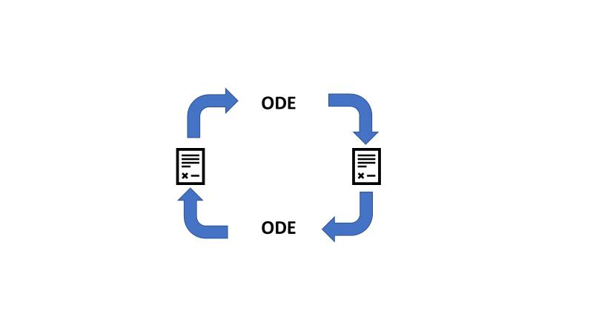

Implementing tradeable contracts offers the possibility to dynamically reallocate ODE tokens either as hashpower (and therefore shares in the total of mined currencies) or as ETH directly to use it for any other purpose. This enables short- as well as long-term-investors to trade better while supporting the network with green energy.

Our technical paper aims to describe the concepts behind the different systems required to successfully operate a cryptocurrency mining facility. In that course we also aim to describe the concepts of blockchain-security. In addition to that, we also want to demonstrate possible rentability calculations using Black-Scholes-Model.
As a reaction to the upcoming shift from proof-of-work to proof-of-stake of the most desirable cryptocurrency to mine at the moment (i.e., ETH), ODEON wants to develop a platform named ODEON Pool as a proof-of-stake mining-pool when said shift happens (currently estimated to be the end of 2019).

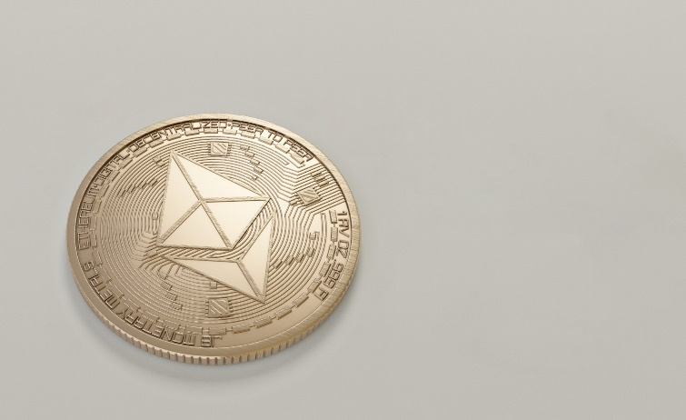

In the following, find more concerning the different platforms we develop as of now.

