- Roadmap
6.1 The beginning

ODEON was not found from scratch. Our team has had their first experience in mining and blockchain applications in 2013: We operated a small-sized mining facility in form of a warehouse in late 2013 which we had to close in 2014, because bitcoins price dropped about 60% and the system was not sustainable anymore.

This was our first attempt to build mining facilities, starting in a warehouse. The concept of ICOs allows us to fascinate investors for the same idea that we believe in.

6.2 Timeline
Years passed and we reassembled our team to work on our dream. The plan was never really lost and we decided to further discuss it in late 2017.
Being already in deep development and with a precise plan, we are proud to present to you our roadmap for what happened since the reformation as well as what is going to happen in the next two years.

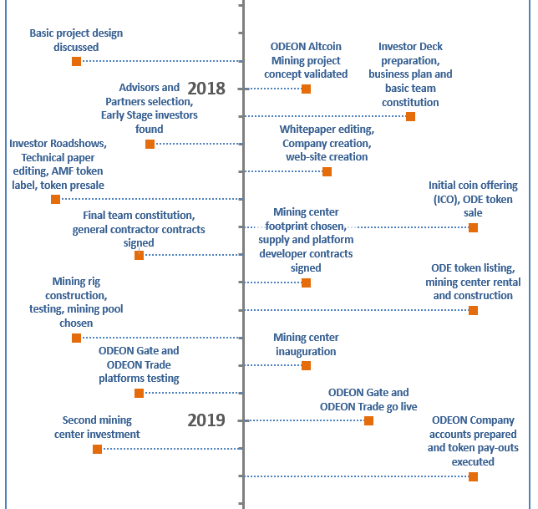

[maybe you guys have a better representation for our roadmap goals?]

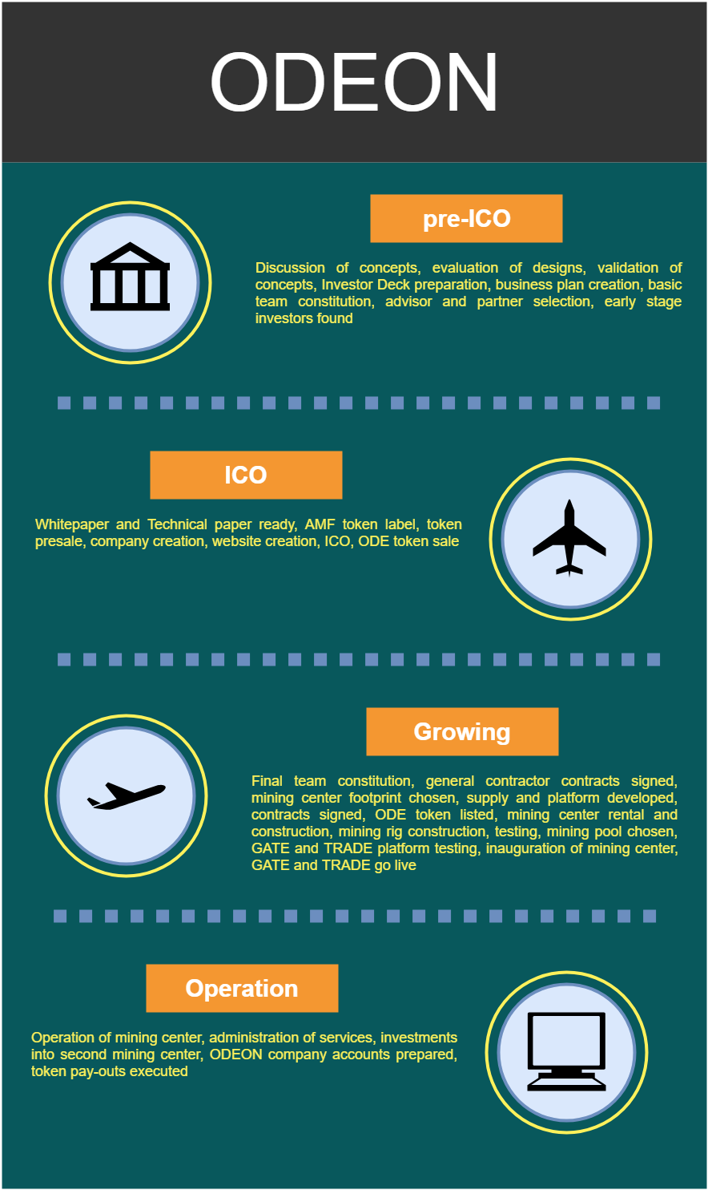

As of now we are right on schedule. The Technical Paper was finished at the end of May and elaborate preparations for the token presale were made. Starting now, we welcome you to participate in the token presale as well as in the ICO afterwards. To ensure the adherence to time limits, ODEON’s expert team is dedicated to keeping a watching brief over the proceedings of the project as a whole.

