ECE 395: Advanced Digital Projects Lab
Spring 2012

Active Electromagnetic Suspension

Vinay Maddali
Sartaj Grewal

Abstract

We have attempted to build a smaller model of an active suspension for use in vehicles. After much research, we settled on using the eLPAS patented design for our suspension for its simplicity and inexpensive nature. Simulations in MATLAB were done to choose some of the design parameters and validate the design as a suspension. We successfully interfaced the eLPAS system with a dsPIC33EP64MC202 microcontroller and used the inbuilt motor interface system to control the PWM going to the Grainger 1LPV3 DC permanent magnet geared brushed motor. We also interfaced a distance sensor, an accelerometer, an optical encoder and used SPI to communicate with an Arduino microcontroller for easy interface with the PC.

Table of Contents

Topics
a. Active suspension
b. eLPAS design
c. Simulations
d. Motor and motor H-bridge
e. dsPIC33e
i) PWM
ii) UART / SPI
iii) ADC
iv) Digital I/O
f. Sensors
i) Encoder
ii) Accelerometer
iii) Distance sensor
g. Additional circuit elements
i) Power supplies and voltage regulators
ii) Op-amp buffer
iii) Voltage dividers / conversion chips
iv) Arduino microcontroller
h. Final demo performance
i. Problems, solutions and future checklist.

Appendix
A. MATLAB code
B. dsPIC33ep64MC202 code and Arduino code
C. eLPAS dimensions
D. Circuit Diagrams
E. Datasheet links

References

Active Suspension

Active Suspension is a suspension in which the stiffness of the suspension can be varied to compromise between the conflicting factors of car control versus ride comfort. An active suspension can take energy out of a system and pump energy into the system as compared to a semi-active suspension that can only take energy out of the system. Active Suspension have only seen widespread use in high end luxury cars and niche areas of high performance due to a certain number of factors. These factors include weight, cost and fail-safe issues. But there has started a resurging interest in these types of suspensions due to their benefits. The choice of electromagnetic suspension with the choice of the project. Electromagnetic suspensions have the advantage of energy recovery over other suspension types like pneumatic suspensions.

eLPAS

eLPAS abbreviated from electromechanical Low-Power Active Suspension is a patented design for simplified suspension design developed by A. Knaap et al. One of the reasons for choosing this design was the high cost of a linear electromagnetic motor, which is an essential component of high performing active suspension. Here we only try to summarise the basics of its operation and for a detailed explanation please refer to the references ^{1,2}.

The structure comprises of a fixed frame(104), a wishbone (103) connected to the frame through pivot (P), a motor(110), connecting rod(108B) and spring mechanism at the top(108A, 109, 105,116,115 etc.). In a traditional spring system, the stiffness of the whole system depends on the compression of spring and the location of the spring relative to the wheel. In the eLPAS system, the inventors have tried to overcome the dependence of the moment on the effective spring stiffness i.e. tried to make both the factors more independently adjustable. It also helps to keep the effective stiffness constant - our overall goal. To achieve the above effect, the motor plane is rotated around the x axis and y axis to get a certain . The inventor also recommends that the center of the spring should coincide with the lowest point on the curve to reduce friciton effects on the suspension. For a detailed explanation please refer to the references ^{1,2}.

The equations:

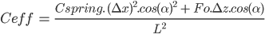

where, M - Moment
Fs - Spring force
- Offset in x.
- Offset in z.
- Angle with vertical connecting center of spring and lowest point on motor.
- Spring pretension
Cspring - Spring stiffness
L - length of wishbone

Using the two equations above, we solved the system to see if the chosen specifications produce a stable system output. The code has been listed in Appendix A. We also tried to solve for the mechanical design of the system to minimize the torque on the pivot, but were unsuccessful to find a practical solution to the problem.
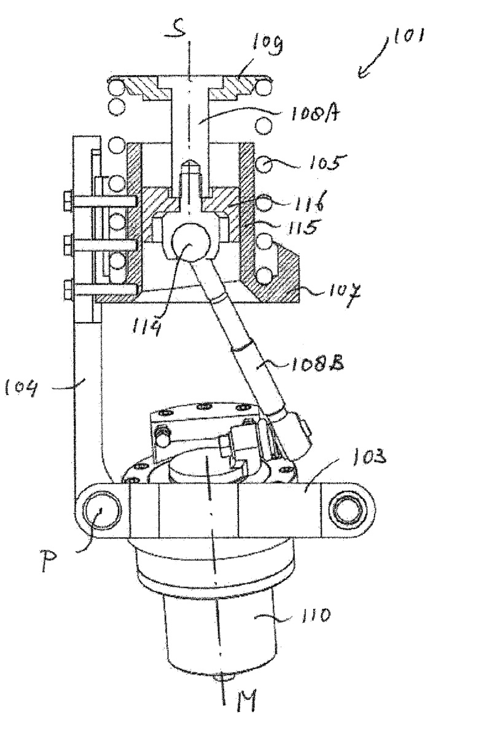
Fig 1: eLPAS design

Simulation

We ran simulations on the eLPAS system using MATLAB code from Appendix A and system specifications from Appendix C. The first simulation was to obtain plots of constant Ceff. The target value was chosen based on the value of Ceff at the lowest point as that was chosen as the default value. Any other value can also be chosen but it should be kept in mind that the system design has some mechanical constraints that depend on the system specifications.

The following figure shows the result of the first simulation. It shows the points of constant Ceff based on the rotation of the wishbone about the pivot. The blue circle is the tilted plane of the motor at rest position. The different lines of black circles represent the different Ceff values. The red line at the top tells us the relative movement in the epicenter for keeping the rod at points of constant Ceff. Obviously, this also gives us a measure of the stroke length of the suspension.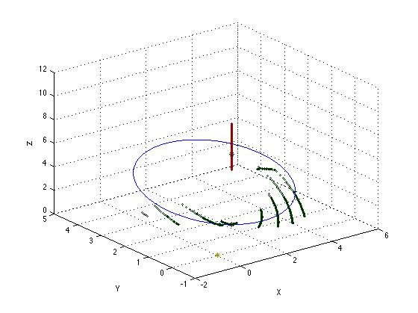

Fig 2: Ceff plot

The other plot simulated the values of Ceff versus the Feff. It showed a measure of the deviation of Ceff from ideal for each position. As can be seen from the higher values of Ceff, the value starts dropping at high deviations from center. The values have to be corrected for standard SI units. The current units are taken in inches and lbs that served us better.

Using the two plots, the resultant values were exported to header files suitable for use in the control aspect of the suspension. As we did not end up using the precise motor position control due to time considerations, we had to settle for a partial fix. As can be seen from the graph, the trajectory for the lowest point is fairly constant in x. So, taking the approximations that x is constant, we just had to maintain the position of the motor while the suspension moved to keep Ceff fairly constant.
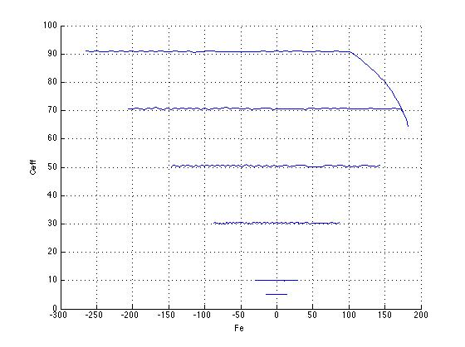
Fig 3: Ceff vs Fe

Motor and Motor Module

Motor is one of the most critical part of the electromagnetic suspension design. The requirements of the motor are that it is fast, inexpensive, easy to control, interface with PIC and has enough torque to sustain movement. The torque is required to keep to apply the push required to keep the motor in a certain place. Additional factors could include weight and efficiency. Since, our design is not for an actual design and we were limited on the cost for the project, we went for the cheapest option that could satisfy our bare minimum requirements.

For the choice of motor type, we chose a DC permanent magnet geared brushed motor. DC was chosen over AC because of easy availability of DC power for actual suspension in an actual car. Permanent magnet brushed motor was chosen as it gave us the best cheap, power and easy control package deal. Although the motor adds extra weight, it can be easily compensated on the spring side. The motor had to be geared to put out a certain acceptable torque. The actual motor chosen was the Grainger 1LPV3 12 V DC motor. One of the factors that we disregarded was the fact that we needed exact position control and being too hard to implement, it was discarded for easier control options.

The motor control module LMD18200(H-Bridge) had enough features for advanced motor control and performed ideally for the project. There was no need for external power MOSFETs as the motor control module had enough power to control a 12V motor. Although the motor module offers many more features like thermal flag check etc., we only made use of direction input. We grounded the brake input as we did not have precise position control feedback and the system performance was static. The connection diagram to hook up the motor to the motor module and microcontroller has been given in Appendix D.

dsPIC33e

The dsPIC33e series boasts an advanced motor control interface and 70 MIPS of processing power. The dsPIC33e was chosen for the above factors as the control unit on the suspension had to be fast. As we realised later, the problem with control came from ineffective sensors rather than motor or microcontroller. Several features were implemented on the PIC using the datasheets provided on the website. Future groups are cautioned against using this line as it is fairly new and does not have sufficient code support. In retrospect, we would have benefitted from using AVR or MSP430 microcontrollers. For the code regarding the following features, please refer to Appendix B and for specific terminology refer to the datasheet links in Appendix E.

PWM - dsPICe supports advanced PWM module interface. we were able to initialize the PWM using the sample code on the datasheet with a few minor changes. PWM is used in driving the motor at different speeds in different configurations.

UART/SPI - These options were considered for debugging the system, especially to check the output of sensors. We tried to initialize UART but the package has 28 pins and we had to re-configure the pins on the PIC. There were a couple of reasons SPI was chosen over UART.
Firstly, SPI already had configured pins as compared to UART that would require work. Secondly, all the implementation of control was done on the last weekend and so we did not have enough time to debug protocols. Thirdly, as PIC was the master and it was only a one-way communication to an Arduino, there was no requirement for external hardware. Arduino was chosen as the slave due to easy availability of code and a pre-configured serial terminal monitor.

ADC - ADCs were required to be configured for reading analog values from the accelerometer and the distance sensor. We obtained the code from the datasheet.

Digital I/O - Digital I/O was required to read the encoder input and write the output on the direction input to the motor module.

A few things we had to consider when coding have been summarised in the last section. We also talk about how we overcame some of the issues.

This is the Pin Diagram:
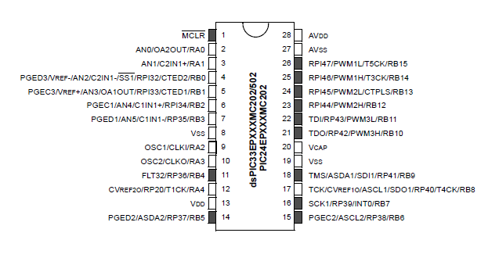

Sensors

Sensors were the brains of the control for the suspension. For a real world active system, sensors have to be reliable enough to give satisfactory output from the suspension. A design choice was made in the case of the placement and the types of sensors being used. First, let us mention what we wanted to control and then what kind of solutions were used.

For this design, we wanted to monitor the displacement of the wishbone from the normal position and the acceleration of the wishbone. We also wanted to monitor the state and position of the motor. Lastly, we wanted to monitor the compression of the spring. Ideally, we would also have like to monitor the force that applied by the system on the wishbone.

As we mentioned before, we could not implement precise motor controls. So we had to estimate the stiffness values based on the position of the motor and also assume that those values did not change when the wishbone rotated. But, we were to monitor the other factors.

Encoder - The encoder is an optical encoder MOC75T1. The encoder outputted a digital HIGH when the signal from the input LED to the output receiver is interrupted. The encoder was placed on the top of the suspension above the spring socket. When the spring get compressed, the rod moves up and moves the encoder along a plastic comb. So, we are able to monitor motion based on how many times the encoder becomes HIGH. For simplicity, we did not measure the total travel the travel of the spring and the use of the encoder was done to sense motion.

Accelerometer - The accelerometer is ADXL335 from Analog Devices which features 3-axis accelerometer with low noise and low power consumption. Only the x axis acceleration sensing was used as z-axis sensing was faulty and we did not require y axis sensing. Due to the mechanical constraints, the motor was only rotated for a part of the whole circle. It was seen that the anti-clockwise rotation led to the wishbone becoming more tilted downwards. So, the accelerometer was implemented as a hack for precise motor position control as we empirically recorded the range of values for the motor rotation.

Distance Sensor - Distance Sensor was used to provide the z-axis sensing as the accelerometer z sensing did not work. In retrospect, the accelerometer could have been attached to the side of the wishbone and the y-axis sensing could have been used for motion in z. The distance that we used is a GP2Y0A21YK0F IR medium distance sensor from SHARP. It should be noted that this sensor measures distances from 10 cm to 32 cm.

Additional Circuit Elements

In this section, we want to cover the circuit elements that were required to make the connections between various components mentioned before.

Power Supplies and Voltage Regulator - Our implementation required two separate power supplies for powering the motor control module at 12 V and supplying the circuit with 5V (required by the encoder and the distance sensor). In the final implementation, only the 12 V connection should be required and the other connection can be obtained by using a variable voltage regulator.

A voltage regulator LM2950 was used to power the PIC at 3.3 V with the input taken from the 5V supply. Another variable voltage regulator LM317 was used to obtain 1.5 V from 5 V supply to feed the input LED of the encoder.

Op-amp Buffer - For reasons that are listed in the last section, we were required to use an op-amp buffer between the input supply variable voltage regulator and the encoder input. Our implementation of the op-amp had R2 replaced by a short while R1 was replaced by an open. So, the resultant gain becomes close to 1.

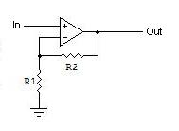Gain = 1 + (R2/R1)

Voltage dividers/Conversion chips - Voltage dividers were required to interface the 5V analog input signals from the sensors to the PIC. The 3.3 V SPI signals going to the 5V Arduino microcontroller did not require the use of conversion chips, but the chips should be incorporated to make sure noise does not play a role in the communication. For voltage dividers, we used 100k potentiometers from the ECE Electronics Service Shop.

Arduino Uno - Arduino Uno was implemented as a terminal device that could display and help debug the internal parameters of the system.

Final Demo Performance

The suspension was shown to work in two static scenarios although many advanced dynamic scenarios can be implemented. When the code runs for the first time, the motor travels from the far left point (Off state) to the lowest point (ON state). The ON state could be kept at any point depending on the effective spring constant required for the application. Though it should also be considered that the lowest point provide us with the maximum possible stroke length. After the motor is in ON state, two scenarios are considered - when the wheel hits hits a bump or if the car is taking a corner at high speed. For the suspension only the compression state is considered as the extension case has been limited by the clip at the top of the spring. When we want to return the suspension to OFF state, we used a button input to make the motor back to its OFF state.

In the first scenario, we want to return the wheel to its normal position. We considered the simple scenario of keeping the Ceff fairly constant although there could be more advanced logic covering all the corner cases. For keeping the Ceff constant, the system detects if the wishbone is displaced and starts applying a small PWM to the motor. The PWM to the motor is applied till the wheel returns to its normal position. We do not track the motion of the suspension and do not time out the motor if the suspension stays in compressed state for a long time.

In the second scenario, we want to make to increase the Ceff when we detect that the car is going around a corner. For detection we used the simple logic of pressing a button till the motor rotates far enough anti-clockwise to offset any force (although no force is applied in this case either) and then rotates back to the ON state when the button is pressed again. This process can be automated but in our final demo we could only implement it manually.

Both the scenarios have shown favorable results for the suspension. We plan to make it more automated but we do not plan to make it any more efficient.

Problems, solutions and future checklist

In this section, we cover the details behind the circuit design choices and create a future checklist for anyone who pursues this project.

Sensor Precision, range and noise - This problem of sensor precision, range and noise was the major cause of performance problems. We should have considered these factors in detail for the specific application of a suspension. The use of generic accelerometers that are used more in UAVs led to unpredictable outputs due to noise and drift. Having unpredictable results on the feedback led to sub-par automation of the suspension and was the major reason of the final tests being static cases. The distance sensor was not meant to be used for such close range applications and produced no discernible change in output when the distance was less than 10 cm.

Encoder Interfacing - The encoder was the toughest part in terms of interfacing but worked ideally afterwards. The problem was that the encoder input dragged the input voltage below the supplied 1.5 V and did not work at that voltage. After debugging the circuit, we believe that the mechanism of using a potentiometer to divide the voltage from 5V to 1.5V and the low input impedance of the encoder were the cause of the problem. To solve this problem, we had to put a variable voltage regulator which outputted the required 1.5 V and then put an op-amp buffer stage to get the appropriate impedance matching. We still got a change of 0.3V on the input line but as the source voltage was isolated from this change, the circuit was not affected substantially.

dsPIC33e - The dsPIC33e is a new line of microcontrollers launched by Microchip this year. This line of dsPICs does not have substantial support on the web (a critical component) but has a detailed family reference document. So, it takes a substantial amount of time to get a generic implementation of the features working. Even after the features work, sometimes we had no idea how to tune the feature to make it more appropriate for the application. The former claim does not criticize the capability of the microcontroller features but pulls into question how much the programmer has to know before programming at such low level. A consequence was that we could not figure out why we could not use the other PWM pins after we had configured PWM1. On the performance side, the dsPIC33e microcontroller is a powerful microcontroller able to handle multiple tasks that were required for this project.

Motor - The motor choice should have been more carefully evaluated. One of the first problems was that the motor peak torque was not able to oppose the spring so a bigger motor would have been more ideal. We also realised that the RPMs of the motor did not have as much consequence as the motor peak torque. The motor could have been chosen with an installed sensor to make position control easy.

eLPAS Design - The design should be changed to make more clearance at the bottom. It can be partially achieved by adjusting the spring at the top but would also require a set of longer base plates. The length of the rod connecting the center of the spring to the motor can be increased for a bigger rotation on the motor for the same stroke length.

Bench Supply - The bench supply is noisy and should not be used in any case. Voltage regulator should be used if the bench supply is used.

Considering all the points above, we recommend this course of action:

1. Replace the PIC microcontroller by an AVR, MSP430 or STM32 microcontroller.
2. Reassess all the sensors and the control for the suspension. Also consider adding a force sensor and replacing the encoder by a better optical encoder.
3. Implement position control on the motor.
4. Make use of voltage regulators and conversion chips to make three lines of 5V, 3.3V and 1.5V(if encoder is used).
5. Implement a protocol to talk to a PC without the use of an Arduino. There are chips on Sparkfun that make this process easier.
6. Make a PCB to make working with the chips easier.

In addition to the checklist, we want to propose an idea that could use this suspension. A computer game could made on a MAC/PC that could communicate with the suspension. The game would be set in a causeway with the player driving a car in a remote country; the condition of the causeway is good at some parts and worse in some parts. The game could also have two scenarios where the car has a passive suspension and one in which it has an active suspension. The suspension would react to the changes in the causeway and the reaction of the suspension would be simulated in the game. This type of game would be ideal to show the benefits of an active suspension.

Appendix

A.MATLAB Code for the simulation of the eLPAS model

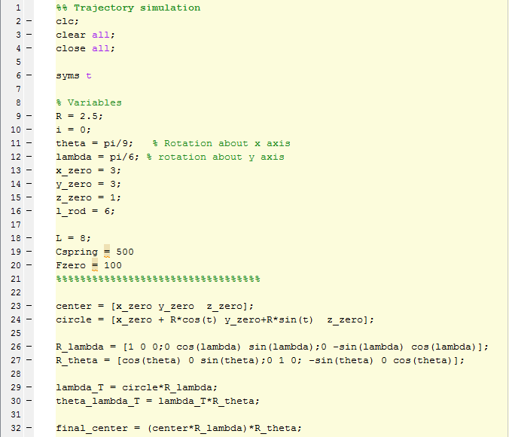
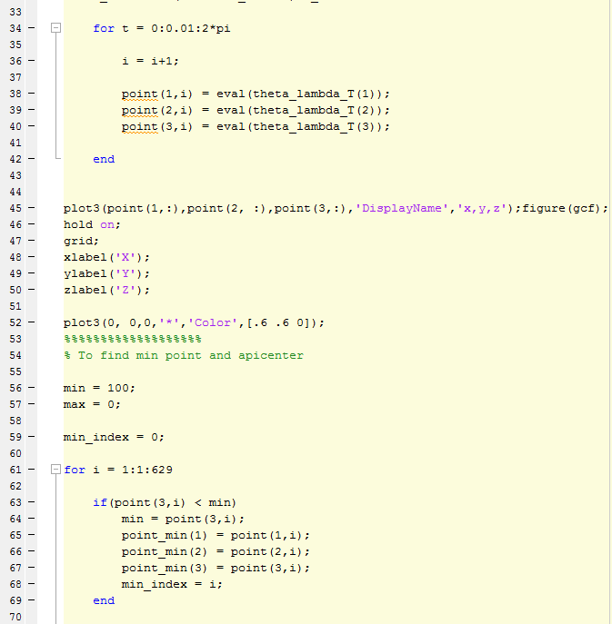

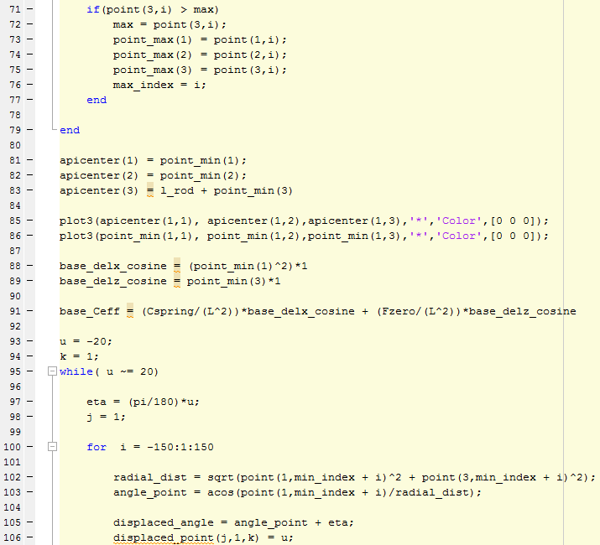

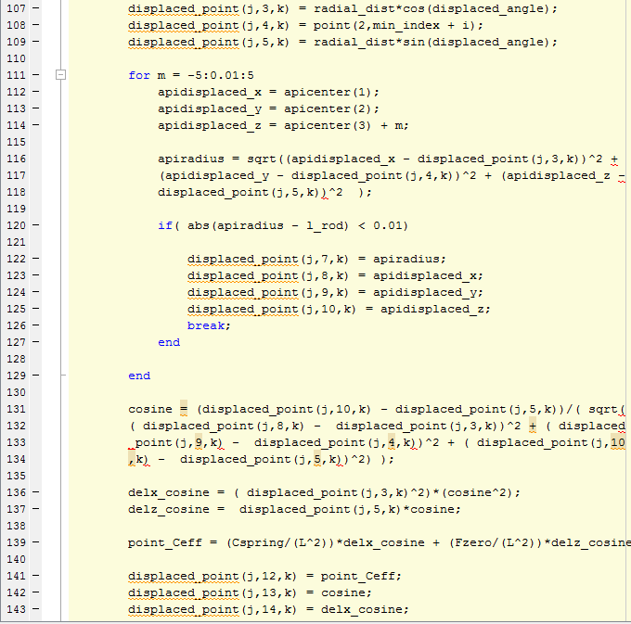
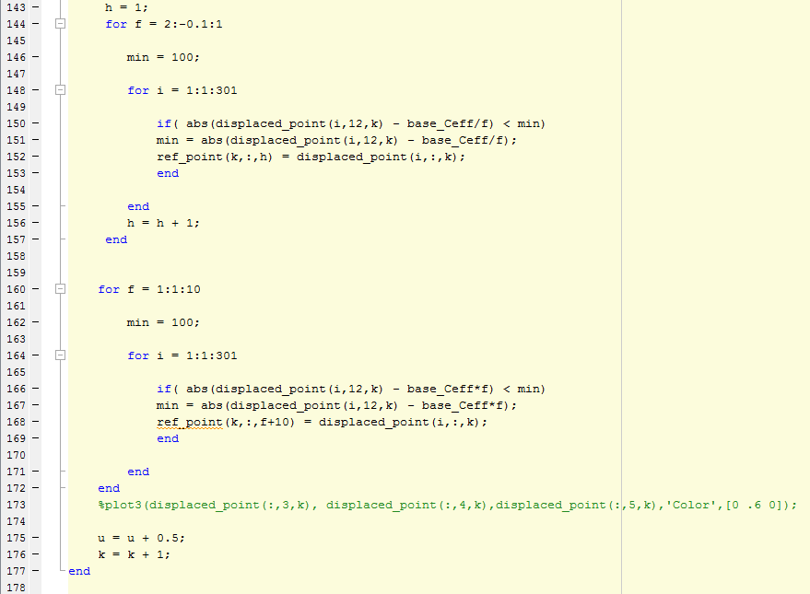

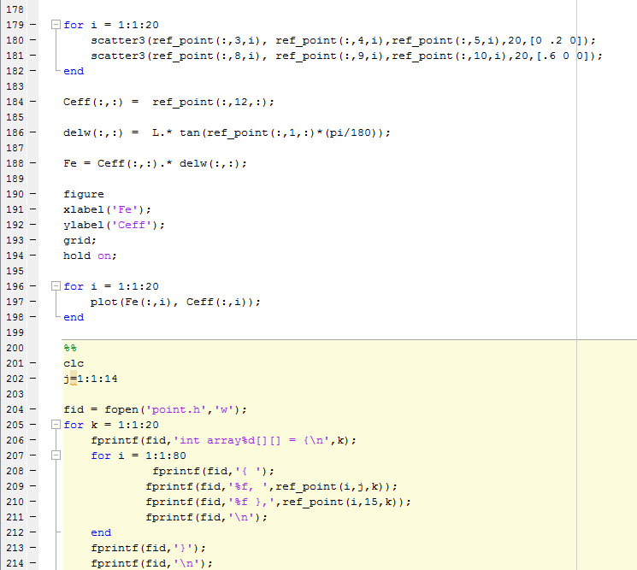

B. dsPIC code for motor control and SPI
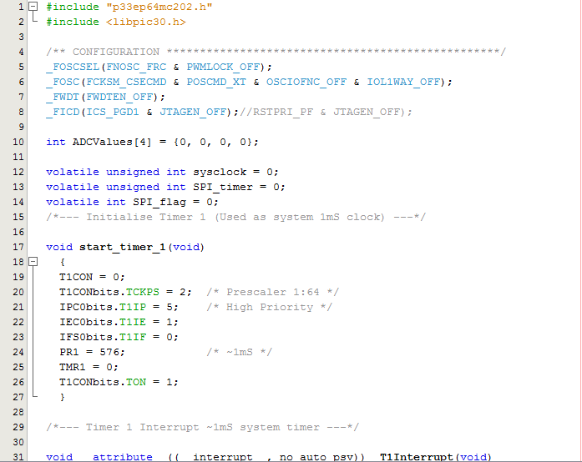
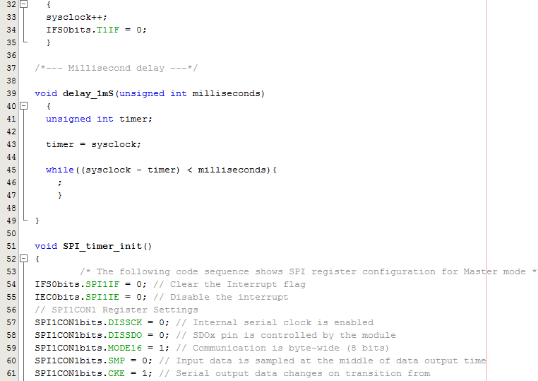

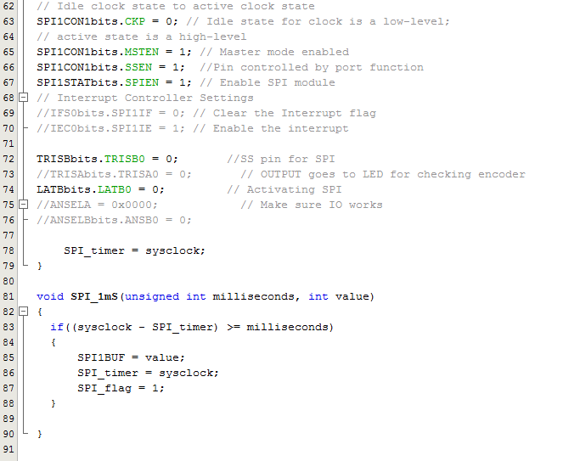
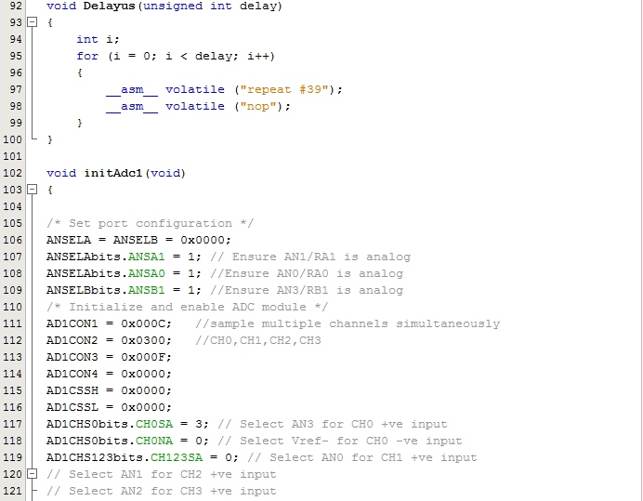
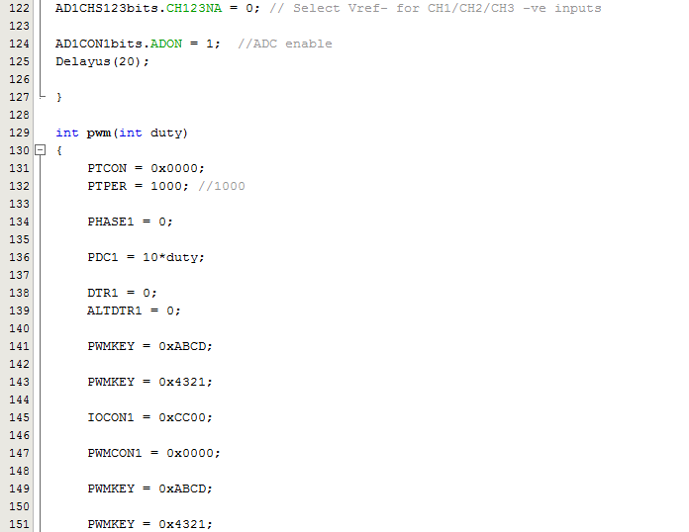
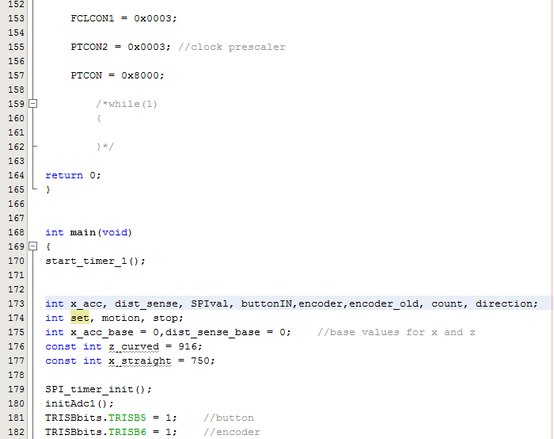
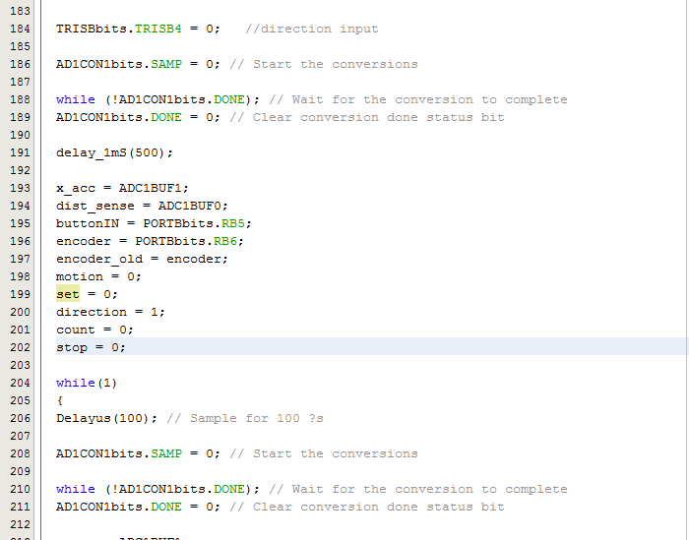
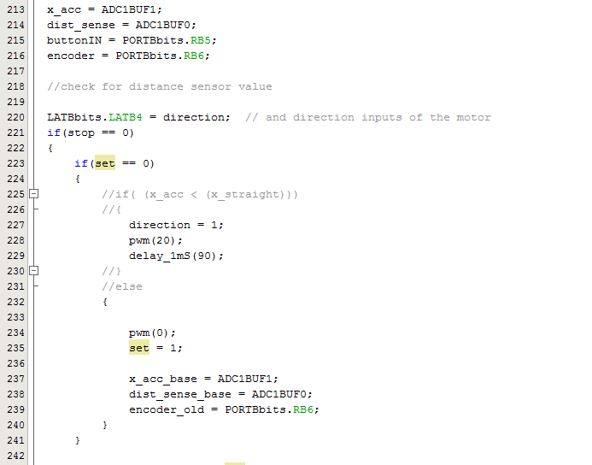
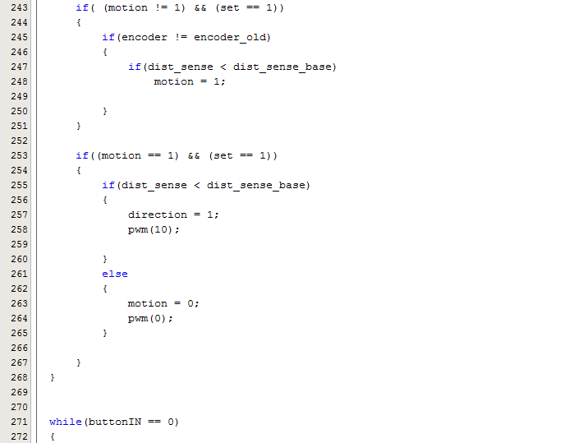
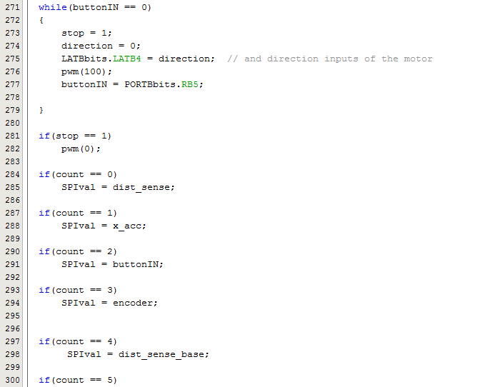
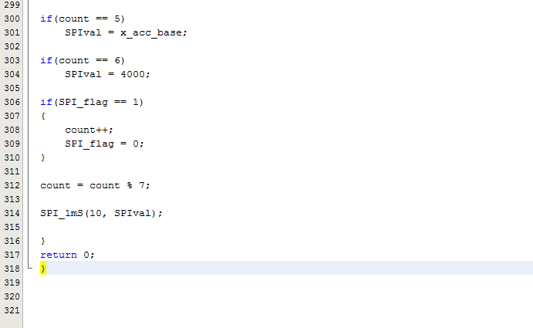

Code for rotation of motor in the event of a curve
#include "p33ep64mc202.h"
#include <libpic30.h>

/** CONFIGURATION **************************************************/
_FOSCSEL(FNOSC_FRC & PWMLOCK_OFF);
_FOSC(FCKSM_CSECMD & POSCMD_XT & OSCIOFNC_OFF & IOL1WAY_OFF);
_FWDT(FWDTEN_OFF);
_FICD(ICS_PGD1 & JTAGEN_OFF);//RSTPRI_PF & JTAGEN_OFF);

int ADCValues[4] = {0, 0, 0, 0};

volatile unsigned int sysclock = 0;
volatile unsigned int SPI_timer = 0;
volatile int SPI_flag = 0;
/*--- Initialise Timer 1 (Used as system 1mS clock) ---*/

void start_timer_1(void)
{
T1CON = 0;
T1CONbits.TCKPS = 2; /* Prescaler 1:64 */
IPC0bits.T1IP = 5; /* High Priority */
IEC0bits.T1IE = 1;
IFS0bits.T1IF = 0;
PR1 = 576; /* ~1mS */
TMR1 = 0;
T1CONbits.TON = 1;
}

/*--- Timer 1 Interrupt ~1mS system timer ---*/

void __attribute__((__interrupt__, no_auto_psv)) _T1Interrupt(void)
{
sysclock++;
IFS0bits.T1IF = 0;
}

/*--- Millisecond delay ---*/

void delay_1mS(unsigned int milliseconds)
{
unsigned int timer;

timer = sysclock;

while((sysclock - timer) < milliseconds){
;
}

}

void SPI_timer_init()
{
/* The following code sequence shows SPI register configuration for Master mode */
IFS0bits.SPI1IF = 0; // Clear the Interrupt flag
IEC0bits.SPI1IE = 0; // Disable the interrupt
// SPI1CON1 Register Settings
SPI1CON1bits.DISSCK = 0; // Internal serial clock is enabled
SPI1CON1bits.DISSDO = 0; // SDOx pin is controlled by the module
SPI1CON1bits.MODE16 = 1; // Communication is byte-wide (8 bits)
SPI1CON1bits.SMP = 0; // Input data is sampled at the middle of data output time
SPI1CON1bits.CKE = 1; // Serial output data changes on transition from
// Idle clock state to active clock state
SPI1CON1bits.CKP = 0; // Idle state for clock is a low-level;
// active state is a high-level
SPI1CON1bits.MSTEN = 1; // Master mode enabled
SPI1CON1bits.SSEN = 1; //Pin controlled by port function
SPI1STATbits.SPIEN = 1; // Enable SPI module
// Interrupt Controller Settings
//IFS0bits.SPI1IF = 0; // Clear the Interrupt flag
//IEC0bits.SPI1IE = 1; // Enable the interrupt

TRISBbits.TRISB0 = 0; //SS pin for SPI
//TRISAbits.TRISA0 = 0; // OUTPUT goes to LED for checking encoder
LATBbits.LATB0 = 0; // Activating SPI
//ANSELA = 0x0000; // Make sure IO works
//ANSELBbits.ANSB0 = 0;

SPI_timer = sysclock;
}

void SPI_1mS(unsigned int milliseconds, int value)
{
if((sysclock - SPI_timer) >= milliseconds)
{
SPI1BUF = value;
SPI_timer = sysclock;
SPI_flag = 1;
}

}

void Delayus(unsigned int delay)
{
int i;
for (i = 0; i < delay; i++)
{
__asm__ volatile ("repeat #39");
__asm__ volatile ("nop");
}
}

void initAdc1(void)
{

/* Set port configuration */
ANSELA = ANSELB = 0x0000;
ANSELAbits.ANSA1 = 1; // Ensure AN1/RA1 is analog
ANSELAbits.ANSA0 = 1; //Ensure AN0/RA0 is analog
ANSELBbits.ANSB1 = 1; //Ensure AN3/RB1 is analog
/* Initialize and enable ADC module */
AD1CON1 = 0x000C; //sample multiple channels simultaneously
AD1CON2 = 0x0300; //CH0,CH1,CH2,CH3
AD1CON3 = 0x000F;
AD1CON4 = 0x0000;
AD1CSSH = 0x0000;
AD1CSSL = 0x0000;
AD1CHS0bits.CH0SA = 3; // Select AN3 for CH0 +ve input
AD1CHS0bits.CH0NA = 0; // Select Vref- for CH0 -ve input
AD1CHS123bits.CH123SA = 0; // Select AN0 for CH1 +ve input
// Select AN1 for CH2 +ve input
// Select AN2 for CH3 +ve input
AD1CHS123bits.CH123NA = 0; // Select Vref- for CH1/CH2/CH3 -ve inputs

AD1CON1bits.ADON = 1; //ADC enable
Delayus(20);

}

int pwm(int duty)
{
PTCON = 0x0000;
PTPER = 1000; //1000

PHASE1 = 0;

PDC1 = 10*duty;

DTR1 = 0;
ALTDTR1 = 0;

PWMKEY = 0xABCD;

PWMKEY = 0x4321;

IOCON1 = 0xCC00;

PWMCON1 = 0x0000;

PWMKEY = 0xABCD;

PWMKEY = 0x4321;

FCLCON1 = 0x0003;

PTCON2 = 0x0003; //clock prescaler

PTCON = 0x8000;

return 0;
}

int main(void)
{
start_timer_1();

int x_acc, dist_sense, SPIval, buttonIN,encoder,encoder_old, count, direction, set, motion, stop, dist_sense_old;
int x_acc_base = 0,dist_sense_base = 0; //base values for x and z
const int z_curved = 916;
const int x_straight = 725;

SPI_timer_init();
initAdc1();
TRISBbits.TRISB5 = 1; //button
TRISBbits.TRISB6 = 1; //encoder

TRISBbits.TRISB4 = 0; //direction input

AD1CON1bits.SAMP = 0; // Start the conversions

while (!AD1CON1bits.DONE); // Wait for the conversion to complete
AD1CON1bits.DONE = 0; // Clear conversion done status bit

delay_1mS(500);

x_acc = ADC1BUF1;
dist_sense = ADC1BUF0;
buttonIN = PORTBbits.RB5;
encoder = PORTBbits.RB6;
encoder_old = encoder;
motion = 0;
set = 0;
direction = 1;
count = 0;
stop = 0;

while(1)
{
Delayus(100); // Sample for 100 ?s

AD1CON1bits.SAMP = 0; // Start the conversions

while (!AD1CON1bits.DONE); // Wait for the conversion to complete
AD1CON1bits.DONE = 0; // Clear conversion done status bit

x_acc = ADC1BUF1;
dist_sense = ADC1BUF0;
buttonIN = PORTBbits.RB5;
encoder = PORTBbits.RB6;

//check for distance sensor value

LATBbits.LATB4 = direction; // and direction inputs of the motor

if(set == 0)
{
if( (x_acc < x_straight +10 ))
{
direction = 1;
pwm(20);
}
else
{
pwm(0);
set = 1;

x_acc_base = ADC1BUF1;
dist_sense_base = ADC1BUF0;
encoder_old = PORTBbits.RB6;
}
}

if((buttonIN == 0))
{
if(direction == 1)
direction = 0;
else
direction = 1;

}

while( (buttonIN == 0))
{
motion = 1;
pwm(10);
buttonIN = PORTBbits.RB5;
}

if(motion == 1)
{
pwm(0);
motion = 0;
}

if(count == 0)
SPIval = dist_sense;

if(count == 1)
SPIval = x_acc;

if(count == 2)
SPIval = buttonIN;

if(count == 3)
SPIval = encoder;

if(count == 4)
SPIval = dist_sense_base;

if(count == 5)
SPIval = x_acc_base;

if(count == 6)
SPIval = 4000;

if(SPI_flag == 1)
{
count++;
SPI_flag = 0;
}

count = count % 7;

SPI_1mS(10, SPIval);

}
return 0;
}

Arduino Code
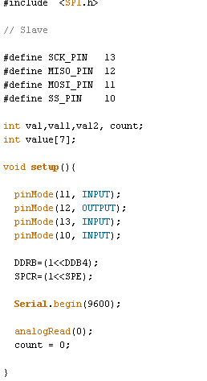
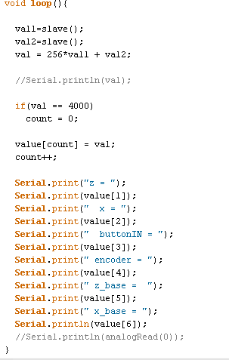

C. eLPAS Dimensions

Length of Wishbone = 8 inches
Length of Shaft = 6 inches
Radius of Motor plate = 2.5 inches
Orientation of motor wrt wishbone : 30 degrees on x and 20 degrees on y
Spring constant = 400N/inch

D. Circuit Diagram

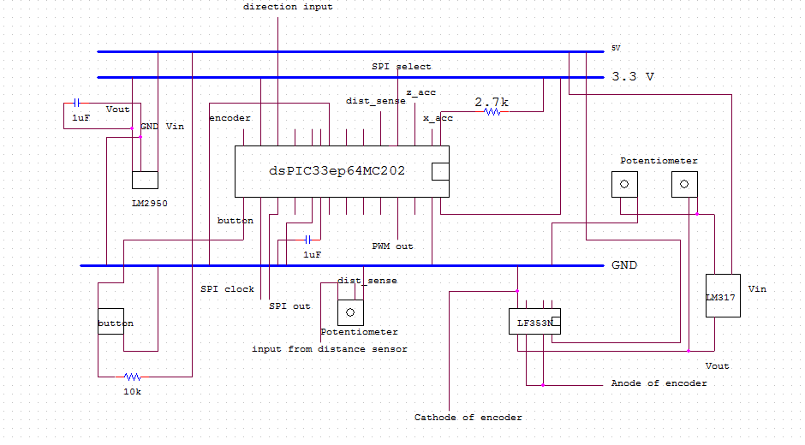

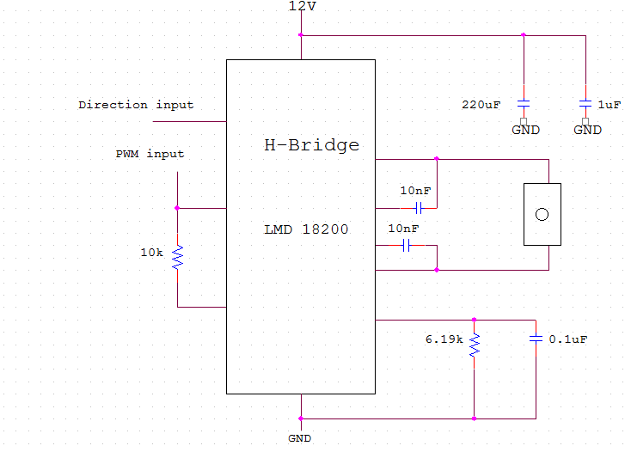

References

Van Der Knaap, Albertes Clemens Maria, Arjan Pieter Teerhuis, Raymond Bernadus Gerhardus Tinsel, and Robert Marjin Anthony Frank Verschuren. Active Suspension Assembly for a Vehicle. ACM Van Der Knaap, assignee. Patent US2010/0301571 A1. 2 Dec. 2010. Print.

The Electromechanical Low-Power Active Suspension: Modeling, Control, and Prototype Testing
Willem-Jan Evers, Arjan Teerhuis, Albert van der Knaap, Igo Besselink, and Henk Nijmeijer, J. Dyn. Sys., Meas., Control 133, 041008 (2011), DOI:10.1115/1.4003278

http://ww1.microchip.com/downloads/en/DeviceDoc/70657E.pdf

http://ww1.microchip.com/downloads/en/DeviceDoc/70569C.pdf

http://ww1.microchip.com/downloads/en/DeviceDoc/70645C.pdf

http://pdf1.alldatasheet.com/datasheet-pdf/view/84044/ETC/LM2950.html
http://www.futurlec.com/Linear/LF353N.shtml

http://www.alldatasheet.com/datasheet-pdf/pdf/250056/AD/ADXL335.html

http://www.arduino.cc/

http://www.ti.com/lit/ds/symlink/lmd18200.pdf

http://www.alldatasheet.com/datasheet-pdf/pdf/53868/FAIRCHILD/MOC70P1.html

http://www.alldatasheet.com/datasheet-pdf/pdf/412635/SHARP/GP2Y0A21YK0F.html

