**Renal Physiology (17 Questions on midterm)**

1. **What is NOT a function of the kidney?**
2. Hormone production
3. Excretion of Waste
4. Glycolysis
5. Maintain ion balance
6. **What is the correct order through the nephron?**
7. proximal tubule 🡪 descending loop 🡪 ascending loop 🡪 distal convoluted tubule
8. proximal loop 🡪 descending tubule 🡪 ascending tubule 🡪 distal convoluted loop
9. distal convoluted tubule 🡪 descending loop 🡪 ascending loop 🡪 proximal tubule
10. proximal tubule 🡪 ascending loop 🡪 descending loop 🡪 distal convoluted tubule
11. **Which of the following is a transporter that increases activity in the presence of aldosterone?**
12. sodium/potassium ATPase in the proximal tubule
13. sodium/potassium ATPase in the collecting duct
14. sodium/hydrogen exchanger in the proximal tubule
15. sodium/hydrogen exchanger in the collecting duct
16. **What is the difference(s) between cortical and juxtamedullary nephron?**
17. Both located in the cortex
18. Cortical nephrons have a longer loop of Henle
19. Juxtamedullary nephron is located in the medulla
20. Humans have more juxtamedullary nephrons than cortical
21. 1 and 3 are correct
22. 2 and 4 are correct
23. Only 1 is correct
24. Only 4 is correct
25. None of the above
26. **Which of the following causes the secretion of ADH?**
27. an increase in plasma osmolarity
28. an increase in the activity of baroreceptors
29. an increase in renin secretion
30. an increase in sodium content of the filtrate
31. **At the afferent arteriolar end of a glomerular capillary, the glomerular capillary hydrostatic pressure is 50 mmHg. In Bowman’s space the hydrostatic pressure is 10 mmHg and the glomerular capillary osmotic pressure is 27 mmHg. Given these measurements, what is the value and direction of the net filtration pressure?**

PGC = _______ (Hydrostatic pressure of glomerular capillaries)

πGC = _______ (Colloid osmotic pressure of glomerular capillaries)

PBC = _______ (Hydrostatic pressure of Bowman’s capsule)

πBC = _______ (Colloid osmotic pressure of Bowman’s capsule)

Formula for NFP =

**Therefore, what is the answer to the question?**

NFP =

Direction of the filtration pressure?

_________________

1. **The glomerular hydrostatic pressure of the capillaries is 55 mmHg. In Bowman’s space the hydrostatic pressure is 15 mmHg and the colloid osmotic pressure is 5mmHg. Finally, the glomerular capillary osmotic pressure is 30 mmHg. Given these measurements, what is the value and direction of the net filtration pressure? Further, what is unique about this situation?**

PGC = _______

πGC = _______

PBC = _______

πBC = _______

NFP =

Direction =

What is unique about the pressures?

______________________________________________________________________________

______________________________________________________________________________

1. **Fill in the blanks for the myogenic response…**

High Glomerular filtration rate….

Afferent Arteriole: ____________________________

Stretch sensitive ion channels: ____________________________

Smooth muscle cells: ____________________________

Smooth muscle voltage-gated: ____________________________

Blood flow: ____________________________

Glomerular filtration ______________

1. **The glomerular filtration rate (GFR) is the amount of fluid filtered by the kidneys per day. This value can be used to determine if there are any problems with your kidneys. In order to measure this rate, you need to select a substance that is excreted 100% from your body. We cannot choose water to calculate this value because water is reabsorbed ~ 99%. However, a molecule called creatinine is excreted 100% by the body and this is typically used to determine your GFR. Keep in mind 2L of urine is produced/day.**
2. **Calculate the glomerular filtration rate of 90mg/L of creatinine, assuming 1mg/L is found in the blood.**

GFR =

1. **Calculate the glomerular filtration rate when 0.07mg/ml of creatinine is found in the urine, assuming 1x10-3mg/ml is found in the blood.**

GFR =

1. **Calculate the glomerular filtration rate when 0.075g/L of creatinine is found in the urine, assuming 0.001 g/L is found in the blood.**

GFR =

1. **Let’s apply this concept to handling of various products in the renal system. Remember that normal GFR is 180L/day or 125mg/min.**
2. **You have 4.5 g/L of sodium in your blood plasma and you have excreted 3.9 g through urine. What is the filtered load of sodium, what percentage was excreted and what percentage was reabsorbed?**

Filtered load of sodium = [substance]plasma x GFR

% Excreted =

% Reabsorbed =

1. **You have 4.5 g/L of sodium in your blood plasma and you have excreted 3.9 g through urine. What is the filtered load of sodium, what percentage was excreted and what percentage was reabsorbed? Assume GFR is the value you calculated from question 7 part b.**

Filtered load of sodium =

% Excreted =

% Reabsorbed =

1. **You have 0.8 g/L of urea in your blood plasma and you have excreted 20 g through urine. What is the filtered load of sodium, what percentage was excreted and what percentage was reabsorbed? Assume GFR is 135mg/min and express answer as g/day.**

Filtered load of urea =

% Excreted =

% Reabsorbed =

1. **You have 0.9 g/L of glucose in your blood plasma and you have excreted 0.5 g through urine. What is the filtered load of glucose, what percentage was excreted and what percentage was reabsorbed? What could you say may be the cause of the extra glucose excretion? Assume GFR is 180 L/day.**

Filtered load of glucose =

% Excreted =

% Reabsorbed =

**Respiratory Physiology (14 Questions on midterm)**

1. **Which one of the following is true about a pneumothorax?**
2. transpulmonary pressure becomes +5 mmHg during a pneumothorax
3. a pneumothorax causes both lungs to collapse
4. damage to the visceral pleura would allow air to escape from inside the lung into the intrapleural space
5. the intrapleural space fills with fluid during a pneumothorax
6. **If in one breath a person takes in a larger tidal volume than they normally would, which one of the following statements would be correct?**
7. they are likely be breathing in less than 500 mL (0.5 liters)
8. they would have a smaller IRV (inspiratory reserve volume)
9. they would have a larger total lung capacity
10. they would have a smaller FEV1
11. **What is the pulmonary ventilation and alveolar ventilation for a 150lb person, with a respiratory rate of 20 breaths/min and tidal volume of 200mL/breath?**
12. **Complete this table on muscle contraction during inspiration and expiration at rest and exercise.**

|  |  |  |  |  |
| --- | --- | --- | --- | --- |
|  | **Inspiration** | | **Expiration** | |
|  | **At rest** | **During exercise** | **At rest** | **During exercise** |
| **Diaphragm (contract/relax)** |  |  |  |  |
| **Internal intercostals** |  |  |  |  |
| **External intercostals** |  |  |  |  |
| **Obliques** |  |  |  |  |
| **Abs** |  |  |  |  |

1. **Label the following on this figure: Tidal volume, inspiratory reserve volume, expiratory reserve volume, residual volume, vital capacity and total lung capacity.**

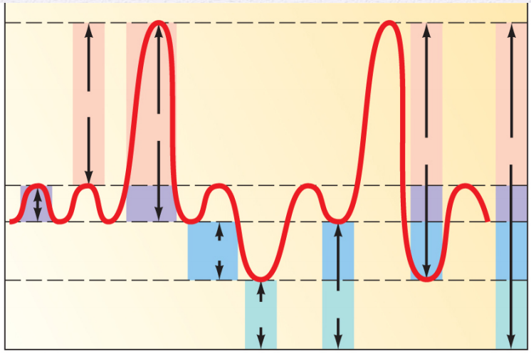

1. **Give an example of an obstructive lung disease? How does the FEV1 and FVC change?**
2. **Give an example of a restrictive lung disease? How does the FEV1 and FVC change?**
3. **Fill in the following diagram showing the partial pressures of O2 and CO2.**

**___________ PO2** = **______ mmHg**

**___________ PCO2** = **______ mmHg**

**3 General Rules**

1. _________________________________

2. _________________________________

3. _________________________________

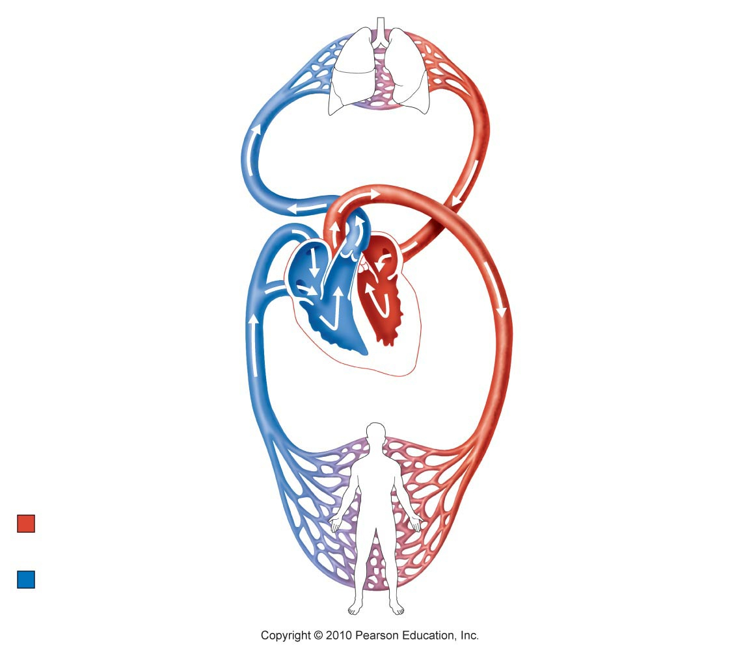

**___________ PO2** = **______ mmHg**

**___________ PCO2** = **______ mmHg**

**___________ PO2** = **______ mmHg**

**___________ PCO2** = **______ mmHg**

**___________ PO2** = **______ mmHg**

**___________ PCO2** = **______ mmHg**

**_________________**

**capillaries**

**___________ PO2** = **______ mmHg**

**___________ PCO2** = **______ mmHg**

**___________ PO2** = **______ mmHg**

**___________ PCO2** = **______ mmHg**

**_________________**

**capillaries**

**___________ PO2** = **______ mmHg**

**___________ PCO2** = **______ mmHg**