**Renal Physiology – Label the Diagrams**

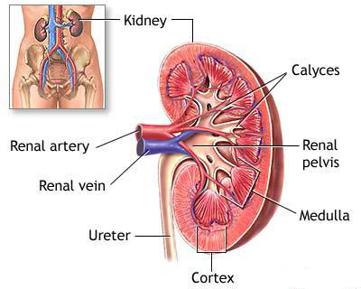

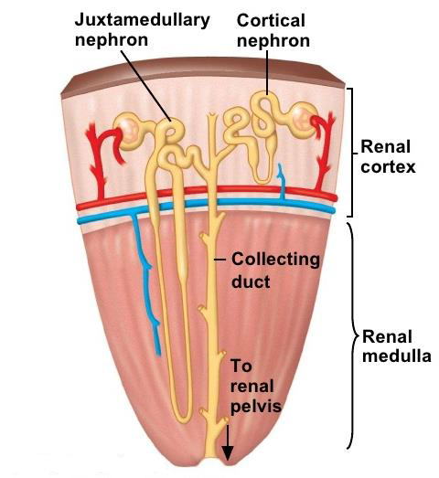

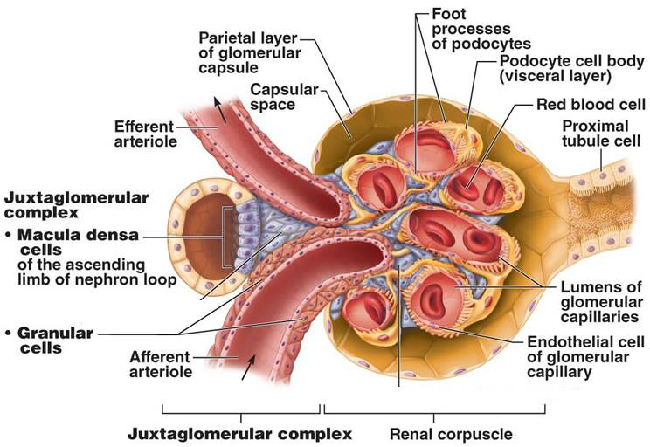

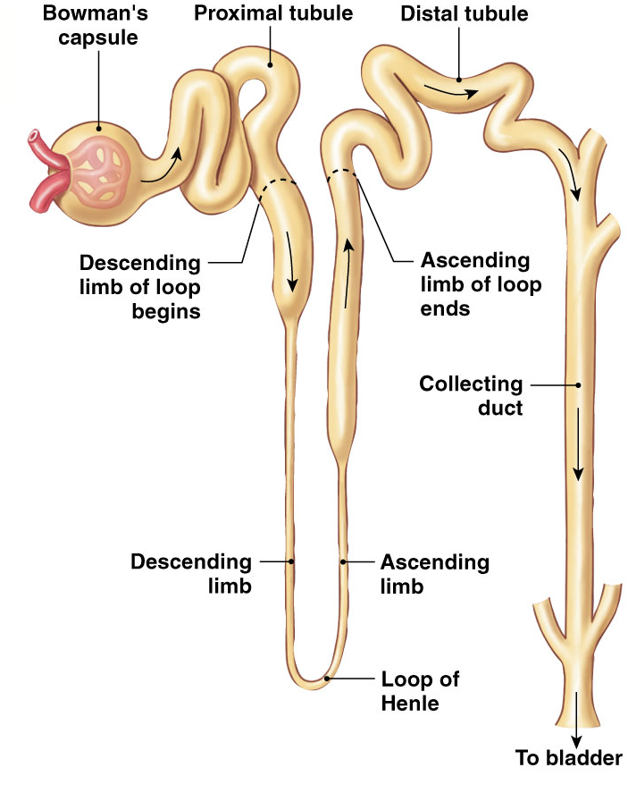

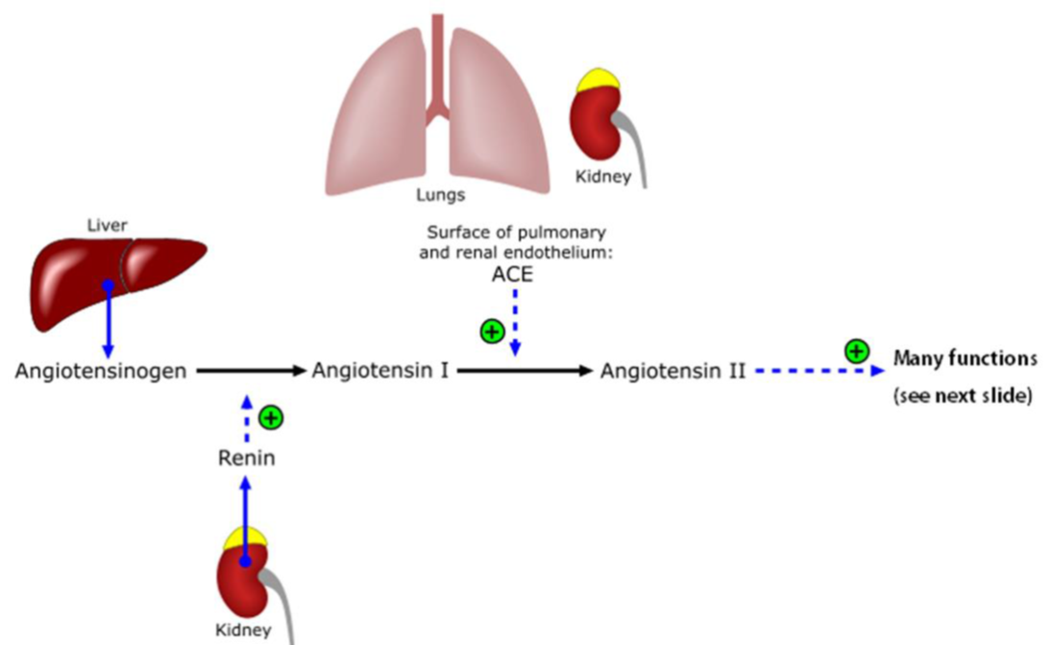

**Angiotensin Converting Enzyme**

**# of amino acids: 8**

**# of amino acids: 10**

**# of amino acids: 452**

**Released in response to: decrease in Na levels**

**RATE LIMITING ENZYME?: Renin**

**Renal Physiology – Fill In The Tables**

**Three key process that occur in kidneys**

|  |  |  |  |
| --- | --- | --- | --- |
|  | **Filtration** | **Reabsorption** | **Secretion** |
| **Where does it occur?** | Renal Corpuscle | Tubule | Tubule |
| **From _____ to _____.** | From glomerular capillaries to Bowman’s space | From lumen of tubule to surrounding capillaries (peritubular/ vasa recta) | From surrounding capillaries (peritubular/ vasa recta) to lumen of tubule to |
| **Overall** | Blood 🡪 Pre-urine (filtrate) | Removes from filtrate (e.g. body wants to keep) | Adds to filtrate (e.g. body wants to remove as waste) |

**Glomerular Filtration**

|  |  |  |  |  |
| --- | --- | --- | --- | --- |
|  | **Hydrostatic Pressure of Glomerular Capillaries** | **Colloid Osmotic Pressure of Glomerular Capillaries** | **Hydrostatic Pressure of Bowman’s Capsule** | **Colloid Osmotic Pressure of Bowman’s Capsule** |
| **Abbreviation** | PGC | πGC | PBC | πBC |
| **Caused by** | Blood flowing into glomerulus | Presence of proteins in glomerulus | Filtrate remaining in Bowman’s space | Presence of proteins in Bowman’s space |
| **Filtration** | Promotes | Inhibits | Inhibits | Promotes |
| **mmHg** | 55 | 30 | 15 | 0 |

**Net filtration pressures**

|  |  |  |  |  |
| --- | --- | --- | --- | --- |
|  | **PGC** | **πGC** | **PBC** | **πBC** |
| **Filtration** | Promotes | Inhibits | Inhibits | Promotes |
| **mmHg** | 55 | 30 | 15 | 0 |

**GFR Regulation**

|  |  |  |  |  |
| --- | --- | --- | --- | --- |
|  | **Afferent Arteriole** | | **Efferent Arteriole** | |
| **Smooth Muscle** | Dilate | Constrict | Dilate | Constrict |
| **GFR** | Increases | Decreases | Decreases | Increases |

**Reabsorption along the tubule**

|  |  |  |  |
| --- | --- | --- | --- |
| **Segment of Tubule** | **Substances** | **Hormone Regulation** | **Percent** |
| **Proximal Tubule** | Glucose, amino acids, H2O, Na+, K+, Cl- | Yes | 65% |
| **Descending Limb of LOH** | H2O, minimal Na+ | No | 20 % |
| **Ascending Limb of LOH** | Na+, K+, Cl- | No |
| **Distal Tubule** | Na+, K+, Cl- , Ca2+ | Yes | 14% |
| **Collecting Duct** | H2O, Na+ | Yes |

**Summary of transport in kidneys**

|  |  |  |  |  |  |
| --- | --- | --- | --- | --- | --- |
|  | **Proximal Tubule** | **Descending Limb** | **Ascending Limb** | **Distal Tubule** | **Collecting Duct** |
| **Goal** | Reabsorption of everything | Water reabsorption | Ion reabsorption | Ion reabsorption | Fine tuning (water and Na) |
| **Water** | Yes | Yes | No | No | Yes |
| **Ions** | Yes (Na+, Cl-, K+) | Yes (Na+) | Yes (Na+, Cl-, K+) | Yes (Na+, Cl-, K+,Ca2+) | Yes (Na+) |
| **Paracellular Transport** | Yes | No | Yes | No | No |
| **Hormone Regulation** | Angiotensin II | - | - | PTH | Aldosterone  ADH |

**Respiratory Physiology – Label the Diagrams**

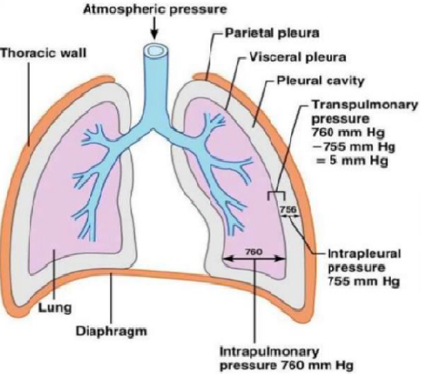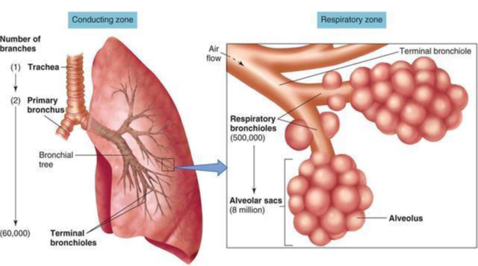

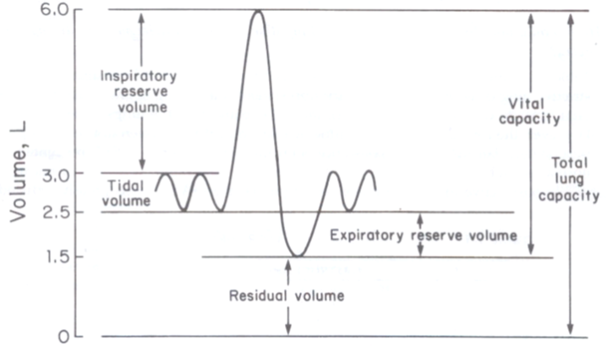

**Name of device used to produce these graphs?: Spirometer**

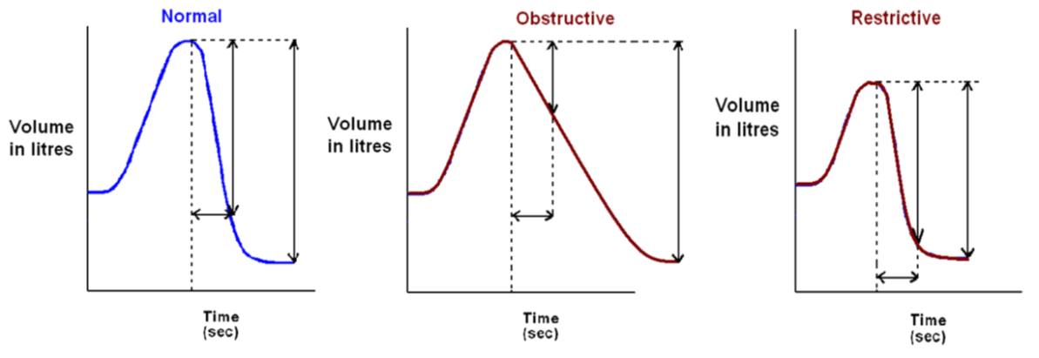

**FVC**

**FEV1**

**FEV1/FVC ratio = more than 80%**

**FEV1/FVC ratio = less than 80%**

**FEV1/FVC ratio = 80%**

**Respiratory Physiology – Fill In The Tables**

**FEV1/FVC in Diseases**

|  |  |  |
| --- | --- | --- |
|  | **Obstructive** | **Restrictive** |
| **FEV1** | Decreases | No Change |
| **FVC** | No Change | Decreases |
| **FEV1/FVC = 80 % (Normal)** | FEV1/FVC < 80% | FEV1/FVC > 80% |
| **Examples** | Asthma, chronic bronchitis, emphysema | Pulmonary fibrosis |

**Obstructive Lung Diseases**

|  |  |  |
| --- | --- | --- |
| **Example** | **Cause** | **Effect** |
| **Asthma** | Spasms triggered by exercise, air pollution and allergies | Airway inflammation and hyper-responsiveness |
| **Chronic Bronchitis** | Smoking | Excessive mucus and inflammation |
| **Emphysema** | Smoking | Alveolar wall breaks down creates large air sacs (decrease surface area = poor gas exchange). Loss of elastin reduces elastic recoil (increase compliance so lungs fill but can’t empty) |

**Restrictive Lung Diseases**

|  |  |  |
| --- | --- | --- |
| **Example** | **Cause** | **Effect** |
| **Pulmonary Fibrosis** | Chronic inhalation of asbestos, coal, dust, pollution or sometimes unknown | * Fibrous scar tissue (thickened tissue) in alveoli and other lung tissue * Due to thick walls, poor gas exchange (similar to emphysema but different reason) * Lungs become stiff due to increase in collagen = decrease compliance (opposite to emphysema) |

**Chemoreceptors**

|  |  |  |
| --- | --- | --- |
|  | **Central** | **Peripheral** |
| **Location** | Medulla | Aortic arch and carotid body |
| **Respond to changes in** | pH only  Note: H+ cannot cross the blood brain barrier, but CO2 can. So CO2 is converted into bicarbonate and H+ in CSF for detection | PO2  PCO2  pH |