**Renal Physiology – Label the Diagrams**

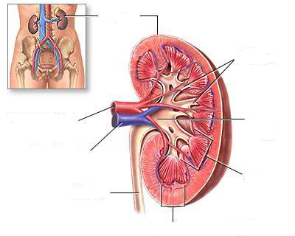

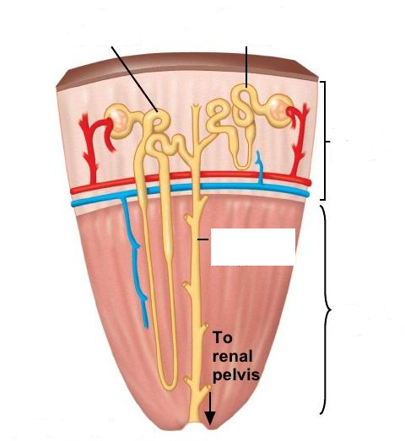

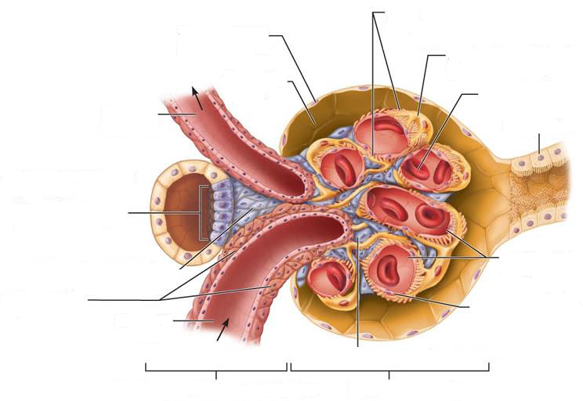

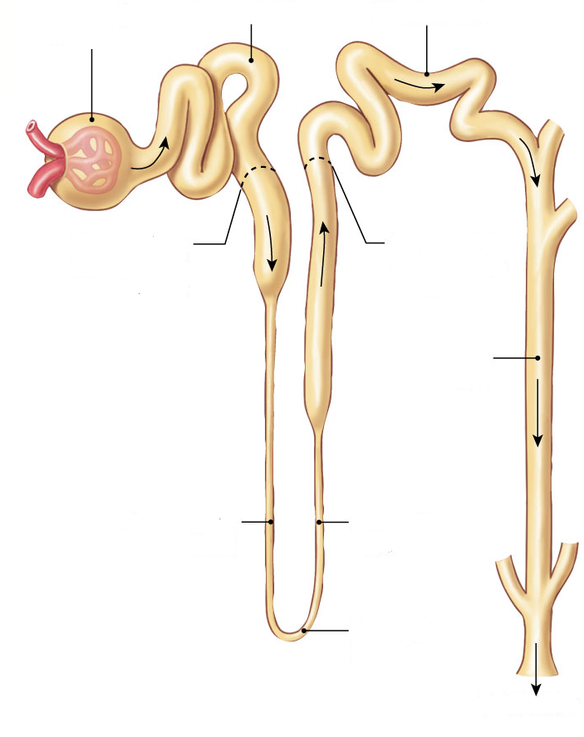

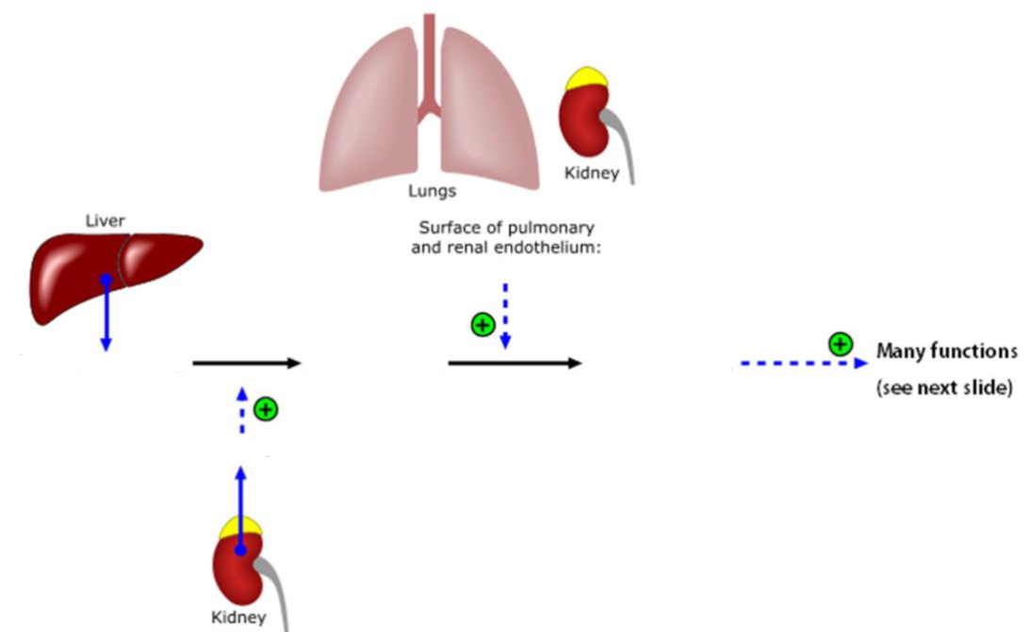

**# of amino acids: ______**

**# of amino acids: ______**

**# of amino acids: ______**

**Released in response to: _____________**

**RATE LIMITING ENZYME?: _____________**

**Renal Physiology – Fill In The Tables**

**Three key process that occur in kidneys**

|  |  |  |  |
| --- | --- | --- | --- |
|  | **Filtration** | **Reabsorption** | **Secretion** |
| **Where does it occur?** |  |  |  |
| **From _____ to _____.** |  |  |  |
| **Overall** |  |  |  |

**Glomerular Filtration**

|  |  |  |  |  |
| --- | --- | --- | --- | --- |
|  | **Hydrostatic Pressure of Glomerular Capillaries** | **Colloid Osmotic Pressure of Glomerular Capillaries** | **Hydrostatic Pressure of Bowman’s Capsule** | **Colloid Osmotic Pressure of Bowman’s Capsule** |
| **Abbreviation** |  |  |  |  |
| **Caused by** |  |  |  |  |
| **Filtration** |  |  |  |  |
| **mmHg** |  |  |  |  |

**Net filtration pressures**

|  |  |  |  |  |
| --- | --- | --- | --- | --- |
|  | **PGC** | **πGC** | **PBC** | **πBC** |
| **Filtration** |  |  |  |  |
| **mmHg** |  |  |  |  |

**GFR Regulation**

|  |  |  |  |  |
| --- | --- | --- | --- | --- |
|  | **Afferent Arteriole** | | **Efferent Arteriole** | |
| **Smooth Muscle** |  |  |  |  |
| **GFR** |  |  |  |  |

**Reabsorption along the tubule**

|  |  |  |  |
| --- | --- | --- | --- |
| **Segment of Tubule** | **Substances** | **Hormone Regulation** | **Percent** |
| **Proximal Tubule** |  |  |  |
| **Descending Limb of LOH** |  |  |  |
| **Ascending Limb of LOH** |  |  |
| **Distal Tubule** |  |  |  |
| **Collecting Duct** |  |  |

**Summary of transport in kidneys**

|  |  |  |  |  |  |
| --- | --- | --- | --- | --- | --- |
|  | **Proximal Tubule** | **Descending Limb** | **Ascending Limb** | **Distal Tubule** | **Collecting Duct** |
| **Goal** |  |  |  |  |  |
| **Water** |  |  |  |  |  |
| **Ions** |  |  |  |  |  |
| **Paracellular Transport** |  |  |  |  |  |
| **Hormone Regulation** |  |  |  |  |  |

**Respiratory Physiology – Label the Diagrams**

**zone**

**zone**

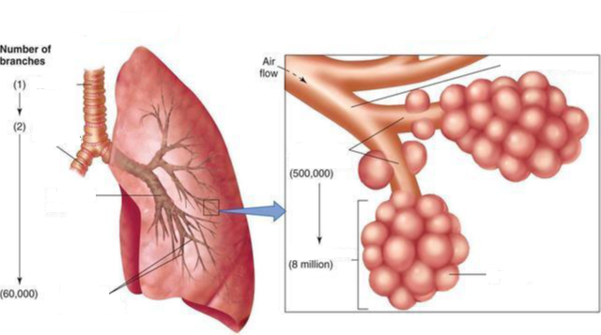

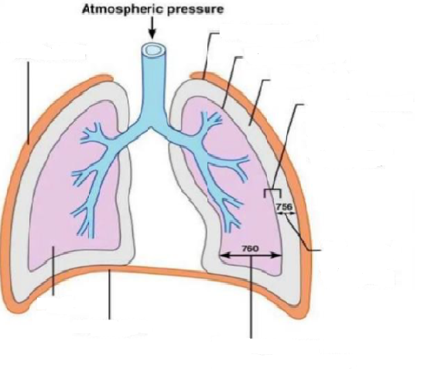

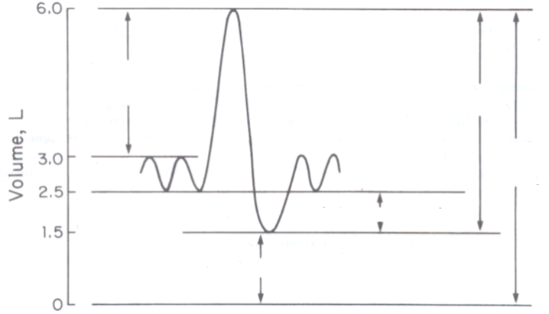

**Name of device used to produce these graphs?: _________________**

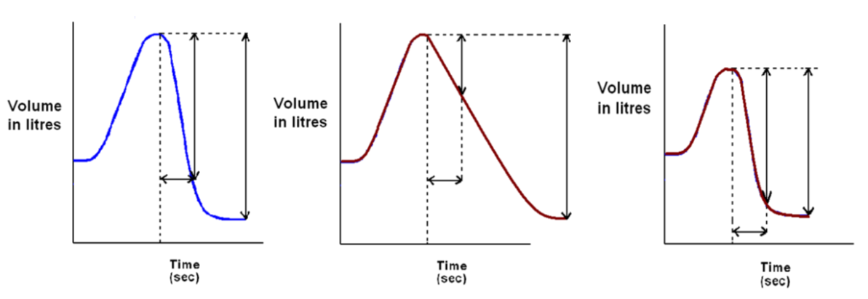

**FEV1/FVC ratio = _______**

**FEV1/FVC ratio = _______**

**FEV1/FVC ratio = _______**

**Respiratory Physiology – Fill In The Tables**

**FEV1/FVC in Diseases**

|  |  |  |
| --- | --- | --- |
|  | **Obstructive** | **Restrictive** |
| **FEV1** |  |  |
| **FVC** |  |  |
| **FEV1/FVC = 80 % (Normal)** |  |  |
| **Examples** |  |  |

**Obstructive Lung Diseases**

|  |  |  |
| --- | --- | --- |
| **Example** | **Cause** | **Effect** |
|  |  |  |
|  |  |  |
|  |  |  |

**Restrictive Lung Diseases**

|  |  |  |
| --- | --- | --- |
| **Example** | **Cause** | **Effect** |
| **Pulmonary Fibrosis** |  |  |

**Chemoreceptors**

|  |  |  |
| --- | --- | --- |
|  | **Central** | **Peripheral** |
| **Location** |  |  |
| **Respond to changes in** |  |  |