Ubuntu lifehacks (ver. Aug 11, 2022 19:29)
Table of Contents
Ubuntu lifehacks (ver. 08/11/22 07:29:58 PM) 1
Ubuntu Linux Install Nvidia Driver (Latest Proprietary Driver) 1

Ubuntu Linux Install Nvidia Driver (Latest Proprietary Driver)
https://www.cyberciti.biz/faq/ubuntu-linux-install-nvidia-driver-latest-proprietary-driver/
$ sudo lshw -C display
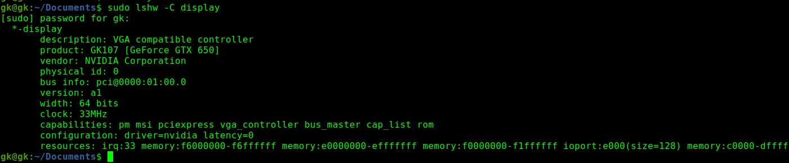
You must have Nvidia GPU card detected by your system.
$ lspci | grep -i --color 'vga\|3d\|2d' or
$ lspci -v | egrep -i --color 'vga|3d|2d'
Please note the device ID # 01:00.0. Now, to get detailed information, enter:
$ sudo lspci -v -s 01:00.0
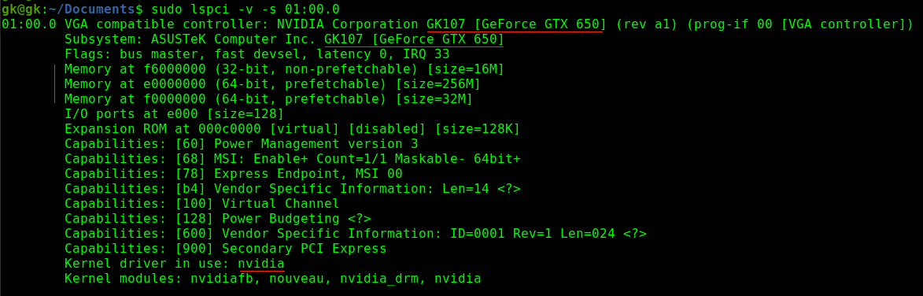
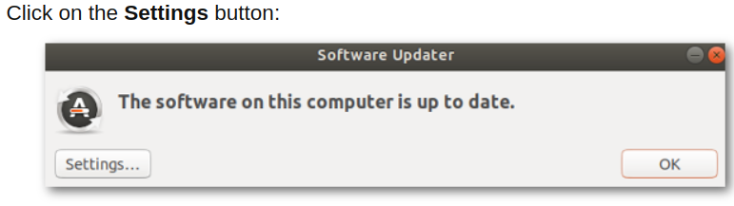
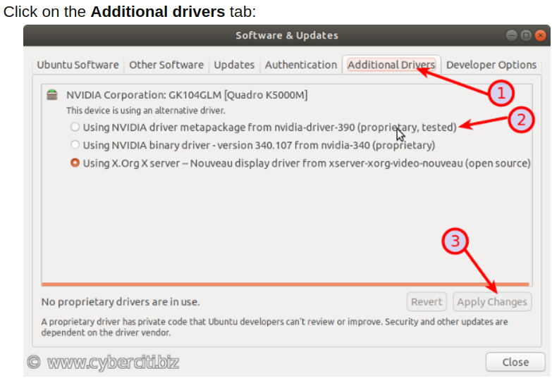
$ sudo reboot

