Layout Documentation

Drawing units are millimeters.

Glass drawing file name: glass.dxf
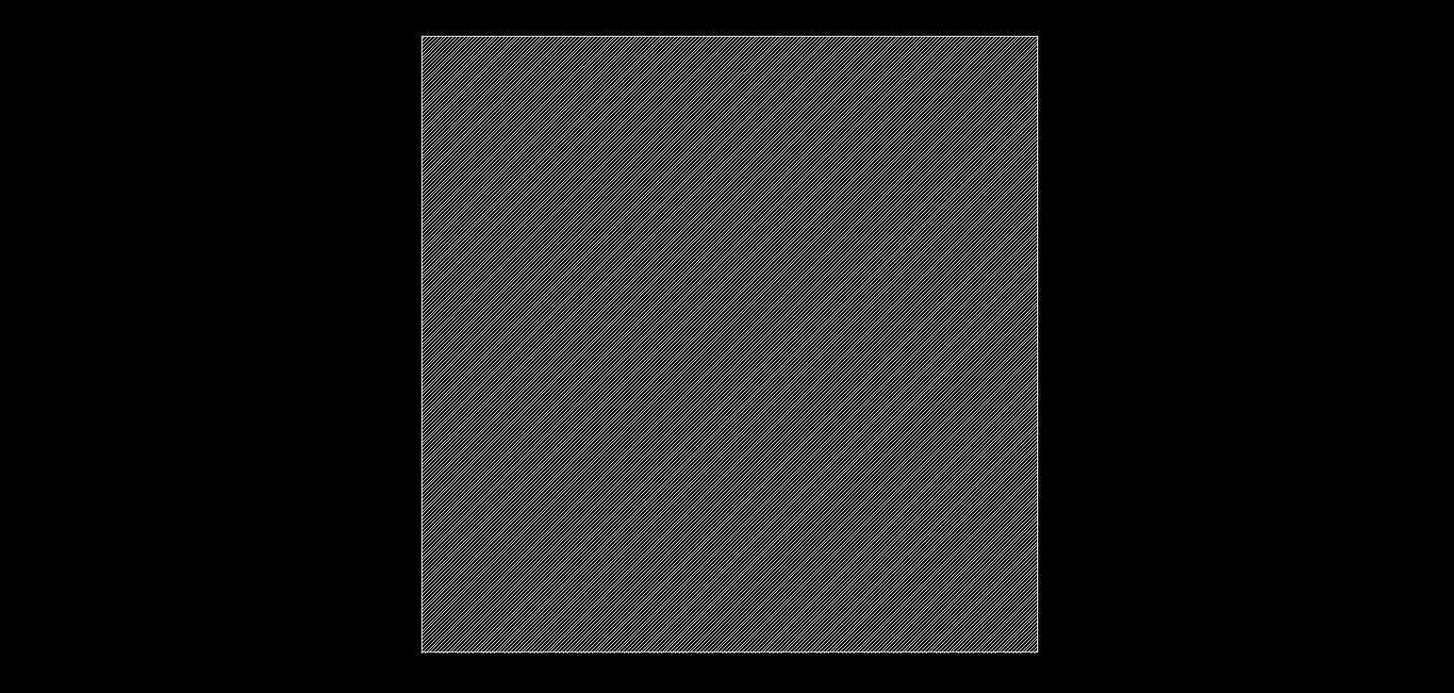
Nominal dimensions: 30.00 mm square
Final shape tolerance: 0.2mm or better

Illumination aperture drawing name: light.dxf
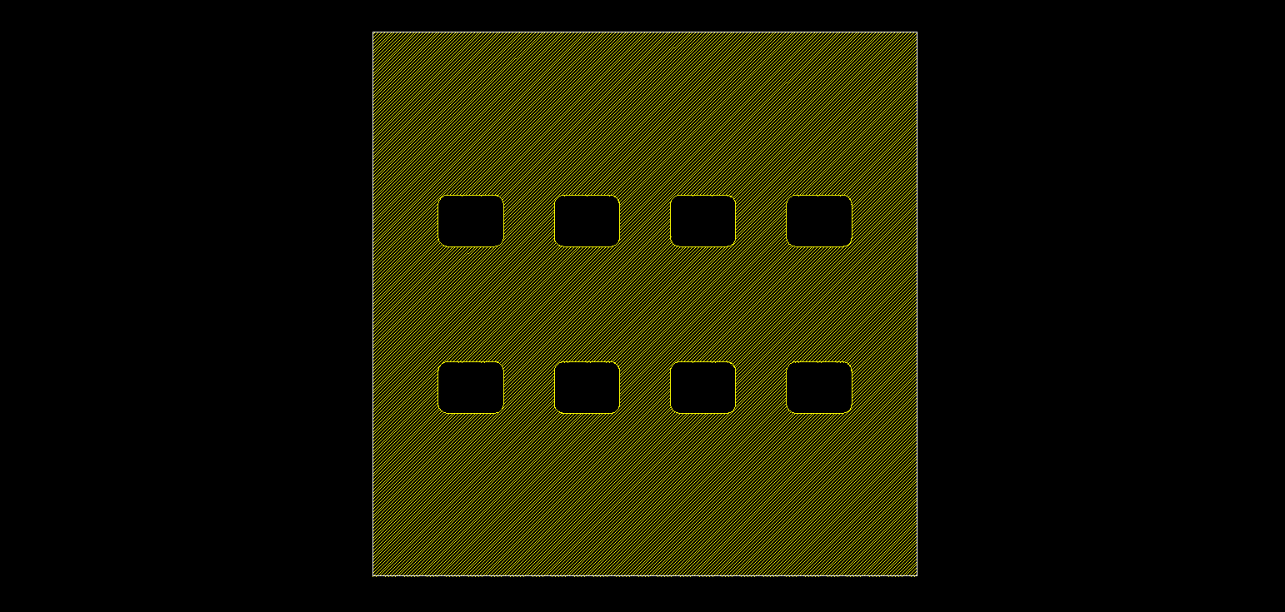a: area = 10 mm^2
r: radius = -sqrt(-a + h w)/sqrt(4 - π) ~= 0.530959
h: height = 2.845 mm
w: width = 3.6 mm
governing equation: (a-r*r*(π-4))/h=w

geometric dark area
da: dark area = 16.038 mm^2
dh: dark height = 0.8 + h = 3.645 mm
dw: dark width = 0.8 + w = 4.4 mm
governing equation: da = dw*dh
Active area mask drawing name: active.dxf


Drawing name for areas that must be clean when metal is deposited: clean.dxf

Everything except the two central black rectangles shown here must be clean when metal deposition takes place so that metal is deposited directly onto glass or TCO with no active/ETL/HTL or other device layers in between.
Encapsulation drawing name: encapsulation.dxf
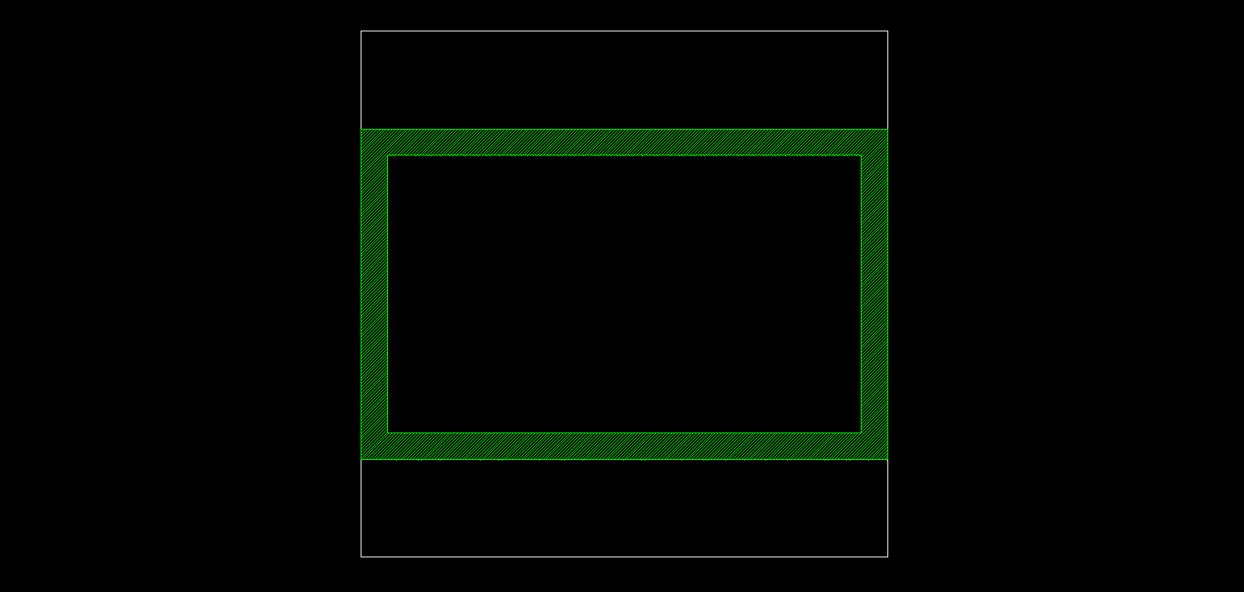
The outer dimensions of the encapsulation glass should be 30mm by 18.84mm. The inner pocket should be 27mm by 15.84mm so that the nominal width of glued region is 1.5mm wide.
Metal mask drawing name: metal.dxf

Pixel #1 indicated by a flat region in the lower left corner.
TCO pattern drawing name: tco.dxf
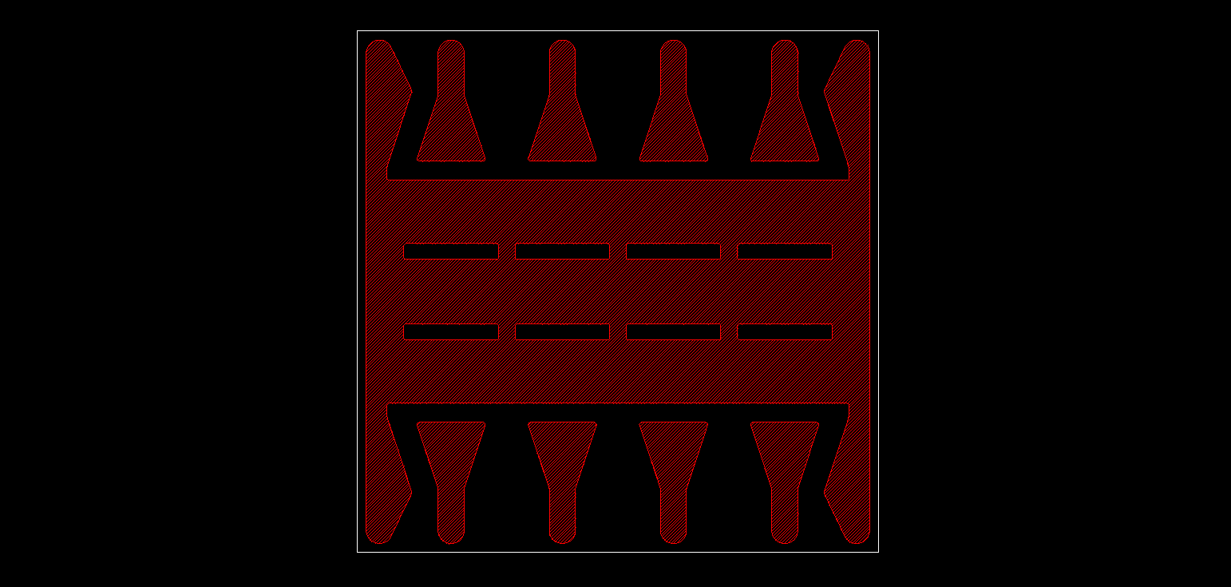
TCO should remain in the red hatched areas, bare glass in the black areas.

