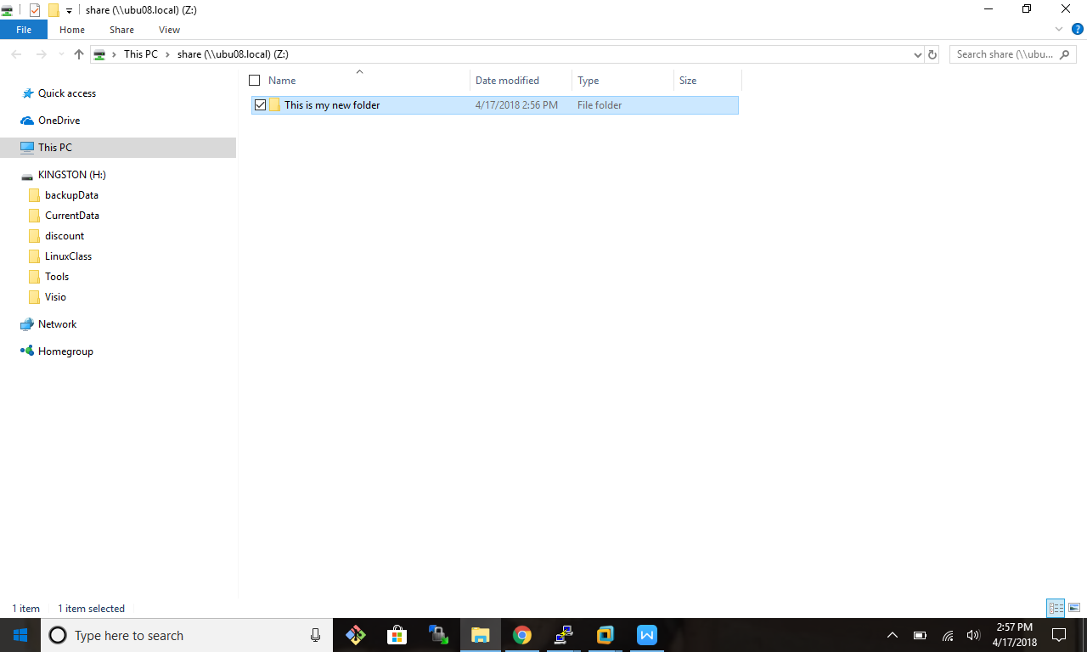

root@ubu08:/srv# smbstatus

Samba version 4.3.11-Ubuntu

PID Username Group Machine Protocol Version

------------------------------------------------------------------------------

1668 nobody nogroup 10.106.3.1 (ipv4:10.106.3.1:49194) Unkno wn (0x0311)

Service pid machine Connected at

-------------------------------------------------------

share 1668 10.106.3.1 Tue Apr 17 14:56:23 2018

Locked files:

Pid Uid DenyMode Access R/W Oplock Share Path Name Time

-------------------------------------------------------------------------------- ------------------

1668 65534 DENY_NONE 0x100081 RDONLY NONE /srv/ samba/share . Tue Apr 17 14:56:36 2018

1668 65534 DENY_NONE 0x100081 RDONLY NONE /srv/ samba/share . Tue Apr 17 14:56:47 2018

1668 65534 DENY_NONE 0x100081 RDONLY NONE /srv/ samba/share . Tue Apr 17 14:56:47 2018

root@ubu08:/srv# cd /srv

root@ubu08:/srv# ls

samba

root@ubu08:/srv# cd samba/

root@ubu08:/srv/samba# ls

share

root@ubu08:/srv/samba# cd share/

root@ubu08:/srv/samba/share# ls

This is my new folder

root@ubu08:/srv/samba/share# smbstatus --shares

Service pid machine Connected at

-------------------------------------------------------

share 1668 10.106.3.1 Tue Apr 17 14:56:23 2018

root@ubu08:/srv/samba/share# systemctl status smbd nmbd

● smbd.service - LSB: start Samba SMB/CIFS daemon (smbd)

Loaded: loaded (/etc/init.d/smbd; bad; vendor preset: enabled)

Active: active (running) since Tue 2018-04-17 14:08:21 PDT; 55min ago

Docs: man:systemd-sysv-generator(8)

Process: 1329 ExecStart=/etc/init.d/smbd start (code=exited, status=0/SUCCESS)

Tasks: 4

Memory: 7.2M

CPU: 542ms

CGroup: /system.slice/smbd.service

├─1344 /usr/sbin/smbd -D

├─1349 /usr/sbin/smbd -D

├─1354 /usr/sbin/smbd -D

└─1668 /usr/sbin/smbd -D

Apr 17 14:08:21 ubu08 systemd[1]: Starting LSB: start Samba SMB/CIFS daemon (smbd)...

Apr 17 14:08:21 ubu08 smbd[1329]: * Starting SMB/CIFS daemon smbd

Apr 17 14:08:21 ubu08 smbd[1329]: ...done.

Apr 17 14:08:21 ubu08 systemd[1]: Started LSB: start Samba SMB/CIFS daemon (smbd).

● nmbd.service - LSB: start Samba NetBIOS nameserver (nmbd)

Loaded: loaded (/etc/init.d/nmbd; bad; vendor preset: enabled)

Active: active (running) since Tue 2018-04-17 14:08:21 PDT; 55min ago

Docs: man:systemd-sysv-generator(8)

Process: 1212 ExecStart=/etc/init.d/nmbd start (code=exited, status=0/SUCCESS)

Tasks: 1

Memory: 9.5M

CPU: 694ms

CGroup: /system.slice/nmbd.service

└─1328 /usr/sbin/nmbd -D

Apr 17 14:08:17 ubu08 systemd[1]: Starting LSB: start Samba NetBIOS nameserver (nmbd)...

Apr 17 14:08:21 ubu08 nmbd[1212]: * Starting NetBIOS name server nmbd

Apr 17 14:08:21 ubu08 nmbd[1212]: ...done.

Apr 17 14:08:21 ubu08 systemd[1]: Started LSB: start Samba NetBIOS nameserver (nmbd).