Site configurations

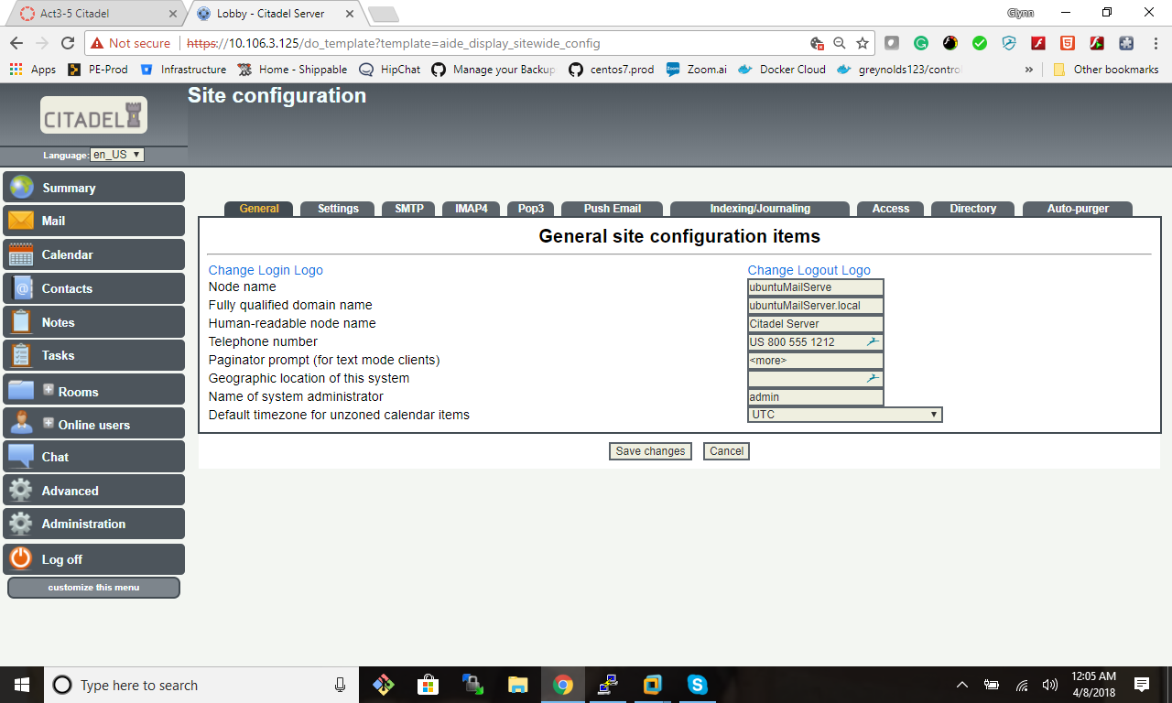

User Alice account

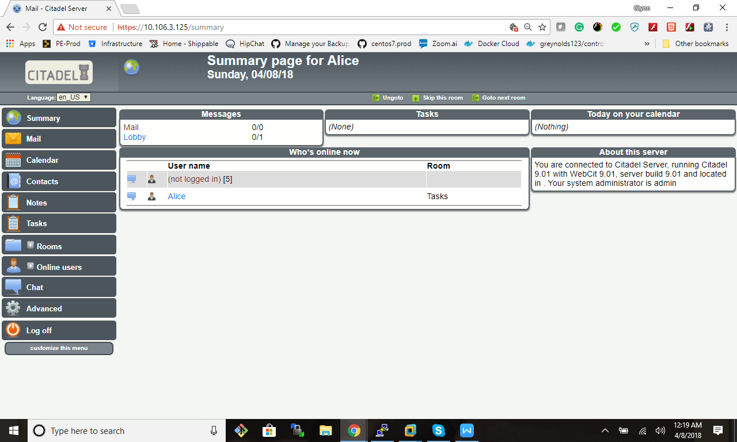

User Alice emails the admin.

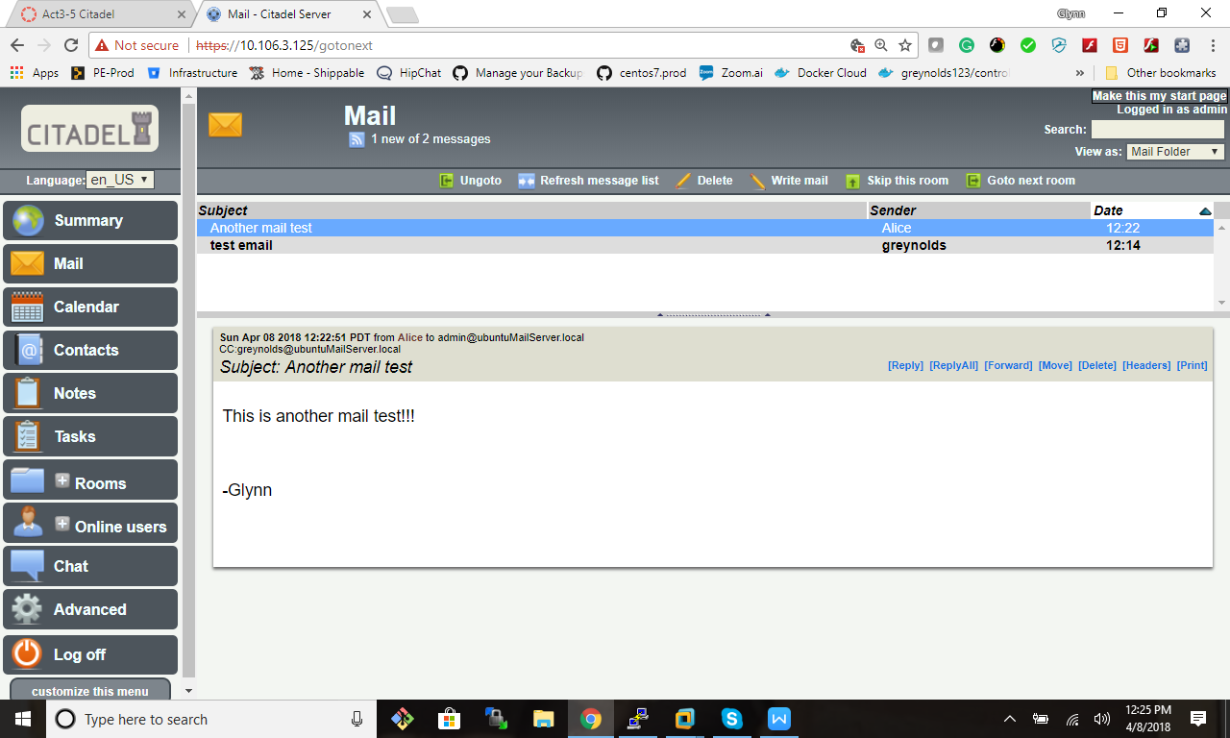

Available ports

root@ubuntuMailServer:~# netstat -antpl | grep cit

tcp 0 0 0.0.0.0:119 0.0.0.0:\* LISTEN 1329/citserver

tcp 0 0 0.0.0.0:504 0.0.0.0:\* LISTEN 1329/citserver

tcp 0 0 0.0.0.0:25 0.0.0.0:\* LISTEN 1329/citserver

tcp 0 0 0.0.0.0:443 0.0.0.0:\* LISTEN 1324/webcit

tcp 0 0 0.0.0.0:993 0.0.0.0:\* LISTEN 1329/citserver

tcp 0 0 0.0.0.0:995 0.0.0.0:\* LISTEN 1329/citserver

tcp 0 0 0.0.0.0:2020 0.0.0.0:\* LISTEN 1329/citserver

tcp 0 0 0.0.0.0:5222 0.0.0.0:\* LISTEN 1329/citserver

tcp 0 0 0.0.0.0:587 0.0.0.0:\* LISTEN 1329/citserver

tcp 0 0 0.0.0.0:110 0.0.0.0:\* LISTEN 1329/citserver

tcp 0 0 0.0.0.0:143 0.0.0.0:\* LISTEN 1329/citserver

tcp 0 0 0.0.0.0:80 0.0.0.0:\* LISTEN 1322/webcit

tcp 0 0 0.0.0.0:465 0.0.0.0:\* LISTEN 1329/citserver

tcp 0 0 0.0.0.0:563 0.0.0.0:\* LISTEN 1329/citserver

tcp 0 0 127.0.0.1:56098 127.0.0.1:504 ESTABLISHED 1324/webcit

tcp 0 0 127.0.0.1:56104 127.0.0.1:504 ESTABLISHED 1324/webcit

tcp 0 0 127.0.0.1:56096 127.0.0.1:504 ESTABLISHED 1324/webcit

tcp 0 0 127.0.0.1:504 127.0.0.1:56106 ESTABLISHED 1329/citserver

tcp 0 0 127.0.0.1:504 127.0.0.1:56096 ESTABLISHED 1329/citserver

tcp 0 0 127.0.0.1:56106 127.0.0.1:504 ESTABLISHED 1324/webcit

tcp 0 0 127.0.0.1:504 127.0.0.1:56100 ESTABLISHED 1329/citserver

tcp 0 0 127.0.0.1:56100 127.0.0.1:504 ESTABLISHED 1324/webcit

tcp 0 0 127.0.0.1:504 127.0.0.1:56098 ESTABLISHED 1329/citserver

tcp 0 0 127.0.0.1:504 127.0.0.1:56104 ESTABLISHED 1329/citserver

Open ports for the firewall

root@ubuntuMailServer:~# ufw status

Status: active

To Action From

-- ------ ----

22/tcp ALLOW Anywhere

443/tcp ALLOW Anywhere

80/tcp ALLOW Anywhere

143/tcp ALLOW Anywhere

993/tcp ALLOW Anywhere

465/tcp ALLOW Anywhere

587/tcp ALLOW Anywhere

25/tcp ALLOW Anywhere

110/tcp ALLOW Anywhere

995/tcp ALLOW Anywhere

22/tcp (v6) ALLOW Anywhere (v6)

443/tcp (v6) ALLOW Anywhere (v6)

80/tcp (v6) ALLOW Anywhere (v6)

143/tcp (v6) ALLOW Anywhere (v6)

993/tcp (v6) ALLOW Anywhere (v6)

465/tcp (v6) ALLOW Anywhere (v6)

587/tcp (v6) ALLOW Anywhere (v6)

25/tcp (v6) ALLOW Anywhere (v6)

110/tcp (v6) ALLOW Anywhere (v6)

995/tcp (v6) ALLOW Anywhere (v6)