Glynn Reynolds

Snapshot For the vm

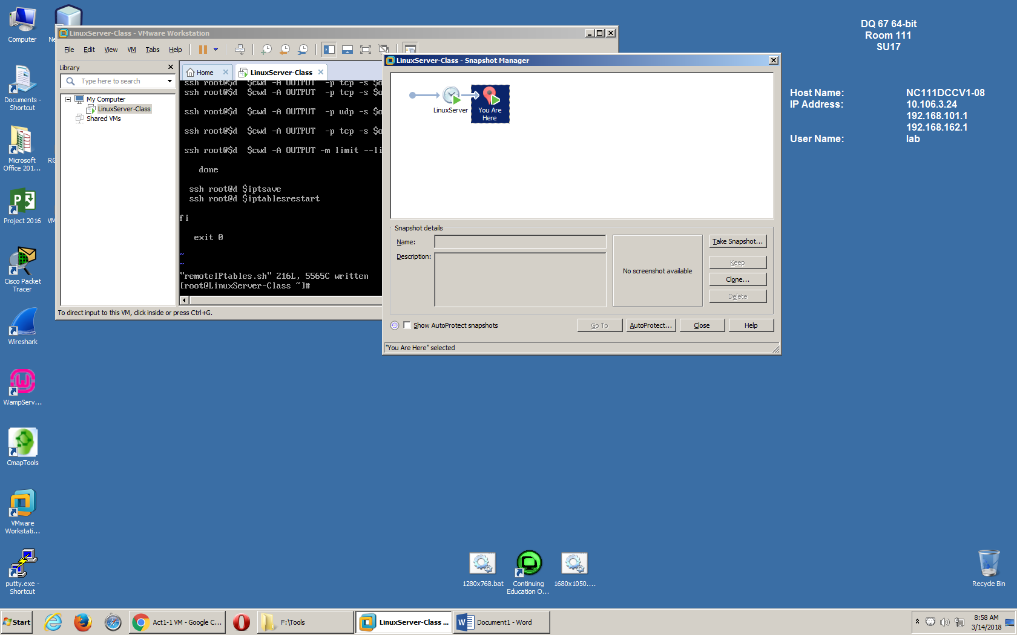

Hostname

[root@LinuxServer-Class ~]# hostname

LinuxServer-Class

[root@LinuxServer-Class ~]#

Users

[root@LinuxServer-Class ~]# ls -l /home/

total 4

drwx------. 4 greynolds linuxtech 4096 Mar 12 11:05 greynolds

drwx------. 2 kienen kienen 59 Mar 12 11:59 kienen

user-id

[root@LinuxServer-Class greynolds]# id greynolds

uid=1000(greynolds) gid=1002(linuxtech) groups=1002(linuxtech),10(wheel),1000(greynolds)

File size

[root@LinuxServer-Class greynolds]# df test1.txt

Filesystem 1K-blocks Used Available Use% Mounted on

/dev/mapper/centos-root 39359716 2337808 37021908 6% /

Disk space usage

/dev/mapper/centos-root 39359716 2337808 37021908 6% /

/dev/sda1 508588 175696 332892 35% /boot

Disk consumption

[root@LinuxServer-Class greynolds]# du -sh /usr/share

550M /usr/share