Httpd( apache web server)

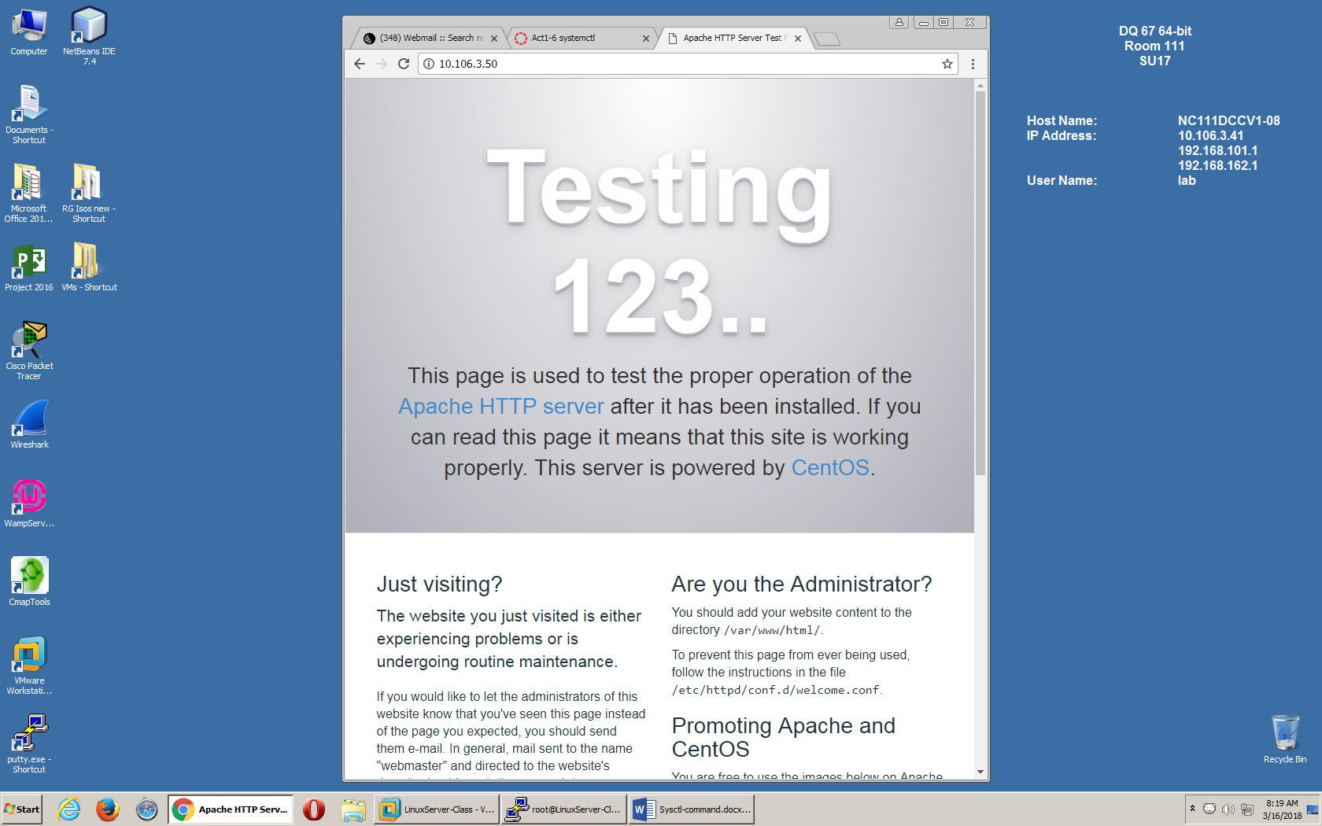

[root@LinuxServer-Class ~]# systemctl enable httpd

Created symlink from /etc/systemd/system/multi-user.target.wants/httpd.service to /usr/lib/systemd/system/httpd.service.

[root@LinuxServer-Class ~]#

● httpd.service - The Apache HTTP Server

Loaded: loaded (/usr/lib/systemd/system/httpd.service; enabled; vendor preset: disabled)

Active: active (running) since Fri 2018-03-16 08:15:26 PDT; 9min ago

Docs: man:httpd(8)

man:apachectl(8)

Main PID: 2152 (httpd)

Status: "Total requests: 11; Current requests/sec: 0; Current traffic: 0 B/sec"

CGroup: /system.slice/httpd.service

├─2152 /usr/sbin/httpd -DFOREGROUND

├─2153 /usr/sbin/httpd -DFOREGROUND

├─2154 /usr/sbin/httpd -DFOREGROUND

├─2155 /usr/sbin/httpd -DFOREGROUND

├─2156 /usr/sbin/httpd -DFOREGROUND

├─2157 /usr/sbin/httpd -DFOREGROUND

├─2162 /usr/sbin/httpd -DFOREGROUND

└─2163 /usr/sbin/httpd -DFOREGROUND

Mar 16 08:15:26 LinuxServer-Class systemd[1]: Starting The Apache HTTP Server...

Mar 16 08:15:26 LinuxServer-Class httpd[2152]: AH00558: httpd: Could not rel...e

Mar 16 08:15:26 LinuxServer-Class systemd[1]: Started The Apache HTTP Server.

Hint: Some lines were ellipsized, use -l to show in full.

Stop the service

systemctl stop httpd

● httpd.service - The Apache HTTP Server

Loaded: loaded (/usr/lib/systemd/system/httpd.service; enabled; vendor preset: disabled)

Active: inactive (dead) since Fri 2018-03-16 08:27:15 PDT; 8s ago

Docs: man:httpd(8)

man:apachectl(8)

Process: 2248 ExecStop=/bin/kill -WINCH ${MAINPID} (code=exited, status=0/SUCCESS)

Main PID: 2152 (code=exited, status=0/SUCCESS)

Status: "Total requests: 11; Current requests/sec: 0; Current traffic: 0 B/sec"

Mar 16 08:15:26 LinuxServer-Class systemd[1]: Starting The Apache HTTP Server...

Mar 16 08:15:26 LinuxServer-Class httpd[2152]: AH00558: httpd: Could not rel...e

Mar 16 08:15:26 LinuxServer-Class systemd[1]: Started The Apache HTTP Server.

Mar 16 08:27:14 LinuxServer-Class systemd[1]: Stopping The Apache HTTP Server...

Mar 16 08:27:15 LinuxServer-Class systemd[1]: Stopped The Apache HTTP Server.

Hint: Some lines were ellipsized, use -l to show in full.

[root@LinuxServer-Class ~]# systemctl -a | grep httpd

httpd.service loaded active running The Apache HTTP Server