Re-install Ubuntu-Webserver

Disk Configuration

Disk /dev/mapper/sda5_crypt: 24.5 GiB, 26327646208 bytes, 51421184 sectors
Units: sectors of 1 * 512 = 512 bytes
Sector size (logical/physical): 512 bytes / 512 bytes
I/O size (minimum/optimal): 512 bytes / 512 bytes

Disk /dev/mapper/ubuntuWebServer--vg-root: 21.9 GiB, 23462936576 bytes, 45826048 sectors
Units: sectors of 1 * 512 = 512 bytes
Sector size (logical/physical): 512 bytes / 512 bytes
I/O size (minimum/optimal): 512 bytes / 512 bytes

Disk /dev/mapper/ubuntuWebServer--vg-swap_1: 2.7 GiB, 2831155200 bytes, 5529600 sectors
Units: sectors of 1 * 512 = 512 bytes
Sector size (logical/physical): 512 bytes / 512 bytes
I/O size (minimum/optimal): 512 bytes / 512 bytes

Disk /dev/mapper/cryptswap1: 2.7 GiB, 2830630912 bytes, 5528576 sectors
Units: sectors of 1 * 512 = 512 bytes
Sector size (logical/physical): 512 bytes / 512 bytes
I/O size (minimum/optimal): 512 bytes / 512 bytes

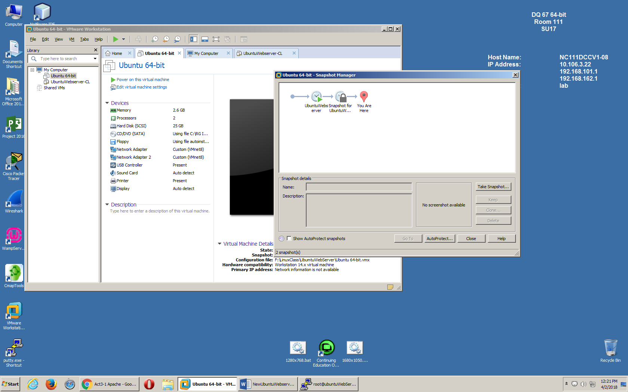

UFW status

root@ubuntuWebServer:~# ufw status
Status: active

To Action From
-- ------ ----
Apache Full ALLOW Anywhere
OpenSSH ALLOW Anywhere
Bind9 ALLOW Anywhere
Samba ALLOW Anywhere
Apache Full (v6) ALLOW Anywhere (v6)
OpenSSH (v6) ALLOW Anywhere (v6)
Bind9 (v6) ALLOW Anywhere (v6)
Samba (v6) ALLOW Anywhere (v6)

Apache2 command line test
root@ubuntuWebServer:/var/www/html# curl -a http://10.106.3.125:80
<!doctype html>
<html>
<head>
<title>Glynn D Reynolds</title>

<meta charset="utf-8" />
<meta http-equiv="Content-type" content="text/html; charset=utf-8" />
<meta name="viewport" content="width=device-width, initial-scale=1" />
<style type="text/css">
body {
background-color: #f0f0f2;
margin: 0;
padding: 0;
font-family: "Open Sans", "Helvetica Neue", Helvetica, Arial, sans-serif ;

}
div {
width: 600px;
margin: 5em auto;
padding: 50px;
background-color: #fff;
border-radius: 1em;
}
a:link, a:visited {
color: #38488f;
text-decoration: none;
}
@media (max-width: 700px) {
body {
background-color: #fff;
}
div {
width: auto;
margin: 0 auto;
border-radius: 0;
padding: 1em;
}
}
</style>
</head>

<body>
<div>
<h1>Glynn D Reynolds</h1>
<p>This domain is established to be used for illustrative examples in docume nts. You may use this
domain in examples without prior coordination or asking for permission.</p>
<p><a href="http://www.iana.org/domains/example">More information...</a></p>
</div>
</body>
</html>

Web access from Google chrome.
