Listed are the remote access shell for the Ubuntu Server&Client

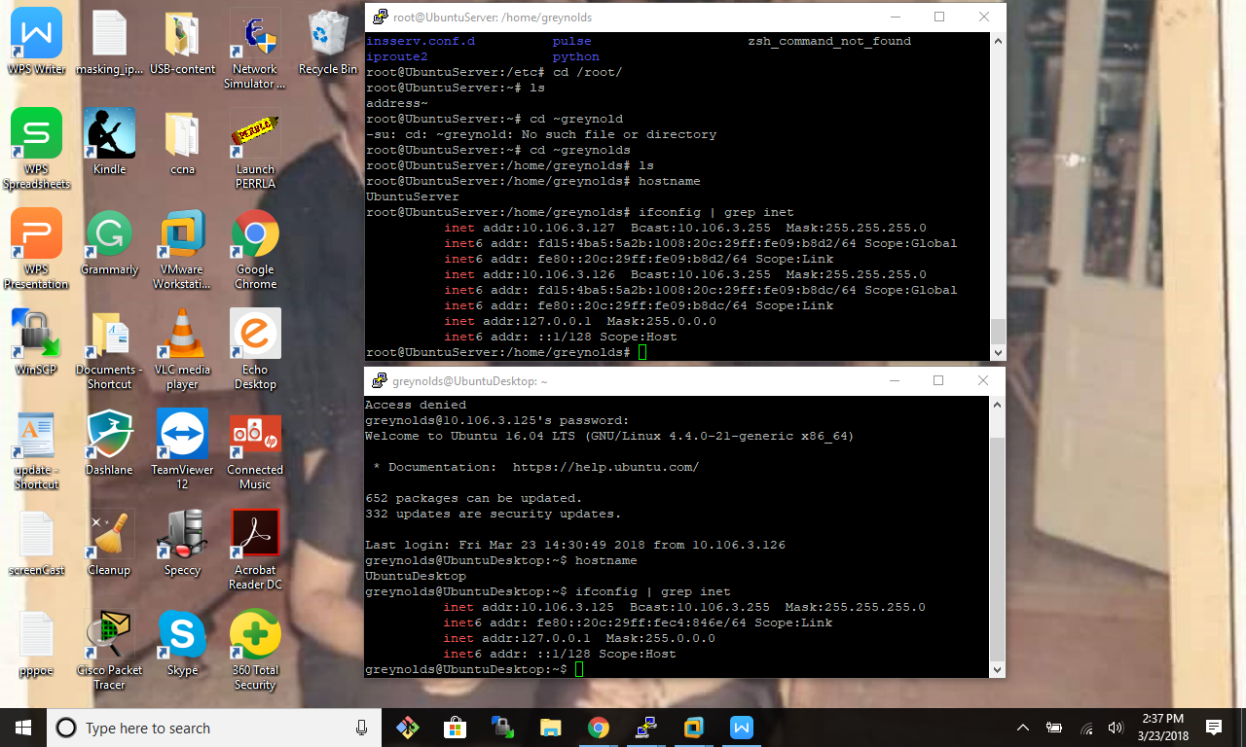

Client configuration

greynolds@UbuntuDesktop:~$ sudo dpkg --list | grep openssh

[sudo] password for greynolds:

ii openssh-client 1:7.2p2-4ubuntu2.4 amd64 secure shell (SSH) client, for secure access to remote machines

ii openssh-server 1:7.2p2-4ubuntu2.4 amd64 secure shell (SSH) server, for secure access from remote machines

ii openssh-sftp-server 1:7.2p2-4ubuntu2.4 amd64 secure shell (SSH) sftp server module, for SFTP access from remote machines

greynolds@UbuntuDesktop:~$ status ssh

status: Name "com.ubuntu.Upstart" does not exist

greynolds@UbuntuDesktop:~$ service ssh status

● ssh.service - OpenBSD Secure Shell server

Loaded: loaded (/lib/systemd/system/ssh.service; enabled; vendor preset: enab

Active: active (running) since Fri 2018-03-23 14:29:27 PDT; 11min ago

Main PID: 4174 (sshd)

Tasks: 1 (limit: 512)

CGroup: /system.slice/ssh.service

└─4174 /usr/sbin/sshd -D

root@UbuntuDesktop:/etc/ssh# ls

moduli ssh_host_dsa_key ssh_host_ed25519_key.pub

ssh_config ssh_host_dsa_key.pub ssh_host_rsa_key

ssh_config.bak ssh_host_ecdsa_key ssh_host_rsa_key.pub

sshd_config ssh_host_ecdsa_key.pub ssh_import_id

sshd_config.bak ssh_host_ed25519_key

Remote connection to the remote server.

root@UbuntuDesktop:/etc/ssh# ssh greynolds@10.106.3.127

greynolds@10.106.3.127's password:

Welcome to Ubuntu 16.04 LTS (GNU/Linux 4.4.0-21-generic x86_64)

* Documentation: https://help.ubuntu.com/

271 packages can be updated.

164 updates are security updates.

Last login: Fri Mar 23 14:15:41 2018 from 10.106.3.127

greynolds@UbuntuServer:~$

Exit from the UbuntuServer

greynolds@UbuntuServer:~$ exit

logout

Connection to 10.106.3.127 closed.

root@UbuntuDesktop:/etc/ssh#

The client/desktop .ssh directory

root@UbuntuDesktop:~# ls .ssh/

id_rsa id_rsa.pub known_hosts

root@UbuntuDesktop:~#

Known host on the Desktop client after the login of the client.

|1|lSda1RbQsizSJOeA2tQLiFyGjTI=|3eQ3Xbhr2wXwZA1Rl6tOqS6MTF0= ecdsa-sha2-nistp256 AAAAE2VjZHNhLXNoYTItbmlzdHAyNTYAAAAIbmlzdHAyNTYAAABBBHAw4vXGc1brgTnFzqUNjjrYZ0uQa

c43f6o7NafDj3HDOCZHjEMJd7dTJFay4kLwvYjv8gT/OJzc4Q62cRUjX7E=

The client copy of the key on the server, located /root/.ssh/know_hosts

|1|W6EToePkASyHkzkt1hqQlGaI3dM=|V9o23Pn72CruY1TWARWDPnkXQ0k= ecdsa-sha2-nistp256 AAAAE2VjZHNhLXNoYTItbmlzdHAyNTYAAAAIbmlzdHAyNTYAAABBBHAw4vXGc1brgTnFzqUNjjrYZ0uQac43f6o7NafDj3HDOCZHjEMJd7dTJFay4kLwvYjv8gT/OJzc4Q62cRUjX7E=

Generated a new set of keys for ssh

greynolds@UbuntuDesktop:~$ ssh-keygen -t rsa -b 4096

Generating public/private rsa key pair.

Enter file in which to save the key (/home/greynolds/.ssh/id_rsa):

/home/greynolds/.ssh/id_rsa already exists.

Overwrite (y/n)? y

Enter passphrase (empty for no passphrase):

Enter same passphrase again:

Your identification has been saved in /home/greynolds/.ssh/id_rsa.

Your public key has been saved in /home/greynolds/.ssh/id_rsa.pub.

The key fingerprint is:

SHA256:N0L1x0Yxjaulb6SP0Xxn4n7Iqw/Mixf6n5+9LftzuCk greynolds@UbuntuDesktop

The key's randomart image is:

+---[RSA 4096]----+

| . ++ |

| . . o...|

| . . +. |

| . oo |

| S o + |

| o ++o. |

| .=*+o+|

| ..E*BBB|

| .o=O%@O|

+----[SHA256]-----+

Copied the ssh key for greynolds to the UbuntuServer.

greynolds@UbuntuDesktop:~/.ssh$ ssh-copy-id -i id_rsa.pub 10.106.3.127

/usr/bin/ssh-copy-id: INFO: Source of key(s) to be installed: "id_rsa.pub"

//usr/bin/ssh-copy-id: INFO: attempting to log in with the new key(s), to filter out any that are already installed

/usr/bin/ssh-copy-id: INFO: 1 key(s) remain to be installed -- if you are prompted now it is to install the new keys

greynolds@10.106.3.127's password:

Permission denied, please try again.

greynolds@10.106.3.127's password:

Number of key(s) added: 1

Now try logging into the machine, with: "ssh '10.106.3.127'"

and check to make sure that only the key(s) you wanted were added.

Logged into the UbuntuServer from the UbuntuDesktop

greynolds@UbuntuDesktop:~/.ssh$ ssh greynolds@10.106.3.127

Welcome to Ubuntu 16.04 LTS (GNU/Linux 4.4.0-21-generic x86_64)

* Documentation: https://help.ubuntu.com/

271 packages can be updated.

164 updates are security updates.

*** System restart required ***

Last login: Sat Mar 24 13:27:06 2018 from 10.106.3.125

greynolds@UbuntuServer:~$

Logged onto the Ubuntu Server from the UbuntuDesktop

greynolds@UbuntuDesktop:~$ sudo ssh bsmith@10.106.3.126

The authenticity of host '10.106.3.126 (10.106.3.126)' can't be established.

ECDSA key fingerprint is SHA256:yhLDWb/x2pyncdwPJ/FzpjrDEiVtt2QJwKHEptUN2Js.

Are you sure you want to continue connecting (yes/no)? yes

Warning: Permanently added '10.106.3.126' (ECDSA) to the list of known hosts.

bsmith@10.106.3.126's password:

Welcome to Ubuntu 16.04 LTS (GNU/Linux 4.4.0-21-generic x86_64)

* Documentation: https://help.ubuntu.com/

252 packages can be updated.

131 updates are security updates.

Last login: Sat Mar 24 14:52:34 2018 from 10.106.3.125

Added the sudoers and admin group to bsmith -> Configured from the UbuntuDesktop.

root@UbuntuServer:~# usermod -g 27 bsmith

root@UbuntuServer:~# usermod -g 4 bsmith

Created two scripts. One to copy over to the server and the other to execute once on the server.

Sync.sh

#!/bin/bash

#

#

# Author: Glynn D. Reynolds

# Type: To add users and sync files.

# Date: 03/25/2018

# Time: 14:09:24

###########################

# Script Function

read -p "What is the name of the user you want to add: " name

for i in "$name"; do

$(/usr/sbin/useradd -m "$i") && $(/usr/bin/chage -d 0 "$i") &&

passwd -S "$i"

passwd "$i"

echo "$i" created;

done

exit 0

#!/bin/bash

#

#

# Author: Glynn D. Reynolds

# Type: To add users and sync files.

# Date: 03/25/2018

# Time: 14:09:24

###########################

userScript='/home/greynolds/DomainScript/Sync.sh'

# Script Function

scp $userScript greynolds@10.106.3.126:~greynolds

exit

On the desktop

greynolds@UbuntuDesktop:~/DomainScript$ sudo ./Sync.sh

What is the name of the user you want to add: bsmith

bsmith L 01/01/1970 0 99999 7 -1

Enter new UNIX password:

Retype new UNIX password:

passwd: password updated successfully

bsmith created

On the server

root@UbuntuServer:/home/greynolds# ./Sync.sh

What is the name of the user you want to add: bsmith

bsmith L 01/01/1970 0 99999 7 -1

Enter new UNIX password:

Retype new UNIX password:

passwd: password updated successfully

bsmith created

Myfile on the sever for bsmith account

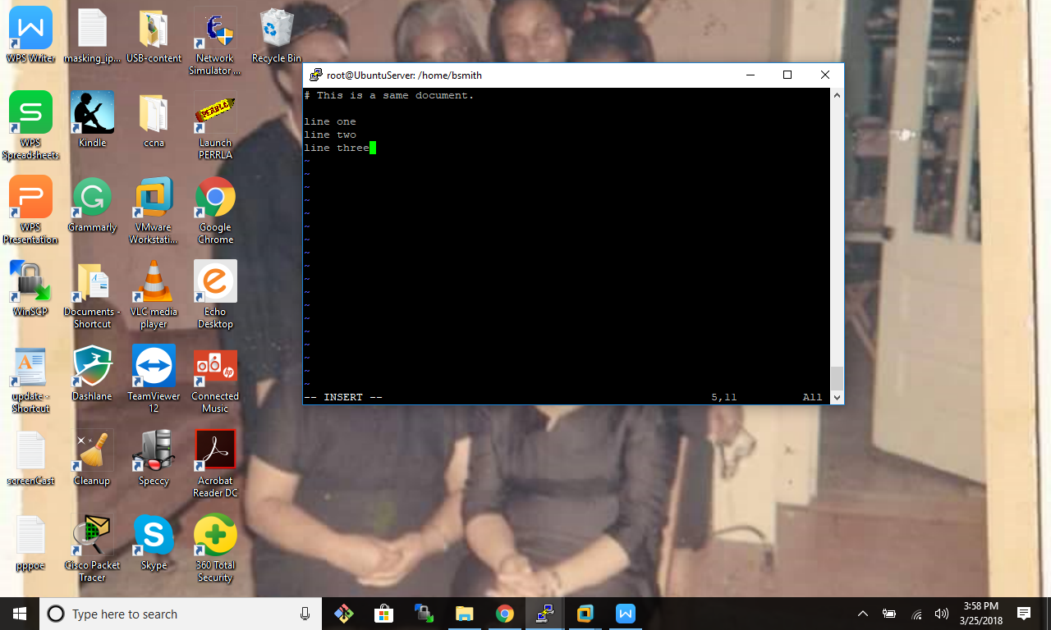

Myfile on the desktop.

greynolds@UbuntuDesktop:/home/bsmith$ sudo scp bsmith@10.106.3.126:~bsmith/myfile .

[sudo] password for greynolds:

bsmith@10.106.3.126's password:

myfile 100% 58 0.1KB/s 00:00

greynolds@UbuntuDesktop:/home/bsmith$ sudo scp bsmith@10.106.3.126:~bsmith/myfile .

[sudo] password for greynolds:

bsmith@10.106.3.126's password:

myfile 100% 58 0.1KB/s 00:00

greynolds@UbuntuDesktop:/home/bsmith$ ls

examples.desktop myfile

greynolds@UbuntuDesktop:/home/bsmith$

Rsync to the server form the desktop

greynolds@UbuntuDesktop:/home/bsmith$ sudo rsync -avl bsmith@10.106.3.126:~bsmith/myfile myfile

bsmith@10.106.3.126's password:

receiving incremental file list

myfile

sent 49 bytes received 149 bytes 44.00 bytes/sec

total size is 58 speedup is 0.29

greynolds@UbuntuDesktop:/home/bsmith$

Rsync push to the server

greynolds@UbuntuDesktop:/home/bsmith$ sudo rsync myfile -avl bsmith@10.106.3.126:~bsmith/myfile

bsmith@10.106.3.126's password:

sending incremental file list

sent 45 bytes received 12 bytes 12.67 bytes/sec

total size is 121 speedup is 2.12

greynolds@UbuntuDesktop:/home/bsmith$

New updates now on the server for myfile.

# This is a same document.

line one

line two

line three

line four

line five

line six

line seven

line eight

line nine