CAP5610 – Machine Learning

Prudvi Kamtam

UCF ID: 5498416

**K- Means**

Stopping criteria: If centroids don’t change

Stopping criteria: “when there is no change in centroid position OR when the SSE value increases in the next iteration OR when the maximum preset value (e.g., 500, you can set the preset value by yourself) of iteration is complete”

Q5: Summary observations/Algorithm Analysis

* Euclidean seems to be taking the longest time in every case

**Recommender Systems**

Question C.

*Average MAE and RMSE of the Probabilistic Matrix Factorization (PMF) (5-folds CV)*

*Average MAE and RMSE of User based Collaborative Filtering (5-folds CV)*

*Average MAE and RMSE of Item based Collaborative Filtering (5-folds CV)*

Question D.

*Comparing RMSE values:*

Question E.

*Cosine Similarity with User based Collaborative Filtering (5-folds CV)*

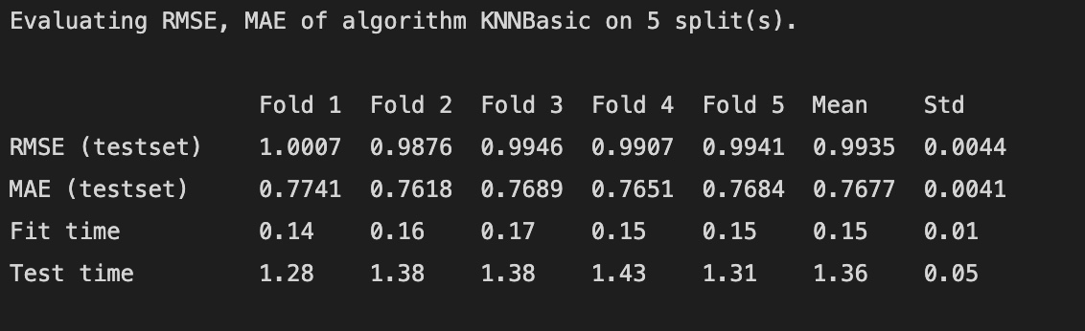

*MSD Similarity with User based Collaborative Filtering (5-folds CV)*

*Pearson Similarity with User based Collaborative Filtering (5-folds CV)*

*Cosine Similarity with Item based Collaborative Filtering (5-folds CV)*

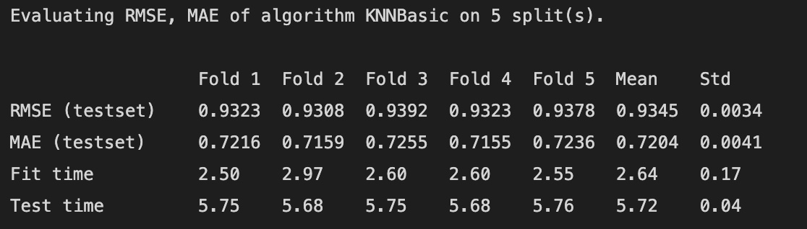

*MSD Similarity with Item based Collaborative Filtering (5-folds CV)*

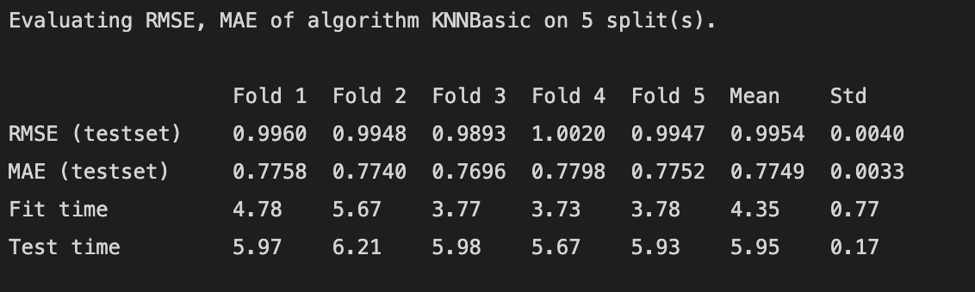

*Pearson Similarity with Item based Collaborative Filtering (5-folds CV)*

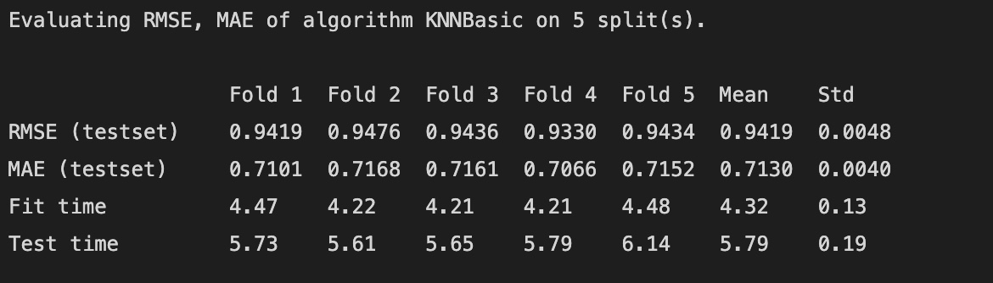

*Plot your results*

*Is the impact of three metrics consistent between user-based and item-based?*

The impact of the three metrics seems to be inconsistent when comparing with MAE but somewhat consistent when comparing with RMSE

Question F.

*Impact of number of neighbors on the performance of User-based and Item-based*

