College Complaint and Issue Management System

A Project Report submitted to
The Maharaja Sayajirao University of Baroda
in the partial fulfilment for the award of the degree of

Post Graduate Diploma in Computer Applications
at
The Department of Applied Mathematics
by
Grena Panchal(Seat No.)
Manav Bhatt (Seat No.)

Under the Guidance of
INTERNAL GUIDE
Dr. Nilima Shah
Department of Applied Mathematics,
Faculty of Technology & Engineering,
The Maharaja Sayajirao University of Baroda,
Vadodara.

April, 2026

CERTIFICATE
This is to certify that the project report entitled “College Complaint and Issue Management System” which is submitted by Grena Panchal and Manav Bhatt in partial fulfilment for the award of the degree of Post Graduate Diploma in Computer Application at The Department of Applied Mathematics, The Maharaja Sayajirao University of Baroda has been carried out under our supervision and guidance in the academic year 2025-2026.

INTERNAL GUIDE
Dr. Nilima Shah

Department of Applied Mathematics,
Faculty of Technology & Engineering,
The M. S. University of Baroda,
Vadodara.

Head,  Department of Applied Mathematics | Dean,  Faculty of Technology and Engineering
The Maharaja Sayajirao University of Baroda
Vadodara – 390001
CERTIFICATE

This is to certify that the project report entitled “College Complaint and Issue Management” submitted by Grena Panchal and Manav Bhatt in the partial fulfilment for the award of the degree of Post Graduate Diploma in Computer Application at The Department of Applied Mathematics, The Maharaja Sayajirao University of Baroda is hereby approved.

__________________________ __________________________

__________________________ __________________________

__________________________ __________________________

__________________________ __________________________

Date: _____________
Place: Vadodara
Department of Applied Mathematics
Faculty of Technology & Engineering
The Maharaja Sayajirao University of Baroda
Vadodara – 390001

ACKNOWLEDGMENT
We are highly thankful to our project guide for providing valuable insights and constructive suggestions during the development of the College Complaint and Issue Management System. Their guidance played a crucial role in shaping this project successfully.
We would also like to thank the Department of Applied Mathematics for providing us with the necessary resources and a supportive environment to carry out this work.

NAME OF STUDENTS
Grena Panchal
Manav Bhatt

INDEX
No. | Content | Page No
 | Introduction | 7
 | Scope | 7
 | Problem defination | 8
 | Problem solution | 8
 | Advantages of the system | 9
 | Module description | 9
 | Tools | 10
 | Diagrams | 11

Contents

- INTRODUCTION TO PROJECT

The College Complaint Management System is a web-application system that helps students and staff submit complaints related to college issues such as infrastructure, library, and administration.

Users can track the status of their complaints, and college authorities can manage and resolve them online.

- SCOPE

The scope of this system is limited to internal college operations. It includes managing complaints related to classrooms, laboratories, hostel facilities, library services, campus safety, and administrative departments.
The system supports complaint tracking, status updates, and record maintenance to improve communication between users and college authorities.

- PROBLEM DEFINATION

The existing complaint handling system is mostly manual and informal, which leads to inefficiency, inconsistency, and lack of accountability. The major problems of the existing system include:

- No proper tracking mechanism
- Delays in grievance resolution
- Complaints recorded in physical registers
- Complaints may be ignored or misplaced
- Lack of transparency for students

- PROBLEM SOLUTION

- Students can file a complaint anytime, anywhere.
- Eliminates paperwork and physical complaints.
- All complains are stored securely in a database.
- Easy record management.
- Student can view complains status anytime.
- Admin can manage all complains easily.

- ADVANTAGES OF THE SYSTEM
• Eliminates manual complaint registers
• Faster complaint resolution
• Easy tracking of complaints
• Improves transparency
• Reduces chances of complaint loss
• User-friendly interface

- MODULE DESCRIPTION

- User Module
- Registration & Login
- Submit Complaint
- View Complaint Status

- Admin Module
- View Complaints
- Update Status
- Manage Users

- TOOLS

- Frontend :

HTML
CSS
Javascript

- Backend :

Node.js

- Database :
MySQL

- Server :
Apache

- DIAGRAMS

- Use Case Diagram :-

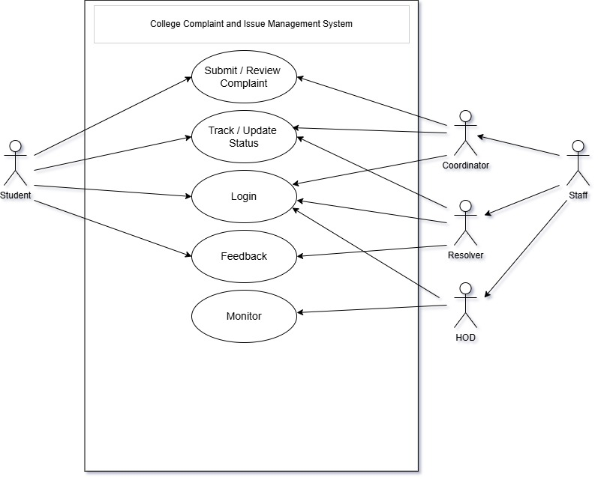

- Data Flow Diagrams :-

- DFD Level – 0
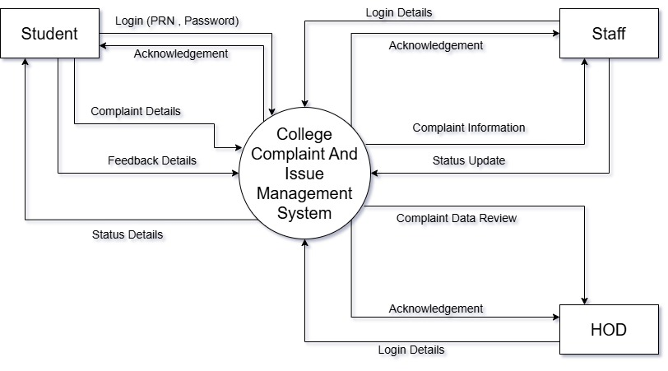
- DFD Level – 1
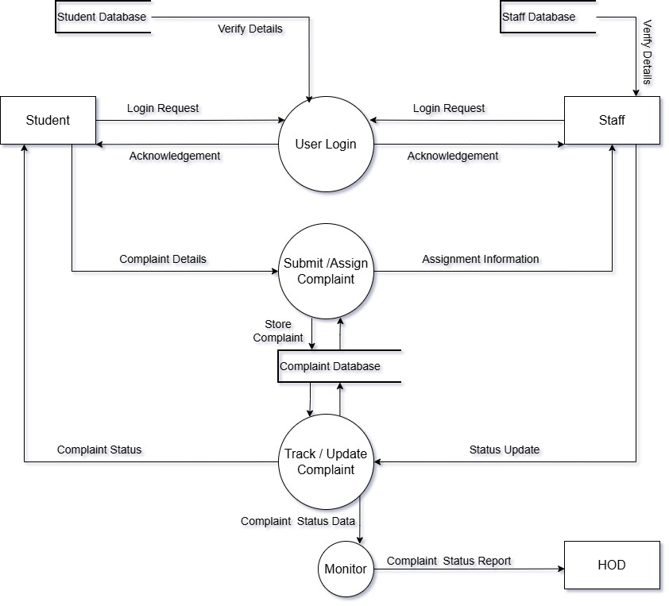
- E-R Diagram :-

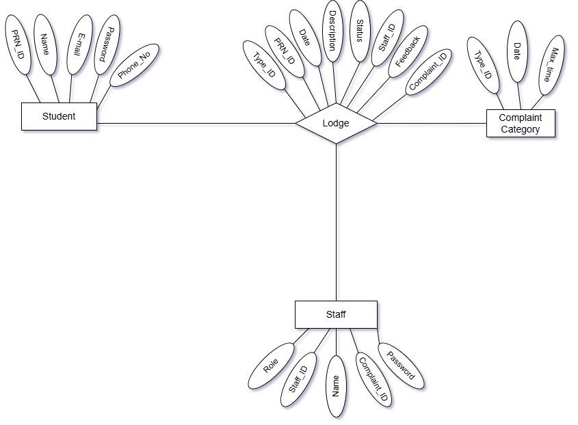

Instructions
- Font to be used for the contents - Times New Roman, Size – 12
- Program code is not required in the project report.
- Run the spell-checker for checking spelling mistakes.

- Contents of the project:
a) Project Description – Definition and Scope
Platform and tools used (Explanation not required)

b) Diagrams of the Project in the following order:

Use Case diagrams
Data flow diagrams
Class diagrams/ E-R diagram
Sequence diagrams (Optional)
State diagrams (Optional)
Activity diagrams (Optional)
Data dictionary

c) Screen Shots (Input screens and Reports (wherever applicable))

Note: At the end of the document please mention all the references (Books, websites, papers that you have studied for the project )

