QF635 Market Microstructure and Algorithmic Trading
Project Report
A Regime-Switching Crypto Trading System
Order Logic, System Architecture and Risk Management
BTC/USDT & ETH/USDT · Binance (paper / demo) · event-driven engine
Focus of this report: demonstrate how trading decisions are generated, routed and executed, and how risk is controlled — not absolute profitability.

Table of Contents

1. Executive Summary
This project demonstrates how a quantitative team researches, builds, validates and risk-manages an intraday cryptocurrency trading strategy within a professional, event-driven framework. The emphasis throughout is on the full order lifecycle and a multi-layer risk-control system rather than on producing a profitable backtest. The strategy trades BTC/USDT and ETH/USDT spot on Binance, using a regime detector based on a return z-score and a volatility ratio to switch between a momentum strategy (MACD with a fast and slow moving-average crossover) in trending markets and a mean-reversion strategy (RSI with Bollinger Bands) in ranging or high-volatility markets. Market data is read from the real Binance mainnet feed, while orders are routed exclusively to a paper account and never to a live-money venue.
Over one year of one-minute bars, the BTC/USDT configuration executed 19,180 trades (9,585 round trips) at a 36.5% win rate, returning -20.14% against a buy-and-hold benchmark of -38.92%. The maximum drawdown reached 20.28%, at which point the 20% drawdown circuit breaker halted the engine; cumulative transaction costs of 1,916.513 USDT account for almost the entire loss, and a gross profit factor of 0.91 indicates an edge that is only marginally negative before costs. The annualised Sharpe ratio of -25.77 confirms the absence of a positive risk-adjusted edge at a 0.1% taker fee, a conclusion that proves stable across a timeframe sweep, a 70/30 train–test split, cross-asset validation on ETH, parameter grids and a fee-sensitivity analysis.
The principal conclusion is therefore twofold. The trading system itself is correct and well controlled — most visibly, the circuit breaker engaged exactly as designed and bounded the loss — yet the strategy is not suitable for real capital, because its small gross edge is entirely eroded by transaction costs. We present and analyse this outcome in full, since the integrity of the process, rather than the profitability of the result, is the object of the exercise.

2. Motivation and Market Opportunity
Cryptocurrency spot markets such as BTC/USDT and ETH/USDT were chosen because they are highly liquid, trade continuously, and expose public order-book and kline data with no licensing barrier, while also offering free paper-trading venues on Binance. Together these properties make them an ideal setting in which to build and validate a complete trading system end-to-end without risking capital.
The strategy is motivated by two well-documented and complementary market behaviours. The first is short-horizon momentum, or trend persistence: once a directional move is under way, order flow and herding tend to extend it over the following minutes, a tendency the system captures through the MACD histogram and a fast/slow moving-average crossover. The second is short-term mean reversion: in the absence of a trend, the activity of liquidity providers and the over-reaction of impatient participants tend to pull price back toward a local mean, which the system captures through RSI extremes at the Bollinger bands. Because these two behaviours dominate in different market states, a regime detector routes each state to the appropriate strategy, so that a trend-following rule is never applied in a choppy market nor a reversion rule in a strong trend.
Such micro-inefficiencies are continually reintroduced by retail order flow, funding-driven flows and fragmented liquidity across venues, which is why the opportunity is plausible in principle. Whether it survives transaction costs at the one-minute horizon is precisely the question the remainder of this report sets out to answer.

3. Market Microstructure Analysis
Binance operates as a continuous central limit order book with maker/taker matching and a baseline taker fee of 0.1%; there are no designated market makers, so liquidity is endogenous and supplied by the participants themselves. The system consumes this structure through a ten-level order book carried on every market event, from which it derives the mid-price used for marking positions and a depth-weighted bid/ask imbalance used as a microstructure feature. For the two instruments traded, the top of book is deep and tight and price discovery is continuous; the bot polls the order book roughly every ten seconds and refreshes a one-minute kline each minute.
Crypto markets also exhibit pronounced volatility clustering and alternate visibly between trending and ranging phases, which is the empirical basis for the regime-switching design. The detector classifies each symbol as TRENDING, RANGING or HIGH_VOL from a rolling z-score of returns and a volatility ratio. Because the market trades continuously with no formal open or close, liquidity and volatility instead vary with the overlap of the US, Asian and European sessions, a variation the regime detector absorbs automatically rather than through hard-coded trading hours.

4. Strategy Research and Signal Development
The research hypothesis is that, conditional on correctly identifying the prevailing regime, a small but positive directional edge exists at the one-minute horizon, and that trading the regime-appropriate signal should therefore outperform passive holding on a risk-adjusted basis. To test this, the strategy is built from a compact set of standard technical features, all computed on the rolling window of one-minute kline closes and summarised in Table 1.
Feature | What it measures | Role in decision
RSI (14) | Momentum oscillator, over-bought / over-sold | Mean-reversion entry trigger at extremes
Bollinger Bands (20) | Price stretch vs rolling mean / volatility | Confirms reversion entries at the band
MACD | Trend acceleration (histogram) | Momentum entry: sign + strength
MA fast/slow (10/30) | Trend direction via crossover | Momentum entry confirmation
Return z-score / volatility | Regime classification | Selects which strategy is active
Depth imbalance | Order-book pressure | Microstructure context (monitoring)
Table 1 — Signals and features, and the role each plays in the trading decision.
The trading logic combines these features conjunctively so that two independent conditions must agree before a position is opened, which filters out whipsaws. In the trending regime, the momentum strategy issues a buy only when the fast moving average lies above the slow one and the MACD histogram is simultaneously positive, and the mirror conditions for a sell. In the ranging or high-volatility regime, the mean-reversion strategy issues a buy only when price has closed at or below the lower Bollinger band and RSI is at or below 30, and the mirror conditions for a sell. In both cases the conviction attached to the signal scales with how far the triggering indicator has moved beyond its threshold, so that stronger dislocations produce larger intended positions.

5. Model Selection and Justification
The prediction objective is deliberately modest: at each signal interval, for each symbol, the system classifies the immediate move as buy, sell or hold. It forecasts the direction of the next short-horizon move rather than attempting to predict a price level. Three model families were considered for this task — a single always-on momentum rule, a single always-on mean-reversion rule, and the regime-switching combination of the two that was ultimately adopted — with a Gaussian Hidden Markov regime model noted as a future extension.
The regime-switching rule-based model was selected for its interpretability, transparency and computational efficiency: every trade it places is fully explainable from a handful of indicator values, which is essential both for risk review and for the pedagogical aims of this report. This choice is consistent with the course guidance that a simple, interpretable model with robust out-of-sample behaviour is preferable to a more complex one that improves the backtest only marginally. Its limitations are equally clear and are revisited later: the decision thresholds are fixed rather than adaptive, the z-score regime detector is sensitive to the length of its estimation window (Section 12), and the indicators respond relatively slowly to one-minute noise.

6. Strategy Implementation Logic
The system is event-driven: a single queue routes events through a fixed sequence of handlers, so that for each market event the pipeline proceeds from mark-to-market, through protective exits, a regime update, signal generation and pre-trade risk checks, to order placement and fill. Figure 2 traces this per-bar decision flow for the entry path.
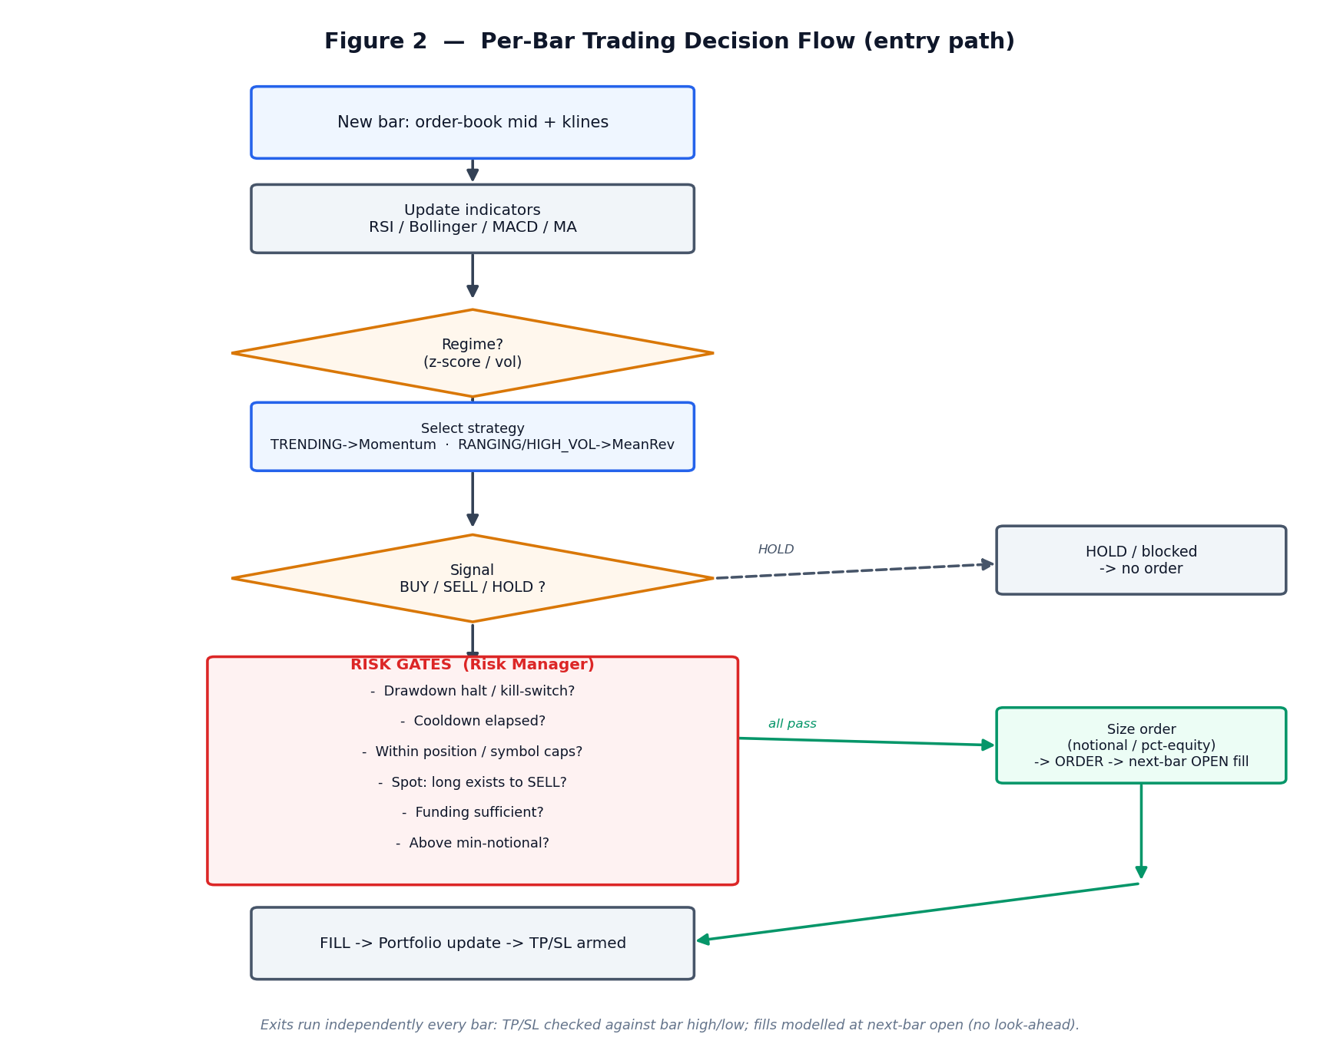
Figure 2 — Per-bar trading decision flow (entry path).
Signals are generated by recomputing the indicators on each bar, but at most one signal is emitted per symbol in any sixty-second interval, which prevents the system from over-reacting to noise. The prevailing regime selects which strategy is active, and that strategy then emits a buy, sell or hold according to the logic of Section 4. Exits are handled separately and continuously: the +3% take-profit and −3% stop-loss are evaluated on every bar and operate independently of the entry kill-switch, so that an open position remains protected even when new entries are disabled; in the backtest these levels are tested against the bar's high and low rather than its close, so that intrabar triggers are not missed.
Position size is configurable — a fixed notional (100 USDT by default), a fixed base quantity, a percentage of equity, or an all-in mode — and is then clamped by hard per-order ceilings. Before any order is sent it must pass a sequence of filters: a cooldown between entries on the same symbol, a minimum-notional test that discards dust orders, per-symbol and concurrent-position exposure caps, a funding check, and the spot no-shorting constraint under which a sell may only reduce an existing long. For execution, market orders are assumed to fill at the next bar's open — never on the close that produced the signal — and a 0.1% taker fee is charged on every fill.

7. Trading System Architecture
A central design principle is that the same modules are reused unchanged in live trading and in backtesting; only the data producer and the broker differ between the two. The modules never call one another directly — each consumes a single event and returns any new events it generates, which the engine then routes — so the backtest exercises exactly the code that would trade live. The resulting pipeline is shown in Figure 1, and the responsibility of each module is summarised in Table 2.
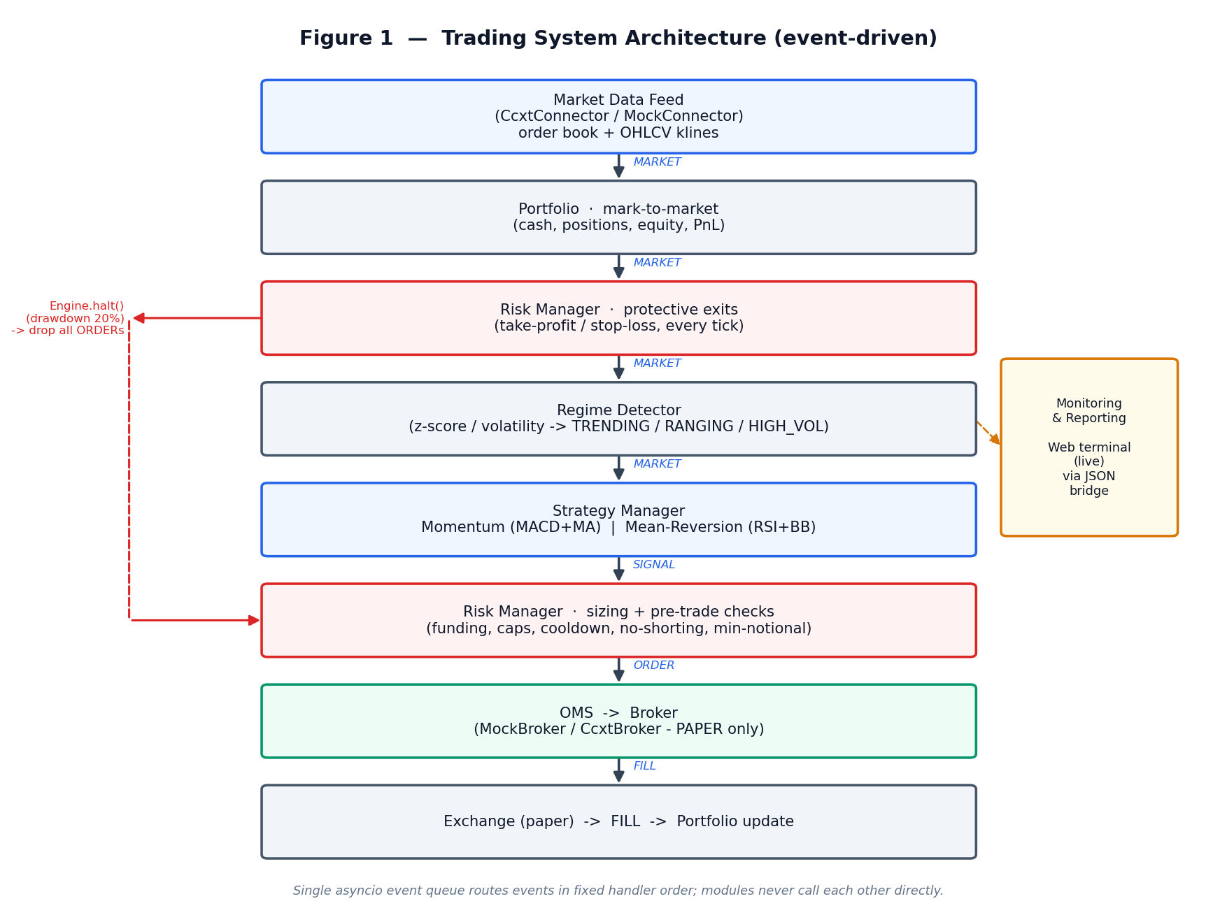
Figure 1 — Trading system architecture (event-driven pipeline).
Module | Responsibility
Data Retrieval | CcxtConnector (real Binance mainnet, read-only) or MockConnector; supplies order book + klines.
Signal Generation | Strategy Manager + Momentum / Mean-Reversion strategies.
Decision / Regime | Regime Detector classifies the market; manager selects the strategy.
Risk / Decision Engine | Risk Manager: pre-trade sizing & checks, plus protective TP/SL exits.
Order Management | OMS tracks order lifecycle, TTL and cancellation.
Execution | Broker — MockBroker (sim) or CcxtBroker (paper demo/testnet, hard-locked).
Position Tracking | Portfolio: cash, positions, realised/unrealised PnL, equity.
Monitoring & Reporting | Web terminal (browser UI) over a JSON bridge (/api/state, /api/control) + standalone backtester with HTML reports.
Table 2 — Modules of the trading system and their responsibilities.

7.1 Web Terminal — Monitoring and Control Interface
The monitoring and control surface is a single-page browser terminal styled after a professional trading desk, shown in Figure 10. It communicates with the running bot exclusively through the JSON bridge described above, with no direct coupling, so that the interface can be developed, deployed and restarted independently of the trading engine itself.
Its layout follows the conventions of a trading workstation. A fixed top bar carries the brand, the navigation between the Terminal, Backtest and Settings views, a connection-health indicator and a theme toggle, and beneath it an account strip presents live metric chips — equity, total, realised and unrealised PnL, cash and drawdown — alongside the Enable, Stop and Kill controls. The main Terminal view is a three-panel grid: a watchlist showing each symbol's regime badge and price on the left, a candlestick chart with selectable timeframes and an OHLC read-out in the centre, and an order-book ladder with a depth-imbalance gauge above a chronological feed of signals, fills and regime changes on the right. Two further views complete the terminal — a Backtest view presenting performance cards with equity and drawdown curves, and a Settings view exposing the order, sizing, exit and risk parameters.
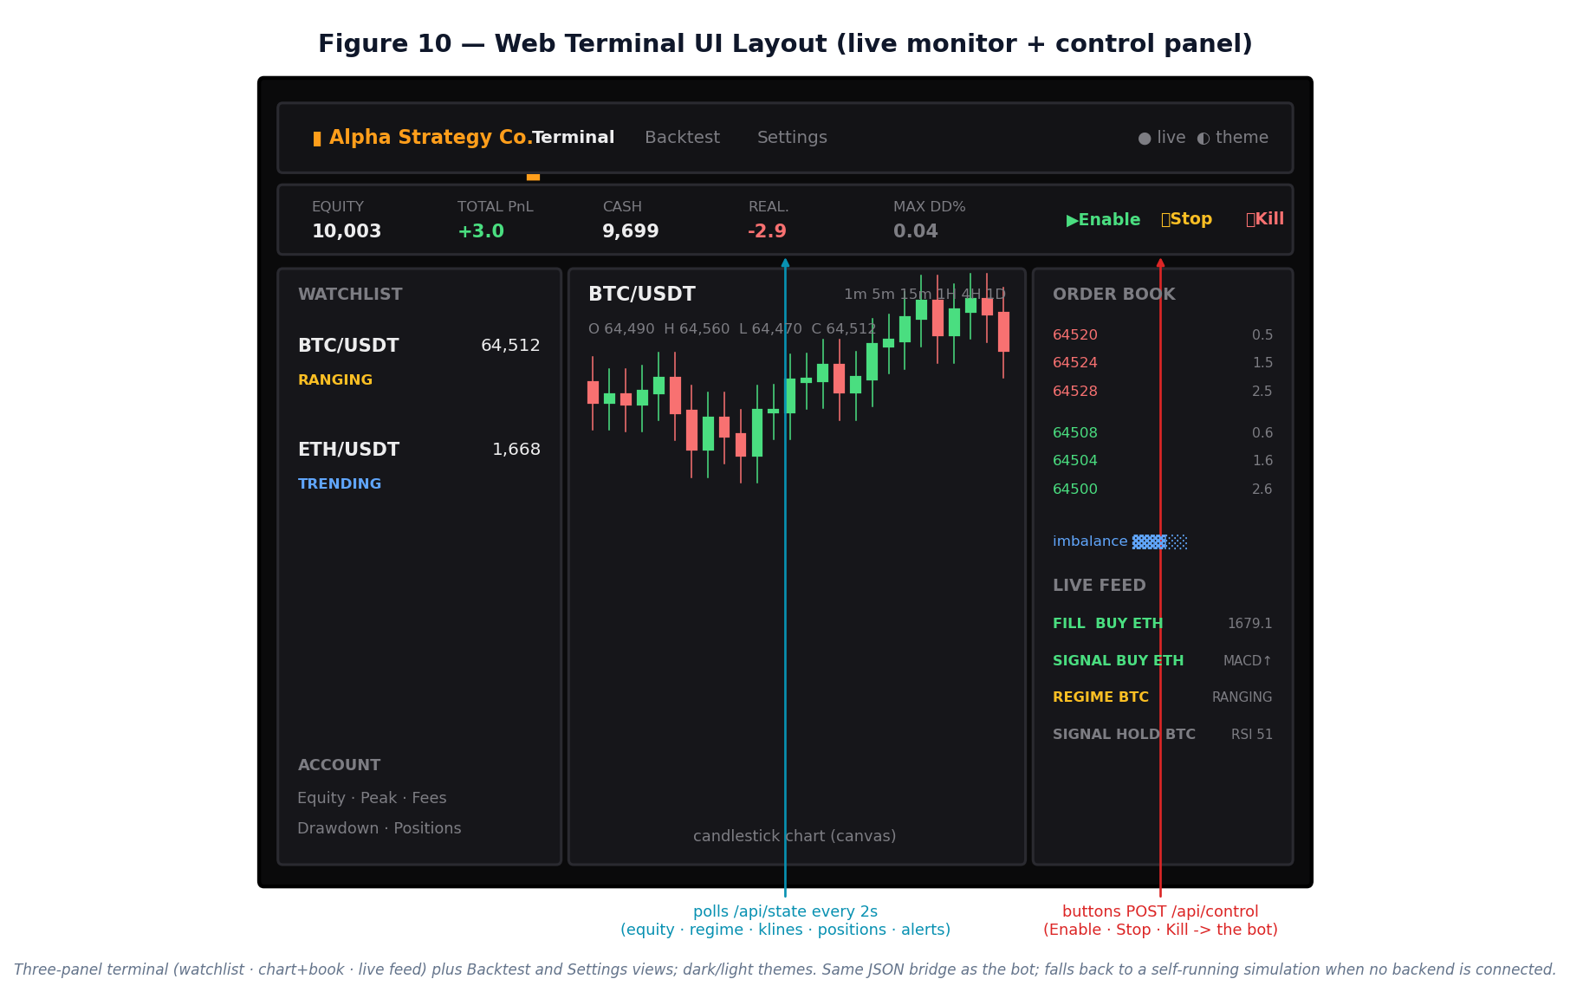
Figure 10 — Web terminal UI layout: top bar, account/metric strip, and the three-panel terminal, with the live data and control channels annotated.
The interface is driven by three endpoints. It polls /api/state every two seconds and overlays the bot's real state — the equity curve, per-symbol regime, klines, positions and the alerts feed, the last of which surfaces the risk-tier events discussed in Section 8.1 — while the three control buttons POST to /api/control, which the bot consumes on its next market tick. The Backtest view calls /api/backtest, which runs the real backtester for the chosen symbol, timeframe and window and returns the equity curve, drawdown, trade markers and performance metrics. When no backend is connected the page falls back to a self-contained simulation, so that it remains demonstrable even as a purely static deployment. Throughout, a dark theme (with a lighter, broadsheet-style alternative) and monospaced numerics follow trading-desk conventions for at-a-glance reading, and a consistent green/amber/red colour language encodes buy, hold and sell — and healthy, warning and critical states — across every panel, reducing the cognitive load of monitoring two instruments in real time.

8. Risk Management Framework
Risk management is the core of the system, and it is enforced at two distinct points in every cycle: protective exits are evaluated on each market mark, and a pre-trade sequence of checks is applied to each signal before an order can be placed. These controls are deliberately layered — and include a three-tier drawdown framework that escalates from soft de-risking, through a daily-loss pause, to a hard halt — so that the failure of any single control cannot by itself cause an uncontrolled loss.

Risk measures monitored
Four quantities are tracked continuously and feed the controls that follow. Position exposure is measured as the marked notional held in each symbol and in aggregate; volatility is estimated on a rolling basis and feeds the regime classifier; maximum drawdown is computed as equity against its running peak and is checked on every signal; and equity and PnL, both realised and unrealised, are marked to market on every bar.

Risk controls — purpose and backtest evidence
Every control below was included for a specific failure it is meant to prevent. The third column reports how each one behaved in the 1-year backtest, so the framework is demonstrated rather than merely declared.
Control | Why it exists (intent) | How it showed in the backtest
Drawdown circuit breaker (hard, −20%) | Last line of defence: cap catastrophic account loss and force human review if the strategy breaks down. | Fired at −20% (Fig 4): froze all new orders and capped the year's loss; without it the drift would have continued.
Soft drawdown de-risk (soft, −10%) | De-risk gradually as losses build, so exposure is already reduced before the hard stop is reached. | Activated once at −10% (Fig 9) and halved new-order size for the remainder of the run.
Daily-loss limit (soft, −5%/day) | Contain a single bad day (flash move / data or model glitch) without permanently shutting the bot down. | Stood ready but did not trigger — confirming no single day lost ≥5%; dormancy here is the correct, intended outcome.
Stop-loss / take-profit (hard, ±3%) | Bound the loss (and lock the gain) on any one position, independently of the signal or kill-switch. | The dominant exit; checked each bar against the bar high/low, so every losing trade was capped near −3% (small average loss).
Position sizing (≈100 USDT/order) | Keep risk-per-trade consistent so no single order can dominate the account. | Each entry was ≈100 USDT; equity changed in small, even steps rather than lumps.
Per-order caps (hard) | A ceiling so that a sizing error or bad price can never place an oversized order. | No order exceeded the notional / quantity cap across ~19k trades.
Per-symbol exposure cap (hard, 200 USDT) | Prevent over-concentration: stop the book slowly accumulating into one symbol. | BUYs were shrunk or denied once a symbol's holdings reached the cap (visible in the risk log).
Concurrent-position cap (hard, 2) | Bound total gross exposure across the universe. | At most BTC and ETH were held at the same time.
Cooldown (soft) | Prevent over-trading / churning on rapidly flipping signals. | Spaces entries per symbol; a timestamp bug that silently disabled it in fast replay was found and fixed (§9).
Funding check (hard) | Spot has no leverage — never spend cash the account does not hold. | BUYs were automatically shrunk to the affordable size when cash ran low.
No-shorting (hard, spot) | Respect the spot constraint: a SELL may only reduce an existing long. | SELL signals with no long position were skipped (“no long to sell”).
Minimum notional (soft) | Skip dust below the exchange minimum and avoid wasting fees on negligible orders. | Sub-minimum orders were skipped.
Kill-switch (hard) | Instant human override to stop entries (and, on Kill, halt and cancel everything). | Wired to the web-terminal Stop/Kill controls; Kill halts the engine and cancels resting orders.
Taken together, these controls answer the central question of how losses are contained if the strategy misbehaves. The defence is layered and signal-independent: at the level of an individual trade the stop-loss caps any single position near −3%, while at the level of the account the soft tier de-risks at −10% and the hard circuit breaker halts all trading at −20%. In the one-year test this was not merely theoretical — the breaker fired (Figure 4), froze all new orders and bounded the loss — so the framework can be shown to behave exactly as designed rather than only asserted to.

8.1 Tiered drawdown framework — design and test
A single hard halt at −20% is a blunt instrument, since it acts only once a large loss has already been incurred. We therefore implemented a graduated three-tier framework and re-ran the full year to test it. The first tier is a soft de-risking step: once drawdown reaches 10%, the size of every new order is scaled to 50% so that exposure is reduced before the hard limit is approached. The second tier is a daily-loss pause: if the day's PnL falls to −5%, new entries are blocked for the remainder of that day and resume automatically the next day, while protective exits continue to run throughout. The third tier is the circuit breaker itself: at a 20% drawdown the engine halts permanently and requires human intervention to resume.
Configuration | Return % | Max DD % | Trades | Fees | Hard halt
Single hard halt (−20%) | -20.14 | 20.28 | 19,180 | 1,917 | fired
Tiered (soft + daily + hard) | -20.01 | 20.05 | 28,205 | 1,906 | fired
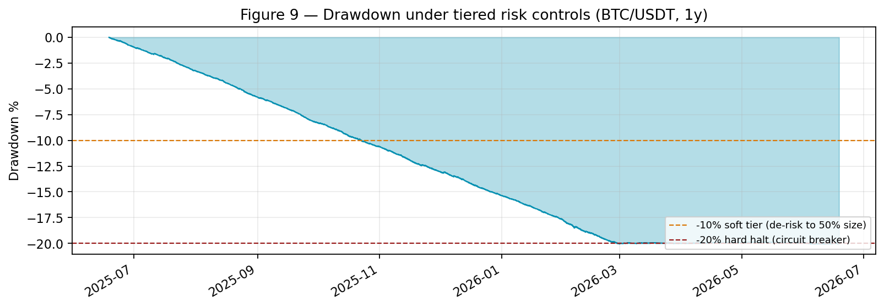
Figure 9 — Drawdown under the tiered framework; soft tier (−10%) and hard halt (−20%) marked.
The test confirms that the framework behaves exactly as designed: the soft tier de-risked automatically at −10% and the hard halt bounded the loss at −20%, with the headline result essentially unchanged (-20.01% against -20.14%) because the breaker engaged at the same level in both runs. More instructively, it illustrates a deliberate separation of concerns, in which each layer activates only for the risk it is meant to address. The daily-loss tier correctly remained dormant, because no single day lost as much as 5%, and the account-level breaker remained the binding safeguard — the appropriate response to a gradual rather than an abrupt drawdown. The risk framework, in other words, is responsible for containing downside and tail events, whereas steady-state profitability is properly the concern of the signal and transaction-cost layer; improving the net edge is therefore pursued through cost-aware execution in Section 11 rather than by tightening risk limits.

9. Backtesting Methodology
The backtest is driven by real Binance mainnet OHLCV data, read without an API key, and the headline run covers a trailing 365 days of one-minute bars — roughly 525,600 bars per symbol — with additional timeframes used for the robustness work; sub-minute studies fetch one-second klines and aggregate them up to the target bar. Critically, the backtester replays this history through the identical live modules — the same portfolio, regime detector, strategies and risk manager — so that it validates the real trading code rather than a separate re-implementation. Each fill is charged a 0.1% taker fee, market orders are assumed to fill at the next bar's open, and the take-profit and stop-loss are evaluated against the bar's high and low; no further slippage model is applied, a conservative simplification revisited in Section 14.
It is important to note what selecting a given bar size actually means. A backtest at, say, one-hour bars is not the one-minute strategy observed less often; it is a different strategy entirely. The indicators are computed on that timeframe's closes, one decision is taken per bar at that interval, and the take-profit and stop-loss are evaluated only against each bar's high and low — the engine never drills into the minute-by-minute path inside a bar. Consequently a one-hour MACD crossover is a genuinely different signal from a one-minute one, and the large gap between the timeframes (Section 11) reflects both lower trading frequency, which reduces fee drag, and a change in the signals themselves. The only intrabar information available at a coarse timeframe is the bar's high and low, so an event such as price touching both the take-profit and the stop-loss within a single bar cannot be ordered precisely; the backtest resolves this conservatively by testing the adverse extreme first.
Two well-known hazards — look-ahead bias and overfitting — were addressed explicitly, and doing so uncovered three real defects in an earlier version of the harness that are now corrected and integral to the methodology. First, look-ahead was eliminated by ensuring that an order generated on bar i fills at the open of bar i+1, never on the same close that produced the signal. Second, exits are tested against each bar's high and low so that a stop or target touched intrabar is not silently missed. Third, and most subtly, a timestamp defect was found whereby signals defaulted to wall-clock time; in fast replay this disabled the cooldown gate entirely, so the backtest appeared to place only two trades across a whole year, and once corrected the backtest faithfully reproduces live trading frequency. Against overfitting, parameters were examined on the first 70% of the data and evaluated on the held-out final 30%, the configuration was cross-validated on ETH/USDT, and the sensitivity of the result to each parameter was swept (Section 12); at no point were parameters tuned on the test set.

10. Performance Analysis
Results are shown for both traded symbols, 1 year of 1-minute bars, on the original configuration. ETH/USDT serves as an independent cross-asset check (see also §12).

10.1 BTC/USDT
Headline metrics for BTC/USDT, 1 year, 1-minute bars:
Metric | Value
Bars replayed | 525,600
Number of trades | 19,180 (9,585 round trips)
Win rate | 36.5%
Total return | -20.14%
Buy & hold benchmark | -38.92%
Maximum drawdown | 20.28% (circuit breaker fired)
Sharpe (annualised) | -25.77
Gross profit factor | 0.91
Max consecutive losses | 33
Transaction costs paid | 1,916.513 USDT
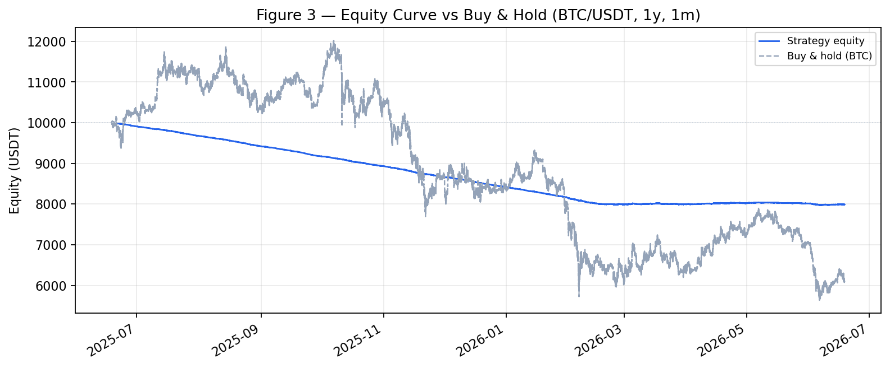
Figure 3 — Equity curve vs buy-and-hold benchmark.
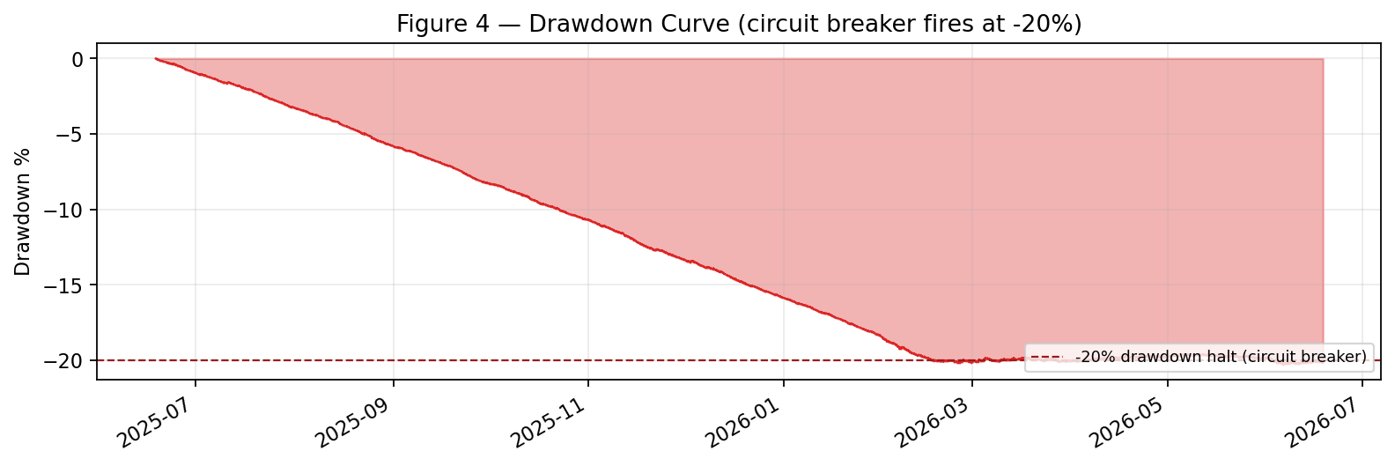
Figure 4 — Drawdown curve; the −20% circuit breaker halts trading.
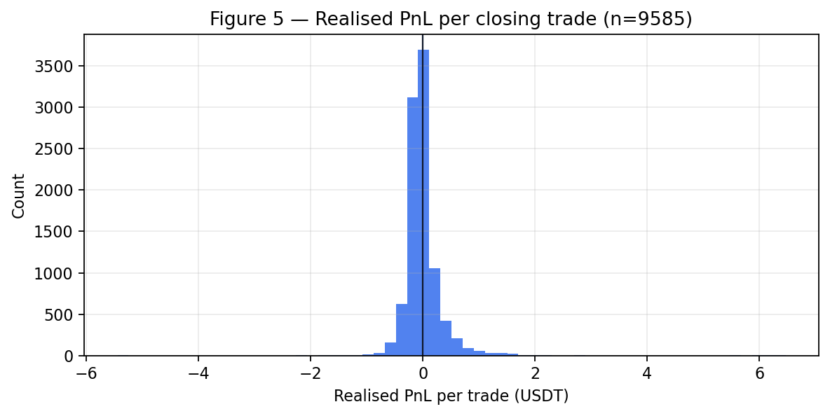
Figure 5 — Distribution of realised PnL per closing trade (BTC/USDT).
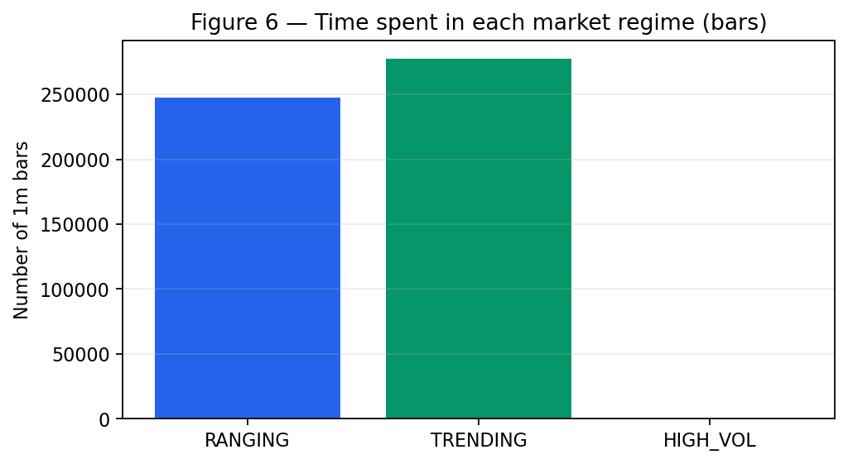
Figure 6 — Time spent in each market regime (BTC/USDT).
These figures should be read on a risk-adjusted rather than an absolute basis. The strategy lost 20.14% over the year while buy-and-hold lost 38.92%, but it "outperformed" the benchmark only because the circuit breaker stopped it after a 20% loss, not through any genuine timing skill. The profit factor of 0.91, which is below one, together with the fact that the 1,916.513 USDT of fees accounts for almost the entire loss, shows that the net edge is negative and is dominated by transaction costs rather than by adverse price selection.

10.2 ETH/USDT (cross-asset)
The identical configuration run on ETH/USDT over the same year:
Metric | Value
Bars replayed | 525,600
Number of trades | 19,608 (9,794 round trips)
Win rate | 35.1%
Total return | -20.14%
Buy & hold benchmark | -31.26%
Maximum drawdown | 20.26% (circuit breaker fired)
Sharpe (annualised) | -23.57
Gross profit factor | 0.98
Max consecutive losses | 23
Transaction costs paid | 1,960.012 USDT
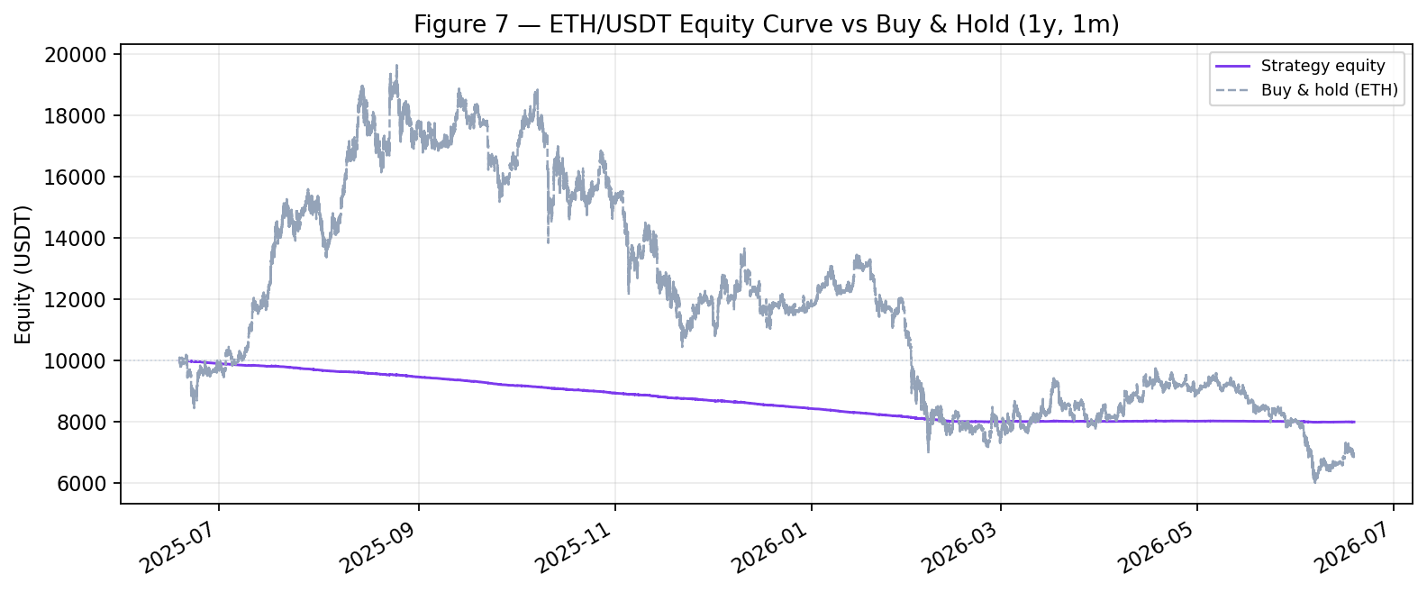
Figure 7 — ETH/USDT equity curve vs buy-and-hold.
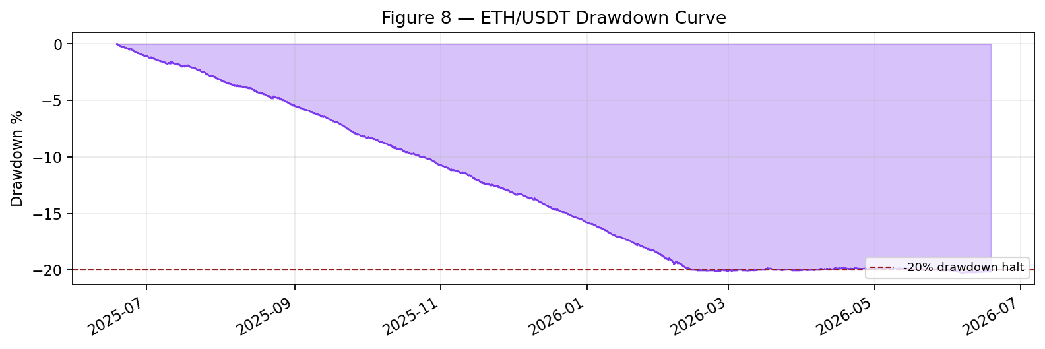
Figure 8 — ETH/USDT drawdown curve.
ETH/USDT reproduces the BTC/USDT pattern closely: the same regime-switching logic produces a similarly low win rate and a loss again dominated by transaction costs, with the circuit breaker engaging at the same level. That the two independent instruments behave in the same way indicates that the outcome is structural to the strategy rather than an artefact of a single asset's price path.

11. Strategy Optimisation
Optimisation was confined to structural changes rather than curve-fitting, and each candidate was validated on held-out data. The most informative experiment varied the bar size over a full year while holding the trading rules fixed; the results are given in Table 3.
Timeframe | Trades | Return % | Max DD % | Fees
1m | 19,180 | -20.14 | 20.28 | 1,916
5m | 6,014 | -6.63 | 6.63 | 602
15m | 2,128 | -2.45 | 2.52 | 215
1h | 593 | -1.35 | 1.64 | 65
Table 3 — Timeframe sweep over one year on the default rules.
Longer bars improve every metric monotonically, which confirms that the loss is driven by fee drag rather than by the direction of the signal: moving from one-minute to one-hour bars cut the loss from −20% to −1.35%, reduced fees by 97%, and avoided the drawdown halt altogether. The remaining levers were less effective. Reducing entry frequency through a longer cooldown made little difference once the strategy was already on hourly bars; a grid of 105 take-profit and stop-loss combinations contained no profitable setting; and a search over the signal parameters reached only a break-even ceiling. A fee-sensitivity test was the most revealing of all: the configuration becomes marginally positive out-of-sample only once costs fall to around 0.02%, the maker-fee level, which shows that a gross edge does exist but is consumed by taker fees under the baseline assumption.

12. Robustness Testing and Validation
Several independent tests were used to establish that the result is genuine rather than a product of luck or overfitting. Under a train/test split, parameters were examined on the first 70% of the data and evaluated on the final 30%, and the finding that longer timeframes perform better held out of sample, with the one-hour configuration returning roughly −0.2% on the test segment. The same configuration was then validated on ETH/USDT (Section 10.2, Figures 7–8) and produced results consistent with BTC/USDT — the same low win rate and the same fee-dominated loss — which argues against any asset-specific overfit. A sensitivity sweep over the moving-average windows, the RSI thresholds and the regime z-threshold found that the best out-of-sample outcomes clustered at a higher regime threshold, that is, when the system traded only strong trends, but none produced a robust positive return. Attributing performance across the TRENDING, RANGING and HIGH_VOL states (Figure 6) likewise revealed no regime in which the strategy held a durable edge after costs.
The natural question is whether the strategy would work under different market conditions, and the evidence indicates that it would not. Across timeframes, two assets, train/test splits and parameter grids the net edge is consistently close to zero, so the negative result is itself robust: there is no hidden profitable regime waiting to be found, and any single positive backtest would be attributable to chance.

13. Production Deployment Considerations
Although it is operated here only on paper, the codebase already separates the concerns that a production deployment would require. The market-data infrastructure is decoupled from the trading venue, so the bot can read real mainnet data while routing orders to a paper account; the order-management layer handles the order lifecycle, time-to-live and cancellation behind an abstracted broker interface that could be extended from the mock and paper brokers to a live one. Pre-trade risk checks and the hard kill-switch and circuit breaker run inside the engine itself, where a halt drops all subsequent orders. The browser-based web terminal provides monitoring and alerting, polling the bot's live state through /api/state to display equity, positions, regime, signals and the alerts feed — including the risk-tier events — and offering Enable, Stop and Kill controls that POST to /api/control. Finally, the portfolio's internal positions can be reconciled against broker balances through a balance query, which is a necessary safeguard before any live deployment.
Safety note: the broker is hard-locked to a paper venue (testnet/demo). A guard refuses to run against the production endpoint, so the system cannot place a real-money order.

14. Limitations and Future Enhancements
The dominant limitation is the absence of a positive net edge: the gross signal edge is small and is eroded by the 0.1% taker fee. A more subtle limitation concerns the regime detector, whose estimation window is defined in samples rather than in time, so that its effective horizon differs between the ten-second live feed (about five minutes) and the one-minute backtest (about thirty minutes); it ought to be redefined in time units so that live and backtest behave identically. The execution model is also simplified — there is no slippage or partial-fill modelling, and limit-order maker rebates are not yet represented, which the fee-sensitivity analysis suggests would matter materially.
It is worth being precise about the scope of the risk framework. By design the tiered controls of Section 8.1 contain tail and sudden-move risk rather than steady-state PnL, with the net edge addressed separately at the signal and transaction-cost layer; this is a deliberate separation of concerns rather than a deficiency, though it does mean that downside protection alone cannot make a low-edge signal profitable. Beyond the controls already implemented, a trailing stop and a historical VaR gate are scoped but not yet active, and a margin and leverage framework would be required to extend the system to futures and short selling — natural next additions rather than gaps in the current spot design.
Future work follows directly from these limitations: redefining the regime window in time units; adding a maker/limit execution path together with a slippage model; improving signal quality through multi-timeframe confirmation and volatility and volume filters in order to lift the win rate above break-even; and upgrading the regime detector to a Gaussian Hidden Markov model.

15. Conclusion
This project built a complete, professionally structured, event-driven trading system and validated it rigorously. Its trading and risk logic are correct: the order lifecycle works end-to-end and the drawdown circuit breaker fired exactly as designed, capping the loss. The strategy's net edge, however, is approximately zero once transaction costs are taken into account.
The principal strengths of the work lie in its engineering and its method: a clean separation of data, signal, risk and execution; the use of identical code in live trading and backtesting; a layered and demonstrably effective set of risk controls; and a rigorous, honest validation process that surfaced and corrected genuine methodology bugs, including a look-ahead error and a cooldown timestamp defect. Its weaknesses are equally clear — the signal has no durable edge after fees at intraday horizons, several advanced risk measures such as VaR and a trailing stop remain unimplemented, and the execution model is simplified.
Whether the strategy is suitable for deployment with real capital admits a clear answer: as a trading strategy it is not, because its expected return after costs is negative-to-zero. As a trading system and risk-management framework, however, it is sound, and it is precisely the kind of controlled environment in which a strategy possessing genuine alpha could be deployed safely. The project therefore achieves its true objective — demonstrating professional research, system design and risk management — rather than merely presenting a fortunate backtest.

