Access Without Depth: Financial Inclusion 2011–2024 and Aggregation Pitfalls in the Global Findex Database 2025
[Author Name]
[Affiliation]
[email@example.com]
Working Paper — July 2026
Abstract
The Global Findex Database 2025 extends the World Bank’s survey of how adults access and use financial services to a fifth wave. Using a balanced panel of 117 economies covering 96.5 percent of the surveyed adult population, this paper documents the corrected long-run picture: account ownership rose from 51 to 79 percent of adults between 2011 and 2024 — nearly two billion adults gained access — while formal saving in developing economies, flat for a decade, surged by 14 percentage points between 2021 and 2024, largely over mobile-money rails. Financial resilience, by contrast, stagnated near 55 percent, and the income gap in account ownership (10.5 points) remains wider than the gender gap, which halved to 4 points. The paper’s second contribution is methodological. The Findex 2025 country file stacks demographic disaggregations, embeds the World Bank’s own aggregate rows, and varies indicator coverage across waves. Four resulting aggregation pitfalls are quantified. Individually each biases levels by only one to two percentage points; compounded, they reverse trend signs — turning stable resilience into an apparent decline, rising borrowing into an apparent fall, and almost doubling the global mobile-money figure. A validation-first workflow that benchmarks every computed series against the embedded official aggregates catches all four. Code and data are openly available.
Keywords: financial inclusion; Global Findex; mobile money; digital payments; measurement error; reproducibility
JEL codes: C81, G21, G51, O16
Data and code: [repository URL]
This paper grew out of the author’s bachelor’s thesis; the empirical analysis was rebuilt and audited for this version, and the audit of the earlier version supplied the error catalogue analysed in Section 5. All remaining errors are the author’s own.

1. Introduction
Access to formal financial services — an account to receive wages, a safe place to save, a channel to pay and be paid — is a precondition for participating in a modern economy and an enabler of several Sustainable Development Goals. Since 2011 the World Bank’s Global Findex Database has been the standard yardstick for measuring that access: a nationally representative survey of adults in more than 140 economies, repeated roughly every three years (Demirgüç-Kunt and Klapper, 2012). The 2025 edition adds a fifth wave, collected in 2024, and with it the first full picture of how financial inclusion evolved through the pandemic period and its aftermath (Klapper, Singer, Starita and Norris, 2025).
This paper does two things. First, it documents the headline trends of 2011–2024 on a balanced panel of 117 economies — the same set of countries in every wave — so that changes over time reflect behaviour rather than a shifting country mix. The corrected picture is more interesting than a simple success story: access expanded enormously (51 to 79 percent of adults) and formal saving finally surged in the latest wave (+14 percentage points in developing economies, the largest wave-on-wave change in the series), but financial resilience — the ability to raise emergency funds — barely moved, and the income gap in account ownership remains wider than the gender gap. Access, in short, has not yet translated into depth.
Second, the paper treats the dataset itself as an object of study. The Findex 2025 country-level file has three structural features that make naive aggregation hazardous: it stacks demographic disaggregations (gender, age, income, education, labour-force status) as additional rows beneath each economy’s total-population row; it embeds the World Bank’s own regional, income-group and world aggregates as pseudo-economy rows in the same file; and its indicator coverage varies across waves and economies — mobile money is only surveyed where such services operate, and the digital-payment composite was collected for just five of forty high-income panel economies in 2024. Section 5 formalises four resulting pitfalls and quantifies each. The striking result is not that mistakes are possible — it is their arithmetic: each pitfall alone shifts levels by only one to two percentage points, easily dismissed as noise, but plausible combinations reverse the sign of headline trends. A stable resilience series becomes a four-point decline; rising formal borrowing becomes a fall; the global mobile-money share nearly doubles.
The economics literature has a well-known precedent for consequential aggregation error: the spreadsheet and weighting problems that overturned a widely cited result on public debt and growth (Herndon, Ash and Pollin, 2014). The pitfalls documented here are smaller in consequence but far easier to fall into, because the Findex file’s structure invites them. The remedy proposed is procedural rather than clever: because the publisher ships its own aggregates inside the file, every computed series can be benchmarked against an official counterpart before any substantive conclusion is drawn. This validation-first workflow, applied throughout the paper (every figure carries the official aggregate as hollow markers), catches all four pitfalls immediately. The full pipeline — from raw file to every figure and table — is open and reproducible.
The rest of the paper proceeds as follows. Section 2 describes the data. Section 3 sets out the sample, weighting and validation methodology. Section 4 presents the corrected trends in access, usage, resilience and equality of access. Section 5 quantifies the aggregation pitfalls. Section 6 discusses limitations, and Section 7 concludes.
2. Data
The Global Findex Database 2025 is built from nationally representative surveys of the population aged 15 and older, carried out as part of the Gallup World Poll with roughly 1,000 respondents per economy per wave (World Bank, 2025). The country-level file used here covers 162 economies over five waves — 2011, 2014, 2017, 2021 and 2024 — with 139 to 146 economies per wave. Sixteen economies whose 2021-round fieldwork was delayed by COVID-19 restrictions appear in the file under a nominal “2022” wave; following World Bank practice, they are merged into the 2021 wave here, before any other processing.
The file is in long format: one row per economy, wave and population group, with 437 indicator columns expressed as population shares. The group dimension stacks the total-adult row (group “all”) together with ten to twelve demographic subgroups per economy and wave. Interspersed with the economies are twelve aggregate entities published by the World Bank itself — the world, developing economies as a block, seven regional groupings and four income groups. These aggregate rows carry no adult-population weight and no region code, which is what distinguishes them mechanically from economy rows. Both structural facts — stacked subgroups and embedded aggregates — are central to Section 5.
Indicators are referenced by their database codes. Table 1 maps the concepts used in this paper to those codes. Two definitional details matter. The headline saving and borrowing measures (“saved formally”, “borrowed formally”) include activity through mobile-money accounts, not only at banks and similar institutions; their narrower “at a financial institution” variants coexist in the file under similar names, and the two families diverge sharply after 2021. Account dormancy is expressed as a share of adults and is related to account ownership below to obtain the share of account holders whose account is inactive.
Table 1. Concepts and Findex 2025 indicator codes used in this paper.
Concept | Definition (share of adults 15+) | Findex code
Account ownership | Has an account at a financial institution or mobile-money provider | account_t_d
Mobile money account | Has a registered mobile-money account | mobileaccount_t_d
Digital payment | Made or received a digital payment in the past year | g20_any
Saved formally | Saved at a financial institution or via a mobile-money account | fin17a_17a1_d
Borrowed formally | Borrowed from a financial institution, credit card, or mobile-money account | fin22a_22a1_22g_d
Inactive account | Has an account with no deposit or withdrawal in the past year | inactive_t_d
Emergency funds | Could raise emergency funds with some or no difficulty | fin24aSD_ND

3. Methodology
3.1. Balanced panel
All headline series are computed on the 117 economies present in every wave (77 of them developing). The panel restriction costs little coverage — 96.5 percent of the adult population of all surveyed economies in 2024 — and buys compositional consistency: without it, part of any measured change is simply the set of surveyed economies changing between waves. Section 5 shows this is not a theoretical concern.
3.2. Population-weighted aggregation
Country indicators are aggregated with adult-population weights, matching World Bank methodology: an aggregate share is Σ wᵢxᵢ / Σ wᵢ, where xᵢ is economy i’s indicator value and wᵢ its adult population in the given wave. Only total-population rows (group “all”) of economy entities enter these calculations; gender- and income-group series use the corresponding subgroup rows, one row per economy and wave. Ratio measures (the dormancy ratio; ownership gaps) are formed from the weighted aggregates, not averaged across countries.
3.3. Validation against embedded official aggregates
Because the file ships the publisher’s own aggregates, every computed series can be benchmarked before interpretation. Table 2 reports the comparison for the headline indicator. The panel tracks the official world series to within 1.5 percentage points, and the deviation has a mechanical explanation: the World Bank imputes values for economies missing from a wave, and those economies are disproportionately poorer, so the official series sits slightly below the panel. Throughout the paper, figures carry the official aggregates as hollow markers alongside the panel estimates.
Table 2. Account ownership, percent of adults: balanced panel vs. the official world aggregate embedded in the Findex 2025 file.
Wave | Balanced panel | Official world aggregate | Difference (pp)
2011 | 51.4 | 50.6 | +0.8
2014 | 62.8 | 61.7 | +1.1
2017 | 70.5 | 69.3 | +1.2
2021 | 75.3 | 73.8 | +1.5
2024 | 78.9 | 78.7 | +0.2

3.4. A taxonomy of aggregation pitfalls
Section 5 quantifies four pitfalls, each mapped to a structural feature of the file. P1 — disaggregation-row leakage: aggregating without fixing the group dimension, so that every demographic subgroup row enters the average alongside the total-population row, each carrying the full country weight. P2 — unbalanced composition: aggregating over whichever economies happen to be surveyed in each wave. P3 — indicator-variant confusion: using a narrower or broader variant of an indicator family than the concept requires. P4 — coverage-driven missingness: averaging only the economies that report an indicator when non-reporting is informative (mobile money is not surveyed where services are absent) or when coverage collapses in a wave (the high-income digital-payment composite in 2024).
4. Results
4.1. Access: the decade of the account
Account ownership rose from 51.4 percent of adults in 2011 to 78.9 percent in 2024 (Figure 1) — in absolute terms, from 2.4 to 4.4 billion adults on the panel, an expansion of nearly two billion people. Growth decelerates as saturation approaches: +11.4 points in 2011–2014, +3.6 points in 2021–2024.
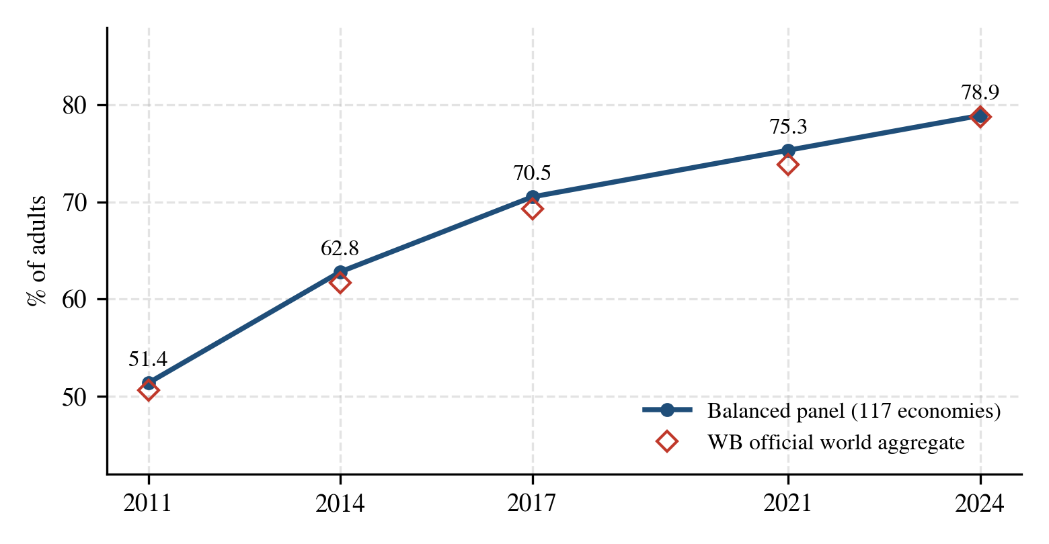
Figure 1. Account ownership, share of adults, 2011–2024. Solid line: balanced panel of 117 economies; hollow markers: official world aggregate. Source: author’s calculations from the Global Findex Database 2025.
The regional picture (Figure 2) contains three different convergence stories. South Asia made the largest leap (32.5 to 77.6 percent), concentrated in the 2014–2017 period of India’s mass account-opening programme. Sub-Saharan Africa more than doubled from the lowest base (23.9 to 59.8 percent). Latin America climbed steadily to 69.8 percent. High-income economies, near saturation throughout, drifted from 87.8 to 95.3 percent.
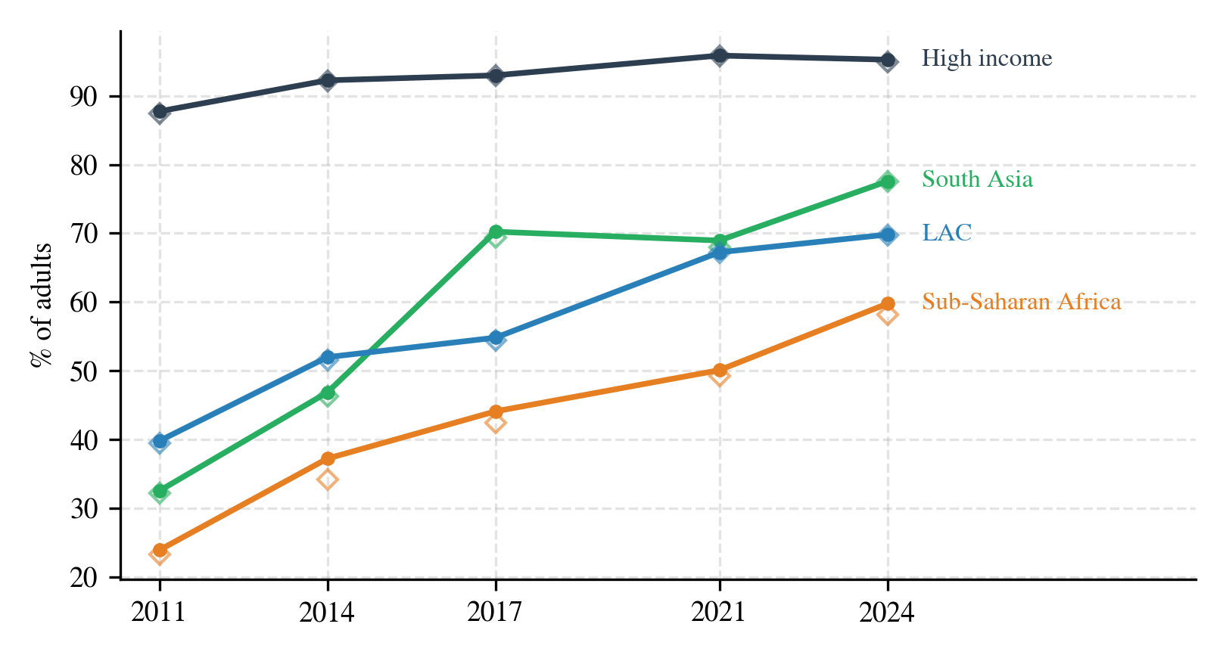
Figure 2. Account ownership by region. Hollow markers: official regional aggregates. Source: author’s calculations from the Global Findex Database 2025.
4.2. Mobile money: Africa’s parallel banking system
Mobile money is the indicator where measurement care matters most, because it is only surveyed where such services operate. Treating non-surveyed economies as effectively zero-adoption reproduces the official world aggregate almost exactly (Section 5, pitfall P4).
On that basis, global ownership reached 17.0 percent of adults in 2024 (official: 16.0). The global figure is, however, mostly a Sub-Saharan African story (Figure 3): there, mobile-money ownership reached 44.0 percent of adults — exceeding ownership of accounts at financial institutions (37.5 percent). For much of the region the phone, not the bank branch, is the financial system’s front door (Suri and Jack, 2016).
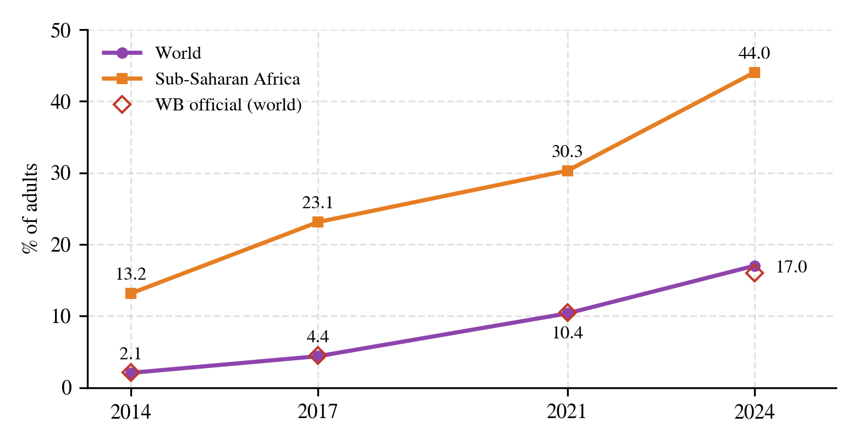
Figure 3. Mobile-money account ownership, 2014–2024. World series treats non-surveyed economies as zero-adoption; hollow markers: official world aggregate. Mobile money was not measured in 2011. Source: author’s calculations from the Global Findex Database 2025.
4.3. Usage: payments first, saving finally, borrowing slowly
Digital payments are the fastest-moving usage indicator: the share of adults in developing economies who made or received one rose from 35.1 percent in 2014 to 60.9 percent in 2024. Regionally (Figure 4), Sub-Saharan Africa’s curve rides on mobile money while South Asia’s reflects public digital-payment infrastructure. The high-income series ends in 2021: the composite was collected for only 5 of 40 high-income panel economies in the 2024 wave, too few to represent the group (Section 5, pitfall P4).
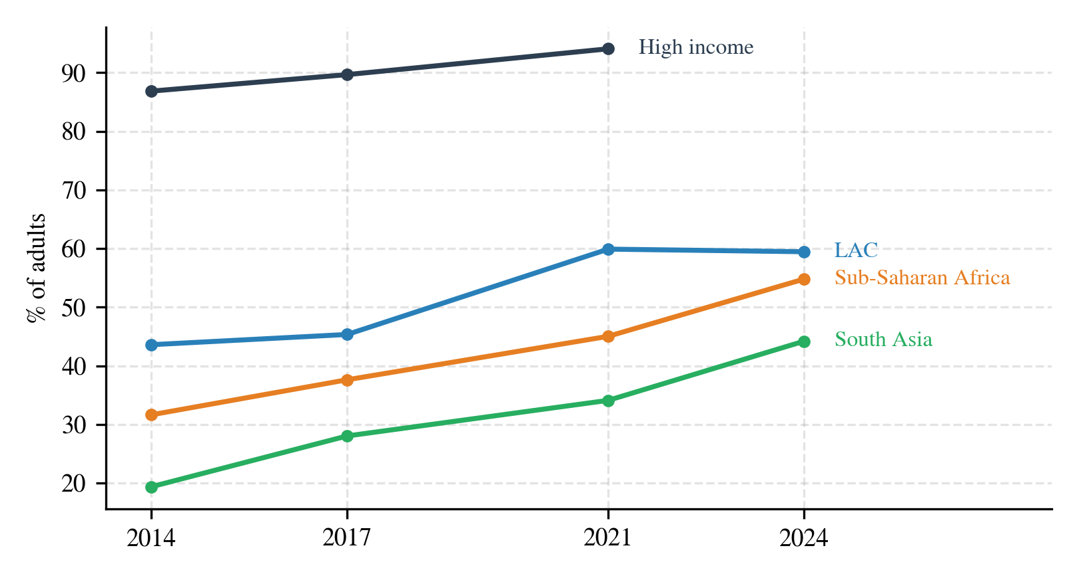
Figure 4. Made or received a digital payment, by region. The high-income line ends in 2021 because the indicator was collected for only 5 of 40 high-income panel economies in 2024. Source: author’s calculations from the Global Findex Database 2025.
The flagship change of the 2025 wave is in saving (Figure 5). Formal saving in developing economies was essentially flat for a decade — 17.6 percent in 2011, 24.3 percent in 2021 — and then jumped to 38.0 percent in 2024, a rise of 13.7 points on the panel (the official aggregate puts it at +16.0 points, to 39.7 percent).
Decomposing the headline definition shows mobile-money accounts contribute 4.3 points of the 2024 level — the saving surge largely travelled on the rails built by the payments expansion. Formal borrowing, by contrast, moved gradually throughout: 15.7 percent in 2014 to 23.2 percent in 2024, rising, not falling (a point that matters in Section 5).
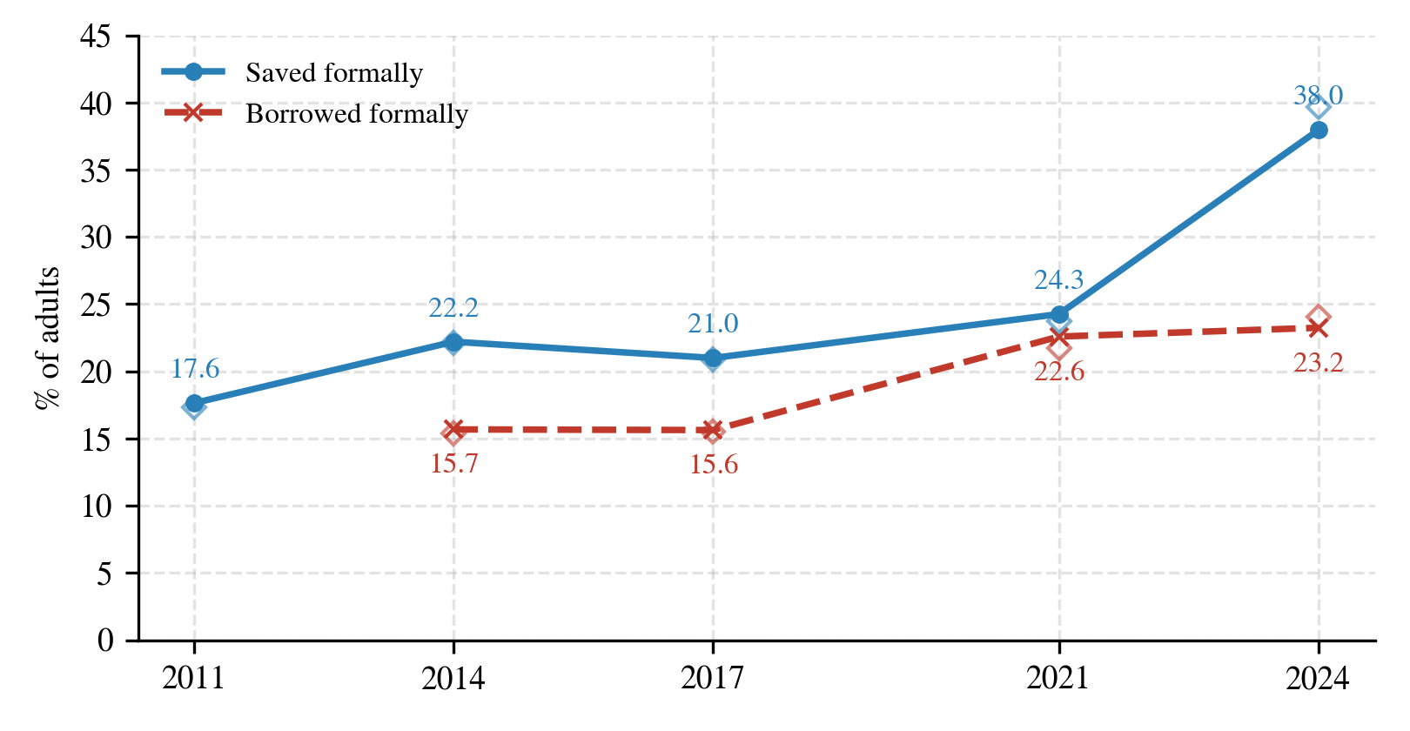
Figure 5. Saved formally and borrowed formally, developing economies. Hollow markers: official aggregates for developing economies. Source: author’s calculations from the Global Findex Database 2025.
Dormancy — the quality check on the access story — peaked at 16.9 percent of account holders in 2017, immediately after the largest account-opening drives, and fell to 8.2 percent by 2024. Newly opened accounts increasingly get used.
4.4. Resilience: the dimension that did not move
The ability to raise emergency funds with at most some difficulty — the survey’s resilience proxy, available for 2021 and 2024 — was broadly flat in developing economies: 54.7 percent of adults in 2021 and 54.5 percent in 2024 on the panel; the official aggregate improves modestly, from 54.4 to 56.4 percent (Figure 6). Either way, roughly 45 percent of adults in developing economies could not comfortably raise emergency funds in 2024. This is the paper’s title in one number: the decade delivered access at scale, but financial security — the outcome access is meant to enable — moved on a much slower clock.
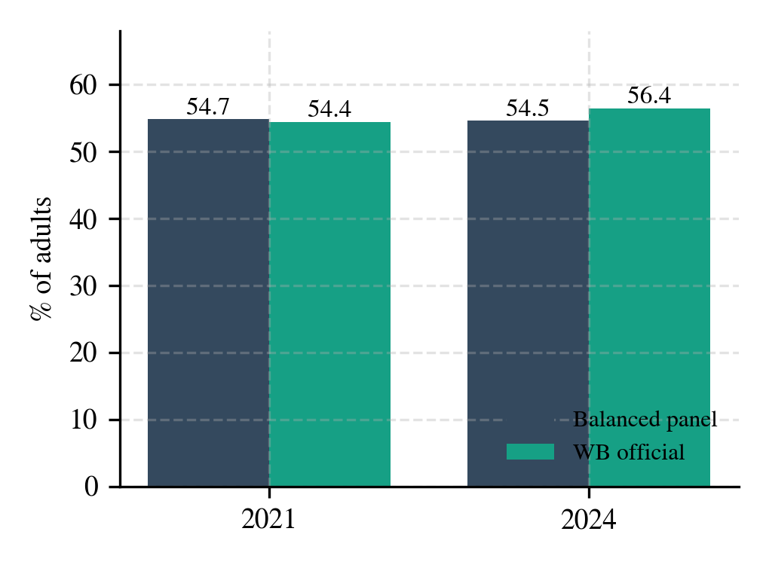
Figure 6. Could raise emergency funds with some or no difficulty, developing economies, 2021 vs. 2024. Source: author’s calculations from the Global Findex Database 2025.
4.5. Who is still left out
The global gender gap in account ownership halved over the period, from 8.8 points in 2011 to 4.0 points in 2024 (Figure 7), with the sharpest narrowing after 2017 as mobile money and mass account-opening programmes reached women outside the banking system.
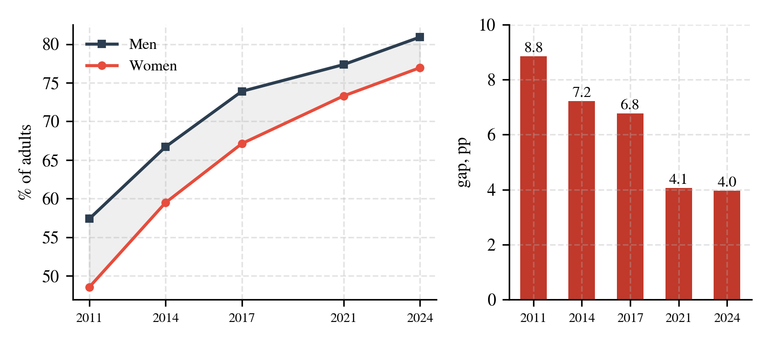
Figure 7. Account ownership by gender (left) and the gender gap in percentage points (right), world. Source: author’s calculations from the Global Findex Database 2025.
The income gap — richest 60 versus poorest 40 percent of households — is consistently wider: 18.2 points in 2011, 10.5 in 2024 (Figure 8). Its path is not monotonic: the unusually narrow 2021 gap (7.6 points) coincides with the COVID-era wave, when emergency government transfers pushed millions of poorer adults into first-time account ownership; part of that convergence receded by 2024. Economic status, not gender, remains the strongest observable predictor of exclusion.
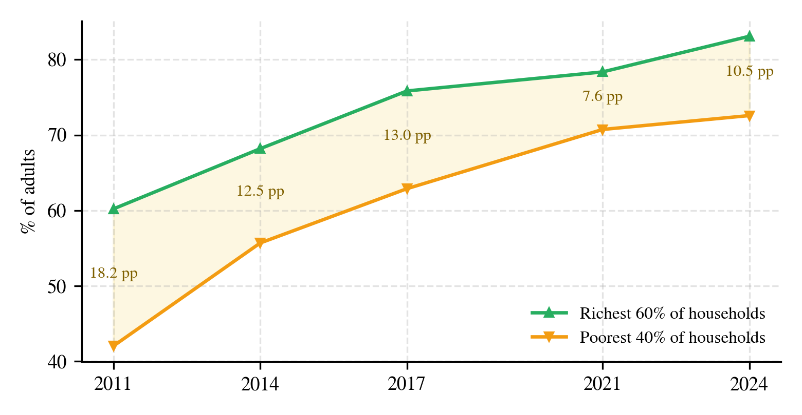
Figure 8. Account ownership by household income group, world. Annotations show the gap in percentage points. Source: author’s calculations from the Global Findex Database 2025.
5. How aggregation pitfalls flip trends
Each pitfall of Section 3.4 is now quantified in isolation — holding everything else correct and toggling one choice — and then in a plausible combination. Table 3 collects the results.
Table 3. Aggregation pitfalls quantified, percent of adults. Isolated pitfalls (P1–P4) toggle one choice; compound rows reproduce plausible naive pipelines. Naive borrowing uses the narrow at-a-financial-institution variant.
Pitfall (indicator used for the demonstration) | Naive estimate | Corrected (panel) | Official aggregate
P1 Disaggregation-row leakage  (emergency funds, developing, 2021→2024) | 53.2 → 52.8 | 54.7 → 54.5 | 54.4 → 56.4
P2 Unbalanced composition  (borrowed formally, developing, 2021→2024) | 21.7 → 22.6 | 22.6 → 23.2 | 21.7 → 24.0
P3 Indicator-variant confusion  (saving, developing, 2021→2024) | 22.5 → 33.7 | 24.3 → 38.0 | 23.7 → 39.7
P4 Coverage-driven missingness  (mobile money, world, 2024) | 28.5 | 17.0 | 16.0
Compound: P1+P2+P4 with global scope  (emergency funds, 2021→2024) | 57.2 → 52.7 | 54.7 → 54.5 | 54.4 → 56.4
Compound: P2+P3 with global scope  (borrowing, 2021→2024) | 27.0 → 21.3 | 22.6 → 23.2 | 21.7 → 24.0

Read individually, the pitfalls look survivable. P1 biases the resilience level by about 1.5 points, because subgroup rows carry the full country weight and minority subgroups with lower financial inclusion are overrepresented relative to their population shares. P2 shifts the borrowing series by roughly a point. P3 understates 2024 saving by 4.3 points — exactly the mobile-money component of the headline definition. P4 is the largest in isolation: averaging only the economies that survey mobile money puts the global figure at 28.5 percent, nearly double the official 16.0 percent, because the surveyed subset is dominated by high-adoption African economies.
The compound rows show why these pitfalls matter beyond level accuracy. Combining the group-row leak with global scope and wave-varying coverage turns flat resilience (54.7 → 54.5) into an apparent four-and-a-half-point decline (57.2 → 52.7) — a spurious finding that invites a ready-made macroeconomic narrative about post-pandemic erosion of household security. Combining composition drift with the narrow borrowing variant turns gradual growth into an apparent six-point fall (27.0 → 21.3): the 2021 full sample contains far more high-income, high-borrowing economies than 2024, so the composite series tracks sample composition, not behaviour. A similar mechanism produces an apparent collapse of high-income digital-payment usage from 92.1 to 71.9 percent when the five reporting economies of 2024 are plotted as if they were the group.
None of these errors survives contact with the file’s own aggregate rows: each naive series deviates from its official counterpart by amounts far exceeding the panel’s 1.5-point benchmark tolerance, and the resilience and borrowing reversals contradict the official direction outright. The practical recommendation is correspondingly simple, and it is a workflow rather than a technique: fix the group slice first; fix the country composition; check which indicator variant the concept requires; count reporting economies before averaging them; and benchmark every series against the embedded official aggregates before interpreting it.
6. Discussion and limitations
The findings are descriptive. Findex is a repeated cross-section of country-level survey aggregates; nothing here identifies the causal effect of access on saving, resilience or anything else. The balanced panel trades a small coverage loss (3.5 percent of the surveyed adult population) for compositional consistency, and its deviation from the official, imputation-based aggregates is bounded at about 1.5 points on the headline indicator, with a known direction. The resilience comparison rests on two waves and a survey question whose framing invites reporting effects; it should be read as “no evidence of improvement at scale” rather than as a precise level. Mobile-money estimates treat non-surveyed economies as zero-adoption; this reproduces the official aggregates but by construction understates whatever marginal adoption exists in non-surveyed markets. Finally, survey mode changed for some economies between 2017 and 2021 (face-to-face to telephone), a comparability caveat the World Bank documents and which applies equally to the official series.
7. Conclusion
Between 2011 and 2024 the world put an account in the hands of nearly two billion adults — the fastest documented expansion of access to a formal financial service. The 2024 wave adds the first genuine usage breakthrough beyond payments: a fourteen-to-sixteen point surge in formal saving in developing economies, carried largely by mobile money. But the dimension that access was meant to secure — the ability to absorb a financial shock — stayed near 55 percent, and the income gap in ownership remains wider than the gender gap. The agenda implied by the data has shifted from opening accounts to deepening their use.
Methodologically, the paper’s message is that the Findex 2025 file is both a hazard and its own remedy. Its stacked disaggregations, embedded aggregates and uneven coverage make sign-flipping aggregation errors easy to produce from individually small mistakes — and its embedded official aggregates make every one of them detectable in a single comparison. Validation against the publisher’s own numbers should be the first step of any analysis built on this database, not an afterthought.
Data and code availability
The Global Findex Database 2025 is published by the World Bank at worldbank.org/globalfindex. All code producing every figure, table and statistic in this paper, together with the analysis notebook, is available at [repository URL].
References
Demirgüç-Kunt, A., and L. Klapper (2012). “Measuring Financial Inclusion: The Global Findex Database.” World Bank Policy Research Working Paper 6025. Washington, DC: World Bank. https://doi.org/10.1596/1813-9450-6025.
Demirgüç-Kunt, A., L. Klapper, D. Singer, and S. Ansar (2022). The Global Findex Database 2021: Financial Inclusion, Digital Payments, and Resilience in the Age of COVID-19. Washington, DC: World Bank. https://doi.org/10.1596/978-1-4648-1897-4.
Herndon, T., M. Ash, and R. Pollin (2014). “Does High Public Debt Consistently Stifle Economic Growth? A Critique of Reinhart and Rogoff.” Cambridge Journal of Economics 38(2): 257–279. https://doi.org/10.1093/cje/bet075.
Klapper, L., D. Singer, L. Starita, and A. Norris (2025). The Global Findex Database 2025: Connectivity and Financial Inclusion in the Digital Economy. Washington, DC: World Bank. https://doi.org/10.1596/978-1-4648-2204-9.
Suri, T., and W. Jack (2016). “The Long-Run Poverty and Gender Impacts of Mobile Money.” Science 354(6317): 1288–1292. https://doi.org/10.1126/science.aah5309.
World Bank (2025). Global Findex Database 2025: Survey Methodology. Washington, DC: World Bank. https://www.worldbank.org/en/publication/globalfindex/methodology.

