

Functional Specification Document

N1GE Java Admin API
Draft

Document  Version | Comments | Date | Author
0.1 | Initial version | 02/21/2006 | André Alefeld, Richard Hierlmeier

Table of Contents
1 Introduction 4
1.1Description 4
2 Project Overview 4
2.1Project aim 4
2.2Project duration 4
2.3Expected benefit 4
2.4Project Dependencies 4
3 System Architecture 5
3.1Enhancement Functions 5
3.2Overall Block Diagram 5
4 Functional Definition 5
4.1Performance 5
4.2Reliability, Availability, Serviceability (RAS) 5
4.3Diagnostics 5
4.4User Experience 5
4.5Manufacturing 5
4.6Quality Assurance 5
4.7Security & Privacy 5
4.8Government Regulatory Compliance 5
4.9Migration Path 6
4.10Documentation 6
4.11Installation 6
4.12Packaging 6
4.13Issues/Risks and Proposed Mitigation 6
5 Component Descriptions 6
5.1N1GE Java Admin API 6
5.1.1Overview 6
5.1.2Functionality 6
5.1.3qmod Operations 8
5.1.4Java Code Samples 8
5.1.5Interfaces 8
5.1.6Other Requirements 8
6 Document History and Approvals 9
7 Appendix – Appendix #1 Name 9

Introduction

Description
Future N1GE releases shall deliver a new browser based UI (BUI) that shall replace the current Motif based graphical user interface (GUI) qmon. The technology chosen to implement this is the Sun Web Console (aka Lockhart) and its underlying technology (JSF, Sun Web Components v 3.0). To offer the full set of administrative operations that are currently available as a C binding or via a set of CLI tools a Java Admin API has to be developed that provides this functionality. The primary goal is to map and improve the current C based implementation of the qmon tool to a Web bases UI. This requires some additional enhancements of the underlying C gdi functions to allow the delegation of a request to a different user than the web component is run. Therefore an extension to authenticate a user against the system or at least a login of the web component at startup to mark it as a trusted component of the N1GE cluster must be delivered. Apart from that the API shall have the ability to connect to different clusters in order to service different clusters through the same administrative UI. These requirements result in an extension to the current GDI protocol in order to transport the needed information to N1GE. On top of these extension JNI wrapper functions are defined that are the basis of the Java class library to be developed. In order to reduce the effort of redoing similar parts again and again the approach is to develop a code generator that takes the information from the existing Cull datamodel and translates it to the needed Java classes and their corresponding JNI counterparts. This approach gives the additional advantage to maintain changes in an highly automated fashion. Although not everything can be made available through this mechanism and the additional time to develop such a converter it proves very useful and easily extensible to provide additional needed tools like junit testing modules.
Parts of JAAPI might be of interest to other development projects like OSPD and SSS too.

Project Overview

Project aim
Deliver a way to perform all administrative tasks via JAAPI. This requires the definition and implementation of a Java class library that provides a complete set of interfaces to the currently available administrative functionality. The targeted scope is to make the current qmon functional feature set available in order to replace qmon with a browser based UI. Furthermore it shall allow to extend it by functionality that is either needed in the context of other development project Haithabu or must cover new developments like Flexible Resource Limits.

Since the JAAPI highly depends on the configuration objects of N1GE we are not targeting a standard implementation of a Grid Admin API. The impact of changes between different versions of JAAPI shall be kept minimal whenever possible.

Project duration

Expected benefit
The benefit is the easy deployment of N1GE administrative functionality within the Java language. It can be seen as a complement to Java DRMAA thereby being of course more strongly bound to the implementation details inherent in N1GE. A general administrative interface definition is not the primary target of JAAPI.
Another goal is the replacements of current CLI based integrations (e.g. N1SM) with JAAPI/DRMAA based integration to deliver a tighter coupling and additional functionality like changing N1GE configuration from within N1SM for example.

Project Dependencies
Flexible Resource Limits introduce additional administrative functionality and might change existing interfaces like qstat -F. Project Haithabu may also introduce several new interfaces that need to be mapped to JAAPI as well. Ideally these interface extensions should be made available via JAAPI if this is achievable in time.
N1SM UI integration is currently completely based on the CLI interfaces and a migration to JAAPI might be seen as well as the development of the qmon BUI as a test of completeness and usefulness of JAAPI.

Table 2.4 – Project dependencies
Available | Supplier | Product Name | Dependency

System Architecture
JAAPI consists of the following modules:
- JAAPI java classes
- shared JNI C library
- authentication mechanism
- customization, configuration and installation scripts
- Javadoc API documentation and examples

Enhancement Functions
- RMI proxy service (reference implementation, not intended for productive use)

Overall Block Diagram

A prototypical sketch of the architecture of the planned WebUI can be seen below:
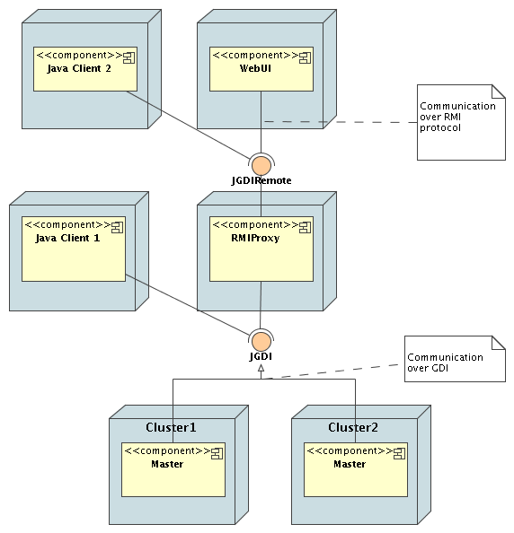

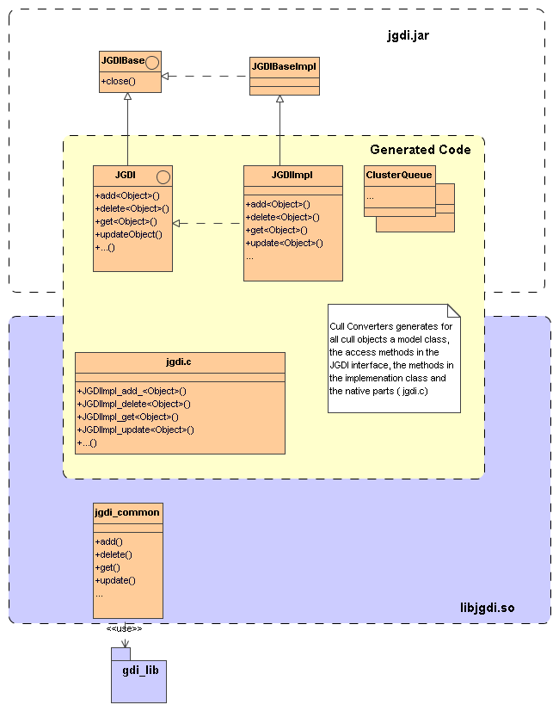
An overview of the internals of the JAAPI is outlined in the following diagram. Further details can be found in the JAAPI javadoc documentation.

Functional Definition

Performance
The performance goals for this release are to deliver a fully functional version that is not notably slower than the current C implementation. In a later phase additional caching mechanisms shall address performance improvements as a goal.

Reliability, Availability, Serviceability (RAS)
High availability can only be inherited from the current N1GE HA implementation. Additional HA aspects that are entered with the RMI proxy are not yet addressed. A possible solution would be an integration of the proxy functionality as a JVM thread of the master. (-> dbwriter)

Diagnostics
Native parts of JAAPI reuse the diagnostic functions of the current implementation. The SGE_DEBUG_LEVEL enviroment variable can be used for tracing errors in the JNI layer. Apart from that standard Java debugging techniques can be used. Errors are translated in Java exceptions wherever possible.

User Experience
This release strives to provide an incremental positive increase in usability of the system in terms of information content and scalability.
JAAPI shall make use of the power of the Java language to facilitate the integration of N1GE admin functionality into 3rd party components.
An optional future enhancement might be a JMX binding of the interfaces to allow integration into standard management applications. Provisioning such a framework is more a decision of what informations to expose to those applications than creating the necessary Java classes. A big part can certainly be generated by adding a new 'JMX generator template' to the conversion framework.

Manufacturing
Vim chainsaw edition ;-) and for those who can memorize the keystrokes Netbeans.

Quality Assurance
- Usual Code reviews
- JUnit tests
- Testsuite integration
- Performance Testing of JAAPI (optional)
- UI integration (as general use case)
- N1SM integration (optional)
Describe different test cases & scenarios

Security & Privacy
Login mechanism to system TBD, RMI Proxy issues, RMI security manager

Government Regulatory Compliance
N1GE 6.1 will comply with all government regulations regarding exported software.
(check security issues -> security mechanisms !!!! )

Migration Path

Documentation
Javadoc API documentation with a set of documented examples shall be delivered.

Installation
Will be added to the current N1GE installation procedure. The mechanism for JAAPI is the same as the one used for DRMAA. If the RMI proxy is a standalone component additional installation steps are required.

Packaging
A similar mechanism as for DRMAA packaging shall be used.

Issues/Risks and Proposed Mitigation

Table 4.16 – Risk and Mitigation List
Category | Risk | Impact  (L/M/H) | Probability  (L/M/H) | Mitigation Plan | Owner
Categories: (e.g. Technical, Market, Schedule, Resource and Financial)
Impact: (L) – Low impact; (M) – Medium impact; (H) – High impact
Probability: (L) – Low probability; (M) – Medium probability; (H) – High probability

Component Descriptions

Cullconv mechanism:
Parser parsed sge_*L.h files and creates a list of N1GE objects and there descriptions in a generic form. From this object list several template files are processed for every object and object specific parts of the API are generated. Most of the existing functionality can be mapped by this procedure. If this is not possible the existing native implementation has been wrapped by implementing JNI adapters.

N1GE Java Admin API

Overview

Functionality
Qconf operations:

Object | Add | Modify | Delete | Show | Show List | Generated
Calendar | -acal  -Acal | -mcal  -Mcal | -dcal | -scal | -scall | x
Checkpoint Environment | -ackpt  -Ackpt | -mckpt  -Mckpt | -dckpt | -sckpt | -sckptl | x
Cluster Queue | -aq  -Aq | -mq  -Mq | -dq | -sq | -sql | x
Parallel Environment | -ap  -Ap | -mp  -Mp | -dp | -sp | -spl | x
Project | -aprj  -Aprj | -mprj  -Mprj | -dprj | -sprj | -sprjl | X, subclassed from UP
Execution Host | -ae  -Ae | -me  -Me | -de | -se | -sel | x
User | -auser  -Auser | -muser  -Muser | -duser | -suser | -suserl | X, subclassed from UP
Hostgroup | -ahgrp  -Ahgrp | -mhgrp  -Mhgrp | -dhgrp | -shgrp  -shgrp_tree  -shgrp_resolved_tree | -shgrpl | x
Userset  (ACL,  Department) | -au  -Au | -mu  -Mu | -du  -dul | -su | -sul | x
Sharetree | -astree  -Astree | -mstree  -Mstree | -dstree | -sstree |  | Not yet implemented
Sharetree Node | -astnode | -mstnode | -dstnode | -sstnode  -rsstnode |  | Not yet implemented
Cluster Configuration | -aconf  -Aconf | -mconf | -dconf | -sconf | -sconfl | Not yet implemeted
Submit Host List | -as |  | -ds | -ss |  | x
Admin Host List | -ah |  | -dh | -sh |  | x
Manager List | -am |  | -dm | -sm |  | X, subclassed from
Operator List | -ao |  | -do | -so
Scheduler Configuration |  | -msconf  -Msconf |  | -ssconf
Complex Attributes |  | -mc |  | -sc
Object Attributes | -aattr  -Aattr | -mattr  -Mattr  -rattr  -Rattr | -dattr  -Dattr |  | -sobjl
Other qconf operations:
- -sep
show licensed processors
- -sds
show detached settings
- -secl
show event client list
- -sss
show scheduler status
- -tsm
trigger scheduler monitoring
- -clearusage
clear sharetree usage
- -kec
kill event client(s)
- -ke(j)
kill execution daemon(s)
- -km
kill master
- -ks
kill scheduler

qmod Operations

Object | Operation
Queue | -d disable queue  -e enable queue  -cq clear Queue error state  -c clear error state  -sq suspend queue  -s suspend queue  -usq unsuspend queue  -us unsuspend queue  -rq reschedule jobs running in queue  -r reschedule jobs running in queue  all options can take the -f force flag
Job | -cj clear Job error state  -c clear error state  -sj suspend job  -s suspend job  -usj unsuspend job  -us unsuspend job  -rj reschedule jobs  -r reschedule jobs  all options can take the -f force flag

Interface Javadoc
http://gridware.germany/~rh150277/jgdi/jaapi.pdf

Java Code Samples
http://gridware.germany/~rh150277/jgdi/example/JGDITest.java

Lifecycle
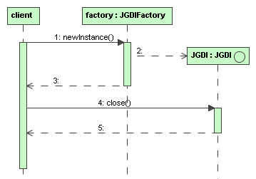

Other Requirements

Document History and Approvals

Table 7 – Document History
Dash | Rev | Date | Description of Change | Originator

Appendix – Timetable

http://gridware.germany/~rh150277/jgdi/todo.pdf

