# Lab Visualizing in Power BI Desktop

In this exercise, you will create visualizations in Power BI Desktop.

## Task 1: Obtain the JDBC connection string to your Azure Databricks cluster

Before you begin, you must first obtain the JDBC connection string to your Azure Databricks cluster.

1. In Azure Databricks, go to Clusters and select your cluster.
2. On the cluster edit page, scroll down and select the JDBC/ODBC tab.
3. On the JDBC/ODBC tab, copy and save the JDBC URL.
   1. Construct the JDBC server address that you will use when you set up your Spark cluster connection in Power BI Desktop.
   2. Take the JDBC URL that you copied and saved in step 3 and do the following:
   3. Replace jdbc:hive2 with https.
   4. Remove everything in the path between the port number and sql, retaining the components indicated by the boxes in the image below.

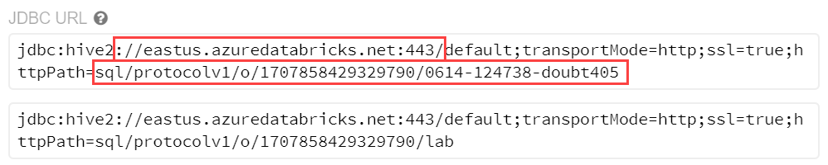

1. In our example, the server address would be:

https://eastus.azuredatabricks.net:443/sql/protocolv1/o/1707858429329790/0614-124738-doubt405 or https://eastus.azuredatabricks.net:443/sql/protocolv1/o/1707858429329790/lab (if you choose the aliased version)

## Task 2: Connect to Azure Databricks using Power BI Desktop

1. Download Power BI Desktop from https://powerbi.microsoft.com/en-us/desktop/
2. When Power BI Desktop starts, you will need to enter your personal information, or Sign in if you already have an account.
3. Select Get data on the screen that is displayed next.
4. Select Other from the side, and select Spark from the list of available data sources.
5. Select Connect.
6. On the next screen, you will be prompted for your Spark cluster information.
   1. Paste the JDBC connection string you constructed a few steps ago into the Server field.
   2. Select the HTTP protocol.
   3. Select DirectQuery for the Data Connectivity mode, and select OK. This option will offload query tasks to the Azure Databricks Spark cluster, providing near-real time querying.
7. Enter your credentials on the next screen as follows:
   1. User name: token
   2. Password: Remember that ADF Access token we generated and asked you to paste in Notepad, that is the password.

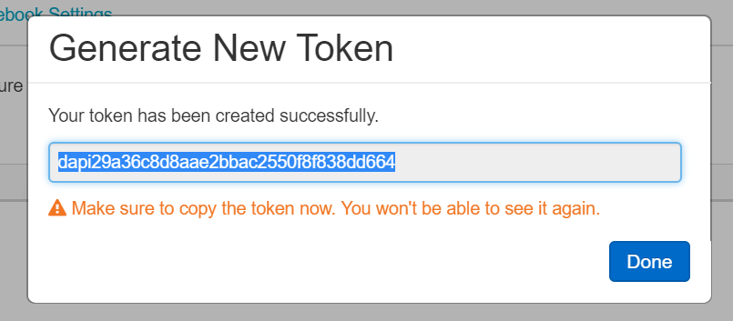

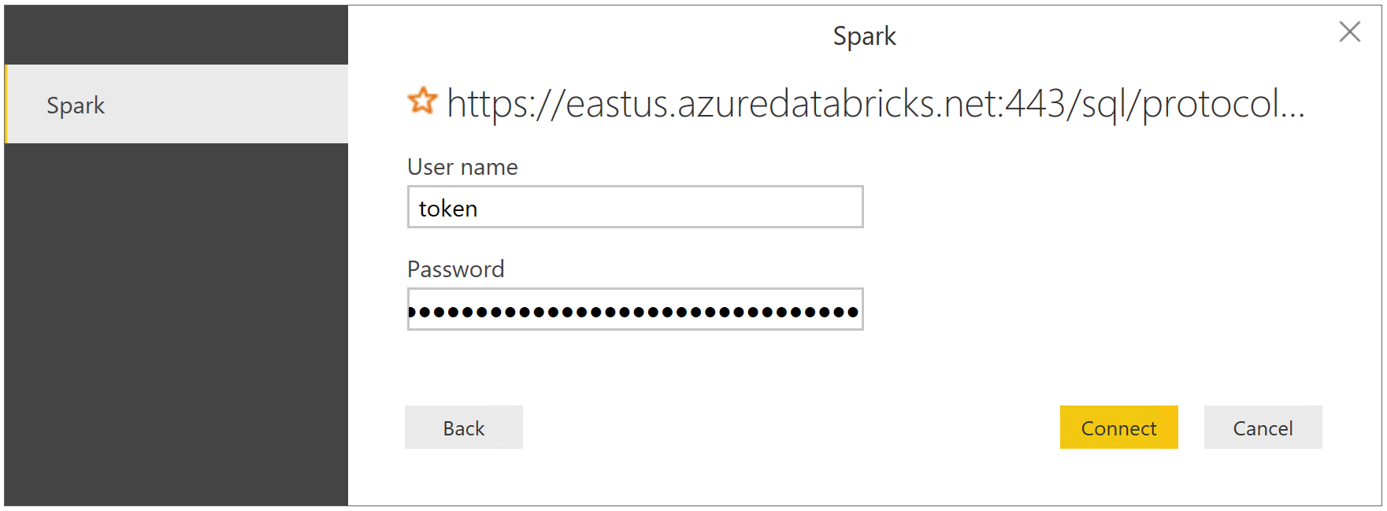

1. Select Connect.
2. In the Navigator dialog, check the box next to flight_delays_summary, and select Load.
3. It will take several minutes for the data to load into the Power BI Desktop client.

## Task 3: Create Power BI report

1. Once the data finishes loading, you will see the fields appear on the far side of the Power BI Desktop client window.
2. From the Visualizations area, next to Fields, select the Globe icon to add a Map visualization to the report design surface.
3. With the Map visualization still selected, drag the OriginLatLong field to the Location field under Visualizations. Then Next, drag the NumDelays field to the Size field under Visualizations.
4. You should now see a map that looks similar to the following (resize and zoom on your map if necessary)

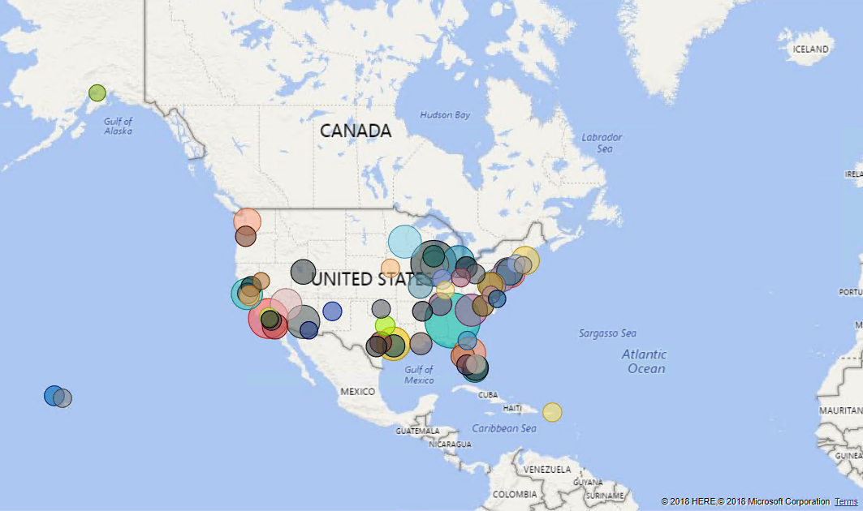

1. Unselect the Map visualization by selecting the white space next to the map in the report area.
2. From the Visualizations area, select the Stacked Column Chart icon to add a bar chart visual to the report's design surface.
3. With the Stacked Column Chart still selected, drag the DayofMonth field and drop it into the Axis field located under Visualizations.
4. Next, drag the NumDelays field over, and drop it into the Value field.
5. Grab the corner of the new Stacked Column Chart visual on the report design surface, and drag it out to make it as wide as the bottom of your report design Surface.
6. Unselect the Stacked Column Chart visual by selecting on the white space next to the map on the design surface.
7. From the Visualizations area, select the Treemap icon to add this visualization to the report.
8. With the Treemap visualization selected, drag the OriginAirportCode field into the Group field under Visualizations.
9. Next, drag the NumDelays field over, and drop it into the Values field.
10. Grab the corner of the Treemap visual on the report design surface, and expand it to fill the area between the map and the side edge of the design surface.
11. You can cross filter any of the visualizations on the report by selecting one of the other visuals within the report, as shown below (This may take a few seconds to change, as the data is loaded).

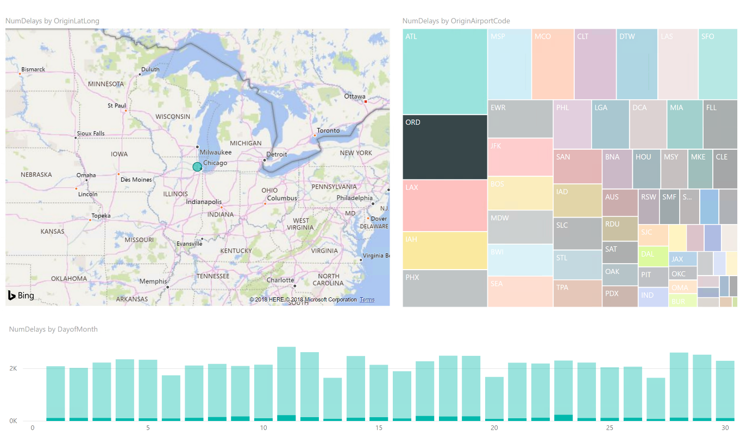

You can save the report, by choosing Save from the File menu, and entering a name and location for the file.