Mistletoe, Friend and Foe: Synthesizing ecosystem implications of mistletoe infection
Anne Griebel ¹, David Watson ², Elise Pendall ¹
¹ Hawkesbury Institute for the Environment, Western Sydney University, Locked Bag 1797, Penrith, NSW, Australia
² Institute for Land, Water and Society, Charles Sturt University, PO box 789, Aulbury, NSW, Australia
Corresponding author: Anne Griebel, email: griebel.anne@gmail.com, telephone: +61 02 4570 1668

Running Head: Mistletoe, Friend and Foe
Keywords: mistletoe, mortality, climate change, biodiversity, disturbance, parasitic plants

Abstract
Biotic disturbances are affecting a wide range of tree species in all climates, and their occurrence is contributing to increasing rates of tree mortality globally. Mistletoe is a widespread group of parasitic plants that establishes long-lasting relationships with a diverse range of host tree species. With climate change, ecophysiological stress is increasing, potentially making trees more susceptible to mistletoe infection, which in turn leads to higher forest mortality rates.
The perception of mistletoe presence in individual trees and forest stands is divided within the scientific community, leading to an ongoing debate regarding its impacts. Forest managers concerned about stand health and carbon sequestration may view mistletoe as a foe that leads to reduced productivity. In contrast, ecologists may see mistletoe as a friend, in light of the wildlife habitat, biodiversity and nutrient cycling it promotes. However, individual studies typically focus on isolated effects of mistletoe presence within their respective research area and lack a balanced, interdisciplinary perspective of mistletoe disturbance.
With this conceptual paper we aim to bring together the positive and negative impacts of mistletoe presence on tree physiology, soil nutrient cycling as well as stand health and stand dynamics. We focus on the role of mistletoe-induced tree mortality in ecosystem succession and biodiversity. In addition, we present potential modifications of mistletoe presence on the energy budget and on forest vulnerability to climate change, which could feed back into stand dynamics and disturbance patterns. Lastly, we will identify the most pressing remaining knowledge gaps and highlight priorities for future research on this widespread agent of biotic disturbance.

Introduction

Background on biotic tree mortality
Forests ecosystems contain 80% of aboveground carbon and 40% of belowground carbon stocks globally (Watson et al 2000) along with the capacity of storing carbon over centuries. Disturbances have the potential to alter ecosystem processes and functioning, yet they are part of the natural cycle of any ecosystem (Kulakowski et al 2017). Climatic induced disturbances, such as heatwaves and droughts, can significantly lower carbon sequestration rates in forests (Yuan et al 2016, Yi et al 2015, Reichstein et al 2013) and cause wide-ranging tree mortality (Kara et al 2017, McDowell et al 2011). Similarly detrimental effects were reported from cyclones and an increase in wildfires as the climate changes (Hutley et al 2013, Schoennagel et al 2017). Furthermore, such climate induced disturbances can weaken ecosystem resilience and alter the occurrence and life-cycle of biotic disturbances such as pest and insect outbreaks (Dukes et al 2009, Johnson et al 2010, Allen et al 2010, Scott and Mathiasen 2012), such as the recent bark beetle outbreaks that affected vast areas across western North America. Beetle-induced stand mortality can compromise atmospheric carbon sequestration rates (Brown et al 2010), but this has not been found in all cases (Reed et al 2014), indicating uncertainty in effects of biotic disturbance on carbon cycling.
While insect attacks and large-scale disturbances like cyclones and wildfires often cause wide-spread stand mortality, the presence of parasitic plants is more subtle in modifying ecosystem processes and stand dynamics. Unlike cyclones and wildfires, which are not necessarily a threat in every climate region, parasitic plants are globally distributed and an integral component of most ecosystems (Mathiasen et al 2008). The relationship between the parasite and the host may reflect mutualism, e.g. vascular epiphytes rely on the structural support of a host plant and in return enhance nutrient cycling by fertilizing the soil with nutrient-enriched litter (Bartels and Chen 2012, March and Watson 2010). The largest group of aerial parasitic plants are mistletoes, which are widespread sap-feeding hemiparasites that portray epiphytic behaviour and belong to the order Santalales (Bell and Adams 2011). Over 1600 species of mistletoes world-wide have developed a remarkable range of adaptations for mimicking various morphological traits specific to their local hosts; at least 20 species are listed as endangered. Because mistletoes are long lived (exceeding 30 years) it can take decades to notice their damaging effect on the host (Figure 1). The potential positive effects of mistletoe infestation arise at the ecosystem scale, such as their ability to boost biodiversity, which has sparked a debate about the role of mistletoes as keystone species and ecosystem engineers (Press and Phoenix 2005, Hatcher et al 2012, Watson and Herring 2012).
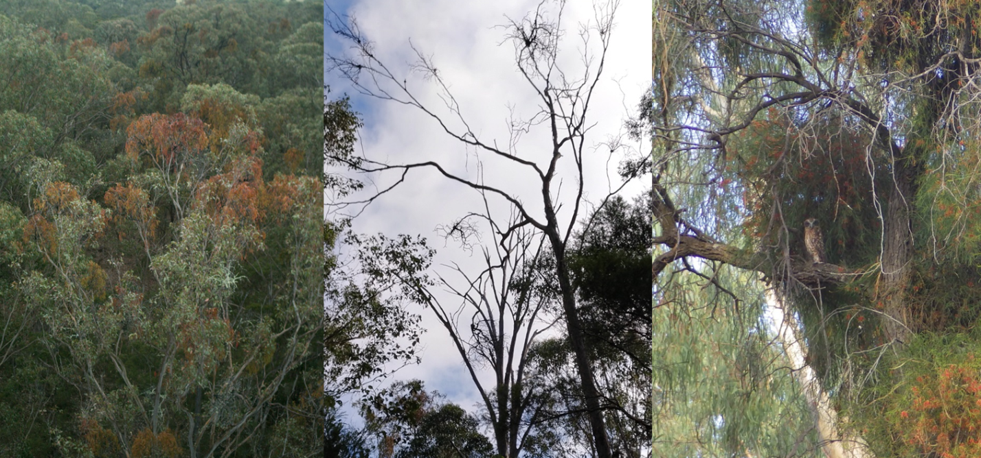
Figure 1. Mistletoe being friend and foe lies in the eye of the beholder. Left: Areal view of a eucalypt stand that is infected with mistletoe (Amyema miquelii; mistletoe brooms are easily distinguished by their red coloured leaves); center: Dead infected trees with the typical establishment of mistletoe brooms expanding from the club-shaped haustoria at the terminal branches; right: An immature Boobook Owl (Ninox novaeseelandiae) roosting in a mistletoe-infected Acacia on a hot (45 °C) day in southern Australia. With their high water content and densely-branched habit, mistletoe clumps represent a more moderate microclimate used by many animals seeking shelter. (Photographs left and center by Anne Griebel, right by Skye Wassens; used with permission).

Mistletoe amplifies tree mortality
Mistletoe abundance has been increasing within existing distributions (Dobbertin and Rigling 2006, Bowen et al 2009, Turner and Smith 2016), and exacerbation in climatic stress in the form of prolonged droughts has amplified tree mortality rates in mistletoe infected forests (Way 2011, Dobbertin and Rigling 2006, Kolb et al 2016, Mutlu et al 2016, Sangüesa-Barreda et al 2012, Mathiasen et al 1990). Future climate change is projected to increase the likelihood, frequency and duration of droughts in many ecosystems (Collins et al 2013), so we must understand the physiological causes, the amplifying role of biotic agents on ecosystem processes and the resulting consequences of this trend (McDowell et al 2011). This is increasingly complex as parasitic infection on its own is rarely lethal; rather, a combination of multiple stress factors exaggerates stand mortality rates. Tree mortality after extreme droughts typically indicates that cavitation is the predominant process causing mortality, while native trees in hot and arid climates (such as Australia) are more adapted to drought so that carbon starvation following stomatal regulation might contribute to tree death during prolonged droughts. This is a long-standing debate (McDowell et al 2008, Sala et al 2010, Sevanto et al 2014), and the parasitic and unregulated water use of mistletoes will likely contribute to both processes at its host: exaggerating vessel cavitation that might ultimately result in failure of the hydraulic transport system, as well as provoking carbon starvation by limiting carbon availability on multiple pathways (see section 2). These include i) the acquisition of heterotrophic carbon from the host, ii) restriction of photosynthetic carbon gain through inducing increased stomatal regulation and iii) the combined effects of both such that failures in the hydraulic system might impair carbon transport from storage reserves. However, most process-based research focused predominantly on the functional understanding of parasite infection on the leaf-level scale (e.g. Bell and Adams 2011, Mathiasen et al 2008), and we are just starting to recognize the multifunctional role of mistletoe in communities and ecosystems (e.g. Hatcher et al 2012, Watson 2001, Press and Phoenix 2005). A holistic view on mistletoe infection is often missing, as we are still limited in our ability of scaling functional relationships to the ecosystem level and in understanding how changes in functional relationships are regulating biodiversity. Thus, the role of mistletoe as a friend or foe depends on the respective research focus, so we consider it necessary to reconcile mistletoe infestation in a holistic approach to assess ecosystem and biodiversity consequences under a changing climate.

Modifications of leaf-to-ecosystem functioning through mistletoe infestation
Mistletoes have been studied across a large range of ecosystems (see e.g. Mathiasen et al 2008, Bell and Adams 2011), and the process of host infection is similar for all mistletoes: the mistletoe attaches to a branch, forming a haustorium, and taps into the xylem of the host tree. When mistletoes are well established they can significantly modify the functional processes of the host tree; the links between the carbon, nutrient, water and energy cycles are conceptualized in Figure 2.
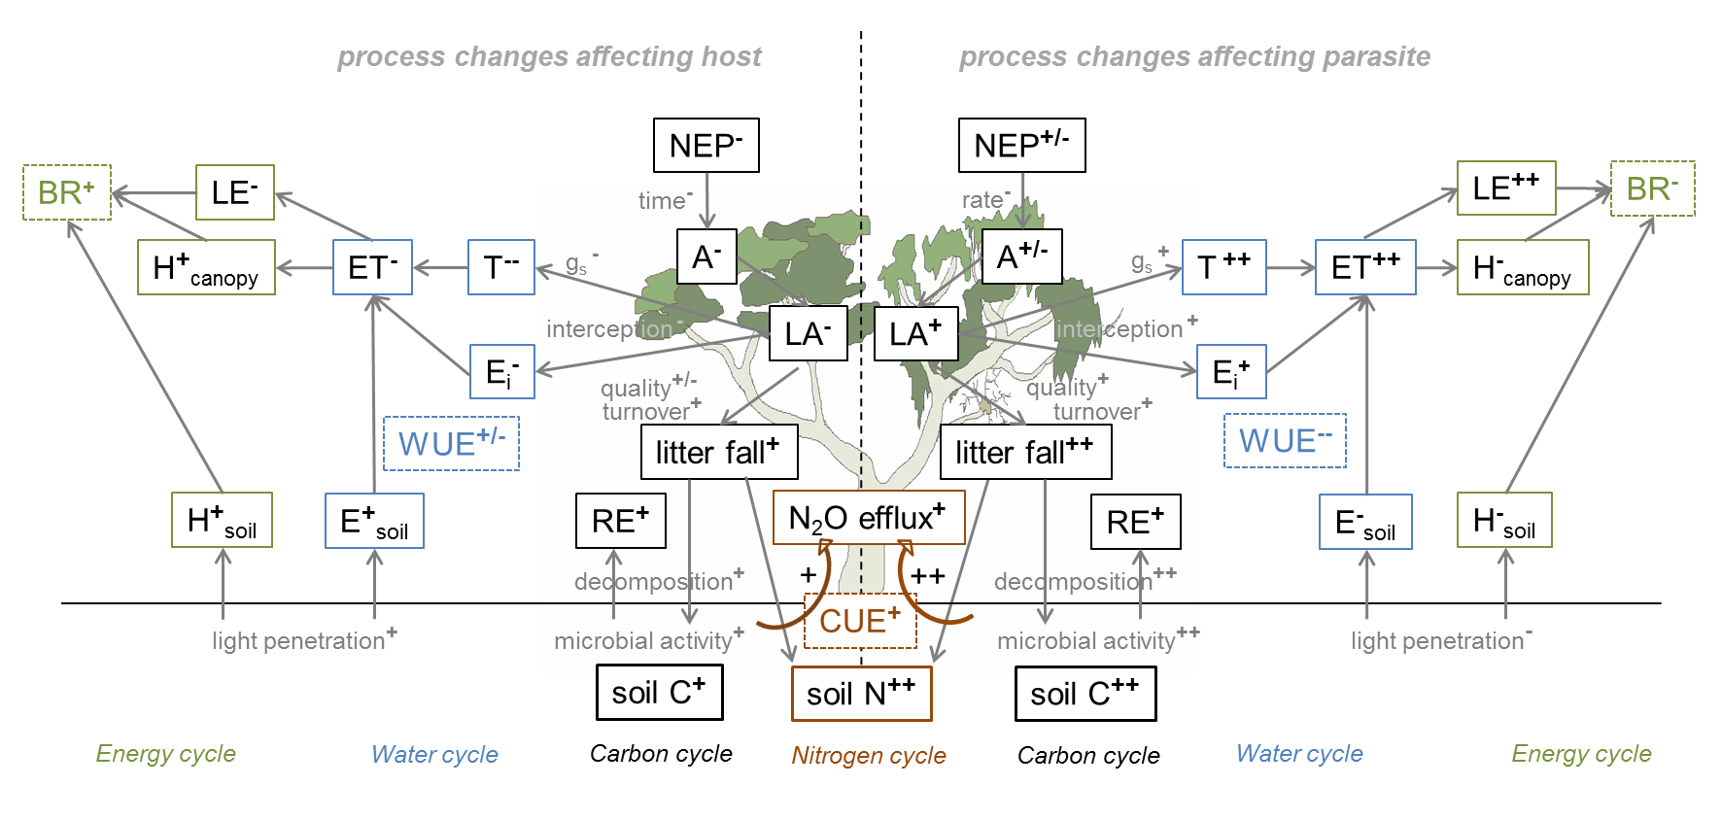
Figure 2. Comparison between the modification of functional relationships of the parasite and a eucalypt host and how these affect the nitrogen, carbon, water and energy cycles. Plus symbols (+) indicate increases and minus symbols (-) indicate decreases in pools or fluxes. Note that this figure is a simplification to conceptualize the process changes at the host (left side) and at the parasite (right side) of a moderately infested tree with ca. 50% parasite and 50% host foliage remaining, while in reality the mistletoe brooms will be mixed within the host's canopy. Abbreviations are as follows: NEP=Net ecosystem productivity, A=Assimilation, gs=Stomatal conductance, RE=Ecosystem respiration, E=Evaporation, T=Transpiration, E_{i}=Interception loss, ET=Evapotranspiration, H=Sensible heat flux, LE=Latent heat flux, BR=Bowen ratio, CUE=Carbon use efficiency, WUE=Water use efficiency.

Carbon and nitrogen cycling
Among the most obvious effects on mistletoe infected stands are reductions in stand basal area and stand volume, which are the result of retarded growth rates of infected trees (Carnegie et al 2009, Reid et al 1994, Sangüesa-Barreda et al 2012). While mistletoe leaves are capable of photosynthesizing and producing basic sugars, they have typically lower photosynthesis rates than their hosts, and many acquire large amounts of heterotrophic carbon from the host phloem sap to allow expansion of the mistletoe leaf area (Lamont 1983, Matsubara et al 2002, Marshall et al 1994, Mathiasen et al 2008). This reduces carbon availability for the host tree, which is typically compensated with reduced growth rates and reductions in host leaf biomass (Raftoyannis et al 2015, Meinzer et al 2004, Agne et al 2014, Rigling et al 2010). Such degradations of the host canopy will further reduce carbon assimilation rates and deplete the non-structural carbohydrate reserves of the host tree (Yan et al 2016, Rigling et al 2010).
Because of their fast growth rates and short leaf lifespan (Reid and Stafford Smith 2000, March and Watson 2007), mistletoes also deprive the host of its nutrients which accumulate in the parasite leaves (Galiano et al 2011, March and Watson 2010). However, an increase in nutrient-rich mistletoe litter deposition has a fertilization effect on the soil by enhancing decomposition rates through high-quality substrate provision that increases microbial activity and microbial community size (March and Watson 2007, Mellado et al 2016). This, in combination with increased light penetration, increases soil carbon and nitrogen cycling and may boost productivity by increasing understory species richness (March and Watson 2007, Watson 2009). We speculate that mistletoe infection may enhance microbial carbon use efficiency (CUE) and lead to increases in soil respiration through either increased light penetration (host) or increased microbial activity (parasite; Figure 2).

Water and energy cycling
In order to acquire carbon, water and nutrients from the host, mistletoe leaves generally maintain lower xylem water potentials than host leaves (Ehleringer et al 1985, Pate 2001, Strong and Bannister 2002). To achieve this mistletoes increase their stomatal conductance and maintain higher transpiration rates than the host leaves (Canyon and Hill 1997, Cernusak et al 2004, Marshall et al 1994, Davidson et al 1989). Continuous sap-flow measurements in Pinus sylvestris trees revealed that the host trees compensate for the additional water loss by reducing host transpiration rates via stomatal regulation (Zweifel et al 2012). Thus, along with reduced photosynthetic rates of the parasite, this results in a markedly decreased water use efficiency (WUE) of mistletoes compared to their hosts (Davidson and Pate 1992, Sangüesa-Barreda et al 2013, Miller et al 2003, Küppers et al 1992). Changes in transpiration rates will likely outweigh changes in soil evaporation rates, which may accelerate with increasing light penetration, or decrease with the built up of mistletoe leaf litter. Thus, evapotranspiration is expected to increase with mistletoe infestation but to decrease from the host tree perspective (Figure 2).
Furthermore, modifications in the water cycle with parasite infection will ultimately alter the energy balance, since reductions in latent heat flux are counteracted by increases in sensible heat flux. Thus, we anticipate that mistletoe infection will decrease the Bowen ratio due to the inherent and above-mentioned parasitic traits, and to increase it through modification of the functional processes of the host tree.

Temporal modifications of ecosystem processes through mistletoe infestation
Mistletoe infection is a dynamic process that continuously modifies stand dynamics over time with progressively increasing infection rates, potentially leading to increases in tree mortality. The process changes during the parasitic life cycle and their impacts from branch to stand dynamics are summarized in Figure 3.
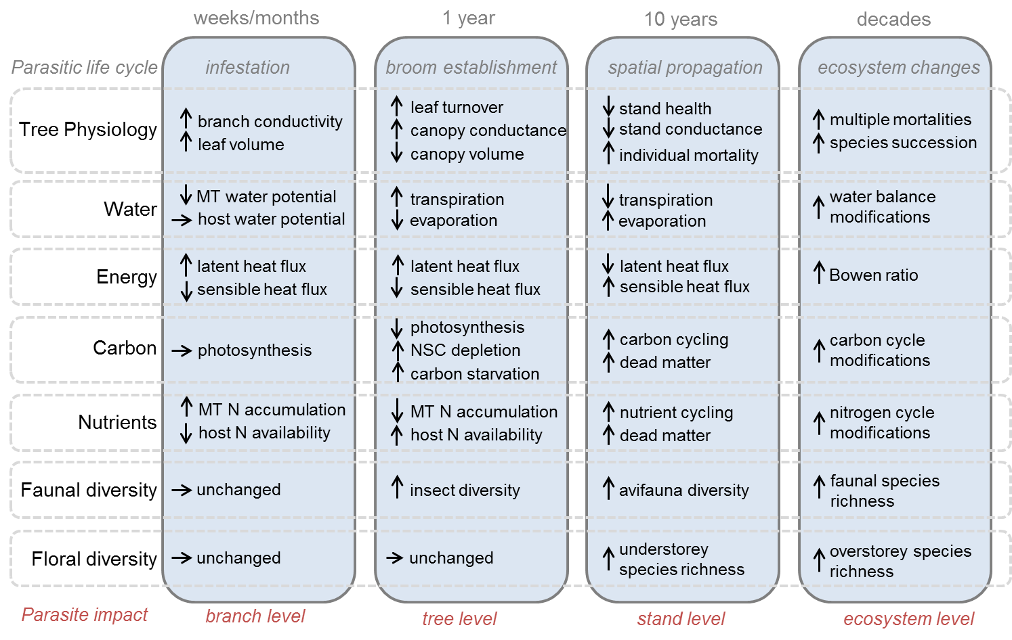
Figure 3. Conceptual figure indicating the temporal dynamics of mistletoe infection from the branch to the ecosystem level with a focus on tree physiology, matter and energy fluxes, and floral and faunal diversity.
At first the effects of parasite establishment are limited to individual branches, where germination and early growth of the mistletoe seedling increases branch leaf volume through the addition of mistletoe leaves. The mistletoe leaves increase the host's branch conductivity and lower their water potential to maintain high transpiration rates and to accumulate water, carbon and nutrients from the host. The increase in branch transpiration results in a marginal increase in latent energy flux, along with a marginal decrease in sensible heat flux through increased shading from the mistletoe leaf area.
The parasitic life cycle is optimized for longevity. The mistletoe broom is well established and flowering about a year after infection, while diameters can exceed a meter within the first couple of years (Reid and Stafford Smith 2000, Carnegie et al 2009). Mistletoe dispersers (typically birds, see biodiversity section) will distribute the seeds within the tree and to neighbouring trees (Ward and Paton 2007, MacRaild et al 2010). Increasing the mistletoe load on individual trees will start to show notable effects on the host tree after a few years, as described in Figure 2. These can be detrimental for young trees, which due to their small canopy volume seem especially vulnerable to mistletoe infection (Carnegie et al 2009). At this early infection stage initial impacts on biodiversity can be noted, as the mistletoe brooms provide favourable nesting sites and food resources for woodland dependent species (Watson 2002, Napier et al 2014, Barea 2008, Cooney and Watson 2005).
Within the next decade, seed dispersers spread the infection from highly infested individuals across the stand (Ward and Paton 2007). At this time step highly infected trees lose vigour, as the canopies increasingly show signs of degradation (Raftoyannis et al 2015, Meinzer et al 2004). The reduction in live canopy area leads to a reduction in stand transpiration rates and an increase in soil evaporation through increased light penetration. Likewise, partitioning of available energy transitions from latent heat flux towards sensible heat flux. The increase in nutrient cycling and light availability enhances floral biodiversity, while faunal diversity is enhanced through the increased availability of mistletoe fruits and shelter (Cooney and Watson 2005, Watson 2009, Bowen et al 2009).
On time scales of 10 years or more, stands lose resilience and infection rates within localized pockets can reach high enough levels to increase individual tree and stand mortality rates if the unregulated water use during adverse climate conditions cause excessive water stress on the host tree (Carnegie et al 2009, Dobbertin and Rigling 2006, Scott and Mathiasen 2012, Zweifel et al 2012). Multiple tree deaths can potentially modify the water and energy balance to a point that successional and stand dynamics are affected. Mistletoes are predominantly present on dominant and codominant trees (Worrall et al 2005, Agne et al 2014), which initiates highly localised gaps after affected trees die. However, these small gaps can decrease tree competition through natural thinning in the long term (Millar et al 2007). In addition, an increase in gap distribution typically has positive impacts on biodiversity, and in recent years the role of parasitic plants as ecosystem engineers is increasingly being acknowledged (Hatcher et al 2012).

Mistletoe increases biodiversity
Although representing a minor canopy constituent in terms of abundance and biomass, mistletoe contributes disproportionately to species richness, community composition and overall ecosystem function. These effects arise from augmented resource provision (nectar, fruit and foliage), increased structural complexity (associated with the growth habit of the mistletoe itself and/or changes to morphology of infected hosts and canopy architecture at tree and stand scales), and subsidies to food webs from increased rate of enriched litter-fall and altered litter inputs from infected hosts at the stand scale. Having synthesized recent work documenting these three classes of direct effects, we review additional research quantifying interactive and indirect effects of mistletoe on biodiversity emphasising how the influence of mistletoe may intersect with climate change.
As semi-succulent plants with few structural and chemical defenses reliant on animal pollinators and seed dispersers, mistletoes are an important food source for many animals (Mathiasen et al 2008, Watson 2001). Like other parasitic plants, mistletoe tissues characteristically contain higher nitrogen, phosphorus and potassium concentrations than their hosts (March and Watson 2010, Mellado et al 2016), and are preferentially browsed by many herbivores (Shaw et al 2004, Canyon and Hill 1997). Browsing herbivores may constrain mistletoe abundance, either by nipping off growing stems or, in the case of elephants and rhinoceros, removing entire plants (Watson 2001). Likewise, individual animals adjust their movements, diets, territories and breeding sites relative to mistletoe abundance and phenology, culminating in consistently close relationships between mistletoe occurrence and faunal species richness (Barea 2008, Bowen et al 2009, Watson 2016). Heavily-infected hosts may be actively defended, both as a food resource (Barea and Watson 2007) but also as a reliable source of water (Walsberg 1977), especially in arid areas where standing water may be unavailable seasonally. Although most research has focused on vertebrates, a large number of arthropod groups have been found associating with mistletoe (Anderson and Braby 2009, Burns et al 2015), both as pollinators and specialist herbivores, with one recent study (Fadini et al 2014) documenting a three way interaction between a beetle that selectively predated mistletoe seeds on one of several potential host species, constraining host range post-dispersal.
Most mistletoe lineages have a densely-branched growth habit (known as witches' brooms), representing distinct structural elements in forest canopies that are used by many animals for shelter, roosting, nesting, hibernating or hiding from predators. This increased structural heterogeneity coupled with the high water content of mistletoe tissues generates a distinct microclimate, and Cooney (2004) (see also Cooney and Watson (2005); Ndagurwa et al (2016)) demonstrated within various locations of a woodland canopy that mistletoes were consistently more humid and cooler than comparable sites within Eucalypt foliage, differences in both temperate and humidity becoming greater as ambient temperatures increased. As well as safe places to raise young, nocturnal animals with lower tolerances to high temperatures seek out mistletoes and mistletoe infected trees for nesting (e.g., Rockweit et al (2012)) and shelter during hot weather (Figure 1). Even dead mistletoes represent important structural elements for forest and woodland animals, with branch mortality and eventual loss an important mechanism for hollow development. In some systems where mistletoe-induced host mortality drives successional change in even-age stands (Shaw et al 2004, Mellado et al 2016), “mistletoes constitute a disrupting force of the frequently assumed equilibrium dominating late stages of ecological succession, where the parasite follows a different successional trajectory from that of the non-parasitized matrix, increasing landscape heterogeneity in space and time” (Mellado and Zamora, in press).
As with other parasitic plants, mistletoe generate large amounts of enriched litter, precipitating a cascading series of facilitative interactions beneath infected hosts. Convergent findings in Australian eucalypt woodlands, African acacia savannah and European pine forests suggest a generalized role of mistletoes as facilitators (reviewed by Watson (2016)). In addition to re-allocating nutrients from infected hosts and shedding litter over a longer duration, the addition of mistletoe litter accelerates decomposition of recalcitrant host litter, thereby boosting nutrient availability. These effects have been noted in epigeic arthropods (Ndagurwa et al 2014), understorey plants (March and Watson 2010), seedling growth (Mellado and Zamora, in press), and fungal diversity (Mueller and Gehring 2006).
While these three classes of interactions are often studied in parallel, they interact at multiple scales to catalyse successional change and increase the quality of forested habitats for a wide range of biota. The most clear-cut example of these effects is a patch-scale removal experiment that compared eucalypt woodlands before and after all mistletoes were removed relative to a set of otherwise comparable woodlands with either no mistletoe or representative mistletoe abundances (Watson and Herring 2012). Three years after mistletoes were removed from woodland canopies, the richness and incidence of birds decreased by up to 36%, treatment effects most pronounced for ground-foraging insectivores (Watson 2015). While some of these losses arose from local extirpations post removal, most of the experimental effect was due to interactions with a severe drought that coincided with the removal phase of the experiment. Once drought conditions ameliorated, those control woodlands (with mistletoe) rebounded, receiving more than twice the proportion of woodland-dependent species and ground foraging insectivores than treatment woodlands (with no mistletoe; Watson (2015)). This complex interaction between mistletoe occurrence and climatic variation provides direct support for Watson’s (2001) hypothesis that mistletoe buffers the effects of drought and other stochastic events, increased provision of a suite of limiting resources increasing community resilience.

Priorities for future research
We synthesized how mistletoe infection typically modifies the functional processes of its host tree and how mistletoe infection affects stand dynamics, species occurrence and animal behaviour with time. We highlighted recently established links between a global increase in tree mortality rates following mistletoe infection and prolonged drought, which is anticipated to worsen in many ecosystems under the predicted changes in climate. Nonetheless, parasite induced tree mortality rarely damages the entire stand, but rather initiates localized gaps that have positive effects for floral and faunal biodiversity, leading to a positive perception of mistletoe parasites as ecosystem engineers. Next, we highlight the most promising approaches to monitor and manage infected stands and conclude with suggestions for future research that examines the link between mistletoe infection and tree mortality.

Promising monitoring and management approaches
Monitoring of mistletoe populations and population dynamics remains tedious and labour intensive, as it predominantly relies on manual inventories (Carnegie et al 2009, MacRaild et al 2010, Turner and Smith 2016). Remote sensing techniques such as combining hyperspectral imaging spectrometry with LiDAR or airborne surveys might allow mapping of distributions on the landscape level, if mistletoe leaves differ notably in their properties from host leaves (Barbosa et al 2016, Ancic et al 2013, Figure 1). However, these landscape-scale assessments of mistletoe mapping are still in development, and although these approaches are promising, they require significantly more testing across a larger range of ecosystems. Another approach might be the use of targeted models that either predict the host range and distribution of mistletoe colonies or the distribution patterns of seed dispersers. The prediction of future population dynamics might then allow for planning and implementing of targeted and timely management strategies to control the distribution of the mistletoe population (Watson et al 2017).
The contrasting perception of mistletoe as either friend or foe is also reflected in highly contrasting management approaches. Selective removal of mistletoe clumps is still practiced widely in heavily infested stands, where a once-off removal can benefit stand productivity for over a decade (Maffei et al 2016). Fungi can act as a successful biological control agent for mistletoe (Varga et al 2012, Reid and Shamoun (2009)), and prescribed burning or wildfires in Australia act as a successful natural control agent (Shaw et al 2004, Start 2011, 2013, 2015). However, the role of mistletoe as a keystone species has been increasingly acknowledged (Watson 2016), and mistletoes are now also managed for conservation biodiversity in some regions of the world (Norton and Reid 1997). Whether the goal is to suppress or promote mistletoe infection, attacking the causes of over-proportional mistletoe distribution might allow for longer-term solutions. This could be achieved through implementing environmental planning strategies that reduce land degradation and thus increase wildlife and natural enemies, or to identify and plant infection-resistant host species in order to contain the spatial distribution through seed dispersers (Norton and Reid 1997, MacRaild et al 2010).

Remaining knowledge gaps
The link between parasitic infection and increased mortality rates is well established and the modifications of host processes following mistletoe infection are increasingly well understood. However, we are still limited in identifying the critical mechanisms that link parasite infection and tree mortality rates. This is increasingly complex due to the combination of multiple stress factors, since climate change and mistletoe infection can exaggerate stand mortality rates individually and in combination. Within recent years, a number of studies demonstrated a clear link between parasite infection and prolonged drought on increasing tree mortality rates, but it remains unresolved whether hydraulic failure, carbon starvation or a combination of both processes are amplifying mortality rates. Hence, it will be essential to design targeted studies that focus on deciphering and quantifying these pathways and to identify critical thresholds that cause trees to die as projections of increasing climatic stress on most ecosystems will likely increase mortality rates of infected stands. In addition, it will be critical to improve our capabilities of automated spatial mapping and ongoing monitoring of stand health dynamics to enable targeted management strategies and to identify the onset of potential large-scale mortality events as early as possible.

References
Agne M C, Shaw D C, Woolley T J and Queijeiro-Bolaños M E 2014 Effects of dwarf mistletoe on stand structure of lodgepole pine forests 21-28 years post-mountain pine beetle epidemic in central Oregon PloS one 9 e107532
Allen C D, Macalady A K, Chenchouni H, Bachelet D, McDowell N, Vennetier M, Kitzberger T, Rigling A, Breshears D D, Hogg E H, Gonzalez P, Fensham R, Zhang Z, Castro J, Demidova N, Lim J H, Allard G, Running S W, Semerci A and Cobb N 2010 A global overview of drought and heat-induced tree mortality reveals emerging climate change risks for forests Forest Ecology and Management 259 660–84
Ancic M, Pernar R, Bajic M, Seletkovic A and Kolic J 2013 Detecting mistletoe infestation on silver fir using hyperspectral images iForest - Biogeosciences and Forestry 7 85–91
Anderson S J and Braby M F 2009 Invertebrate diversity associated with tropical mistletoe in a suburban landscape from northern Australia Northern Territory Naturalist 21 2-23
Barbosa J M, Sebastian-Gonzalez E, Asner G P, Knapp D E, Anderson C, Martin R E and Dirzo R 2016 Hemiparasite-host plant interactions in a fragmented landscape assessed via imaging spectroscopy and lidar Ecological Applications 26 55–66
Barea L P and Watson D M 2007 Temporal variation in food resources determines onset of breeding in an Australian mistletoe specialist Emu 107 203–9
Barea L P 2008 Nest-site selection by the painted honeyeater (Grantiella picta), a mistletoe specialist Emu 108 213–20
Bartels S F and Chen H Y H 2012 Mechanisms regulating epiphytic plant diversity Critical Reviews in Plant Sciences 31 391–400
Bell T L and Adams M A 2011 Attack on all fronts: Functional relationships between aerial and root parasitic plants and their woody hosts and consequences for ecosystems Tree Physiology 31 3–15
Bowen M E, McAlpine C A, House A P N and Smith G C 2009 Agricultural landscape modification increases the abundance of an important food resource: Mistletoes, birds and brigalow Biological Conservation 142 122–33
Brown M, Black T, Nesic Z, Foord V, Spittlehouse D, Fredeen A, Grant N, Burton P and Trofymow J 2010 Impact of mountain pine beetle on the net ecosystem production of lodgepole pine stands in British Columbia Agricultural and Forest Meteorology 150 254–64
Burns A E, Taylor G S, Watson D M and Cunningham S A 2015 Diversity and host specificity of Psylloidea (Hemiptera) inhabiting box mistletoe, Amyema miquelii (Loranthaceae) and three of its host Eucalyptus species Austral Entomology 54 306–14
Canyon D V and Hill C J 1997 Mistletoe host-resemblance: A study of herbivory, nitrogen and moisture in two Australian mistletoes and their host trees Australian Journal of Ecology 22 395–403
Carnegie A J, Bi H Q, Arnold S, Li Y and Binns D 2009 Distribution, host preference, and impact of parasitic mistletoes (Loranthaceae) in young eucalypt plantations in New South Wales, Australia Botany-Botanique 87 49–63
Cernusak L A, Pate J S and Farquhar G D 2004 Oxygen and carbon isotope composition of parasitic plants and their hosts in southwestern Australia Oecologia 139 199–213
Collins M, Knutti R, Arblaster J, Dufresne J-L, Fichefet T, Friedlingstein P, Gao X, Gutowski W, Johns T, Krinner G, Shongwe M, Tebaldi C, Weaver A and Wehner M 2013 Long-term climate change: Projections, commitments and irreversibility Climate change 2013: The physical science basis. contribution of working group i to the fifth assessment report of the intergovernmental panel on climate change ed T Stocker, D Qin, G-K Plattner, M Tignor, S Allen, J Boschung, A Nauels, Y Xia, V Bex and P Midgley (Cambridge, United Kingdom; New York, NY, USA: Cambridge University Press) pp 1029–136
Cooney S 2004 Why do birds nest in mistletoe? An experimental investigation. Honours Thesis, School of Environmental and Information Sciences, Charles Sturt University.
Cooney S J N and Watson D M 2005 Diamond firetails (Stagonopleura guttata) preferentially nest in mistletoe Emu 105 317–22
Davidson N J, True K C and Pate J S 1989 Water relations of the parasite - host relationship between the mistletoe Amyema-linophyllum (fenzl) Tieghem and Casuarina-obesa Miq Oecologia 80 321–30
Davidson N J and Pate J S 1992 Water relations of the mistletoe Amyema-fitzgeraldii and its host Acacia-acuminata Journal of Experimental Botany 43 1549–55
Dobbertin M and Rigling A 2006 Pine mistletoe (Viscum album ssp austriacum) contributes to scots pine (Pinus sylvestris) mortality in the Rhone valley of Switzerland Forest Pathology 36 309–22
Dukes J S, Pontius J, Orwig D, Garnas J R, Rodgers V L, Brazee N, Cooke B, Theoharides K A, Stange E E, Harrington R, Ehrenfeld J, Gurevitch J, Lerdau M, Stinson K, Wick R and Ayres M 2009 Responses of insect pests, pathogens, and invasive plant species to climate change in the forests of northeastern North America: What can we predict? Canadian Journal of Forest Research-Revue Canadienne De Recherche Forestiere 39 231–48
Ehleringer J R, Schulze E D, Ziegler H, Lange O L, Farquhar G D and Cowar I R 1985 Xylem-tapping mistletoes - water or nutrient parasites Science 227 1479–81
Fadini R F, Mellado A and Ghizoni L P 2014 A host creates an enemy-free space for mistletoes by reducing seed predation caused by a woodboring beetle: A hypothesis Biotropica 46 260–3
Galiano L, Martínez-Vilalta J and Lloret F 2011 Carbon reserves and canopy defoliation determine the recovery of Scots pine 4 yr after a drought episode New Phytologist 190 750–9
Hatcher M J, Dick J T A and Dunn A M 2012 Diverse effects of parasites in ecosystems: Linking interdependent processes Frontiers in Ecology and the Environment 10 186–94
Hutley L B, Evans B J, Beringer J, Cook G D, Maier S W and Razon E 2013 Impacts of an extreme cyclone event on landscape-scale savanna fire, productivity and greenhouse gas emissions Environmental Research Letters 8 12
Johnson D M, Buntgen U, Frank D C, Kausrud K, Haynes K J, Liebhold A M, Esper J and Stenseth N C 2010 Climatic warming disrupts recurrent alpine insect outbreaks Proceedings of the National Academy of Sciences of the United States of America 107 20576–81
Kara A, Juan Manuel D, Maria G G, Catherine H, David M, Camila P, Beatriz S-N, Christina M S, Annette T, Skip J V B, Bonnie G W, Xiangtao X and Jennifer S P 2017 Will seasonally dry tropical forests be sensitive or resistant to future changes in rainfall regimes? Environmental Research Letters 12 023001
Kolb T E, Fettig C J, Ayres M P, Bentz B J, Hicke J A, Mathiasen R, Stewart J E and Weed A S 2016 Observed and anticipated impacts of drought on forest insects and diseases in the United States Forest Ecology and Management 380 321–34
Kulakowski D, Seidl R, Holeksa J, Kuuluvainen T, Nagel T A, Panayotov M, Svoboda M, Thorn S, Vacchiano G, Whitlock C, Wohlgemuth T and Bebi P 2017 A walk on the wild side: Disturbance dynamics and the conservation and management of European mountain forest ecosystems Forest Ecology and Management 388 120–31
Küppers M, Küppers B I, Neales T F and Swan A G 1992 Leaf gas exchange characteristics, daily carbon and water balances of the host/mistletoe pair Eucalyptus behriana F. Muell. and Amyema miquelii (Lehm. ex Miq.) Tiegh. at permanently low plant water status in the field Trees-Structure and Function 7 1–7
Lamont B 1983 Germination of mistletoes The biology of mistletoes ed P Calder M; Bernhardt (Sydney: Academic Press) pp 129–43
MacRaild L M, Radford J Q and Bennett A F 2010 Non-linear effects of landscape properties on mistletoe parasitism in fragmented agricultural landscapes Landscape Ecology 25 395–406
Maffei H M, Filip G M, Grulke N E, Oblinger B W, Margolis E Q and Chadwick K L 2016 Pruning high-value Douglas-fir can reduce dwarf mistletoe severity and increase longevity in Central Oregon Forest Ecology and Management 379 11–9
March W A and Watson D M 2007 Parasites boost productivity: Effects of mistletoe on litterfall dynamics in a temperate Australian forest Oecologia 154 339–47
March W A and Watson D M 2010 The contribution of mistletoes to nutrient returns: Evidence for a critical role in nutrient cycling Austral Ecology 35 713–21
Marshall J D, Ehleringer J R, Schulze E D and Farquhar G 1994 Carbon-isotope composition, gas-exchange and heterotrophy in Australian mistletoes Functional Ecology 8 237–41
Mathiasen R L, Hawksworth F G and Edminster C B 1990 Effects of dwarf mistletoe on growth and mortality of Douglas-fir in the Southwest The Great Basin Naturalist 173–9
Mathiasen R L, Nickrent D L, Shaw D C and Watson D M 2008 Mistletoes: Pathology, systematics, ecology, and management Plant disease 92 988–1006
Matsubara S, Gilmore A M, Ball M C, Anderson J M and Osmond C B 2002 Sustained downregulation of photosystem II in mistletoes during winter depression of photosynthesis Functional Plant Biology 29 1157–69
McDowell N, Pockman W T, Allen C D, Breshears D D, Cobb N, Kolb T, Plaut J, Sperry J, West A and Williams D G 2008 Mechanisms of plant survival and mortality during drought: Why do some plants survive while others succumb to drought? New Phytologist 178 719–39
McDowell N G, Beerling D J, Breshears D D, Fisher R A, Raffa K F and Stitt M 2011 The interdependence of mechanisms underlying climate-driven vegetation mortality Trends in ecology & evolution 26 523–32
Meinzer F C, Woodruff D R and Shaw D C 2004 Integrated responses of hydraulic architecture, water and carbon relations of western hemlock to dwarf mistletoe infection Plant Cell and Environment 27 937–46
Mellado A, Morillas L, Gallardo A and Zamora R 2016 Temporal dynamic of parasite-mediated linkages between the forest canopy and soil processes and the microbial community New Phytologist 211 1382–92
Mellado A and Zamora R Parasites structuring ecological communities: The mistletoe footprint in Mediterranean pine forests Functional Ecology, in press doi:10.1111/1365-2435.12907
Millar C I, Westfall R D and Delany D L 2007 Response of high-elevation limber pine (Pinus flexilis) to multiyear droughts and 20th-century warming, Sierra Nevada, California, USA Canadian Journal of Forest Research 37 2508–20
Miller A C, Watling J R, Overton I C and Sinclair R 2003 Does water status of Eucalyptus largiflorens (Myrtaceae) affect infection by the mistletoe Amyema miquelii (Loranthaceae)? Functional Plant Biology 30 1239–47
Mueller R C and Gehring C A 2006 Interactions between an above-ground plant parasite and below-ground ectomycorrhizal fungal communities on pinyon pine Journal of Ecology 94 276–84
Mutlu S, Ilhan V and Turkoglu H I 2016 Mistletoe (Viscum album) infestation in the Scots pine stimulates drought-dependent oxidative damage in summer Tree physiology 36 479–89
Napier K R, Mather S H, McWhorter T J and Fleming P A 2014 Do bird species richness and community structure vary with mistletoe flowering and fruiting in Western Australia? Emu 114 13–22
Ndagurwa H G, Dube J S, Mlambo D and Mawanza M 2014 The influence of mistletoes on the litter-layer arthropod abundance and diversity in a semi-arid savanna, Southwest Zimbabwe Plant and Soil 383 291–9
Ndagurwa H G, Nyawo E and Muvengwi J 2016 Use of mistletoes by the grey go-away-bird (Corythaixoides concolor, Musophagidae) in a semi-arid savannah, south-west Zimbabwe African Journal of Ecology 54 336–41
Norton D A and Reid N 1997 Lessons in ecosystem management from management of threatened and pest loranthaceous mistletoes in New Zealand and Australia Conservation Biology 11 759–69
Pate J S 2001 Haustoria in action: Case studies of nitrogen acquisition by woody xylem-tapping hemiparasites from their hosts Protoplasma 215 204–17
Press M C and Phoenix G K 2005 Impacts of parasitic plants on natural communities New Phytologist 166 737–51
Raftoyannis Y, Radoglou K and Bredemeier M 2015 Effects of mistletoe infestation on the decline and mortality of Abies cephalonica in Greece Annals of Forest Research 58 55–65
Reed D E, Ewers B E and Pendall E 2014 Impact of mountain pine beetle induced mortality on forest carbon and water fluxes Environmental Research Letters 9
Reichstein M, Bahn M, Ciais P, Frank D, Mahecha M D, Seneviratne S I, Zscheischler J, Beer C, Buchmann N, Frank D C, Papale D, Rammig A, Smith P, Thonicke K, Velde M van der, Vicca S, Walz A and Wattenbach M 2013 Climate extremes and the carbon cycle Nature 500 287–95
Reid N and Shamoun S F 2009 Contrasting research approaches to managing mistletoes in commercial forests and wooded pastures Botany-Botanique 87 1–9
Reid N and Stafford Smith D M 2000 Population dynamics of an arid zone mistletoe (Amyema preissii, Loranthaceae) and its host Acacia victoriae (Mimosaceae) Australian Journal of Botany 48 45–58
Reid N, Yan Z and Fittler J 1994 Impact of mistletoes (Amyema miquelii) on host (Eucalyptus blakelyi and Eucalyptus melliodora) survival and growth in temperate Australia Forest Ecology and Management 70 55–65
Rigling A, Eilmann B, Koechli R, Dobbertin M and others 2010 Mistletoe-induced crown degradation in scots pine in a xeric environment Tree Physiol 30 845–52
Rockweit J T, Franklin A B, Bakken G S and Gutiérrez R 2012 Potential influences of climate and nest structure on Spotted Owl reproductive success: A biophysical approach PloS one 7 e41498
Sala A, Piper F and Hoch G 2010 Physiological mechanisms of drought‐induced tree mortality are far from being resolved New Phytologist 186 274–81
Sangüesa-Barreda G, Linares J C and Camarero J J 2012 Mistletoe effects on Scots pine decline following drought events: Insights from within-tree spatial patterns, growth and carbohydrates Tree Physiology 32 585–98
Sangüesa-Barreda G, Linares J C and Camarero J J 2013 Drought and mistletoe reduce growth and water-use efficiency of Scots pine Forest Ecology and Management 296 64–73
Schoennagel T, Balch J K, Brenkert-Smith H, Dennison P E, Harvey B J, Krawchuk M A, Mietkiewicz N, Morgan P, Moritz M A, Rasker R, Turner M G and Whitlock C 2017 Adapt to more wildfire in western North American forests as climate changes Proceedings of the National Academy of Sciences of the United States of America 114 4582–90
Scott J M and Mathiasen R L 2012 Assessing growth and mortality of bristlecone pine infected by dwarf mistletoe using dendrochronology Forest Science 58 366–76
Sevanto S, McDowell N G, Dickman L T, Pangle R and Pockman W T 2014 How do trees die? A test of the hydraulic failure and carbon starvation hypotheses Plant Cell and Environment 37 153–61
Shaw D C, Watson D M and Mathiasen R L 2004 Comparison of dwarf mistletoes (Arceuthobium spp., Viscaceae) in the western United States with mistletoes (Amyema spp., Loranthaceae) in Australia - ecological analogs and reciprocal models for ecosystem management Australian Journal of Botany 52 481–98
Start A N 2011 Fire responses and survival strategies of mistletoes (Loranthaceae) in an arid environment in Western Australia Australian Journal of Botany 59 533–42
Start A N 2013 Mistletoe flora (Loranthaceae and Santalaceae) of the Kimberley, a tropical region in Western Australia, with particular reference to fire Australian Journal of Botany 61 309–21
Start A N 2015 The mistletoe flora of southern Western Australia, with a particular reference to host relationships and fire Australian Journal of Botany 63 636–46
Strong G L and Bannister P 2002 Water relations of temperate mistletoes on various hosts Functional Plant Biology 29 89–96
Turner R J and Smith P 2016 Mistletoes increasing in eucalypt forest near Eden, New South Wales Australian Journal of Botany 64 171–9
Varga I, Taller J, Baltazár T, Hyvönen J and Poczai P 2012 Leaf-spot disease on European mistletoe (Viscum album) caused by Phaeobotryosphaeria visci: A potential candidate for biological control Biotechnology letters 34 1059–65
Walsberg G E 1977 Ecology and energetics of contrasting social systems in Phainopepla nitens (Aves: Ptilogonatidae) University of California Press, Berkeley.
Ward M J and Paton D C 2007 Predicting mistletoe seed shadow and patterns of seed rain from movements of the mistletoebird, Dicaeum hirundinaceum Austral Ecology 32 113–21
Watson R T, Noble I R, Bolin B, Ravindranath N, Verardo D J and Dokken D J 2000 Land use, land-use change and forestry. A special report of the intergovernmental panel on climate change (IPCC) Cambridge: Cambridge University
Watson D M 2001 Mistletoe – a keystone resource in forests and woodlands worldwide Annual Review of Ecology and Systematics 32 219–49
Watson D M 2002 Effects of mistletoe on diversity: A case-study from southern New South Wales Emu 102 275–81
Watson D M 2009 Determinants of parasitic plant distribution: The role of host quality Botany-Botanique 87 16–21
Watson D M and Herring M 2012 Mistletoe as a keystone resource: An experimental test Proceedings of the Royal Society B-Biological Sciences 279 3853–60
Watson D M 2015 Disproportionate declines in ground-foraging insectivorous birds after mistletoe removal Plos One 10
Watson D M 2016 Fleshing out facilitation – reframing interaction networks beyond top-down versus bottom-up New Phytologist 211 803–8
Watson D M, Milner K V and Leigh A 2017 Novel application of species richness estimators to predict the host range of parasites International Journal for Parasitology 47 31–9
Way D A 2011 Parasitic plants and forests: A climate change perspective Tree Physiology 31 1–2
Worrall J J, Lee T D and Harrington T C 2005 Forest dynamics and agents that initiate and expand canopy gaps in Picea–Abies forests of Crawford Notch, New Hampshire, USA Journal of Ecology 93 178–90
Yan C F, Gessler A, Rigling A, Dobbertin M, Han X G and Li M H 2016 Effects of mistletoe removal on growth, N and C reserves, and carbon and oxygen isotope composition in Scots pine hosts Tree Physiology 36 562–75
Yi C X, Pendall E and Ciais P 2015 Focus on extreme events and the carbon cycle Environmental Research Letters 10 8
Yuan W P, Cai W W, Chen Y, Liu S G, Dong W J, Zhang H C, Yu G R, Chen Z Q, He H L, Guo W D, Liu D, Liu S M, Xiang W H, Xie Z H, Zhao Z H and Zhou G M 2016 Severe summer heatwave and drought strongly reduced carbon uptake in Southern China Scientific Reports 6 12
Zweifel R, Bangerter S, Rigling A and Sterck F J 2012 Pine and mistletoes: How to live with a leak in the water flow and storage system? Journal of Experimental Botany 63 2565–78

