**Mistletoe and biodiversity (~750 words)**

Although representing a minor canopy constituent in terms of abundance, biomass and species richness, a growing number of studies have found mistletoe contributes disproportionately to species occurrence, community composition and overall ecosystem function. These effects arise from an articulated set of processes resulting from augmented resource provision (nectar, fruit and foliage), increased structural complexity (associated with the growth habit of the mistletoe itself and/or changes to morphology of infected hosts and canopy architecture at tree and stand scales), and subsidies to food webs from increased rate of enriched litter-fall and altered litter inputs from infected hosts at the stand scale. Having synthesized recent work documenting these three classes of direct effects, we review additional research quantifying interactive and indirect effects of mistletoe on biodiversity emphasising how the influence of mistletoe may intersect with climate change.

As semi-succulent plants with few structural and chemical defences reliant on animal pollinators and seed dispersers, mistletoes are an important food source for many animals. Like other parasitic plants, mistletoe tissues characteristically contain higher cation concentrations than their hosts, and are preferentially browsed by many herbivores. Browsing herbivores may constrain mistletoe abundance, either by nipping off growing stems or, in the case of elephants and rhinoceros, removing entire plants. Likewise, individual animals adjust their movements, diets, territories and breeding sites relative to mistletoe abundance and phenology, culminating in consistently close relationships between mistletoe occurrence and species richness. Heavily-infected hosts may be actively defended, both as a food source (Barea) but also as a reliable source of water (Wahlsberg in Oecologia paper), especially in arid areas where standing water may be unavailable seasonally. Although most research has focused on vertebrates, a large number of arthropod groups have been found associating with mistletoe, both as pollinators and specialist herbivores, with one recent study (Fadini et al.) documenting a three way interaction between a beetle that selectively predated mistletoe seeds on one of several potential host plants, constraining host range post-dispersal.

Most mistletoe lineages have a densely-branched growth habit, representing distinct structural elements in forest canopies that are used by many animals for shelter. As well as roosting, nesting, hibernating or hiding from predators within the mistletoe plant itself, some animals preferentially occupy infected hosts, most notable in the dwarf mistletoes with systemic infections resulting in contorted branches with densely packed foliage (known as witches’ brooms). This increased structural heterogeneity coupled with the high water content of mistletoe tissues generates a distinct microclimate, measurably cooler and more humid than host canopies during hot weather. As well as safe places to raise young, nocturnal animals with lower tolerances to high temperatures seek out mistletoes during hot weather (fig xx). Even dead mistletoes represent important structural elements for forest and woodland animals, with branch mortality and eventual loss an important mechanism for hollow development. In some systems where mistletoe-induced host mortality drives successional change in even-age stands (Hemlock, Shaw; Pinus, Mellado and Zamora), “mistletoes constitute a disrupting force of the frequently assumed equilibrium dominating late stages of ecological succession, where the parasite follows a different successional trajectory from that of the non-parasitized matrix, increasing landscape heterogeneity in space and time” (Mellado and Zamora, Functional Ecology in press).

As with other parasitic plants, mistletoe generate large amounts of enriched litter, precipitating a cascading series of facilitative interactions beneath infected hosts. Convergent findings in Australian eucalypt woodlands, African Acacia savannah and Eurpean pine forests suggest a generalized role of mistletoes as facilitators. In addition to re-allocating nutrients from infected hosts and shedding litter over a longer duration, the addition of mistletoe litter accelerates decomposition of recalcitrant host litter, thereby nutrient boosting availability. These effects have been noted in epigeic arthropods (Ngurwa, Mellado et al. in review), understorey plants (March), seedling growth, and fungal diversity (Spasojevic).

While these three classes of interactions are often studied in parallel, they interact at multiple scales to catalyse successional change and increase the quality of forested habitats for a wide range of biota. The most clear-cut example of these effects is a patch-scale removal experiment that compared eucalypt woodlands before and after all mistletoes were removed relative to a set of otherwise comparable woodlands with either no mistletoe or representative mistletoe abundances. Three years after mistletoes were removed from woodland canopies, the richness and incidence of birds decreased by up to 36%, treatment effects most pronounced for ground-foraging insectivores. While some of these losses arose from local extirpations post removal, most of the experimental effect was due to the combined effect of mistletoe and drought, whereby bird species preferentially returned to woodlands with mistletoe after the drought (Watson PloS ONE)…

Points to pick up in general discussion

--Biotic interactions as mechanistic determinants of host specificity

--mistletoe in cities: foci for biodiversity, so can make genuine contribution to ‘green infrastructure’

--susceptibility of mistletoe to water stress means more hot dry weather could constrain distributions of mistletoe, removing key mechanism for water uptake by many animals (see work by Wahlsberg that marries the ecological and physiological components of this in some exquisite work in the Sonoran Desert)

-- mistletoe increases resilience—clear data that woodlands with mistletoe rebounded after drought—ties in well with climate change theme

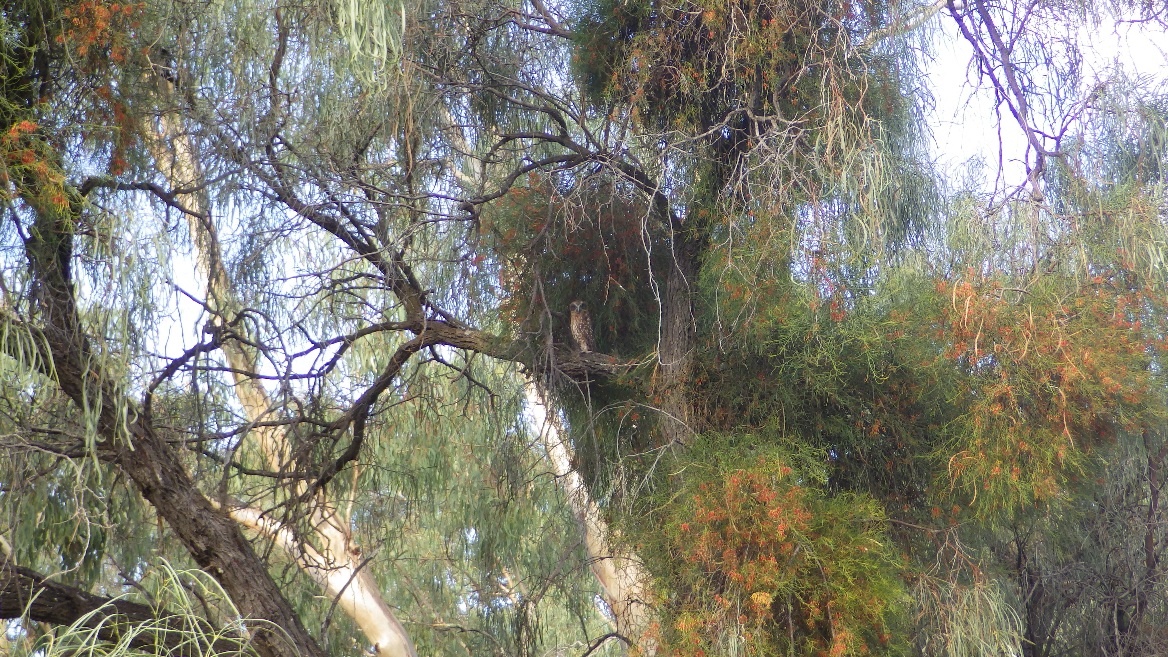

Fig. xx. An immature Boobook Owl *Ninox novaeseelandiae* roosting in a mistletoe-infected Acacia on a hot (45 °C) day in southern Australia. With their high water content and densely-branched habit, mistletoe clumps represent a more moderate microclimate used by many animals seeking shelter. Photograph by Skye Wassens (used with permission) [crop / resize as needed]