Mistletoe, Friend and and Foe; Ecosystem implications of mistletoe infection

Anne Griebel 1, David Watson 2, Elise Pendall 1

1 Hawkesbury Institute for the Environment, Western Sydney University, Locked Bag 1797, Penrith, NSW, Australia  
2 Institute for Land, Water and Society, Charles Sturt University, PO box 789, Aulbury, NSW, Australia

*Corresponding author*: A.Griebel, email: [griebel.anne@gmail.com](mailto:griebel.anne@gmail.com), telephone: +61 02 4570 1668

Running Head: Mistletoe, Friend and Foe

# Abstract

Shitcunt. Biotic disturbances are affecting a wide range of tree species in all climates, and their occurrence is contributing to increasing rates of tree mortality globally. Mistletoe is a widespread group of parasitic plants that establishes long-lasting relationships with a diverse range of host tree species. Over 1300 species of mistletoes world-wide have developed a remarkable range of adaptations for mimicking various morphological traits specific to their local hosts; at least 20 species are listed as endangered. With climate change, ecophysiological stress is increasing, potentially making trees more susceptible to mistletoe infestation, which in turn leads to higher forest mortality rates.

The perception of mistletoe presence in individual trees and forest stands is divided within the scientific community, leading to an ongoing debate regarding its impacts. Forest managers concerned about stand health and carbon sequestration may view mistletoe as a foe that leads to reduced productivity. In contrast, ecologists may see mistletoe as a friend, in light of the wildlife habitat, biodiversity and nutrient cycling it promotes. However, individual studies typically focus isolated effects of mistletoe presence within their respective research area and lack a balanced, interdisciplinary perspective of mistletoe disturbance.

With this conceptual paper we aim to bring together the positive and negative impacts of mistletoe presence on tree physiology, soil nutrient cycling as well as stand health and stand dynamics. We will focus on the implications of mistletoe-induced tree mortality on changes in stand succession and implications for biodiversity. In addition, we will present potential modifications of mistletoe presence on the energy budget and on forest vulnerability to climate change, which could feed back into stand dynamics and disturbance patterns. Lastly, we will identify the most pressing remaining knowledge gaps and highlight priorities for future research on this widespread agent of biotic disturbance.

# Keywords

mistletoe, biodiversity, mortality, climate change, ecosystem processes

# Introduction

## Background

Forests ecosystems have large economical values, as they contain 80% of aboveground carbon and 40% of belowground global carbon stocks (Watson and Climate Change. 2000) along with the capacity of storing carbon over centuries. Disturbances have the potential to alter ecosystem processes and functioning, yet they are part of the natural cycle of any ecosystem (Kulakowski *et al* 2017). Climatic induced disturbances, such as heatwaves and droughts, can significantly lower carbon sequestration rates in forests (Yuan *et al* 2016, Yi *et al* 2015, Reichstein *et al* 2013) and cause wide-ranging tree mortality (Kara *et al* 2017). Similarly detrimental effects were reported from cyclones and an increase in wildfires as the climate changes (Hutley *et al* 2013, Schoennagel *et al* 2017). Furthermore, such climate induced disturbances can weaken ecosystem resilience and alter the occurrence and life-cycle of biotic disturbances such as pest and insect outbreaks(Dukes *et al* 2009, Johnson *et al* 2010, Allen *et al* 2010), the most prominent being the bark beetle outbreaks that affected vast areas across the central and western United States. However, while the latter caused a substantial increase in stand mortality (almost 80%), atmospheric carbon sequestration rates remained unchanged (Reed *et al* 2014), indicating potential for a substantial mis-match between changes in stand dynamics and carbon cycling.

While insect attacks and large-scale disturbances like cyclones and wildfires often cause wide-spread stand mortality, the presence of parasitic plants is typically less obvious as they are slower and more sublte in modifying ecosystem processes and stand dynamics. And unlike cyclones and wildfires, which are concentrating in lower latitudes and are not necessarily a threat in every climate region, parasitic plants are globally distributed and an itegral component of most ecosystems. The relationship between the parasite and the host is often symbiotic, e.g. vasucluar epiphytes rely on the structural support of a host plant and in return enhance nutrient cycling by fertilizing nutrient-enriched litter to the soil (Bartels and Chen 2012, March and Watson 2010). The largest group of areal parasitic plants are mistletoes, which are widespread hemiparasites that portrait epiphytic behaviour and belong to the order of Santalales(Bell and Adams 2011). Mistletoes have been studied across a large range of ecosystems (see e.g. Mathiasen *et al* 2008, Bell and Adams 2011), and the process of host infection can be considered similar for all mistletoes : the mistletoe attaches to a branch and taps into the xlem of the host tree. Although they are capable of photosynthesizing and producing basic sugars (Lamont 1983), they maintain lower xlem water potentials to absorb water and nutrients from the host. However, mistletoes are longlived (exceeding 30 years) and it can take decades to notice their damaging effect on the host. This resulted in an increasing number of studies examining potential positive effects of mistletoe infestation beyond the parasite-host symbiosis, and their ability to boost biodiversity in e.g. bird and understory species richness sparked a debate about the role of mistletoes as keystone species and ecosystem engineers (Press and Phoenix 2005, Hatcher *et al* 2012, Watson and Herring 2012).

Recent reviews concatenated our current state of knowledge on the the functional relationships between parasitic plants and their hosts (e.g. Bell and Adams 2011, Mathiasen *et al* 2008) and the effect of parasitism on community processes and biodiversity (e.g. Hatcher *et al* 2012, Watson 2001, Press and Phoenix 2005). However, our current research focussed predominantly on a process-based understanding of parasate infestation, and we are just starting to reckognize the dryad role of parasites in biodiversity. Therfore, parasites being friends or foes depends on the respective research focus and the interaction between local management history, climate and stand-specific characteristics. Parasitic presence modifies ecosystem processes from the tree to the stand level, but we are still limited in our ability of scaling functional relationships to the ecosystem level, as well as understanding how changes in functional relationships are regulating biodiversity. Thus, the complexity and interaction of the underlying processes still impedes our ability to assess the future fate of the host-parasite symbioses within our globally changing climate (Bell and Adams 2011, Way 2011), which is modifying rainfall patterns and increasing the mean and maximum temperatures in almost every ecosystem (Collins *et al* 2013). These climatic dynamics, in addition to parasitic infestation, might further increase hosts stress and exacerbate tree mortality rates in heavily infested forests, which in return will feedback into biodiversity dynamics. Thus, we consider it necessary to synthesizethe the temporal dynamics of the host-parasite symbioses, which assesses the winners and losers of parasite infection under a changing climate. We will use mistletoe infestation in Australia as an example for parasite infection, since mistletoe is widespread throughout Australian ecosystems and recent studies indicated an increase in mistletoe abundance within existing distributions in Australia (Bowen *et al* 2009, Turner and Smith 2016). Mistletoe infection has clearly been associated with a decrease in tree growth and tree survival rates (Reid *et al* 1994), which was especially detrimental in young trees (Carnegie *et al* 2009). In addition, the Australian climate is already imposing regular heat and drought stress on most ecosystems, which is expected to further increase in the coming decades, making this an ideal example of potential increases in tree mortality due to parasitic infestation under a changing climate.

Figure 1 conceptualizes the temporal dynamics of the parasitic life cycle on tree physiology, the cycling of water, energy, carbon and nutrients, and ultimately the impact on floral and faunal diversity.

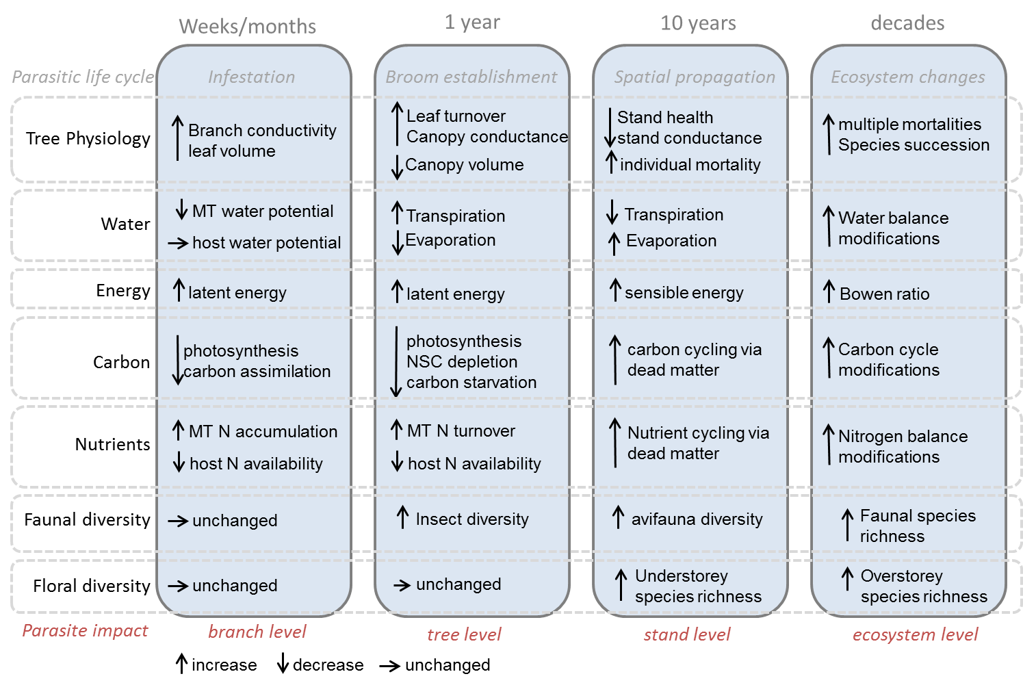

Figure 1. Conceptual figure indicating the temporal dynamics of mistletoe infection from the branch to the ecosystem level with a focus on tree phsysiology, matter and energy fluxes, and floral and faunal diversity.

Recent studies in Australia indicated an increase in mistletoe abundance within existing distributions (Bowen *et al* 2009, Turner and Smith 2016), which had been associated with a decrease in tree growth and survival rates (Reid *et al* 1994) that was especially detrimental in young trees (Carnegie *et al* 2009).

# Advancements in monitoring and management

There were many.

# Mistletoe and biodiversity

David will talk about this.

# Ecosystem processes

This will host Figure 2

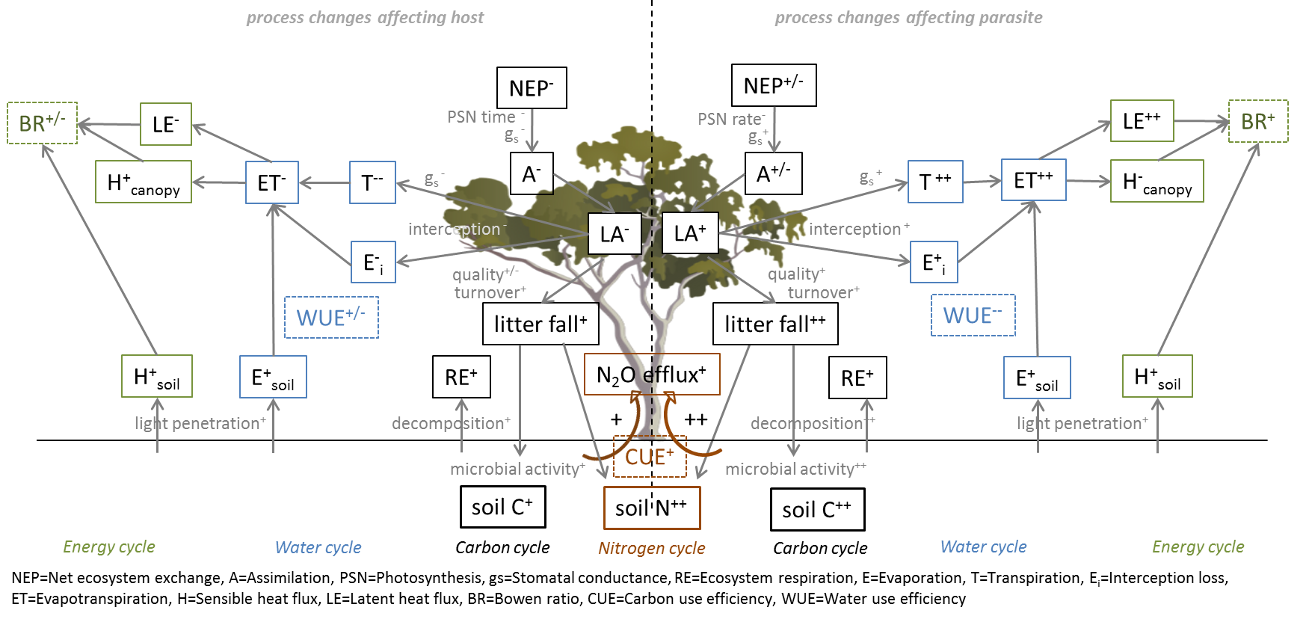

Figure 2. Mistletoe affects processes.

# References

Allen C D, Macalady A K, Chenchouni H, Bachelet D, McDowell N, Vennetier M, Kitzberger T, Rigling A, Breshears D D, Hogg E H, Gonzalez P, Fensham R, Zhang Z, Castro J, Demidova N, Lim J H, Allard G, Running S W, Semerci A and Cobb N 2010 A global overview of drought and heat-induced tree mortality reveals emerging climate change risks for forests *Forest Ecology and Management* **259** 660–84 Online: <Go to ISI>://WOS:000275014400002 http://ac.els-cdn.com/S037811270900615X/1-s2.0-S037811270900615X-main.pdf?_tid=34960aa6-637a-11e6-b62f-00000aacb360&acdnat=1471328900_4355a68986f99ada583dfe7a22c2ff32

Bartels S F and Chen H Y H 2012 Mechanisms regulating epiphytic plant diversity *Critical Reviews in Plant Sciences* **31** 391–400

Bell T L and Adams M A 2011 Attack on all fronts: Functional relationships between aerial and root parasitic plants and their woody hosts and consequences for ecosystems *Tree Physiology* **31** 3–15 Online: <Go to ISI>://WOS:000288272100002 http://treephys.oxfordjournals.org/content/31/1/3.full.pdf

Bowen M E, McAlpine C A, House A P N and Smith G C 2009 Agricultural landscape modification increases the abundance of an important food resource: Mistletoes, birds and brigalow *Biological Conservation* **142** 122–33 Online: <Go to ISI>://WOS:000262596900011 http://ac.els-cdn.com/S0006320708003868/1-s2.0-S0006320708003868-main.pdf?_tid=7feb4c78-1f54-11e7-813e-00000aacb35f&acdnat=1491983524_2fc065e09919804614f2c534840de693

Carnegie A J, Bi H Q, Arnold S, Li Y and Binns D 2009 Distribution, host preference, and impact of parasitic mistletoes (loranthaceae) in young eucalypt plantations in new south wales, australia *Botany-Botanique* **87** 49–63 Online: <Go to ISI>://WOS:000262673600009 http://www.nrcresearchpress.com/doi/abs/10.1139/B08-127

Collins M, Knutti R, Arblaster J, Dufresne J-L, Fichefet T, Friedlingstein P, Gao X, Gutowski W, Johns T, Krinner G, Shongwe M, Tebaldi C, Weaver A and Wehner M 2013 Long-term climate change: Projections, commitments and irreversibility *Climate change 2013: The physical science basis. contribution of working group i to the fifth assessment report of the intergovernmental panel on climate change* ed T Stocker, D Qin, G-K Plattner, M Tignor, S Allen, J Boschung, A Nauels, Y Xia, V Bex and P Midgley (Cambridge, United Kingdom; New York, NY, USA: Cambridge University Press) pp 1029–136 Online: www.climatechange2013.org

Dukes J S, Pontius J, Orwig D, Garnas J R, Rodgers V L, Brazee N, Cooke B, Theoharides K A, Stange E E, Harrington R, Ehrenfeld J, Gurevitch J, Lerdau M, Stinson K, Wick R and Ayres M 2009 Responses of insect pests, pathogens, and invasive plant species to climate change in the forests of northeastern north america: What can we predict? *Canadian Journal of Forest Research-Revue Canadienne De Recherche Forestiere* **39** 231–48 Online: <Go to ISI>://WOS:000265054300003

Hatcher M J, Dick J T A and Dunn A M 2012 Diverse effects of parasites in ecosystems: Linking interdependent processes *Frontiers in Ecology and the Environment* **10** 186–94 Online: <Go to ISI>://WOS:000303425200016 http://onlinelibrary.wiley.com/store/10.1890/110016/asset/fee2012104186.pdf?v=1&t=irx2ycty&s=75f8d2fa3f2927d7a44a11468c73ba77e4b61265

Hutley L B, Evans B J, Beringer J, Cook G D, Maier S W and Razon E 2013 Impacts of an extreme cyclone event on landscape-scale savanna fire, productivity and greenhouse gas emissions *Environmental Research Letters* **8** 12 Online: <Go to ISI>://WOS:000329604900087

Johnson D M, Buntgen U, Frank D C, Kausrud K, Haynes K J, Liebhold A M, Esper J and Stenseth N C 2010 Climatic warming disrupts recurrent alpine insect outbreaks *Proceedings of the National Academy of Sciences of the United States of America* **107** 20576–81 Online: <Go to ISI>://WOS:000284529000078

Kara A, Juan Manuel D, Maria G G, Catherine H, David M, Camila P, Beatriz S-N, Christina M S, Annette T, Skip J V B, Bonnie G W, Xiangtao X and Jennifer S P 2017 Will seasonally dry tropical forests be sensitive or resistant to future changes in rainfall regimes? *Environmental Research Letters* **12** 023001 Online: <http://stacks.iop.org/1748-9326/12/i=2/a=023001>

Kulakowski D, Seidl R, Holeksa J, Kuuluvainen T, Nagel T A, Panayotov M, Svoboda M, Thorn S, Vacchiano G, Whitlock C, Wohlgemuth T and Bebi P 2017 A walk on the wild side: Disturbance dynamics and the conservation and management of european mountain forest ecosystems *Forest Ecology and Management* **388** 120–31 Online: <Go to ISI>://WOS:000399521200012 http://ac.els-cdn.com/S0378112716303930/1-s2.0-S0378112716303930-main.pdf?_tid=0551eb24-4016-11e7-aae6-00000aab0f01&acdnat=1495585078_27e7d5a15c83b070d6ae8fabbefe728f

Lamont B 1983 Germination of mistletoes *The biology of mistletoes* ed P Calder M; Bernhardt (Sydney: Academic Press) pp 129–43

March W A and Watson D M 2010 The contribution of mistletoes to nutrient returns: Evidence for a critical role in nutrient cycling *Austral Ecology* **35** 713–21 Online: <Go to ISI>://WOS:000283594600001 http://onlinelibrary.wiley.com/store/10.1111/j.1442-9993.2009.02056.x/asset/j.1442-9993.2009.02056.x.pdf?v=1&t=irx317ns&s=72cb3e0c660536b73e3ecebfdd0d4d930a1a7c10

Mathiasen R L, Nickrent D L, Shaw D C and Watson D M 2008 Mistletoes: Pathology, systematics, ecology, and management *Plant disease* **92** 988–1006

Press M C and Phoenix G K 2005 Impacts of parasitic plants on natural communities *New Phytologist* **166** 737–51 Online: <Go to ISI>://WOS:000228750700007

Reed D E, Ewers B E and Pendall E 2014 Impact of mountain pine beetle induced mortality on forest carbon and water fluxes *Environmental Research Letters* **9** Online: <Go to ISI>://WOS:000344964000029 http://iopscience.iop.org/article/10.1088/1748-9326/9/10/105004/pdf

Reichstein M, Bahn M, Ciais P, Frank D, Mahecha M D, Seneviratne S I, Zscheischler J, Beer C, Buchmann N, Frank D C, Papale D, Rammig A, Smith P, Thonicke K, Velde M van der, Vicca S, Walz A and Wattenbach M 2013 Climate extremes and the carbon cycle *Nature* **500** 287–95 Online: <Go to ISI>://WOS:000323112400023

Reid N, Yan Z and Fittler J 1994 Impact of mistletoes (amyema miquelii) on host (eucalyptus blakelyi and eucalyptus melliodora) survival and growth in temperate australia *Forest Ecology and Management* **70** 55–65 Online: <Go to ISI>://WOS:A1994QC19900005

Schoennagel T, Balch J K, Brenkert-Smith H, Dennison P E, Harvey B J, Krawchuk M A, Mietkiewicz N, Morgan P, Moritz M A, Rasker R, Turner M G and Whitlock C 2017 Adapt to more wildfire in western north american forests as climate changes *Proceedings of the National Academy of Sciences of the United States of America* **114** 4582–90 Online: <Go to ISI>://WOS:000400358000028 http://www.pnas.org/content/114/18/4582.full.pdf

Turner R J and Smith P 2016 Mistletoes increasing in eucalypt forest near eden, new south wales *Australian Journal of Botany* **64** 171–9 Online: <Go to ISI>://WOS:000373708900009 http://www.publish.csiro.au/?act=view_file&file_id=BT15253.pdf

Watson D M 2001 Mistletoe - a keystone resource in forests and woodlands worldwide *Annual Review of Ecology and Systematics* **32** 219–49 Online: <Go to ISI>://WOS:000172908800008

Watson D M and Herring M 2012 Mistletoe as a keystone resource: An experimental test *Proceedings of the Royal Society B-Biological Sciences* **279** 3853–60 Online: <Go to ISI>://WOS:000307780400029 http://rspb.royalsocietypublishing.org/content/royprsb/279/1743/3853.full.pdf

Watson R T and Climate Change. I P on 2000 *Land use, land-use change, and forestry : A special report of the intergovernmental panel on climate change / edited by robert t. watson . [et al.]* (Cambridge University Press Cambridge) Online: [http://www.grida.no/climate/ipcc/land_use/index.htm](%20http://www.grida.no/climate/ipcc/land_use/index.htm%20)

Way D A 2011 Parasitic plants and forests: A climate change perspective *Tree Physiology* **31** 1–2 Online: <Go to ISI>://WOS:000288272100001 http://treephys.oxfordjournals.org/content/31/1/1.full.pdf

Yi C X, Pendall E and Ciais P 2015 Focus on extreme events and the carbon cycle *Environmental Research Letters* **10** 8 Online: <Go to ISI>://WOS:000366759200001

Yuan W P, Cai W W, Chen Y, Liu S G, Dong W J, Zhang H C, Yu G R, Chen Z Q, He H L, Guo W D, Liu D, Liu S M, Xiang W H, Xie Z H, Zhao Z H and Zhou G M 2016 Severe summer heatwave and drought strongly reduced carbon uptake in southern china *Scientific Reports* **6** 12 Online: <Go to ISI>://WOS:000368190100001