MERIDIAN TECHNOLOGIES
Board of Directors — Annual Strategic Review
CEO Opening Remarks | Catherine Park

Meridian is profitable, decelerating, and at an inflection point:
the decisions we make in 2026 will determine whether we are a managed-decline
business or the defining agentic-work platform in regulated enterprise.

The Numbers in One Picture
Revenue growth has decelerated every year since 2022 — 28% → 19% → 16% → 11%. Operating and free-cash-flow margins have expanded every year. This is what a business looks like when cost discipline outpaces growth investment. Both trends are intentional. Neither is sustainable indefinitely.
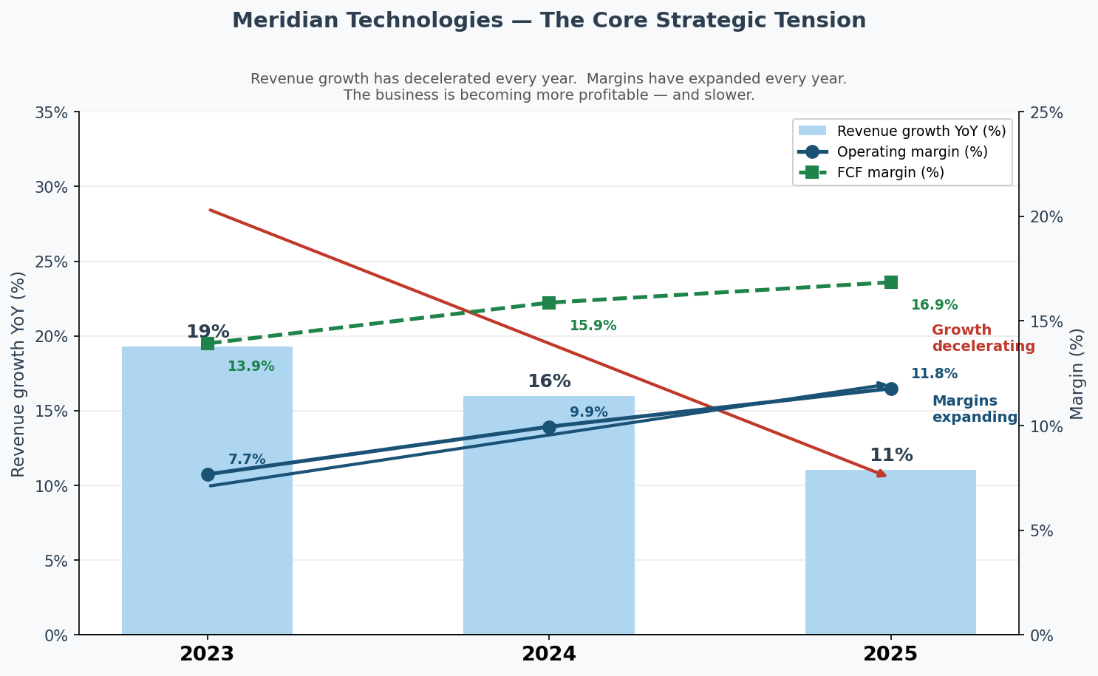
Figure 1 — Revenue growth (bars, left axis) vs. operating and FCF margins (lines, right axis), 2023–2025.

Three Issues for the Board
1. Growth deceleration is structural — and the 2026 plan does not fully reverse it.
We will guide 2026 at 10–14% growth. The plan we approved in 2022 assumed $560M revenue by 2026; we will deliver $440–455M — a $100M+ miss. This is not a communication problem. It is a structural problem.
- Trend: Revenue growth: 28% (2022) → 19% (2023) → 16% (2024) → 11% (2025). No quarter has reversed the trend.
- Efficiency: Magic number fell from 1.20 (Q1 2024) to 0.92 (Q4 2025). CAC payback stretched from 18 to 22 months. We are spending more per dollar of new ARR, not less.
- Mix: SMB, once 38% of ARR, is now 13% and declining 23% YoY. The prior plan called this a controlled wind-down. It was a hemorrhage.
The board needs to understand: reacceleration requires a second leg beyond enterprise growth. My stress-test shows Copilot at per-seat pricing cannot close the gap alone. Consumption pricing — currently a Q3 2026 roadmap item — is the single most leveraged variable in our 2027 growth rate.
2. The AI Copilot bet is real — and fragile.
Copilot reached GA in September 2025, hit 710 paying seats by year-end against an internal target of 600, and achieved a 44% enterprise renewal attach rate. The Helio acquisition has already compressed our agent architecture roadmap by an estimated 15 months. These are genuine wins. Three risks sit directly underneath them.
- Competitive: Asana shipped its full agent suite in November. Monday now has larger ARR than Meridian. ClearAI Work raised $120M at $1B+ valuation. Atlassian's agentic Jira will appear in our enterprise deals directly. The window to establish Copilot as the enterprise-grade choice is 2026.
- Capacity: The 2026 roadmap requires 80 net new engineers in H1. At 15% annual attrition, actual net adds are closer to 25. Six of twelve 2025 roadmap items slipped at least one quarter.
- Retention: The Helio retention equity vests over four years with a cash cliff in 2026. 26 of 28 engineers are still here. The agent-builder roadmap (Q2 2026) depends on keeping them.
The board should ask: what is the specific plan to close the engineering capacity gap, and what is the contingency if Helio retention slips post-cliff?
3. Mid-market is the quiet risk no one is talking about.
Enterprise is healthy. SMB decline is visible and being managed. Mid-market — 47% of our ARR — is quietly eroding and has not found a floor.
- NRR compression: Mid-market NRR has declined every single quarter in our dataset: 108% (Q1 2024) → 102% (Q4 2025). Gross logo churn rose from 9.1% to 10.2%.
- Pricing pressure: Asana is now bundling AI into its standard tier. Mid-market renewals are pushing for price holds, expanded user counts at flat price, or Copilot bundled at no cost. We are holding the line — for now.
- Product gap: The resource management module — the top-3 ask from our customer advisory board and the primary mid-market expansion lever — was deferred in 2025 and is not scheduled until Q2 2026.
- Sales confidence: 28% of sales respondents in the 2025 employee survey said they cannot crisply differentiate Meridian from Asana with AI.
If mid-market NRR continues compressing into the high 90s, this segment becomes a retention story. The math on 15%+ company growth becomes very hard even with strong enterprise execution.

My One Ask of the Board
I am not asking for approval of a full three-year plan today. I will bring that to the board no later than Q1 2026, consistent with the authorization given at the time of my appointment. What I am asking for today is one decision:
Authorize management to move the Copilot consumption-pricing model from a Q3 2026 roadmap item to a Q1 2026 strategic priority, with CFO, CRO, and CPO jointly accountable for a board-ready proposal by the March meeting.
This is the single decision with the highest leverage on our 2027 growth rate. It does not require additional capital. It requires alignment at the executive level and a clear signal from this board that growth reacceleration — not margin expansion — is the primary objective for 2026.

Supporting materials: meridian_financials_2022_2025.csv | meridian_kpis_2024.csv | meridian_segments_overview.md | meridian_product_roadmap_2025.md | meridian_earnings_call_q1–q4_2025.txt | copilot_stress_test.png

