HW5

Q1.

1. P(Z | X,Y) = P(Z, X, Y) / P(X, Y)

P(X | Y) = P(X, Y) / P(Y)

P(X, Y | Z) = P(X, Y, Z) / P(Z)

= P(Z | X, Y) \* P(X | Y)

= P(Z, X, Y) / P (Y)

1. P(X, Y, Z) = P(X | Y, Z) \* P(Y, Z)

= P (X | Y, Z) \* P(Y | Z) \* P(Z)

= P(X | Y, Z) \* P(Y | X, Z) \* P(Z | X, Y) \* P(X, Y) / P(X, Y | Z)

= P(X | Y, Z) \* P(Y | X, Z) \* P(Z | X, Y) \* P (X | Y) \* P(Y) / P(X | Y,Z) \* P (Y | X, Z)

= P(X | Y, Z) \* P(Z | X, Y) \* P(Y)

1. There is no expression because with the given independence assumption, there is no way calculate P(Z)’s table.
2. There is no expression because at one point, with the only given probability table, there is no way to get P(Y | X, Z)
3. a) X ⫫ Z and X ⫫ Y is needed.

Because P(X|Z)\*P(Y) = P (XZ) \* P(Y) / P(Z)

If X ⫫ Z and X ⫫ Y are valid, then P(XZ) = P(X) \* P(Z)

Eventually P(X|Z)\*P(Y) = P(X) \*P(Y) = P(X, Y)

b) do not need any independence assumption since

P(Y | X) \* P(X) / P(Y) = [(X | Y) \* P(Y) \* P(X)] / [(P(X) \* P(Y)) = P(X | Y)

c) it requires at least one independence assumption, either X ⫫ Z or Y ⫫ Z.

because right side of the given equation = [P(XZ) \* P(YZ)] / [P(XY) \* P(Z)]

if there is no assumption, then it cannot be simplified to P(XYZ) / P(XY) = P(Z | X, Y)

d) No, it does not require any independence assumption. Because

given equation’s right side = P(X, Y) / P(Y) \* P(Y) = P(X, Y). This is acquired by law of total probability.

3

1. Because ∑w = W P(W) = 1, the expression reduces to P(X, Y, Z) / P (Y, Z) = P(X | Y, Z)

4) Because ∑w = W P(W) = 1, P(X | Y, Z, w) = P(X | Y, Z)

5) ∑w = W and P(W) = 1, thus P(X, W | Y, Z) = P(X | Y, Z) = P(X | Y, Z).

b.

1) P(X, Y | Z) / P(Y|Z) = P(X | Z) \* P(Y | Z) / P(Y | Z) = P(X | Z).

Thus, it is true.

4) Because ∑y = Y P(Y) = 1,

P(X, y | Z) P(Z) / P(Z) = P(X| Z) P(Z) / P(Z) = P(X|Z). thus it is true.

5) P(X, Z | Y) P(Y) / [P(Z) P(Y/Z)]

= P(X | Z,Y) \* P(Z| Y) P(Y) / [P(Z) \* P(Z | Y) \* P(Y) / P(Z)]

= P(X | Z, Y) = P(X | Z)

Thus it is true.

Q2.

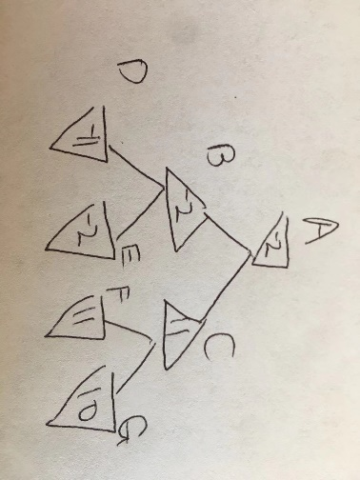

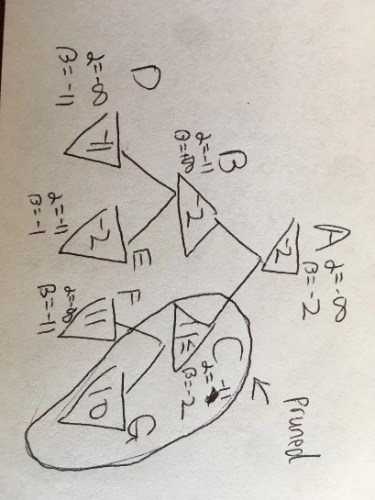

1. In this context, you would want to use alpha-beta pruning over naïve minimax because it saves time to traverse trivial subtree on the right side of the root. If the tree is very large, you should definitely use alpha-beta pruning to save memory and computational power to improve performance.

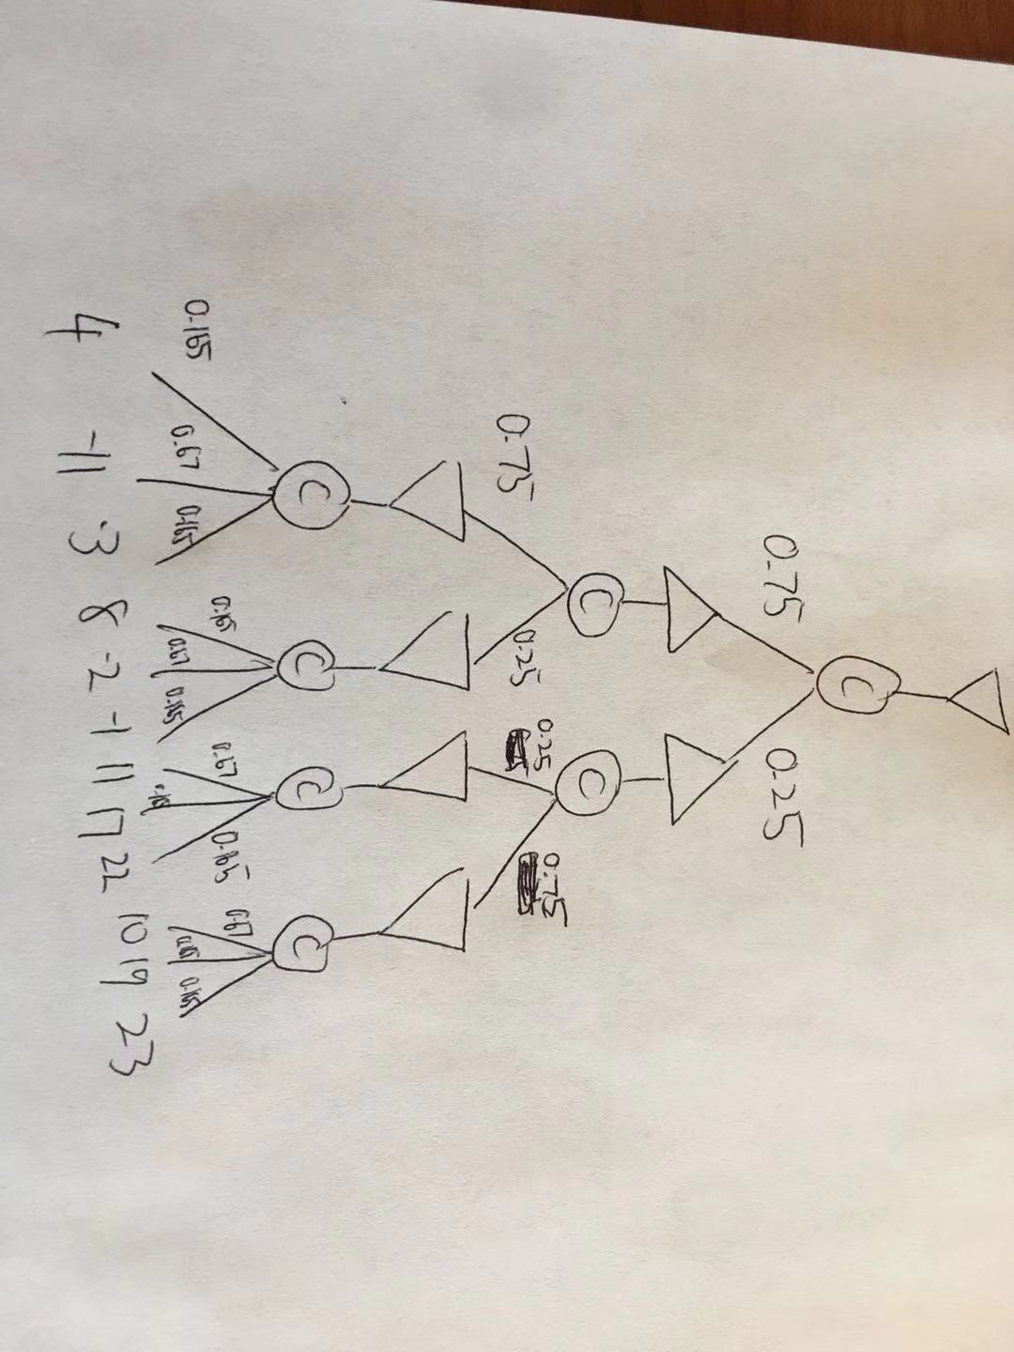

1. E[A] = 0.75 \* -2 + 0.25 \* 11 =

E[B] = 0.75 \* -11 + 0.25 \* -2 =

E[C] = 0.75 \* 10 + 0.25 \* 11 =

E[D] = 0.165 \* 4 + 0.67 \* -11 + 0.165 \* -3 =

E[F] = 0.165 \* 17 + 0.67 \* 11 + 0.165 \* 22 =

E[G] = 0.165 \* 19 + 0.67 \* 10 + 0.165 \* 23 =

Q3.

1. h1 is not admissible because at B node, the h1 value is overestimating, thus h1 is not admissible. On the other hand, h2 is admissible because each node’s heuristic value using h2 is an underestimated value. Thus h2 is admissible.

paths using h1: ADFG

paths using h2: ABCDFG

1. h3 for 0 <= D <= 10
2. h3 for D should be in the range of 8 <= x <= 10 in order for h3 to be admissible