HW8

Question 1:

(p ^ q) -> (q -> r)

= ~(p ^ q) v (q -> r) implication elimination

= (~p v ~q) v (~q v r) de Morgan

= ~p v ~q v ~q v r = ~p v ~q v r

Given: p -> (q -> r)

= ~p v (q -> r) implication elimination

= ~p v ~q v r. implication elimination

Negate the query (p v q v ~r), then resolve it with ~p v ~q v r = empty

Since we have reached empty, and there is a contradiction. Hence, the query is correct with the given statement.

Questions 2:

(1).

1. ∀x child(x) -> love (x, Santa)

2. ∀x love (x, Santa) -> ∀y (reindeer(y) -> love (x, y))

3. reindeer(Rudolph) ^ red nose (Rudolph)

4. ∀x Red nose(x) -> (weird(x) v clown(x))

5. ∀x reindeer(x) -> ~clown(x)

6. ∀x weird(x) -> ~love(scrooge, x)

7. ~child(scrooge)

(2).

1. ∀x (Austinite(x) ^ ~conservative(x)) ->∃y (Armadillo(y) ^ love(x, y)

2. ∀x wear (x, marron-and-white shirts) -> Aggie(x)

3. ∀x ∀y Aggie(x) -> (dog(y) ^ love (x, y))

4. ~∃x ∀y ~∃z (dog(y) -> love(x, y)) ^ (armadillo(z) ^ love(x, z))

5. Austinite (Clem) ^ wear (Clem, maroon-and-white shirts)

6. ∃x Austinite(x) ^ conservative(x)

Question 3:

1.

Alice: ~murderer (Alice) -> (friends (Barney, Victor) ^ ~friends (Caddy, Victor))

Barney: ~murderer (Barney) -> ~friends (Barney, Victor)

Caddy: ~murderer (Caddy) -> friends (Barney, Victor)

2.

∀x ∀y friends (x, y) -> (~murder (x, y) ^ ~murder (y, x))

∃x ∃y murderer(x) ^ murderer(y) ^ (x = y)

∀x ~murderer(x) -> ~lie(x)

3.

1. (murderer (Alice) ^ friends (Barney, Victor)) ^ (murderer (Alive) v ~friends (Caddy, Victor))

2. murderer (Barney)

3. ~friends (Barney, Victor)

3. murderer (Caddy)

4. friends (Barney, Victor)

5. (~friends (x, y) v ~murder (x, y)) ^ (~friends (x, y) v ~murder (y, x))

6. murderer(a) ^ murderer(b) ^ (a = b)

7. murderer(x)

8. ~lie(x)

4.

∃x murderer(x) ^ murder (Victor, x)

5.

Caddy: Friend (Caddy, Victor)

6.

Goal: murderer (Alice)

Negate the Goal: ~murderer(Alice).

Process:

Step 1: combine statement 1 and negated goal will get

friends (Barney, Victor) ^ ~friends (Caddy, Victor)

Step 2: combine Caddy’s statement that has been added in part 5 and result of step 1 will get

Friends (Barney, Victor)

Step 3: combine statement 3 and result of step 2 will get

Empty

Thus, there is a contradiction, which means the goal is unsatisfiable.P

Question 4:

1. 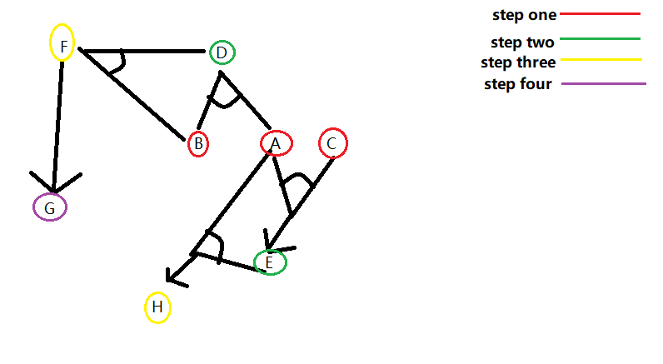
2. 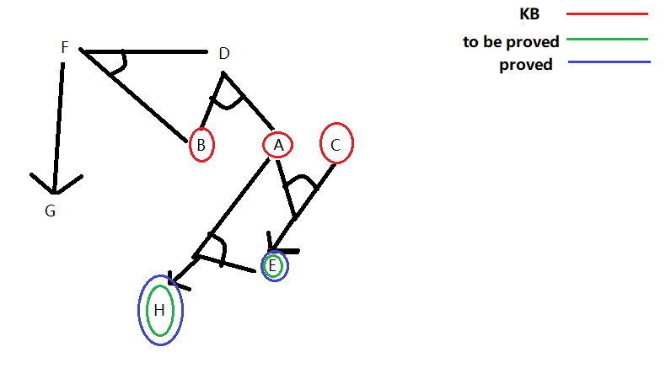

Question 5:

1. 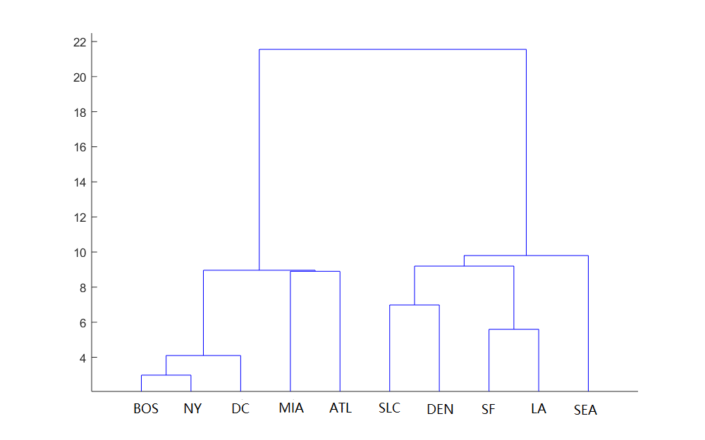
2. Group 1: [BOS, NY, DC, MIA, ATL]

Group 2: [SLC, DEN, SF, LA]

Group 3: [SEA]

1. Group A: [BOS, NY, DC]

Group B: [MIA, SLC, SEA, SF, LA, DEN, ATL]

1. Group A new center coordinate: c1 = (41, 74.0333)

Group B new center coordinate: c2 = (37.07143, 106.3286)

1. Group A: [BOS, NY, DC, MIA, ATL]

Group B: [SLC, SEA, SF, LA, DEN]