Status live and connected to https://7c25787c-567d-4d98-8151-1125794025a5-00-o90cqt9u859u.spock.replit.dev/BOM

As you confirmed I rang in a est check # 12 and it was open when I disconnected the inter this is what happened to my browser page
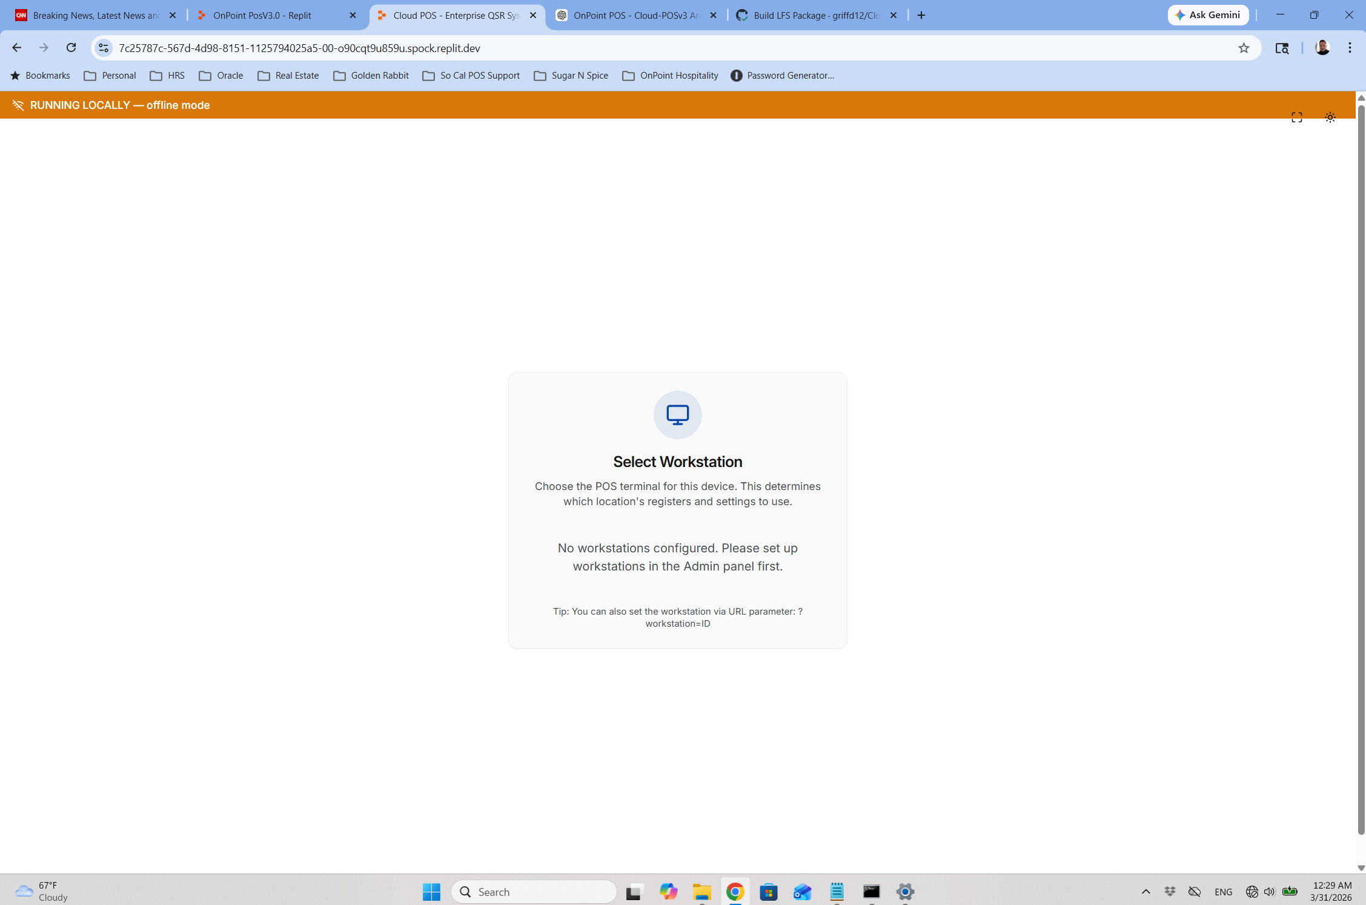
It went to a message of not kn owhwat WS / device I was when I selected the option to select a new WS this is the screen. Sop here is the rub when the cloud bd/hosting site sgoes down my wenb browers is still looking at this url: https://7c25787c-567d-4d98-8151-1125794025a5-00-o90cqt9u859u.spock.replit.dev/ SO if this is the url that I am on and we lose connection to the cloud db or internet how does the web page know to now look at the local host?

Ok now I will oipen up a new internet page to localhost:3001 and if this work s correct I should nbe able ti sign in and see check @ 12 as open as the data should have synced to the LFS server and I should be bale to operatear now lets see.

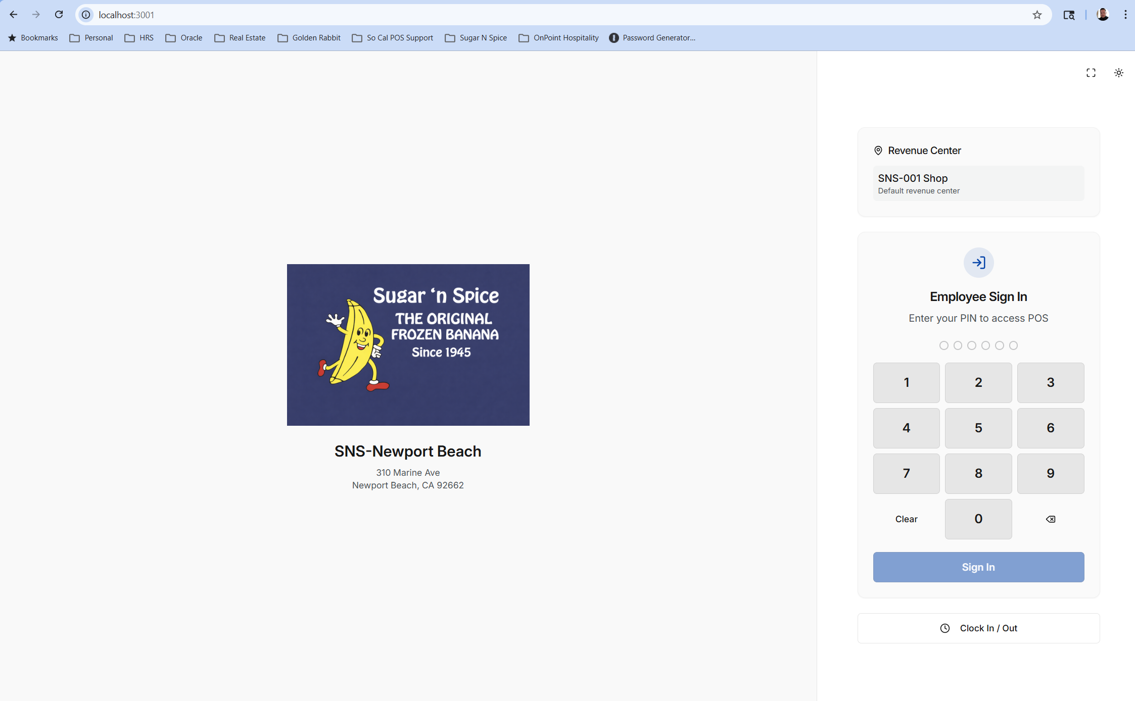
Local host page open but it does not show me any status that the cloud is down now i wil try to sign in..
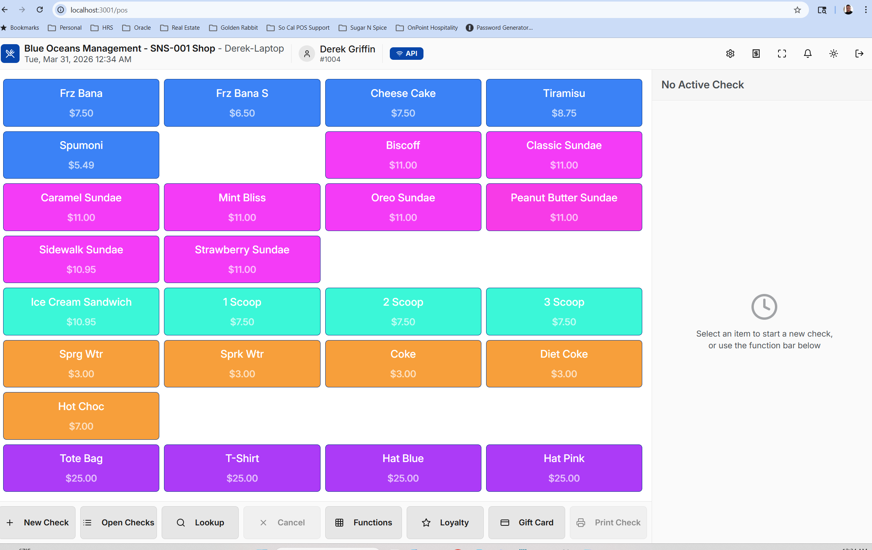
I can sig n in and this looks good so far now I will 1- see if check #12 shows as open
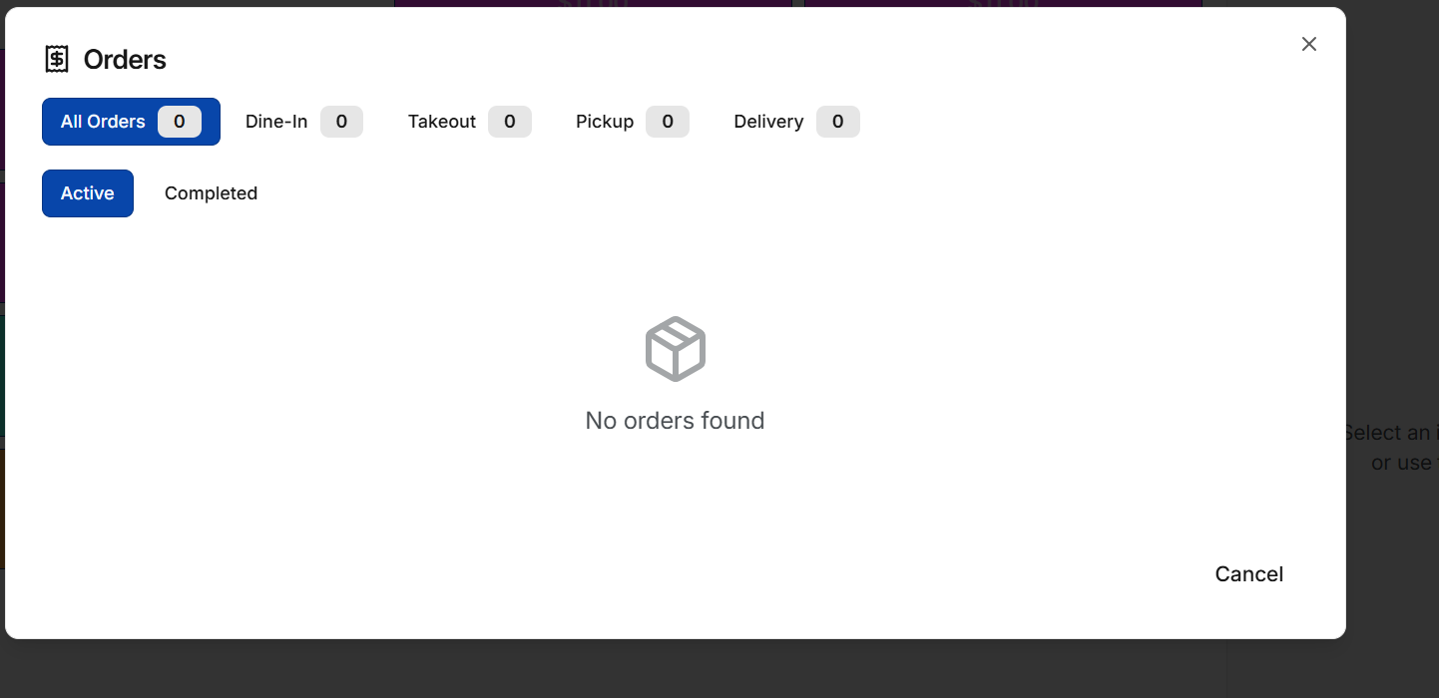
NO open checks so the system is not syncing
Lets see if I can start a check and rin in an item
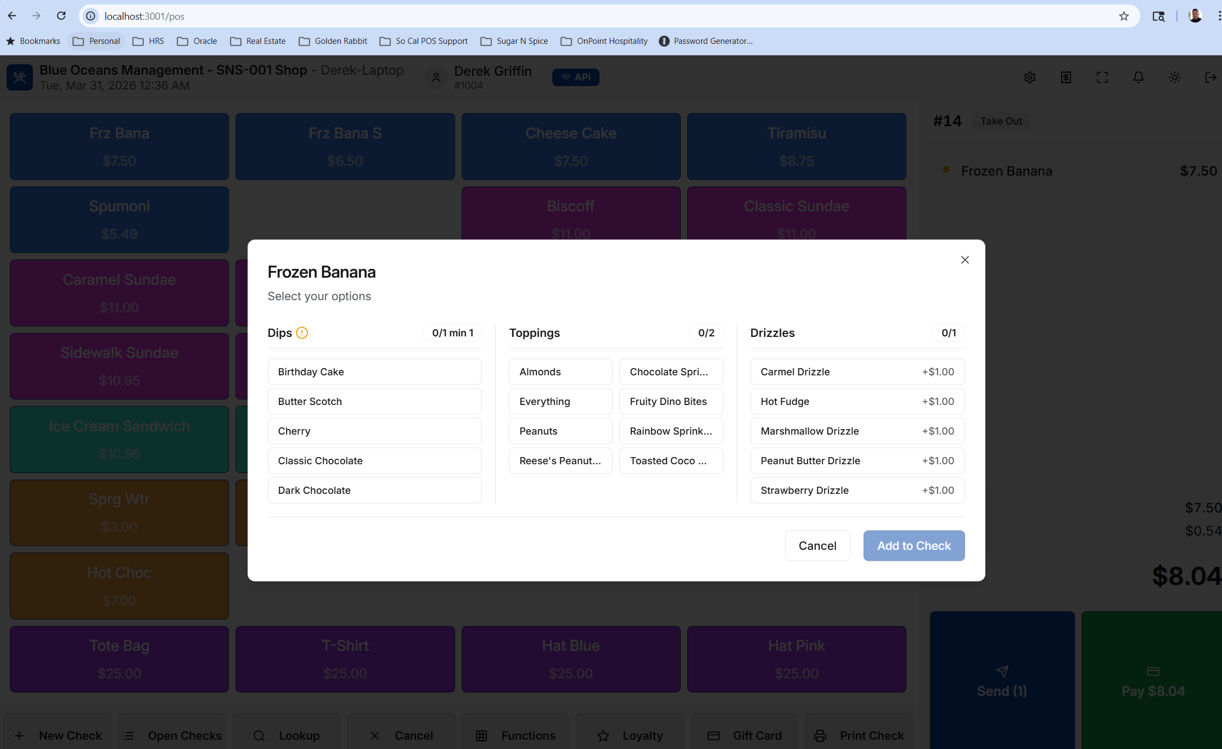
Ok I can select an item and the mod screen comes up

I can add to check and now see the detail on the check detail screen
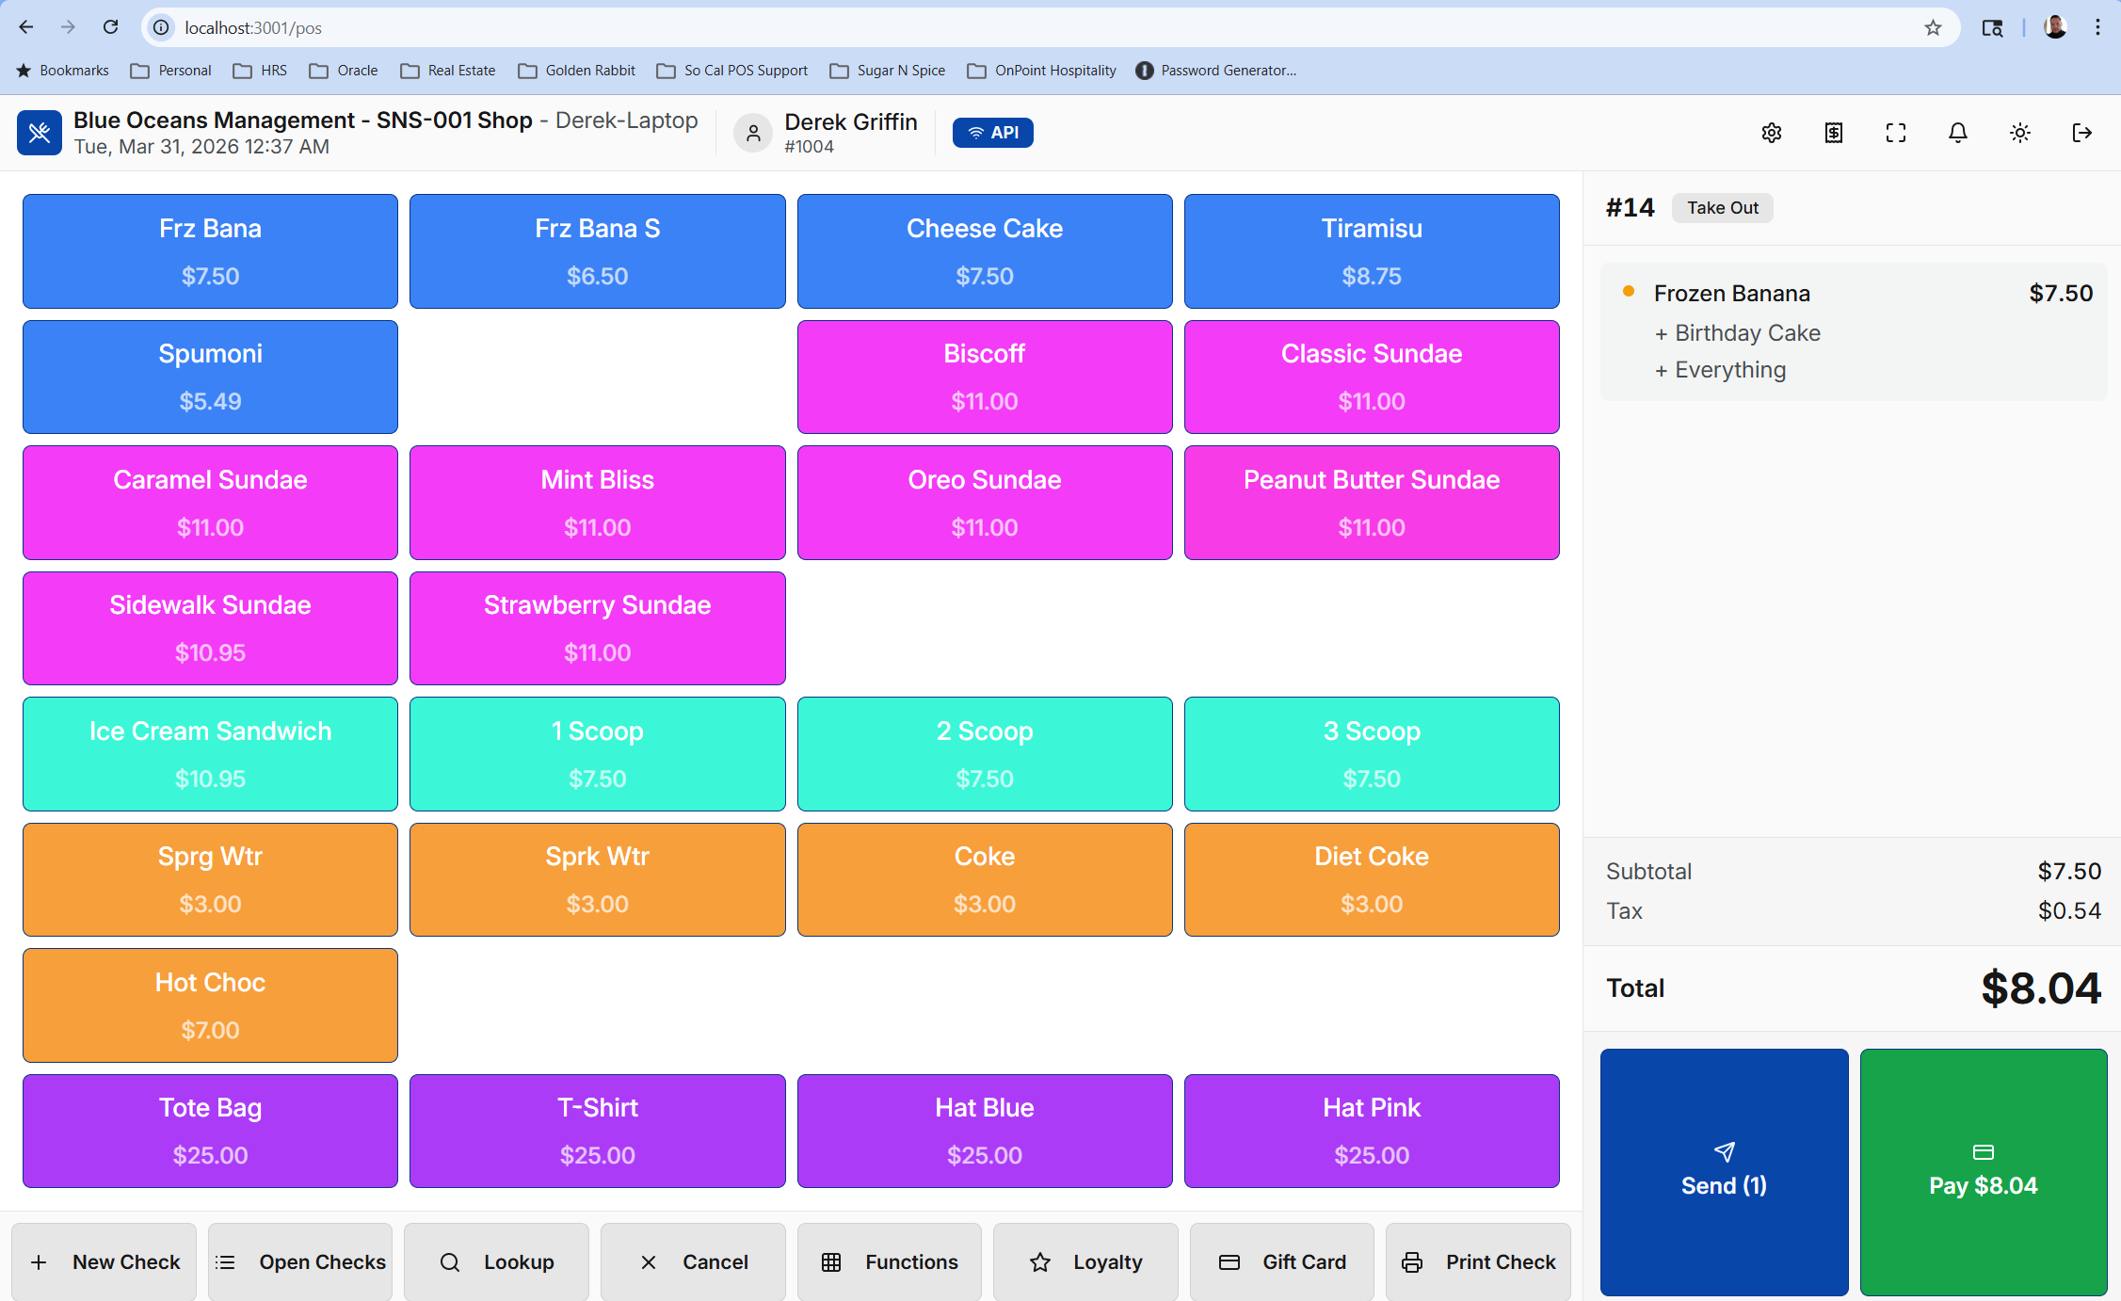
Now let me try to send the check and see if it shows up on pick up open checks slu
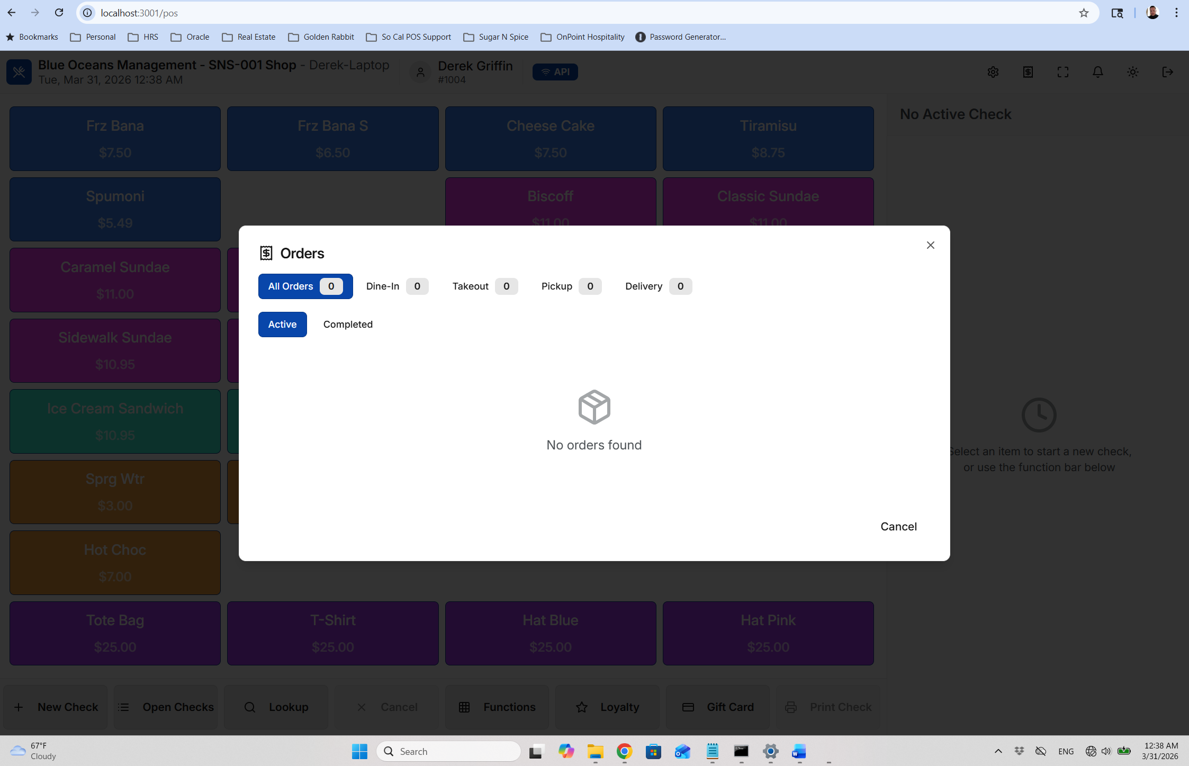no open checks.
Started a new check rang in an itrem troed to delete it and I cant failed to void 400 error
Applied a 10% discount to the item and it ended up compltlye removing the item from the screen

Price override on a menu item seems to work
Pay screen:
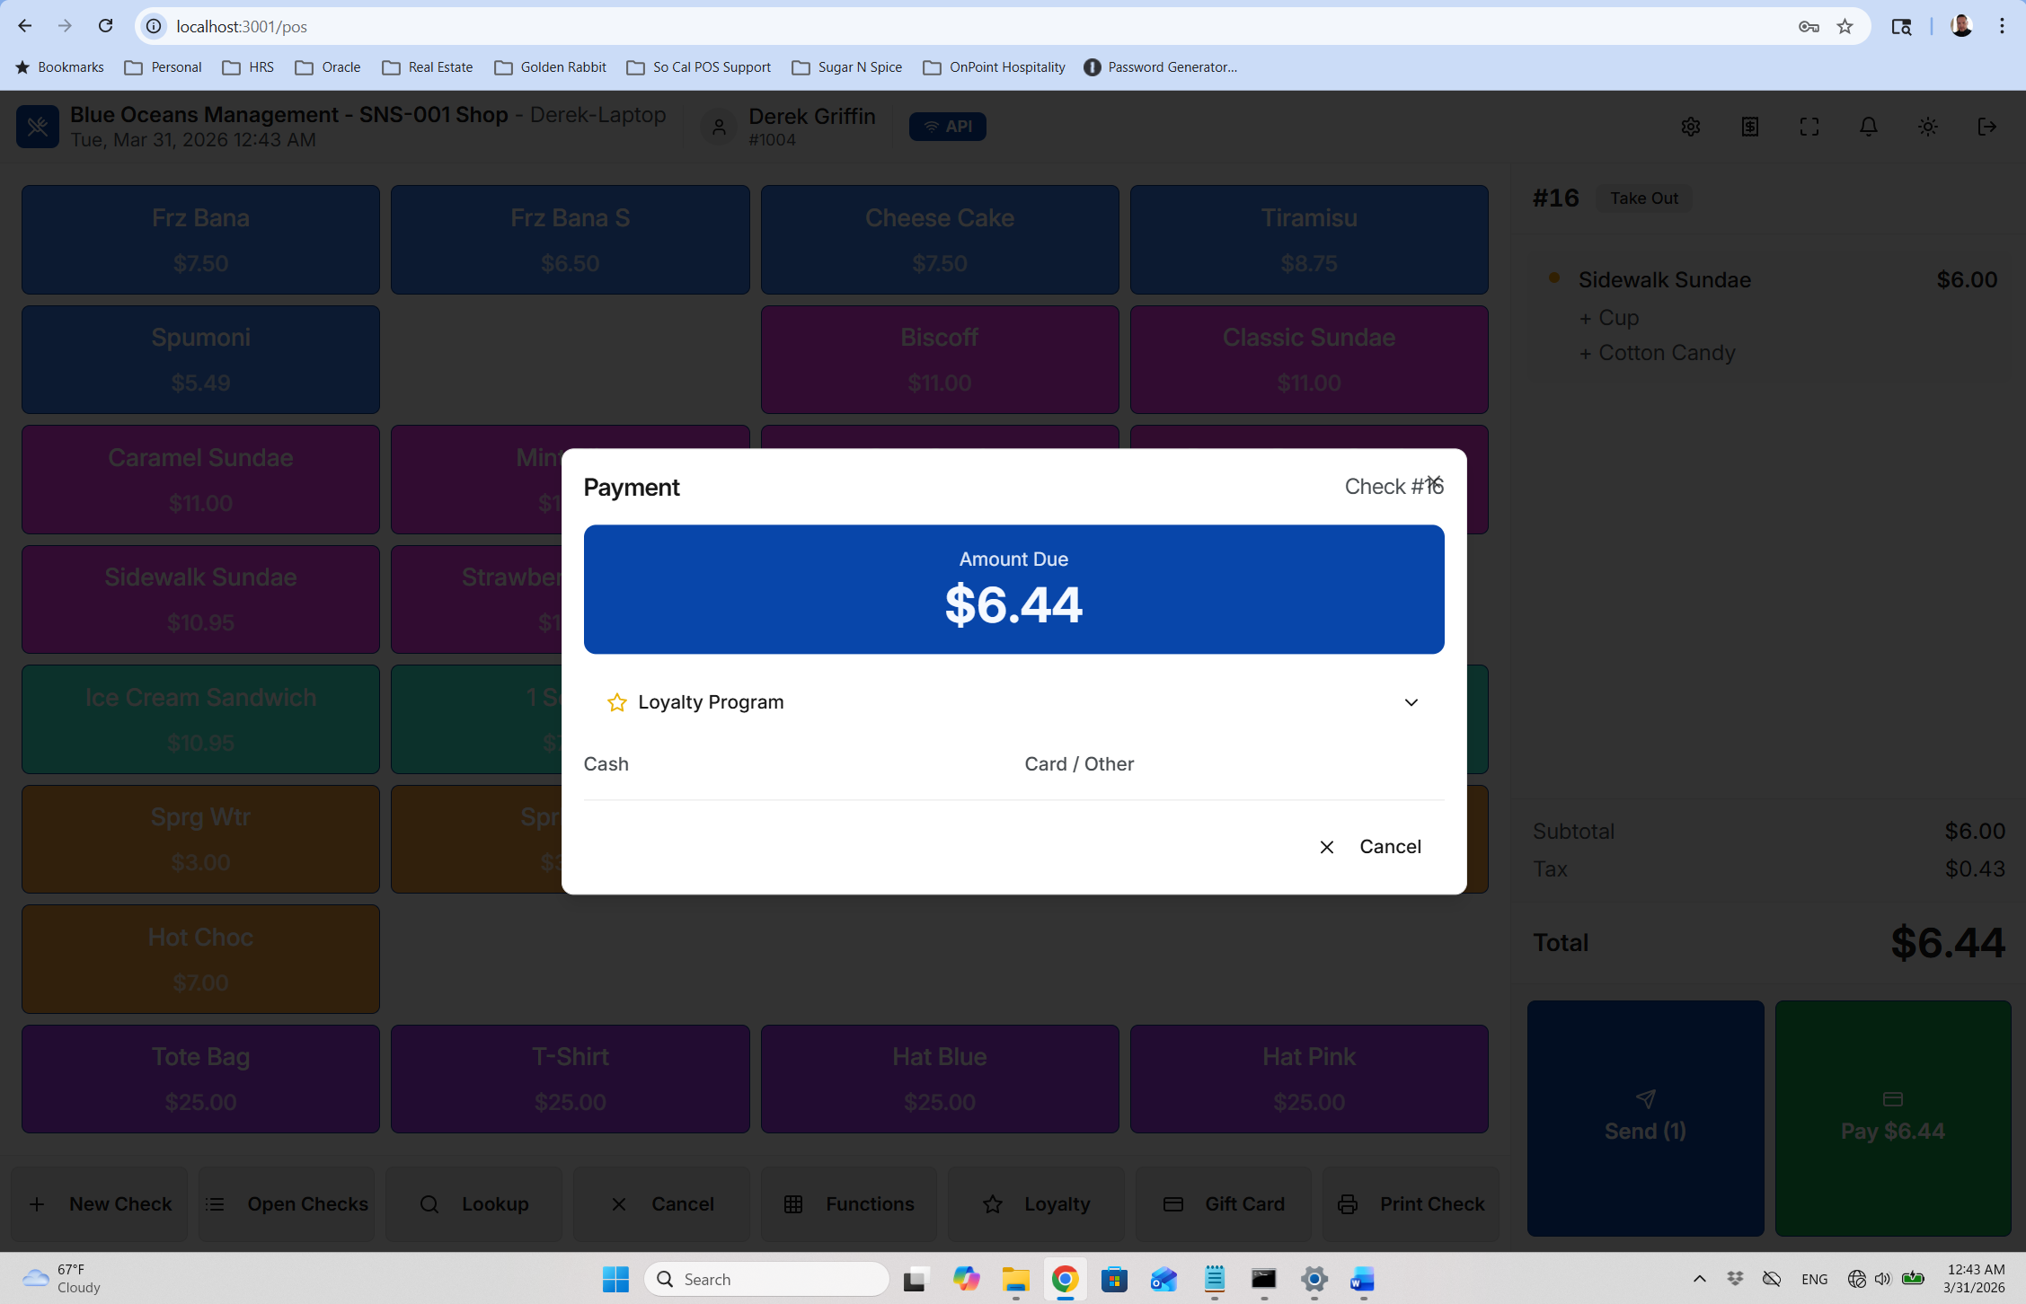
Missing the credit cartd option gift card option missing the quick cash tender 7.00 10.00 20.00 etc so the pay screen looks nothing like hwo it works in cloud

Basically this system is broken

- Login — passed
- Create Check — passed
- Add Items — passed
- Send — passed (did not validate KDS or printing at this time)
- Pickup open check – FAILED
- Check functions
  - Delete item – FAILED
  - Discount – FAILED
  - Price override - PASSED
- Tender (Cash) — FAILED
- Close Check — Unable to test

