Disconnected internet, status bar stayed as green, went to log in got error invalid pin.
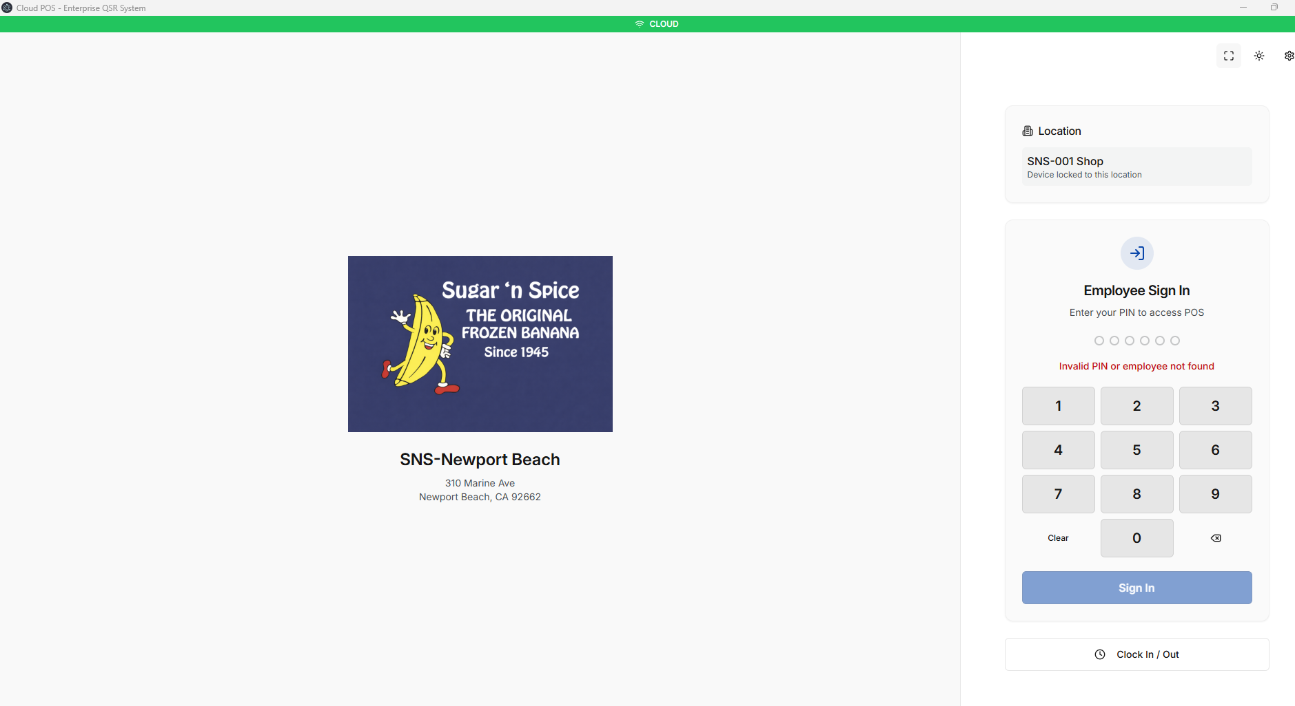
The offline system verification shows me as online?? I run the all api and it shows
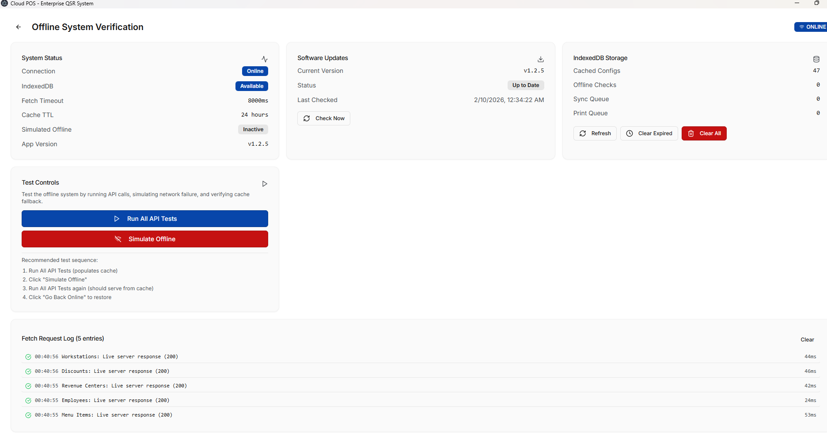

How can the system status show as online when the internet is off the run all api look like im online to cloud not to local db cach.
I close out of the app and re-open I still see a green status bar get invalid id and update shows it failed
