**Stock Market Report  
10-10-19**

**1**

Table of Contents

^DJI......................................................................2  
^GSPC.....................................................................3  
AAPL......................................................................4  
MSFT......................................................................5

**2**

# ^DJI

The daily price movement and volume of ^DJI are shown below. ^DJI opened the day at 26,317.30 and closed the day at 26,462.04 for a gain of 0.550%.

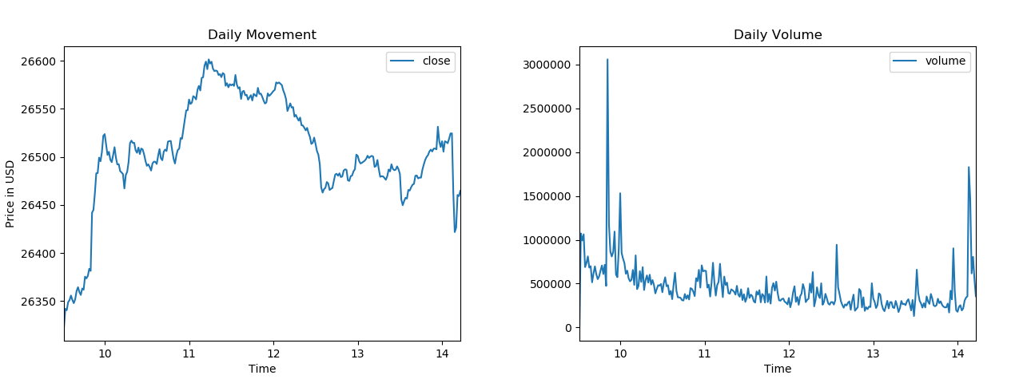

|  |  |  |  |
| --- | --- | --- | --- |
| Previous Close | **26,346.00** | Open | **26,317.30** |
| Volume | **129,976,746** | Day's Range | **26,314.51 - 26,603.31** |

**3**

# ^GSPC

The daily price movement and volume of ^GSPC are shown below. ^GSPC opened the day at 2,918.55 and closed the day at 2,934.95 for a gain of 0.562%.

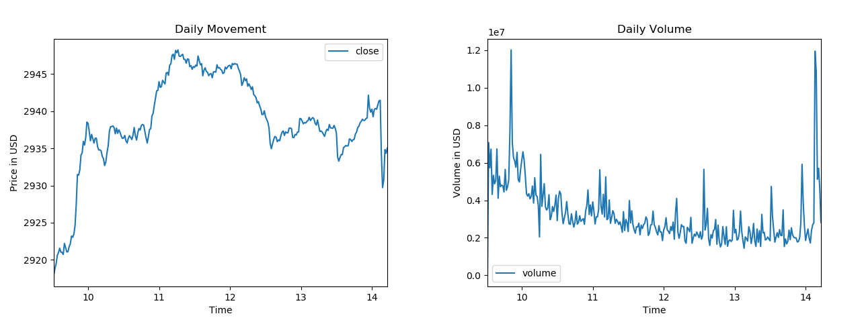

|  |  |  |  |
| --- | --- | --- | --- |
| Previous Close | **2,919.40** | Open | **2,918.55** |
| Volume | **933,925,057** | Day's Range | **2,917.12 - 2,948.46** |

**4**

# AAPL

The daily price movement and volume of AAPL are shown below. AAPL opened the day at 227.93 and closed the day at 229.43 for a gain of 0.658%.

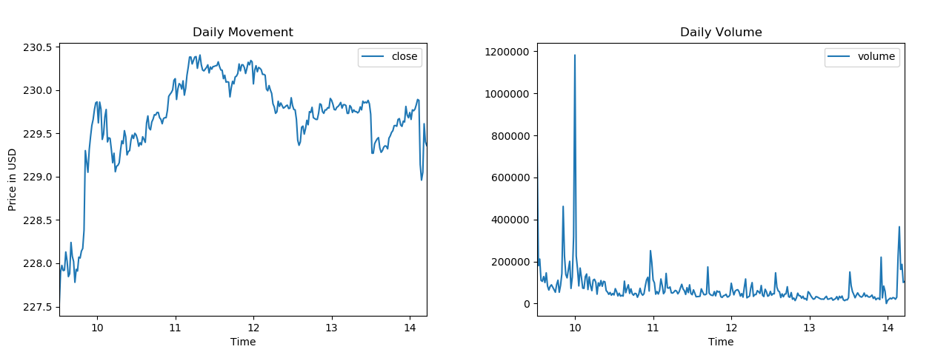

|  |  |  |  |
| --- | --- | --- | --- |
| Previous Close | **227.03** | Open | **227.93** |
| Bid | **229.66 x 1100** | Ask | **229.68 x 800** |
| Ask | **229.68 x 800** | Day's Range | **227.30 - 230.43** |
| Day's Range | **227.30 - 230.43** | 52 Week Range | **142.00 - 230.43** |
| 52 Week Range | **142.00 - 230.43** | Volume | **20,407,866** |
| Volume | **20,407,866** | Avg. Volume | **27,517,484** |
| Avg. Volume | **27,517,484** | Market Cap | **1.037T** |

**5**

# MSFT

The daily price movement and volume of MSFT are shown below. MSFT opened the day at 138.49 and closed the day at 138.75 for a gain of 0.188%.

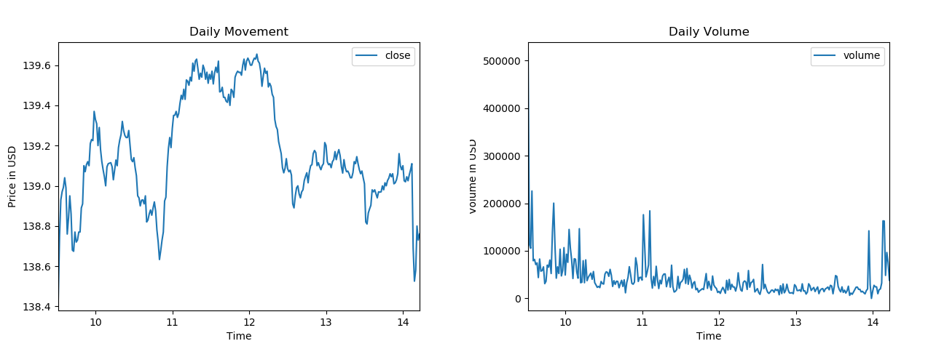

|  |  |  |  |
| --- | --- | --- | --- |
| Previous Close | **138.24** | Open | **138.49** |
| Bid | **139.11 x 800** | Ask | **139.12 x 1000** |
| Ask | **139.12 x 1000** | Day's Range | **138.25 - 139.66** |
| Day's Range | **138.25 - 139.66** | 52 Week Range | **93.96 - 142.37** |
| 52 Week Range | **93.96 - 142.37** | Volume | **11,661,331** |
| Volume | **11,661,331** | Avg. Volume | **24,528,849** |
| Avg. Volume | **24,528,849** | Market Cap | **1.079T** |