# Annex-A

**CropMate: A Smart AI, ML & IoT-Driven Solution for Crop Recommendation and Automated Farm Care**

Final Year Project Proposal

(BSCS)

By

|  |  |  |  |  |
| --- | --- | --- | --- | --- |
| S# | **Name** | **Registration /Roll /Section** | **Mobile** | **E-Mail** |
| 1. | Amna Asad | SP-2022/BSCS/018 | 03006249995 | Sp-2022-bscs-018@lgu.edu.pk |

**Supervised by:**

Sir Umair bin Ahmad **___________________ (**Signature**)**



Department of Computer Science

Lahore Garrison University

Lahore

# **Abstract**

With the help of AI, ML and IoT, CropMate helps farmers make smart choices regarding the crops they plant, how they water and how to fertilise. With data from the NPK, soil moisture, humidity, temperature and rainfall sensors provided in real time, the system transmits environmental values to Firebase. Then, a trained model examines this data and picks the best crop to plant. The findings are presented on a dashboard featuring a chatbot that helps right away with questions on pesticides, fertilisers and other crops. An automated water pump is available to water the plants according to what the soil and environment need which saves water and improves yield from the crops. CropMate is helping modernise farming by introducing clever methods for food production in rural and semi-rural communities.

# **Introduction**

Agriculture in Pakistan deals with a range of difficulties due to unstable weather, poorly managed water and insufficient nutrient use. Many farmers use familiar practises or contact knowledgeable individuals late to pick and manage their crops. Advances in smart technologies mean there is now a chance for AI and IoT to transform farming.

By using sensors, Crop-Mate helps farmers get important real-time data about their land and the weather. Thanks to this information, farmers get personalised advice about which crop to plant and how to water it. Considering both the nutrients in the soil and the condition of the environment connects traditional farming with precision agriculture. These methods help people get more done while using less which enables farming to continue supporting soil health far into the future

# **Problem Statement**

Yet, Pakistan’s farming practises are mostly based on age-old techniques. A big problem is that farmers do not have up-to-date scientific guidance for choosing crops, controlling irrigation and adding fertilisers. As a result of these weaknesses, crop production suffers, water is sometimes either used too much or not enough and the soil frequently loses its nutrients.

Besides, climate change is making it harder for farmers by changing the weather in unpredictable ways. If the data is missing, it can lead to decisions that cost farmers a lot of money and these losses are felt most by those with small or medium-sized farms who lack the funds for professional solutions.

Farmers in rural areas have difficulties getting prompt access to guidance about pesticides, crop diseases or methods of using fertiliser. Because of this lack of information, crops often fail, leading to lasting damage of the environment.

**Target Audience:**

* Small to medium-scale farmers (5+ million in Pakistan)
* Agricultural extension officers
* Government-supported Agri-tech services

**Literature Review**

A range of scientific projects and industry platforms have appeared to help people manage their farming processes using technology. For example, Plantix and Krishi Network allow farmers to recognise problems on their crops and provide useful tweaks for better farming. Even so such systems focus mostly on responding to issues instead of anticipating them and they lack the ability to manage irrigation.

Smart farming practises using IoT and AI have been the focus of recent studies. For example, research shared in IEEE Access and IJETT discusses how sensors and cloud analytics are being used to suggest which crops to plant and cheque the moisture in the soil. However, most implementations are either limited in scope—focusing solely on moisture levels or weather—or lack the integration of real-time soil nutrient (NPK) data, which is critical for accurate crop recommendation.

Additionally, existing tools often ignore the end-user experience. Platforms that are straightforward, offer interaction and deliver useful insights are needed by farmers. The absence of a centralized system that combines environmental sensing, nutrient analysis, predictive modeling, automated irrigation, and user communication (e.g., chatbots) makes most current solutions impractical for widespread deployment.

To tackle this issue, CropMate uses AI, ML and IoT together to advise on what should be grown, handle automatic actions and consistently give helpful guidance to farmers. Because of this approach, leaders make better decisions, do their work more efficiently and improve resource sustainability.

**Project Scope**

CropMate delivers a complete farm care ecosystem including:

In this system, data is acquired instantaneously through sensors for nitrogen, phosphorus, potassium, moisture, humidity, rainfall and soil.

* Cloud storage via Firebase
* Machine learning model for intelligent crop recommendation
* Django web dashboard for displaying predictions and environmental data
* Chatbot for pesticide, fertilizer, and general crop guidance
* Automated water pump controlled by real-time data

**Unique Value:**

* Uses real-time nutrient and environmental data
* Controls irrigation to conserve water
* Provides tailored, actionable insights to farmers

**Hardware Components:**

* NPK Sensor ( Nitrogen–Phosphorus–Potassium )
* Soil Moisture Sensor
* DHT Sensor
* Rain Sensor
* NodeMCU/ESP32 Microcontroller
* Relay Module + Water Pump

**Software Components:**

* Firebase (Cloud database)
* Python (Machine Learning)
* Django (Backend + Dashboard)
* Fine tune LLM (Chatbot)
* HTML/CSS/JavaScript (Frontend)

**Project Development Methodology**

The software development approach will use Agile and concentrate on short cycles and constant integration. We will break the project into separate sprints, so the work is easier to manage, and the results are delivered on time. Having completed one sprint, I will focus on another module, with frequent cheques and updates.

**Tools and Technologies**:

* **Programming Languages and Frameworks:**

1. **Python:** Machine learning and backend development.
2. **Django:** Web development and dashboards creations.
3. **HTML, CSS, JavaScript:** For frontend design.
4. **Firebase:** Handle cloud database.

* **AI Models:**

1. **Machine Learning Base Model:** crop suggestions by analyzing old and current data about the environment (NPK, moisture, humidity, temperature).

* **Hardware:**
  1. **NodeMCU/ESP32:** microcontroller to read sensor’s data and sent to Firebase.
  2. **NPK Sensor:** Checks the amounts of nitrogen, phosphorus and potassium found in the soil.
  3. **Soil Moisture Sensor:** Detects the current soil moisture level used to make irrigation decisions.
  4. **DHT Sensor:** Gives accurate readings of temperature and humidity.
  5. **Rain Sensor:** Checks the rain and changes the irrigation timing.
  6. **Relay Module & Water Pump:** It controls water distribution automatically using important soil and environmental information.
* **Development Environments:**

1. **Arduino IDE**: Programming microcontroller.
2. **Visual Studio Code:** For efficient coding, debugging, and version control.
3. **Dialogflow:** Making and training your chatbot.

**Project Milestones and Deliverables:**

The CropMate project will progress through the following milestones, leading to the development of a system.

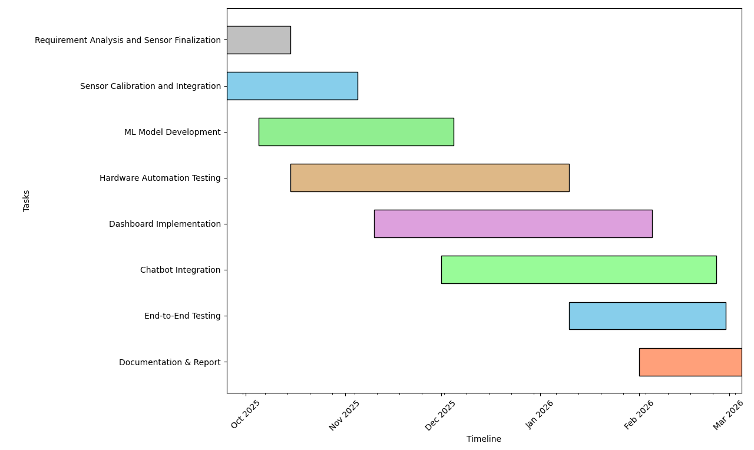

Figure 1 Crop Mate Gantt chart: September 2025 through February 2026

**References**

[1] V. Rani and R. Singh, "IoT and ML-based Crop Recommendation System with NPK and Weather Monitoring," International Journal of Engineering Trends and Technology (IJETT), vol. 68, no. 7, pp. 15–20, 2020.

[2] European Parliamentary Research Service, Precision Agriculture and the Future of Farming in Europe, European Parliament, 2016.

[3] V. R. Khemnar and M. R. Bendre, “Exploring IoT and Machine Learning Integration for Soil Nutrients Monitoring and Crop Recommendation: A Survey,” Computer Science & Engineering: An International Journal, vol. 15, no. 1, pp. 1–10, Mar. 2025.

[4] P. Latha and P. Kumaresan, “Deep Learning for Soil Nutrient Prediction and Strategic Crop Recommendation,” Nature Environment and Pollution Technology, vol. 24, no. 1, pp. 45–52, 2025.

[5] S. Garg, P. Pundir, H. Jindal, H. Saini, and S. Garg, “Towards a Multimodal System for Precision Agriculture using IoT and Machine Learning,” arXiv preprint arXiv:2107.04895, 2021.

[6] G. Deshpande, A. Kshirsagar, R. Suryawanshi, and A. Kale, “IoT-Based Low-Cost Soil Moisture and Soil Temperature Monitoring System,” arXiv preprint arXiv:2206.07488, 2022.

[7] M. Kamilaris, A. Kartakoullis, and F. X. Prenafeta-Boldú, “A review on the practice of big data analysis in agriculture,” Computers and Electronics in Agriculture, vol. 143, pp. 23–37, 2017.

[8] L. Zhang, Y. Zhang, C. Wang, and Y. Wang, “Crop planting recommendation system based on machine learning and Internet of Things,” in Proc. 2021 IEEE Int. Conf. on Big Data (Big Data), pp. 5931–5933.

[9] P. Rawal and P. Shah, “Crop prediction using machine learning and climate data,” International Journal of Innovative Technology and Exploring Engineering (IJITEE), vol. 8, no. 9, pp. 2562–2567, Jul. 2019.

[10] T. Patil, A. Mahalle, and A. Wankhade, “IoT-based smart irrigation and soil nutrients monitoring system,” in Proc. 2021 Int. Conf. on Smart Electronics and Communication (ICOSEC), pp. 1713–1718.

[11] S. S. Lanjewar and S. N. Kale, “A real-time smart irrigation system using a decision tree approach,” in Proc. 2019 2nd Int. Conf. on Intelligent Computing, Instrumentation and Control Technologies (ICICICT), pp. 1382–1386.

[12] F. Wu, X. Li, Y. Zhang, and Y. Ge, “Smart agriculture system design using machine learning and cloud computing,” IEEE Access, vol. 7, pp. 181906–181917, 2019.

[13] M. Jayaraman, V. Balasubramanian, and A. Anitha, “A machine learning model for soil fertility prediction,” Materials Today: Proceedings, vol. 47, pp. 156–161, 2021.

[14] R. Sharma and S. Patel, “Prediction of crop yield using machine learning algorithm,” International Journal of Computer Applications, vol. 178, no. 34, pp. 7–11, Jun. 2019.

[15] K. Chlingaryan, S. Sukkarieh, and B. Whelan, “Machine learning approaches for crop yield prediction and nitrogen status estimation in precision agriculture: A review,” Computers and Electronics in Agriculture, vol. 151, pp. 61–69, 2018.