**NEMO :A Smart AI Robot to Facilitate Everyday Task.**

Final Year Project Proposal

(BSCS)

By

|  |  |  |  |  |
| --- | --- | --- | --- | --- |
| S# | **Name** | **Registration #/Roll #/Section** | **Mobile #** | **E-Mail** |
| 1. | Karimullah | Fa-2021-BSCS-342/E | 03034212419 | fa-21-bscs-342@lgu.edu.pk |
| 2. | Abdul Ahad | Fa-2021-BSCS-349/B | 03014998199 | fa-21-bscs-349@lgu.edu.pk |

**Supervised by:**

Sir Umair bin Ahmad **___________________ (**Signature**)**

**Co Supervisor:**

Sir Hassan Sultan **___________________ (**Signature**)**



Department of Computer Science

Lahore Garrison University

**Abstract**  
NEMO is a state-of-the-art virtual assistant robot, very easy to integrate into the flow of daily life and professional activities. The extended feature set includes advanced conversation skills, virtual mentorship in education, object detection, home automation, image recognition and generation, translation, entertainment, and surveillance. Additionally, NEMO updates news and social media, sets reminders, and enables unique "Follow Me" functions, making the unit act like a loyal pet. Equipped with both very serious AI capabilities and everyday utility functions, NEMO might come to change the concept of personal robotics.  
The project is developed with the use of modern technologies, including Python (FastAPI and Flask), Tailwind CSS, and a Raspberry Pi microprocessor, powered by AI with Llama 3-70B, Mistral 70B, and Gemini 1.0. This proposal summarizes the methodology of the project, its scope, and deliverables, while positioning NEMO as a transformative innovation in personal robotics.

**Introduction**

In today's fast-evolving technological world, artificial intelligence and robotics are playing a very pivotal role in transforming daily life. Many solutions are designed to meet one need or the other, but most lack being comprehensive, versatile, and interactive robots that would be able to serve as companions, educators, and automation tools all at once. NEMO bridges this gap by providing users with a highly functional and intuitive virtual assistant robot.  
NEMO combines advanced AI models with an agile development approach to deliver a very engaging user experience. NEMO addresses the needs for education, home automation, entertainment, and security, among others. Designed to be approachable yet sophisticated, NEMO represents the future of personal robotics, focusing on utility, reliability, and interactivity.

**Problem Statement**

Modern users face challenges in managing their daily tasks, engaging with technology, and accessing accurate information efficiently. Existing solutions lack personalization, versatility, and the capability to act as multi-functional tools, leading to fragmented and cumbersome user experiences. This creates a need for a unified, intelligent assistant robot that combines practicality with cutting-edge technology.

NEMO addresses these challenges by offering an integrated platform for communication, automation, and assistance. Through its conversational abilities, real-time data processing, and interactive features, NEMO empowers users to streamline their daily activities, ensuring convenience, productivity, and engagement.

**Project Scope:**

The scope of our project encompasses several key components and aims to be a versatile and intelligent virtual assistant robot with the following key features:

1. **Conversational Abilities:**

NEMO serves as a smart conversational partner, responding naturally to questions, providing recommendations, and engaging in meaningful discussions to create an interactive user experience.

1. **Educational Assistance:**

NEMO acts as a virtual tutor, offering personalized help with learning, answering academic questions, and providing study resources for users of all ages.

1. **Object Detection:**

With advanced AI, NEMO identifies and interacts with objects, enhancing security and enabling practical uses like locating items or navigating spaces.

1. **News and Social Media Updates:**

NEMO keeps users updated with curated news and tailored social media highlights, ensuring they stay informed and connected effortlessly.

1. **Reminders:**

NEMO simplifies task management by setting reminders for events, tasks, and appointments, ensuring users stay on track.

1. **Home Automation:**

Seamlessly integrates with smart devices to control lights, appliances, and more, making home management intuitive and efficient.

1. **Home Automation:**

Recognizes objects and generates creative visuals, enabling complex visual data analysis and innovative content creation.

1. **Translation Services:**

Supports multilingual communication by providing accurate and instant translations for seamless global interaction.

1. **Entertainment:**

Delivers engaging entertainment, including music, games, and multimedia, to keep users entertained and relaxed.

1. **Surveillance:**

Monitors homes and workplaces, providing real-time alerts for enhanced security and peace of mind.

1. **Follow Me Feature:**

Tracks and follows the user, acting like a loyal companion for constant support and interaction.

**Project Development Methodology:**

The project will follow an agile methodology, allowing iterative development and adaptability to new requirements. The technology stack includes:

* **Programming Languages and Frameworks:**

1. **Python:** FastAPI and Flask for efficient backend development.
2. **Tailwind CSS**: For creating a clean and modern user interface.
3. **JavaScript**: For frontend interactivity and dynamic content.

* **AI Models:**

1. **Llama 3-70B**: For conversational AI and language understanding.
2. **Mistral 70B**: For advanced natural language processing tasks[1].
3. **Gemini 1.0:** For multi-modal AI integration, enabling tasks such as image recognition and generation.

* **Hardware:**

1. **Raspberry Pi:** Acts as the core microprocessor, ensuring seamless integration of hardware and software functionalities[2]

* **Development Environment:**

1. **Visual Studio Code**: For efficient coding, debugging, and version control

This technology stack was selected for its scalability, efficiency, and compatibility with advanced AI and robotics systems. The integration of AI models with a robust backend ensures a seamless and powerful user experience, while the use of Raspberry Pi allows for cost-effective and efficient hardware implementation.

**Project Milestones and Deliverables:**

The NEMO project will progress through the following milestones, leading to the development of a reliable Virtual Assistant Robot

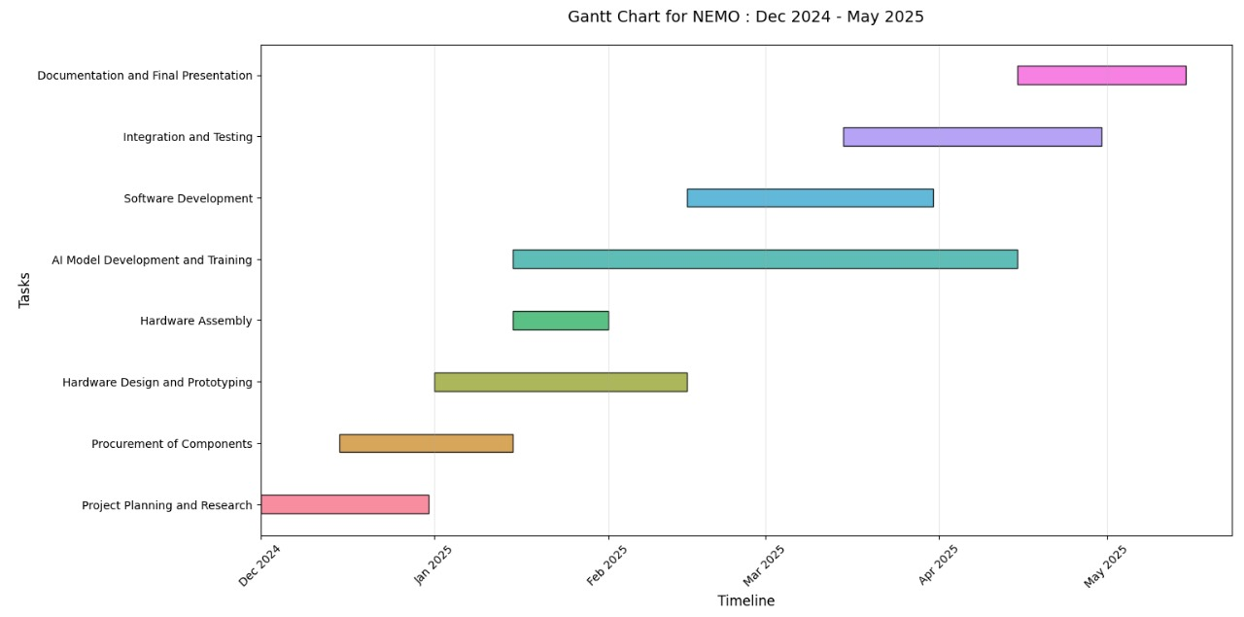

**References**

[1] T. Y. Lin, P. Goyal, R. Girshick, K. He, and P. Dollar, “Focal Loss for Dense Object Detection,” IEEE Trans. Pattern Anal. Mach. Intell., vol. 42, no. 2, pp. 318–327, 2020, doi: 10.1109/TPAMI.2018.2858826.

[2] Z. Bai, “Advancements in robotics engineering: Transforming industries and society,” Appl. Comput. Eng., vol. 32, no. 1, pp. 270–274, Jan. 2024, doi: 10.54254/2755-2721/32/20230861.

[3] X. Zhao, “Research on the application of humanoid robots,” Appl. Comput. Eng., vol. 75, no. 1, pp. 54– 57, Jul. 2024, doi: 10.54254/2755-2721/75/20240507.

[4] K. R. Kunduru, Y. D. Dwivedi, R. Aruna, G. R. Thippeswamy, S. Selvakumar, and M. Sudhakar, “Elevating performance for enhancing AI-powered humanoid robots through innovation,” Appl. AI Humanoid Robot. Ultra-Smart Cybersp., pp. 85–119, Jun. 2024, doi: 10.4018/979-8-3693-2399-1.CH004.

[5] Z. Tabassum, H. Siddiqua, S. Banu, A. Fathima, N. Ayesha, and R. R. Samataray, “The applied artificial intelligence current state-of-the-art and greatest challenges: Applied AI and humanoid robotics,” Appl. AI Humanoid Robot. Ultra-Smart Cybersp., pp. 1–36, Jun. 2024, doi: 10.4018/979-8-3693-2399-1.CH001.

[6] S. Zhao, Z. Jiang, Y. Li, J. Xu, and C. Wang, “Key Components and Future Development Analysis of Humanoid Robots,” 2024 8th Int. Conf. Robot. Control Autom. ICRCA 2024, pp. 140–147, 2024, doi: 10.1109/ICRCA60878.2024.10649218.

1.
2.