This program fills in the missing cells of “Protein groups” and “Gene names” for the MaxQuant output files. It extracts this information by parsing the “Fasta headers” column from the same file. Written in Python 3 by Griffin Calme

1. Copy your ProteinGroups.txt or phospho txt file into the “get_missing_MQ_names” folder
2. Open command prompt (type cmd into windows seach)
3. Type “cd Desktop” hit enter
4. Type “cd Get_missing_MQ_names” hit enter
5. Type “python get_missing_MQ_names” hit enter
6. Then type in the name of your file an enter, or hit enter if it is just the proteinGroups.txt file (default)
7. Fixed file should be saved in the same folder!

Image examples:

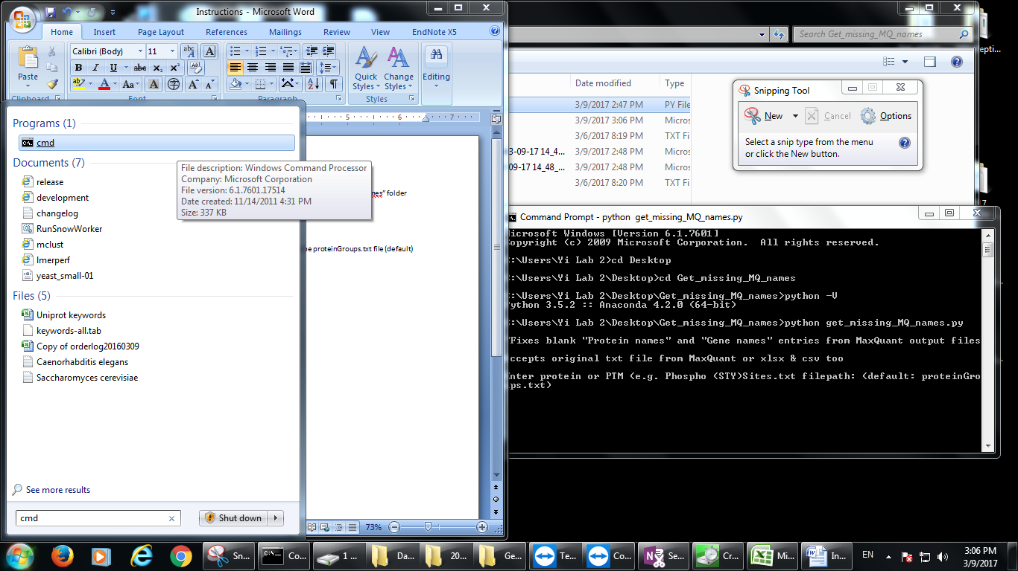

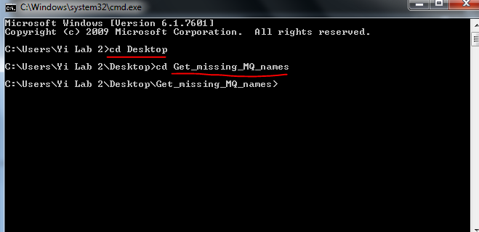

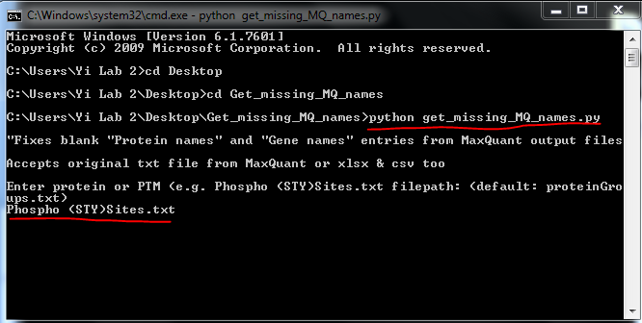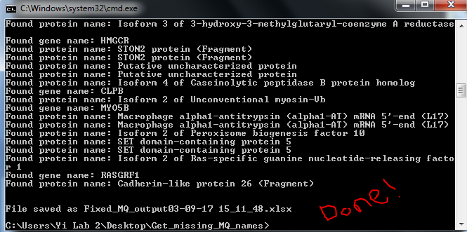

BEFORE

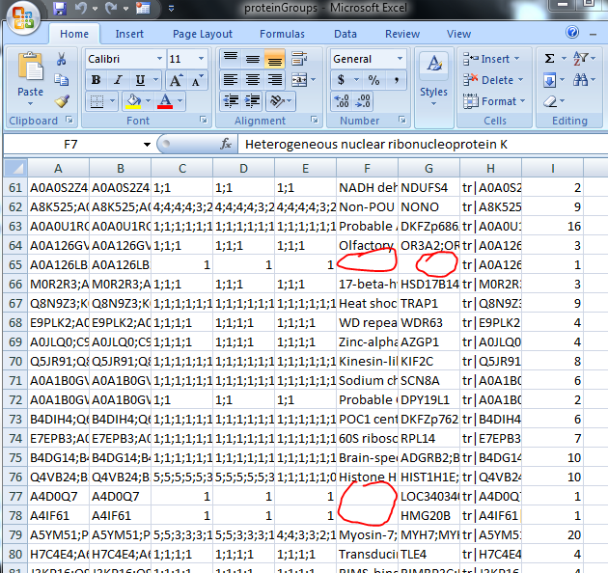

AFTER

