**Contents**

**Individual Work on Further Reearch on Phone Apps 09/20/2012**

Cameras to think about (if they’re released in time)

Nikon COOLPIX S800c 16 MP Digital Camera

Samsung Camera EK-GC100 Galaxy Camera

**APPS:**

**Whiteboard Capture Pro**

This is an iPhone app that takes a picture of a white board and then analyzes it for key content.  
The user selects objects to remove from the photograph. This leaves only the writing on the board behind.

The App then analyzes the writing and removes the background image of the whiteboard itself. This sometimes leaves fuzz or imperfections in the white background, so there is then a slider available to filter out this extra noise/fuzz that shows up in the end product. The resulting image is a pure white background with handwriting on it.  
These photos can then be saved, cropped, shared, and organized within-app tools.

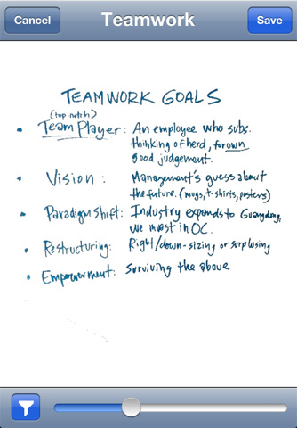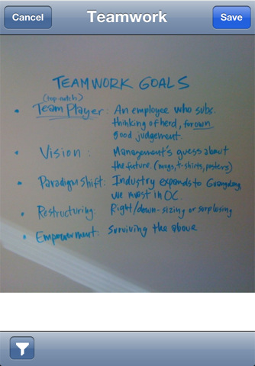

Notice the slider at the bottom of the image on the left. This is the contrast slider that helps remove background noise.

(guesswork)  
Contrast sliders work by analyzing the transition colors between the white and the eventual blue of the writing. The higher the contrast, the faster the transition must be between pure white and pure blue. If the transition is too slow, the transition pixels are assumed to be noise and removed from the photo. This is useful both in making the handwriting appear crisp and in removing random background smudges. Smudges are of course removed because they don’t have the crisp transition periods found in the writing on the board.

(Now back to research)

**WBConference**

This is an Android app that competes with our product because it is another whiteboard capturing device. WBConference differs from Whiteboard Capture Pro in that it is able to automatically recognize which sections of the board are whiteboard. This then allows it to apply its “magnified keystone correction” to remove the excess background imagery. In cases that it cannot recognize the board you can zoom in on just the board boundaries manually before capturing the image. The app has contrast adjustment and image rotation as well so you can take images from any orientation without problems.

This app has editing features as well so you can add postscripts or speech bubbles to the images. The files can then be saved as PDFs along with any notes you want to add to them.  
This app has a widget for the home screen for quick image capturing, and you can set up an email address for quick delivery of the images to an external source.

**CamScanner –Phone PDF Creator**

This is the most downloaded ‘scanner’ app on the market.  
With it you can take photos of any document, whiteboard, etc that you want. You then go through an editing process in which you can select the important portion of the photograph, change the detail level, contrast, light/darkness etc. It will then save your new document in any number of saved folders. You can make notes about each image and these notes will be saved with the image. You can email, print, fax, or transfer via Bluetooth any of the photos. You can also upload your images to google docs, evernote, skydrive, dropbox, or box.net.

These documents get saved as PDFs.

There are different enhancement modes: No enhance, low and high enhance, gray mode, and B&W Document modes. These different modes will be better depending on the environment or object that you’re trying to scan. The B&W mode is particularly helpful when scanning books/papers because it does a better job of removing the background noise.

This app allows for batch photo taking and batch photo scanning, so you can take multiple pictures and it will scan them all at the same time.

You can password protect your documents and even save different document sizes.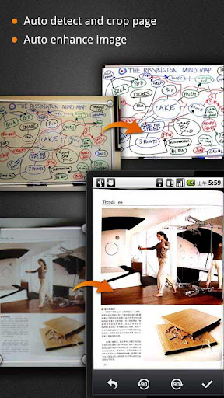

**Whiteboard Snap**

This app is a dumbed down version of the previous three. It does the job, it scans and enhances images, it just isn’t as well known as the others and thus doesn’t have the money/time to invest in extra features.

This aside, it does work, it is free, and it does save images as PDFs for later use. You can email these photos to yourself and store them in different photos. You can attach notes to your images and you can enhance the quality of the whiteboard picture with their auto-enhance tool.  
On the upside, it IS a much smaller program than your avg whiteboard capture app. Over all a smaller lighter free alternative.

I installed this app on my phone and I had trouble using it because it kept crashing.

**Group Meeting with Clients 09/12/2012**

Base System Requirements:

Images must be easy to transfer to the student

Could be sent via email, through a link inviting them to view a different site, net space, etc.

Professor must be able to review the images before okay-ing them for distribution.

Must be able to select different ‘key’ images if they want.

Must be able to enlarge/interact with and edit after export

System should not need to be plugged in.

Set up can be longer the first time as long as you can save the settings so that it doesn’t take so long in the future.

Setup vs. Calibration

Active time vs inactive time

It can take longer to set up if it doesn’t need constant attention. Inactive time to set up is much better than active time.

5 min reasonable

Time stamps of when erasing happens.

Goal #1: End product

#2: Step by step board

**Individual Work on Further Research and Website Content 09/12/12**

*Website Content*

* Added calendars to both the front page and our meetings page.
* Created new ProPANE calendar.
* Added Griffin’s calendar and ProPANE’s calendar to website calendar.

*Further Research*

Found a page that seems to have a piece of demo software available to those with access to Microsoft Research’s internal website:

<http://research.microsoft.com/en-us/um/people/zhang/WhiteboardIt/>

This system takes an image and filters out key information.

The software and technology as a whole is still in its research/development stages. It is a joint project with MS Research and MS Hardware called Distributed Meetings. They have a few technologies going together: A 360 degree video and audio recorder, a Whiteboard image capturing system, (most relevant to us) a PC graphics capture system. Their idea is to record the meeting in several different ways, and then provide easily accessible ways to view all meeting content.

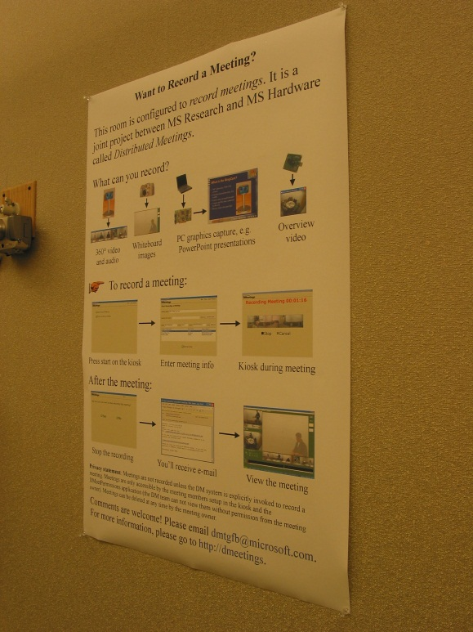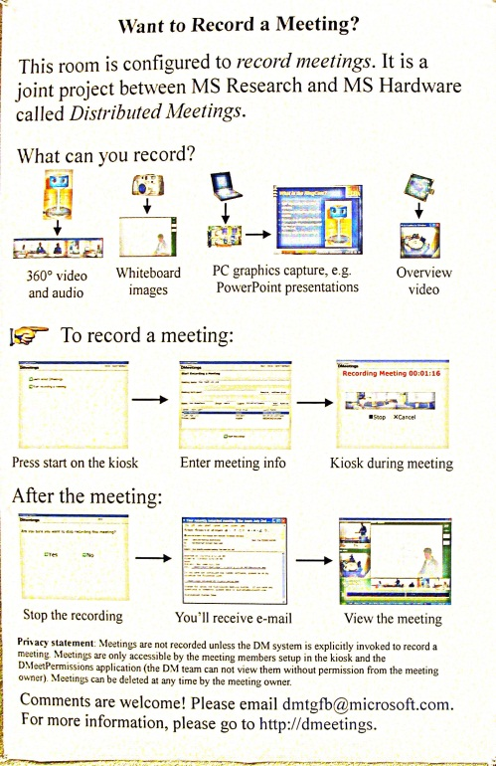

We may wish to contact [dmtgfb@microsoft.com](mailto:dmtgfb@microsoft.com) to ask for more information on their image processing algorithms later on in the process.

I’m not sure how helpful this might be, but here is a link to Ink-Enabled Apps For Tablet PC  
<http://msdn.microsoft.com/en-us/magazine/cc967278.aspx>

<http://www.fxpal.com/?p=reboard>  
<http://arxiv.org/abs/0911.0039>  
The following is a paper that talk about another whiteboard captureing technology called ReBoard:

<http://arxiv.org/ftp/arxiv/papers/0911/0911.0039.pdf>

<http://www.fxpal.com/publications/FXPAL-PR-10-546.pdf>

Additional Apps:

* Whiteboard Capture
* Whiteboard Share
* WBConference
* Whiteboard Snap
* BoardTabla

**Individual Work on Front Page and Bios 09/11/2012**

I first uploaded pictures to the website for our personal biographies.

[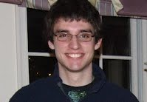](https://sites.google.com/site/bupropane/team/385382_292867657415589_62218325_n.jpg.1347386358762.jpg?attredirects=0) [](https://sites.google.com/site/bupropane/team/317245_285496214796784_1887684652_n.jpg.1347386359691.jpg?attredirects=0) [](https://sites.google.com/site/bupropane/team/323107_3583993486701_359779052_o.jpg.1347386361964.jpg?attredirects=0)

After this I wrote an overview about ProPANE on our front page:

Welcome to the website for the Electrical and Computer Engineering senior design project led by Griffin Dunn, Phil Stahlfeld, and Colin Madigan.

ProPANE's goal is to design and implement a system that will automatically capture all information written on a board during class. This system will then present the saved information in a readily accessible manner so that Bucknell can both better meet the needs of students with disabilities and provide professors with a means to easily compare their notes with the actual information presented in a lecture.

This project was motivated by Bucknell’s desire to cheaply meet the needs of their students with disabilities. Hiring professional note takers is an expensive endeavor and finding cheaper alternatives is much more desirable.

This project involves the capture of information from a 2D surface. It will likely require image capture and image processing technology.

Design Constraints:

ProPANE must be fully autonomous. After setup the system should require little to no outside interference. The professor should be able to turn it on and leave it running during class and afterwards return to find a set of images depicting everything that was on the board during class.

The information must be presented in a format that allows for easy manipulation, zooming, and editing so that students with disabilities can easily view all content that is displayed on the board.

The system must be discreet. It cannot make loud noises, flashes of light, or create any other forms of distraction during class. Students must be able to concentrate on the lecture not the board capture device.

**Individual Work on Competing Technologies 09/05/2012**

We have three technologies to compete with:

1) *The phone app*. There are several smartphone apps out there that will scan pictures of white boards and filter out the unnecessary information. These applications range from free to a couple dollars on most app stores.

http://www.beetlebugsoftware.com/ is a good example.

Other notable apps:

* Qipit White
* Genius Scan
* JotNot Scanner Pro
* Whiteboard Capture Pro

2) *Scanners*. There are scanners that you can attach to an existing white board. After calibrating these scanners, they track your movements using the combination of the sanner and an electronic pen. These electronic pens have replaceable dry erase tips to draw with and replaceable batteries to keep them charged. Some of them require a projector to display background information and others do not.

Examples:

* MimoCapture
* eBeam System 3
* Interlink FreeBeam

3) *Electronic Whiteboards*. Electronic whiteboards are special boards that sense pressure and can display electronic pen interactions with a high degree of accuracy. These displays come in two standard varieties: Those that are electronic displays and those that require a projector to project both the images and any user-inputted writing. Electronic whiteboards tend to be the easiest to use, but they're not very portable because the entire board is required. The trade-off for poor portability is that they can do much more. Multiple people can interact with the board at the same time, and it can be a much more interactive experience.

Examples:

* Smarttech’s SMARTboard
* Panasonic’s Panaboard
* Hitachi’s Starboard
* The Promethean board

**Initial Group Meeting 08/30/2012**

*With Colin Madigan and Phil Stahlfeld*

Began working on group tasks:

* Team Name
* Team Logo
* Document Template
* Design specifications

*Team Name*

After some discussion we decided that names such as ‘White board scanner’ and ‘board capture system’ weren’t catchy enough. We decided to create an acronym instead so to make our name catchier and thus more memorable. Colin finally came up with our final acronym: ProPANE, short for Professional Portable Automatic Note Extractor. With this agreed upon we moved on to deciding upon our team logo.

*Team Logo*

We decided that our logo had to relate to our team name, so with that in mind we searched for images related to the molecular structure of propane. Our favorite image is shown below, and has been adopted as our team logo:

*Document Template*

We decided to use LaTEX as our default layout manager for all of our documents. We chose this formatter because it takes care of all the formatting and leaves us with the job of finding and preparing the information, which is the more important part of our job.

*Technical Specifications*

As noted in our first deliverable, “The goal of this project is to create a system that captures all of the information written on a board during a class in a readily accessible manner. The two driving forces behind solving this problem are: autonomous collection of notes for students with disabilities and providing a means for professors to compare their notes with the actual information presented during a lecture.”

We will be meeting with Robert Midkiff and Douglas Gabauer on 09/13/2013 to discuss more detailed specifications for the project.