Exercise 1.2

I frame average size = 183776

P frame average size = 111412

B frame average size = 36093

Exercise 2.3

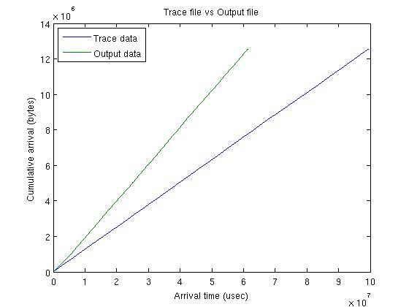

Figure 1: Cumulative arrivals of file data and trace file

The accuracy of the traffic generator can be improved by reading the trace file in one thread and transmitting the created packets in another thread. After these modifications in code, this change has been reflected on Figure 2.

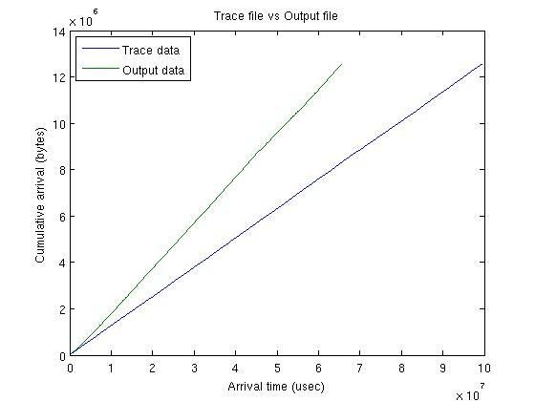

Figure 2: Improved cumulative arrivals of file data and trace file

Exercise 2.4

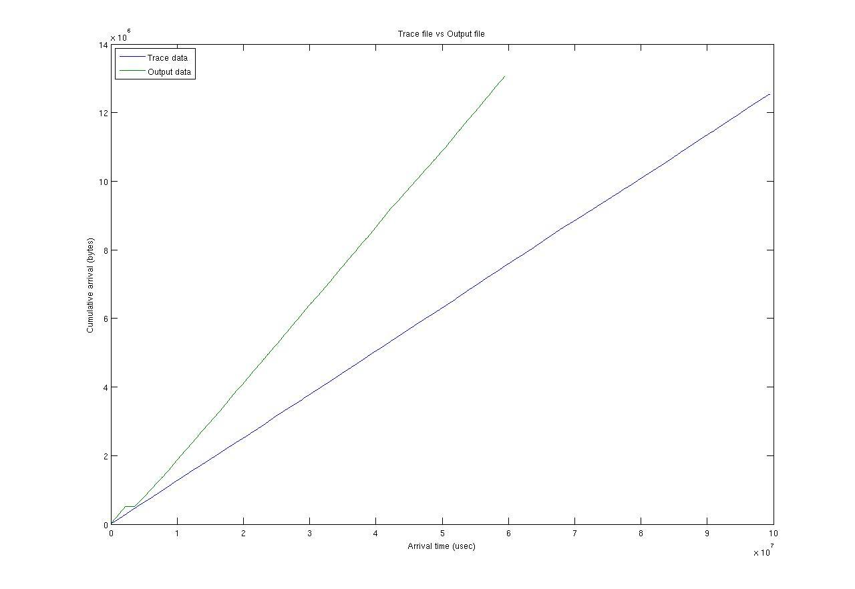

Figure 3: Cumulative arrivals of file data and trace file with packet loss