THECHAISHOP&CO
A CRM APPLICATION
Complete Project Documentation

Salesforce-based Customer Relationship Management System
Customer • Employer • Enterprise • Orders • Billing • Automation • Analytics

Group Members:
1.Arun B (Team Lead)
2.Arun D
3.Arun A
4.Aravind Kumar A
5.Arunachalam H

Table of Contents
1. Introduction
2. Ideation Phase
3. Requirement Analysis Phase
4. Project Design Phase
5. Project Planning & Scheduling
6. Project Development & Implementation
7. Functional & Performance Testing
8. Advantages & Disadvantages
9. Conclusion
10. Future Scope
11. Appendix
12. GitHub Repository Structure

1. Introduction

1.1 Project Overview
The project “A CRM Application for TheChaiShop&Co” focuses on developing a Salesforce-based Customer Relationship Management (CRM) system to manage customer, employer, and enterprise accounts efficiently. The system automates sales processes, maintains customer records, generates reports, and improves customer engagement through automated notifications.

1.2 User Story
As a sales representative at TheChaiShop&Co, I want to efficiently manage customer relationships and streamline sales processes using our CRM application. I want to access and update employer details, distinguish online and offline customer records using record types, automate order quantity and total bill calculations, generate reports and dashboards, and automate birthday email notifications with special offers.

1.3 Purpose
- Streamline customer relationship management
- Automate billing and order calculations
- Improve data accuracy
- Enable data-driven decision-making
- Enhance customer engagement through email automation

2. Ideation Phase

2.1 Problem Statement
Persona | Goal | Problem / Cause | Impact
Sales Representative | Manage customer orders and billing | Manual calculations cause incorrect order quantities and bills | Stressed and inefficient
Store Manager | Monitor sales and customer records | Reports are delayed/incomplete and data is spread across files | Confused and dissatisfied
Customer | Receive personalized offers and updates | No timely automated communication | Disconnected and undervalued

2.2 Empathy Map Canvas
Aspect | Description
Think & Feel | Need accurate customer data and reports
Hear | Feedback from management
See | Multiple registers and spreadsheets
Say & Do | Enter data manually
Pain | Errors, delays, data loss
Gain | Automation, fast reports

2.3 Brainstorming
- Manual CRM system
- Excel-based management
- Web-based CRM
- Salesforce-based CRM
- Automated email system
Selected Idea: Salesforce-based CRM Application for TheChaiShop&Co.

3. Requirement Analysis Phase

3.1 Customer Journey Map
Login → Access CRM Application → Enter Customer Data → Generate Orders → Calculate Bills → View Reports → Decision Making

3.2 Functional Requirements
ID | Requirement
FR-1 | User Login
FR-2 | Object Creation
FR-3 | Data Entry
FR-4 | Billing Automation
FR-5 | Report Generation
FR-6 | Email Automation

3.3 Non-Functional Requirements
ID | Attribute | Requirements
NFR-1 | Usability | Simple UI, clear navigation, easy forms, user-friendly dashboards.
NFR-2 | Security | Role-based access, secure authentication, encrypted storage, backup/recovery.
NFR-3 | Reliability | Automatic saving, regular backups, error handling, stable cloud environment.
NFR-4 | Performance | Fast page loading, quick reports, smooth dashboards, minimal delay.
NFR-5 | Availability | 24/7 access, minimal downtime, cloud hosting, disaster recovery.
NFR-6 | Scalability | Support more users/data, expandable storage, maintained speed.

3.4 Data Flow Diagram
User → Salesforce UI → Custom Objects → Validation Rules → Flows → Reports → Dashboards.

3.5 Technology Stack
Layer | Technology
Frontend | Salesforce Lightning
Database | Salesforce Cloud
Automation | Flows
Backend | Salesforce Platform
Analytics | Reports & Dashboards

4. Project Design Phase

4.1 Problem–Solution Fit
The CRM system replaces manual records with automated data management. Cloud storage prevents data loss, dashboards improve analysis, and real-time reports reduce delays, supporting accurate and timely business insights.

4.2 Proposed Solution
Capability | Description
User Login & Authentication | Secure access using valid credentials.
Customer Record Management | Create, view, update and delete customer details.
Employer & Enterprise Management | Manage employer and enterprise account information.
Order Management | Create and track customer orders, quantities and product details.
Automated Billing | Formula fields calculate order quantity and total bill.
Validation Rules | Validate phone, PAN and Aadhaar-related data.
Record Types & Page Layouts | Separate layouts for online and walk-in customers.
Global Picklists | Standardize gender, items, payment mode and item types.
Email Notification System | Birthday, offer and order-related notifications.
Workflow & Flow Automation | Trigger updates and alerts using Salesforce Flows.
Report Generation | Sales, customer and enterprise performance reports.
Dashboard Visualization | Interactive analytics for management.
Data Backup & Recovery | Secure cloud storage and recovery.
User Role Management | Profiles and permission sets control access.

4.3 Solution Architecture
- Presentation Layer – Lightning UI
- Application Layer – Flows and Logic
- Data Layer – Custom Objects
- Analytics Layer – Reports and Dashboards

5. Project Planning & Scheduling

5.1 Project Planning
- Salesforce Developer account created.
- Custom objects designed for customer, employer and enterprise data.
- Custom tabs and Lightning Application developed.
- Fields, relationships and global picklists configured.
- Page layouts and record types created.
- Validation rules implemented.
- Email templates and automated flows developed.
- Reports and dashboards created.
- Regular sprint reviews and testing conducted.

5.2 Product Backlog
Story | Task | Points | Priority | Sprint
USN-1 | Create Salesforce developer account | 1 | High | Sprint-1
USN-2 | Create Customer, Employer and Enterprise objects | 3 | High | Sprint-1
USN-3 | Create separate tabs | 3 | High | Sprint-2
USN-4 | Create dedicated Lightning App | 3 | High | Sprint-2
USN-5 | Create customer and order fields | 5 | Medium | Sprint-2
USN-6 | Customize page layouts | 5 | High | Sprint-2
USN-7 | Create Online/Walk-In record types | 5 | Medium | Sprint-2
USN-8 | Validate customer and order inputs | 3 | High | Sprint-3
USN-9 | Automate email notifications | 5 | High | Sprint-3
USN-10 | Automate billing calculations | 5 | High | Sprint-4
USN-11 | Create sales/customer reports | 4 | High | Sprint-5
USN-12 | Create visual dashboards | 4 | Medium | Sprint-6

5.3 Sprint Schedule
Sprint | Points | Duration | Start | End | Release / Completion
Sprint-1 | 20 | 6 Days | 24 Oct 2022 | 29 Oct 2022 | 20 / 29 Oct 2022
Sprint-2 | 20 | 6 Days | 31 Oct 2022 | 05 Nov 2022 | —
Sprint-3 | 20 | 6 Days | 07 Nov 2022 | 12 Nov 2022 | —
Sprint-4 | 20 | 6 Days | 14 Nov 2022 | 19 Nov 2022 | —

6. Project Development & Implementation

6.1 Project Flow / Milestones
Milestone 1: Creation of developer account
Milestone 2: Object creation
Milestone 3: Tabs
Milestone 4: The Lightning App
Milestone 5: Global Picklists
Milestone 6: Fields and Relationships
Milestone 7: Page Layouts
Milestone 8: Record Types
Milestone 9: Validation Rules
Milestone 10: Email Templates
Milestone 11: Flows
Milestone 12: Reports and Dashboards
Milestone 13: Conclusion

6.2 Salesforce Objects
Object | Purpose | Key Data
Employer Account | Employer/staff information | Name, gender, phone, email, DOB, Aadhaar, PAN, designation, salary
Customer Account | Customer and sales information | Name, gender, phone, DOB, email, address, products, chai, payment mode, employer
Enterprise Account | Enterprise sales information | Enterprise name, phone, email, address, products, employer, order quantity, total bill, payment mode

6.3 Custom Tabs & Lightning App
The application is named TheChaiShop&Co and uses standard navigation with Customer Accounts, Employer Accounts, Enterprise Accounts, Reports and Dashboards.
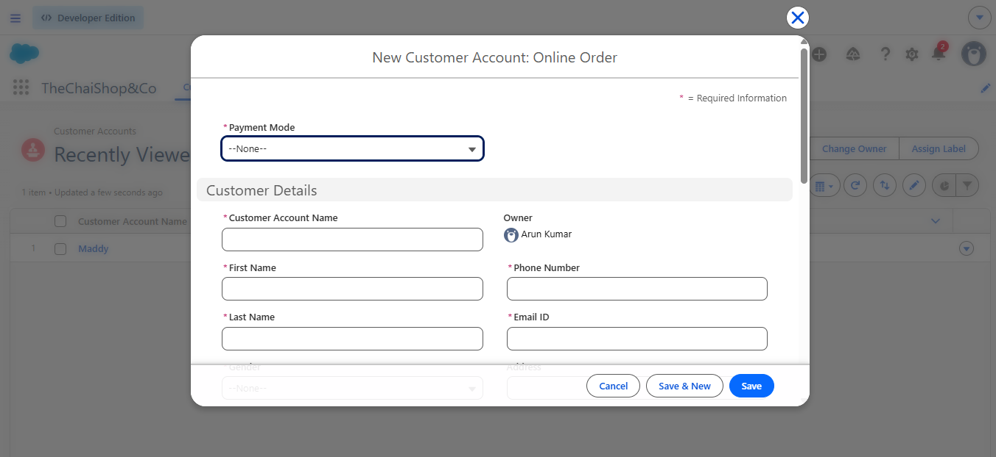
Figure 1. Customer Accounts implementation screen.
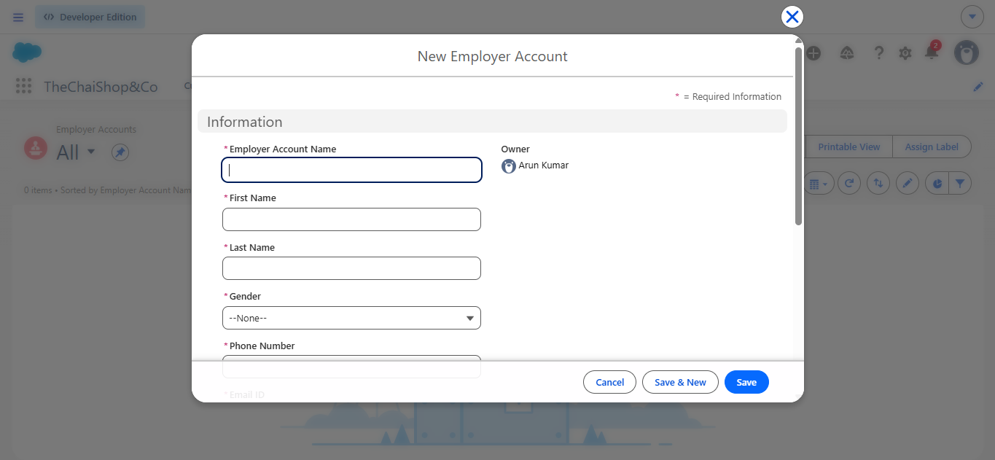
Figure 2. Employer Accounts implementation screen.
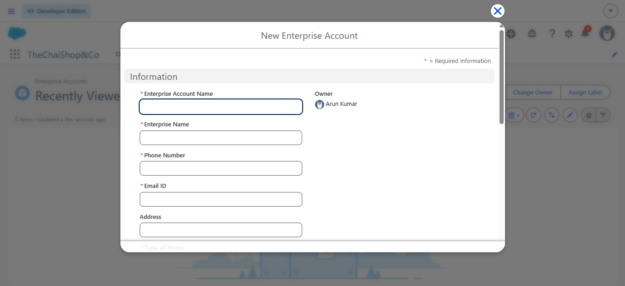
Figure 3. Enterprise Accounts implementation screen.

6.4 Global Picklists
Picklist | Values
Gender | Male; Female; Others
Items | Platinum Tea Powder; Double Delight Tea Powder; Super Dust Tea Powder; Osmania Biscuits (Value Pack); Osmania Biscuits (Premium Pack); Dry Fruit Biscuits; Fruit Biscuits; Salt Biscuits; Multigrain Biscuits; Ragi Biscuits; Double Choco Chip Cookies; Butter Almond Cookies; Melting Moments Cookies; Honey Oats Cookies; Delight Box; Signature Box; Assorted Box
Payment Mode | Gpay; PhonePe; Paytm; Credit or Debit card; Cash
Type of Items | Tea powder; Cookies; Gift Hampers

6.5 Key Customer Fields
Field | Type | Purpose
First Name | Text | Customer first name
Last Name | Text | Customer last name
Gender | Picklist | Standardized value
Phone Number | Phone | Customer contact
Date of Birth | Date | Birthday automation
Date of Birthday is today? | Formula / Checkbox | TRUE when day and month match today
Email ID | Email | Notification recipient
Address | Text | Customer address
Type of Items | Multi-select Picklist | Product category
Products purchased | Multi-select Picklist | Selected products
Chai | Multi-select Picklist | Tea selection
Payment Mode | Picklist | Payment method
Associated Employer | Lookup | Employer relationship
Order Quantity | Formula / Number | Counts selected products/tea items
Total Bill | Formula / Number | Calculates bill from configured prices
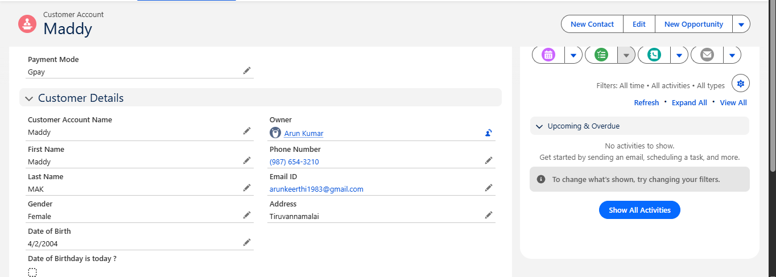
Figure 4. Sample Customer Account record.

6.6 Order Quantity Formula
The source implementation counts each selected product/tea item as one unit using INCLUDES() against Products_Purchased__c and Chai__c.
IF(INCLUDES(Products_Purchased__c, "Platinum Tea Powder"),1,0) + IF(INCLUDES(Products_Purchased__c,"Double Delight Tea Powder"),1,0) + IF(INCLUDES(Products_Purchased__c,"Super Dust Tea Powder"),1,0) + IF(INCLUDES(Products_Purchased__c,"Osmania Biscuits (Value Pack)"),1,0) + IF(INCLUDES(Products_Purchased__c,"Osmania Biscuits (Premium Pack)"),1,0) + IF(INCLUDES(Products_Purchased__c,"Dry Fruit Biscuits"),1,0) + IF(INCLUDES(Products_Purchased__c,"Fruit Biscuits"),1,0) + IF(INCLUDES(Products_Purchased__c,"Salt Biscuits"),1,0) + IF(INCLUDES(Products_Purchased__c,"Multigrain Biscuits"),1,0) + IF(INCLUDES(Products_Purchased__c,"Ragi Biscuits"),1,0) + IF(INCLUDES(Products_Purchased__c,"Double Choco chip Cookies"),1,0) + IF(INCLUDES(Products_Purchased__c,"Butter Almond Cookies"),1,0) + IF(INCLUDES(Products_Purchased__c,"Melting Moments Cookies"),1,0) + IF(INCLUDES(Products_Purchased__c,"Honey Oats Cookies"),1,0) + IF(INCLUDES(Products_Purchased__c,"Delight Box"),1,0) + IF(INCLUDES(Products_Purchased__c,"Signature Box"),1,0) + IF(INCLUDES(Products_Purchased__c,"Assorted Pack"),1,0) + IF(INCLUDES(Chai__c,"TheChaiShop&Co Special Tea"),1,0) + IF(INCLUDES(Chai__c,"Single Tea"),1,0) + IF(INCLUDES(Chai__c,"Masala Tea"),1,0) + IF(INCLUDES(Chai__c,"Lemon Tea"),1,0) + IF(INCLUDES(Chai__c,"Ginger Tea"),1,0) + IF(INCLUDES(Chai__c,"Green Tea"),1,0) + IF(INCLUDES(Chai__c,"Sugar Free Tea"),1,0)

6.7 Total Bill Formula
The configured formula assigns the documented price to each selected item and adds the values. Documented prices: Platinum Tea Powder 175; Double Delight Tea Powder 150; Super Dust Tea Powder 125; Osmania Biscuits Value Pack 50; Premium Pack 80; Dry Fruit Biscuits 110; Fruit Biscuits 160; Salt Biscuits 110; Multigrain Biscuits 170; Ragi Biscuits 190; Double Choco chip Cookies 200; Butter Almond Cookies 110; Melting Moments Cookies 150; Honey Oats Cookies 160; Delight Box 850; Signature Box 1500; Assorted Pack 600; Special Tea 70; Single Tea 50; Masala Tea 60; Lemon Tea 40; Ginger Tea 55; Green Tea 45; Sugar Free Tea 55.

6.8 Page Layouts & Record Types
Two Customer Account page layouts are used: Online Orders and Walk-In Orders. Two active record types map to these layouts: Online Order and Walk-In Order.
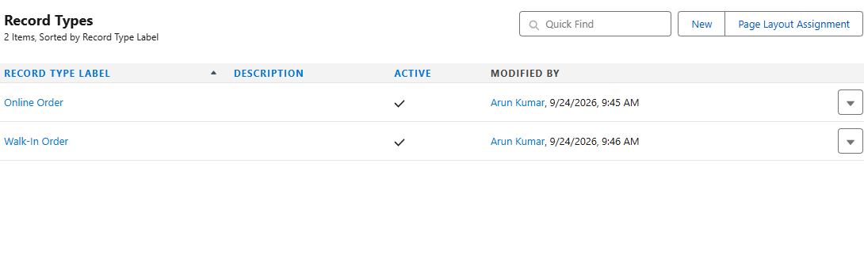
Figure 5. Customer Account record types.

6.9 Validation Rules
Validation is used to prevent invalid phone/Aadhaar-style numeric input according to the configured rules.
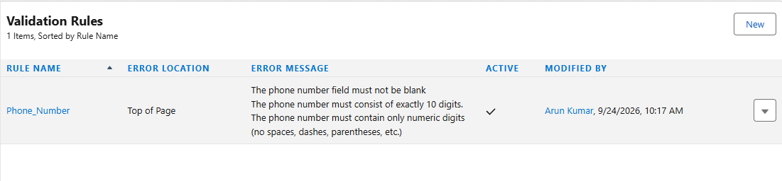
Figure 6. Validation Rules configured in Salesforce.

6.10 Birthday Email Template
Template: Birthday Offer Email. Subject: Special Birthday Offer Inside! The template uses the Customer Account First Name merge field and communicates a birthday discount.
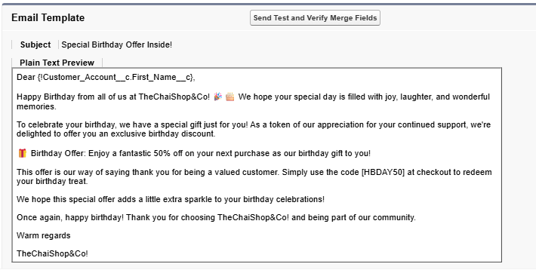
Figure 7. Birthday Offer Email template.

6.11 Birthday Email Alert & Scheduled Flow
The Email Alert uses the Birthday Offer Email template and sends to the customer Email ID. A scheduled-triggered Flow runs daily, selects Customer Accounts where the birthday formula is TRUE and an email address exists, and invokes the Happy Birthday email alert.
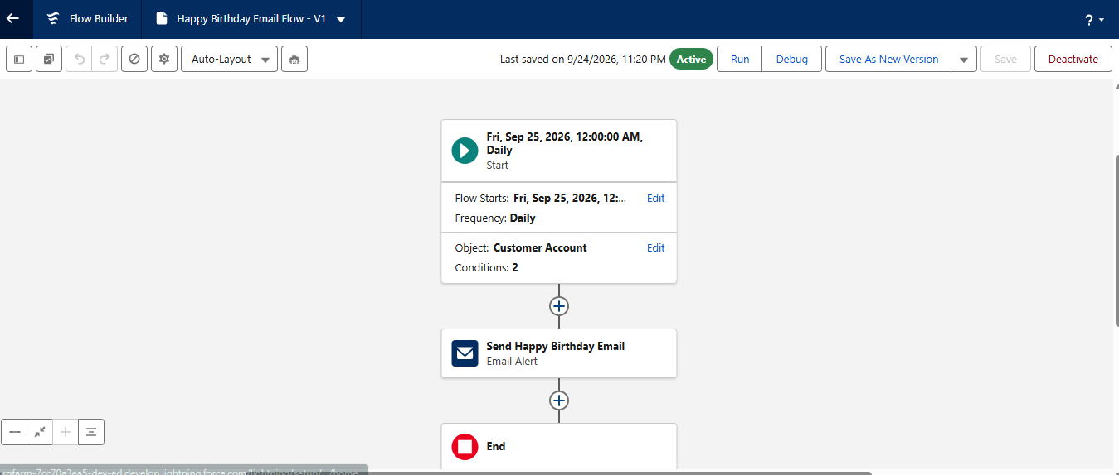
Figure 8. Scheduled Birthday Email Flow.

6.12 Reports
Two reports are configured: Customer Account Sales Report and Enterprise Account Sales Report.
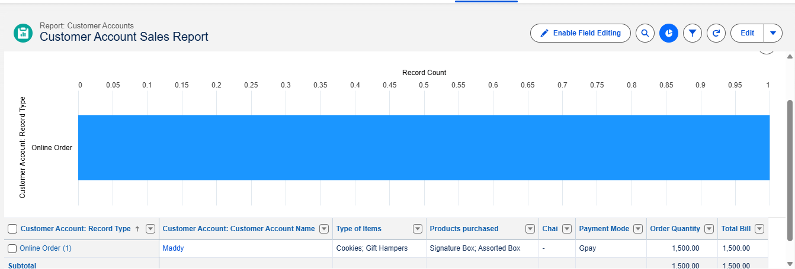
Figure 9. Customer Account Sales Report.
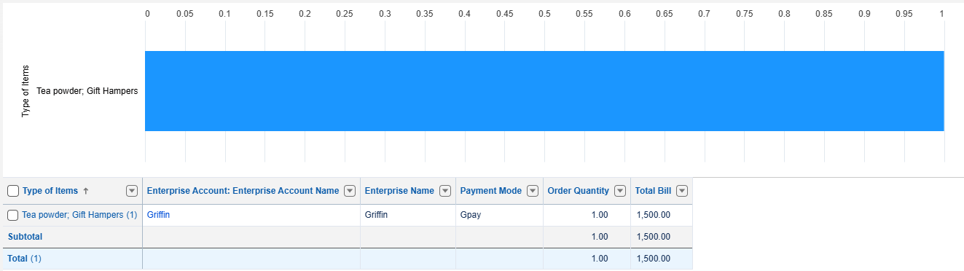
Figure 10. Enterprise Account Sales Report.

6.13 Dashboard
Dashboard: Customer Vs Enterprise Sales. It uses the Customer Account Sales Report and Enterprise Account Sales Report as dashboard components.
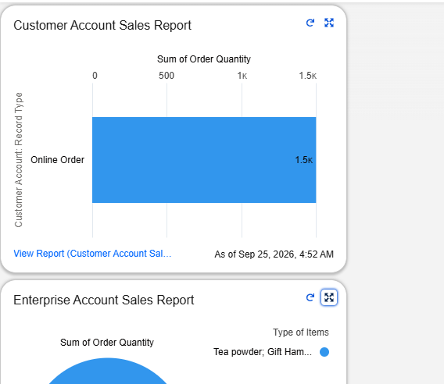
Figure 11. Customer Vs Enterprise Sales Dashboard.

7. Functional & Performance Testing
Test Area | Expected Result | Evidence
Employer / Customer / Enterprise records | Records can be created and displayed with configured fields | Figures 1–4
Record Types | Online Order and Walk-In Order are active | Figure 5
Validation Rules | Invalid input is rejected according to configured rules | Figure 6
Billing formulas | Order Quantity and Total Bill calculate from selected items | Figure 4 + reports
Birthday automation | Daily flow selects birthday customers and sends email alert | Figures 7–8
Reports | Customer and Enterprise reports generate grouped data | Figures 9–10
Dashboard | Customer vs Enterprise sales are visualized | Figure 11
The reference documentation states a performance target of approximately 2–3 seconds for a monthly sales report involving hundreds of customers.

8. Advantages & Disadvantages
Advantages | Disadvantages
Centralized data management | Requires Salesforce license
Reduced manual work | Internet dependency
Automated calculations | Limited offline access
Improved customer engagement
Real-time analytics

9. Conclusion
The CRM Application for TheChaiShop&Co integrates customer data, employer information and enterprise records in a Salesforce environment. Automated billing calculations, validation rules, birthday communication, reports and dashboards reduce manual effort and support structured business operations.

10. Future Scope
- Mobile CRM integration
- AI-based sales prediction
- WhatsApp/SMS alerts
- Inventory management
- Multi-branch support
- Advanced customer profiling

11. Appendix
Item | Details
Source Code | Salesforce Configuration & Flows
Dataset | Customer and Sales Records
Platform | Salesforce Developer Org
UI | Salesforce Lightning

11.1 Implementation Checklist
☐ Developer org created
☐ Employer Account object created
☐ Customer Account object created
☐ Enterprise Account object created
☐ Custom tabs created
☐ TheChaiShop&Co Lightning app configured
☐ Global picklists configured
☐ Custom fields and relationships configured
☐ Online Orders and Walk-In Orders page layouts created
☐ Online Order and Walk-In Order record types created
☐ Validation rules configured
☐ Birthday email template created
☐ Birthday email alert created
☐ Scheduled birthday flow activated
☐ Customer Account Sales Report created
☐ Enterprise Account Sales Report created
☐ Customer Vs Enterprise Sales dashboard created
☐ Functional testing completed

12. GitHub Repository Structure
TheChaiShopCo-CRM/
├── README.md
├── docs/
│ ├── A_CRM_Application_TheChaiShopCo.pdf
│ └── A_CRM_Application_TheChaiShopCo.docx
└── screenshots/
├── 01-employer-accounts.png
├── 02-customer-accounts.png
├── 03-enterprise-accounts.png
├── 08-record-types.png
├── 09-sample-customer-account.png
├── 09-validation-rules.png
├── 10-birthday-email-template.png
├── 11-birthday-email-flow.png
├── 12-customer-account-sales-report.png
├── 12-enterprise-account-sales-report.png
└── 13-customer-vs-enterprise-sales-dashboard.png

