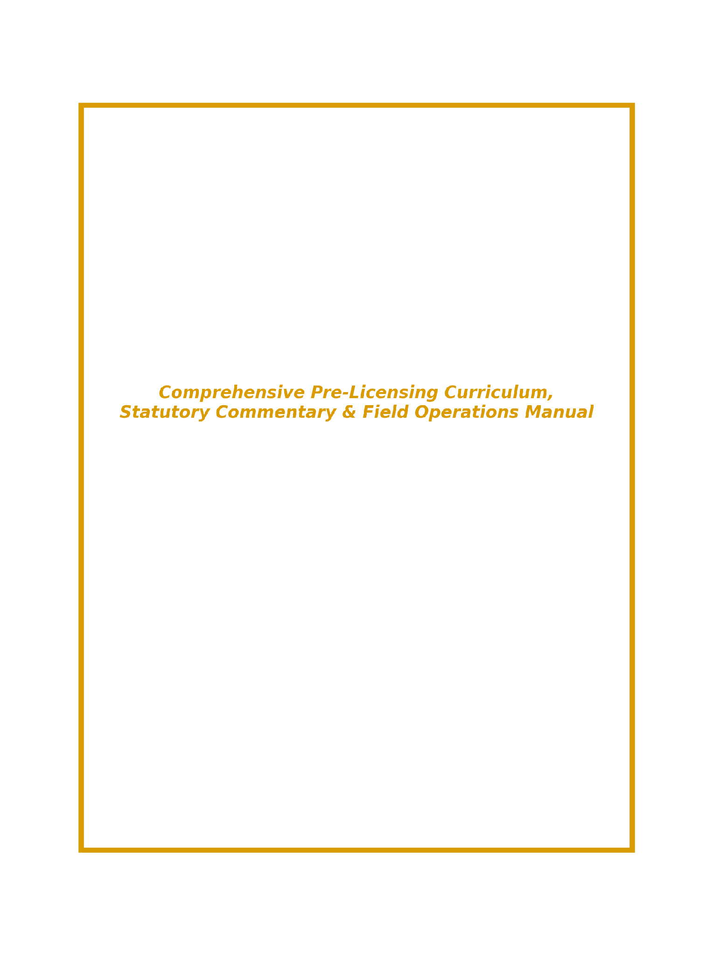

MISSOURI BAIL BOND & SURETY RECOVERY AGENT MASTER TEXTBOOK
INSTRUCTOR MASTER MANUAL

MISSOURI BAIL BOND & SURETY RECOVERY AGENT MASTER TEXTBOOK
Comprehensive Pre-Licensing Curriculum, Statutory Commentary & Field Operations Manual
EDITION 1 • 2026
AUTHORS
Krystal Allen & Travis Griffin
EDITORS
[Lead Curriculum Editor]
[Legal Review & Statutory Compliance Editor]
PUBLISHER
[Educational Publishing House Placeholder]
[Jefferson City, Missouri]

COPYRIGHT & PUBLICATION DETAILS
Missouri Bail Bond & Surety Recovery Agent Master Textbook: Comprehensive Pre-Licensing Curriculum, Statutory Commentary & Field Operations Manual (Edition 1).
Copyright © 2026 by Krystal Allen & Travis Griffin. All rights reserved.
Published in the United States of America. No part of this publication may be reproduced, stored in a retrieval system, or transmitted in any form or by any means—electronic, mechanical, photocopying, recording, or otherwise—without prior written permission of the authors and publisher, except in the case of brief quotations embodied in critical reviews or educational coursework.
ISBN-13: [ISBN 978-1-56974-000-0 - PLACEHOLDER]
Publisher: [Educational Publishing House Placeholder - Jefferson City, MO]
Publication Date: 2026 Edition (First Printing)
DISCLAIMER OF LEGAL LIABILITY: This textbook is designed solely as an educational pre-licensing guide under 20 CSR 700-6.150 and RSMo Chapters 374 and 544. While every effort has been made to ensure statutory accuracy, state regulations and court rules are subject to legislative amendment and judicial interpretation. This text does not constitute formal legal advice. Practitioners must consult active Missouri Revised Statutes, the Missouri Department of Commerce and Insurance (DCI), and licensed legal counsel for binding legal guidance.

TABLE OF CONTENTS SUMMARY
PREFACE & INSTRUCTIONAL ARCHITECTURE
UNIT 1: FOUNDATIONS OF BAIL, INTAKE & STATE REGULATION
Chapter 1: Ground Zero Foundations — What is Bail? — Baseline Concepts, Penal Bonds, Tripartite Contracts & Intake
Chapter 2: State Regulatory Oversight — RSMo Chapter 374 & 20 CSR 700 — DCI Authority, Licensing, Prohibited Acts & Fiduciary Collateral
UNIT 2: CRIMINAL PROCEDURE, JUDICIAL RULES & BOND FORFEITURES
Chapter 3: Criminal Code Mechanics — RSMo Chapter 544 — Recognizance, Public Safety Bail Denials & Surrender Procedures
Chapter 4: Judicial Release Rules — Supreme Court Rule 33 — Arrest Warrants, 4-Step Forfeitures, Writs of Scire Facias & Rule 33.16
UNIT 3: FUGITIVE RECOVERY, FIELD TACTICS & LEGAL LIABILITY
Chapter 5: Legal Rights & Constitutional Limits — Taylor v. Taintor Common Law vs. 4th Amendment Payton Directives
Chapter 6: Field Apprehension Tactics, OSINT & Safety Equipment — Digital Skip Tracing, LE Pre-Notification & Tactical Gear
Chapter 7: Use of Force, Custody Logistics & Legal Liability — Graham v. Connor Standards, Transport Safety & Risk Management
UNIT 4: END-TO-END BUSINESS OPERATIONS & PRACTICE
Chapter 8: The Complete Life Cycle of a Bail Bond Transaction — 8-Stage Operational Workflow Roadmap & Case Studies
BACK MATTER & APPENDICES
Appendix A: Comprehensive Glossary of Statutory & Bail Terminology — Alphabetical Legal & Industry Dictionary
Appendix B: Extra Reference Materials, Forms & Data Tables — Sample Form B1, Form BR, Indemnity Contracts & Property Receipts
Appendix C: Bibliography & Academic References — Missouri Statutes, Court Rules, Case Law & DCI Guidelines
Appendix D: Alphabetical Subject & Statutory Index — Topic & Statute Locator
Appendix E: Master Assessment Keys & Score Tracker — Student Score Sheet / Instructor Master Solution Key

PREFACE & INSTRUCTIONAL ARCHITECTURE
Welcome to the Missouri Bail Bond & Surety Recovery Agent Master Textbook (Edition 1, 2026). This comprehensive manual serves as the primary educational authority for individuals preparing to enter the bail bond and fugitive recovery professions in Missouri. Regulated by the Missouri Department of Commerce and Insurance (DCI) under Title 20 of the Code of State Regulations (20 CSR 700-6.150) and Revised Statutes of Missouri (RSMo) Chapters 374 and 544, the bail bond profession demands a rigorous blend of legal knowledge, administrative meticulousness, ethical integrity, and field safety protocols.
The State of Missouri mandates a minimum of 24 hours of initial basic pre-licensing education prior to sitting for the state examination administered through Pearson VUE. This textbook is specifically engineered to meet and exceed every objective established in the state curriculum outline, providing deep contextual analysis, statutory commentary, historical case law foundations, practical forms, and field tactics.
INSTRUCTIONAL ARCHITECTURE & PEDAGOGICAL DESIGN:
To maximize retention and real-world application, each unit and chapter in this textbook utilizes a structured pedagogical framework:
1. 🎯 Section & Chapter Learning Objectives: Clear, measurable outcomes establishing what learners must master prior to advancing.
2. 📜 Unabridged Statutory Analysis & Context: Section-by-section breakdowns of RSMo 374, RSMo 544, and Supreme Court Rule 33, explaining not only what the law mandates, but the legal intent behind it.
3. 💡 Practitioner Callouts & Warnings: Highlighting critical administrative requirements, common compliance pitfalls, and liability traps.
4. 📖 Applied Case Studies & Real-World Examples: Detailed legal scenarios illustrating how state statutes and court rules govern daily operations.
5. 📊 Visual Diagrams, Flowcharts & Tables: Architectural models, workflow timelines, and force continuum pyramids mapping complex processes.
6. 📌 Section Knowledge Checks & Chapter Assessments: Review questions and multi-part scenario exercises to evaluate comprehension.

UNIT 1: FOUNDATIONS OF BAIL, INTAKE & STATE REGULATION
CHAPTER 1
Ground Zero Foundations — What is Bail?
Baseline Concepts, Penal Bonds, Tripartite Contracts & Intake Mechanics
🎯 CHAPTER 1 LEARNING OBJECTIVES
1. Define the legal nature of a bail bond as a financial guarantee and penal contract submitted to a Missouri court.
2. Diagram and explain the Tripartite Contract Model (Principal, Obligee, Obligor/Surety, Indemnitors).
3. Compare the four primary types of pretrial release in Missouri: Own Recognizance (OR), Full Cash, 10% Cash Deposit, and Commercial Surety Bond.
4. Conduct a thorough intake application, gathering 10-year employment/residency histories for flight risk assessment and skip tracing.
5. Properly execute indemnity agreements, real estate Deeds of Trust, non-technical collateral receipts (RSMo 374.719), and Power of Attorney (POA) jail deliveries.

1.1 The Legal Definition & Purpose of Bail
At its core, bail is a constitutional mechanism designed to balance two competing societal interests: the presumption of innocence guaranteed to criminal defendants prior to conviction, and the compelling necessity of the state to ensure that accused individuals appear in court to face criminal charges. In Missouri, the right to bail is anchored in Article I, Section 20 of the Missouri Constitution, which mandates that all persons shall be bailable by sufficient sureties, except for capital offenses when the proof is evident or the presumption great.
A commercial bail bond is not a fee paid for freedom; it is a penal financial guarantee submitted to a judicial court. When a licensed bail bond agent writes a bond, they execute a legal undertaking pledging that if the defendant (the principal) fails to appear at any required court proceeding, the agent and their general agent/surety company will forfeit the full monetary face amount of the bond to the court.
THE TRIPARTITE CONTRACT ARCHITECTURE:
Unlike standard two-party commercial contracts, a commercial bail bond involves a complex tripartite contractual structure consisting of three distinct legal relationships:
• Obligee (The Court / State of Missouri): The judicial entity holding authority over the criminal charges. The obligee receives the financial guarantee and enforces compliance.
• Principal (Criminal Defendant): The accused individual released from physical incarceration in exchange for the financial guarantee and conditional release terms.
• Obligor / Surety (Bail Bond Agent & General Agent): The licensed professional guarantor who executes the bond instrument, assuming financial liability and legal custody over the principal.
• Indemnitors (Co-Signors): Third parties (family members, employers, friends) who execute a secondary Master Indemnity Agreement agreeing to hold the bail agent harmless and reimburse all loss, fees, and recovery expenses if the principal defaults.
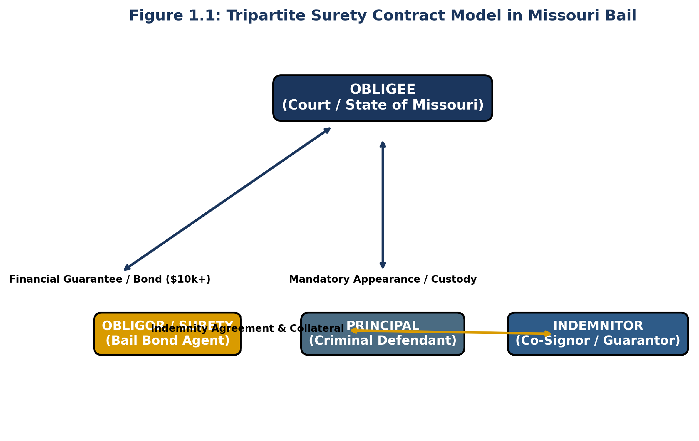
Figure 1.1: Visual Model of the Tripartite Surety Contract Architecture in Missouri Bail
1.2 Types of Pretrial Release in Missouri
Missouri courts utilize four primary mechanisms for granting pretrial release under Supreme Court Rule 33.01 and RSMo Chapter 544. Understanding these distinctions is critical for bail agents during intake assessment:
1. Own Recognizance (OR) Release: Release granted based solely on the defendant's signed unsworn promise to appear. No monetary security or commercial surety is required. Used primarily for low-level non-violent offenses.
2. 100% Full Cash Bond: The court requires the full monetary face amount of the bail (e.g., $50,000) to be deposited in cash directly with the court clerk. If the defendant appears, the cash is refunded (less court administrative fees). Commercial agents do not write cash bonds.
3. 10% Cash Deposit to the Court: The court allows the defendant or a friend/family member to deposit 10% of the total bail amount in cash directly with the court clerk. Upon successful case completion, up to 90% of that deposit is returned to the payer. If the defendant fails to appear, the court issues a judgment for the remaining 90%.
4. Commercial Surety Bond: The defendant contracts with a licensed Missouri bail bond agent. The agent charges a non-refundable premium fee (statutorily set, typically 10%) and posts a financial guarantee (backed by an approved Power of Attorney or qualifying property asset) for 100% of the bail amount.
1.3 Intake Application, Background Tracing & Collateral Management
The intake application is the foundation of risk management in commercial bail. A complete application serves two crucial purposes: underwriting the financial risk of default and establishing an extensive tracing roadmap in the event of a skip.
MANDATORY INTAKE DATA REQUIREMENTS:
Bail bond agents must require applicants and co-signors to go back at least 10 years on employment history, personal references, and residential addresses. When defendants fail to appear, they almost invariably seek shelter or assistance from established social networks, former employers, or family members. Capturing these historical nodes at intake provides immediate leads for recovery agents.
REAL ESTATE COLLATERAL & THE JOINT-OWNERSHIP TRAP:
When taking real estate property as collateral (via a Deed of Trust), every single titled owner of the property must sign the Master Indemnity Agreement and Deed of Trust. If a husband and wife hold joint title to a parcel of real estate and only the husband signs the indemnity contract, a court judgment obtained after a forfeiture cannot attach to or foreclose upon the property.
FIDUCIARY COLLATERAL RECEIPTS (RSMo 374.719):
Under RSMo 374.719, all collateral accepted by a bail bond agent must be held in a fiduciary capacity and physically segregated from personal assets. Agents must issue an immediate pre-numbered receipt. When accepting physical personal property (such as jewelry), agents MUST NEVER use technical terms unless certified. For example, write 'yellow metal band with one clear stone,' NEVER '14K gold diamond ring.' Describe all pre-existing scratches, damage, or defects to prevent false claims upon return.
📖 CASE STUDY 1.1: The Unsigned Deed of Trust Disaster
Scenario: An agent posted a $25,000 surety bond for Defendant Jones. As collateral, Jones's mother offered a home valued at $120,000. The agent drafted a Deed of Trust but only obtained the signature of Jones's mother, failing to note that Jones's stepfather was also listed on the recorded county property deed.
Outcome: Defendant Jones skipped court, and a $25,000 forfeiture judgment was entered against the agent. When the agent attempted to foreclose on the mother's home, the Circuit Court dismissed the action because tenancy by the entirety required both spousal owners to execute the encumbrance.
Key Takeaway: Always pull county assessor deeds prior to executing real estate collateral. All titled owners must execute the indemnity contract and encumbrance instrument.

📌 SECTION 1.3 KNOWLEDGE CHECK
Question: Under RSMo 374.719, how must a bail bond agent describe a ring accepted as collateral on an official receipt?
A) '18K solid gold diamond ring valued at $2,000'
B) 'Yellow metal band with clear stone, noting existing scratches on band'
C) 'Precious gemstone jewelry item'
D) 'Generic personal property deposit'
✓ CORRECT ANSWER: B. Agents must use non-technical physical descriptions and document defects to avoid fraudulent claims upon return.

CHAPTER 2
State Regulatory Oversight — RSMo Chapter 374 & 20 CSR 700
DCI Authority, Licensing, Prohibited Acts & Fiduciary Collateral Rules
🎯 CHAPTER 2 LEARNING OBJECTIVES
1. Identify the legislative powers and regulatory scope exercised by the Missouri Department of Commerce & Insurance (DCI).
2. Master all statutory definitions under RSMo 374.700 (Bail Bond Agent, General Agent, Surety Recovery Agent).
3. Understand licensing qualifications, examination procedures, and $10,000 assignment of savings under RSMo 374.715.
4. Enforce strict compliance with RSMo 374.717 prohibited acts (steering legal defense, paying jailer kickbacks).
5. Comply with pre-apprehension local police dispatch notification mandates under RSMo 374.757 and monthly unsatisfied judgment affidavits under RSMo 374.760.

2.1 Legislative Authority of the Missouri DCI
The Missouri Department of Commerce and Insurance (DCI), headed by the Insurance Director, exercises primary administrative, licensing, and disciplinary jurisdiction over all commercial bail bond agents, general bail bond agents, and surety recovery agents operating in the state under RSMo 374.695 through 374.789 and Title 20 of the Code of State Regulations (20 CSR 700-6.100 et seq.).
The DCI possesses broad statutory powers to inspect business records, audit collateral escrow accounts, investigate consumer complaints, issue subpoenas, administer examinations, and file formal disciplinary complaints before the Administrative Hearing Commission (AHC) under RSMo 374.755 and 20 CSR 800-1.020.
STATUTORY DEFINITIONS (RSMo 374.700):
• Bail Bond Agent: An individual licensed by the DCI to write, execute, and solicit bail bonds on behalf of a licensed General Bail Bond Agent or insurance company.
• General Bail Bond Agent: An individual or corporation licensed by the DCI who meets statutory financial asset qualifications ($10,000 assignment) and appoints/supervises individual bail bond agents.
• Surety Recovery Agent: An individual licensed by the DCI strictly to locate, track, detain, and apprehend fugitives who have breached bail contracts or absconded. Recovery agents CANNOT solicit or write bail bonds unless independently licensed as bond agents.
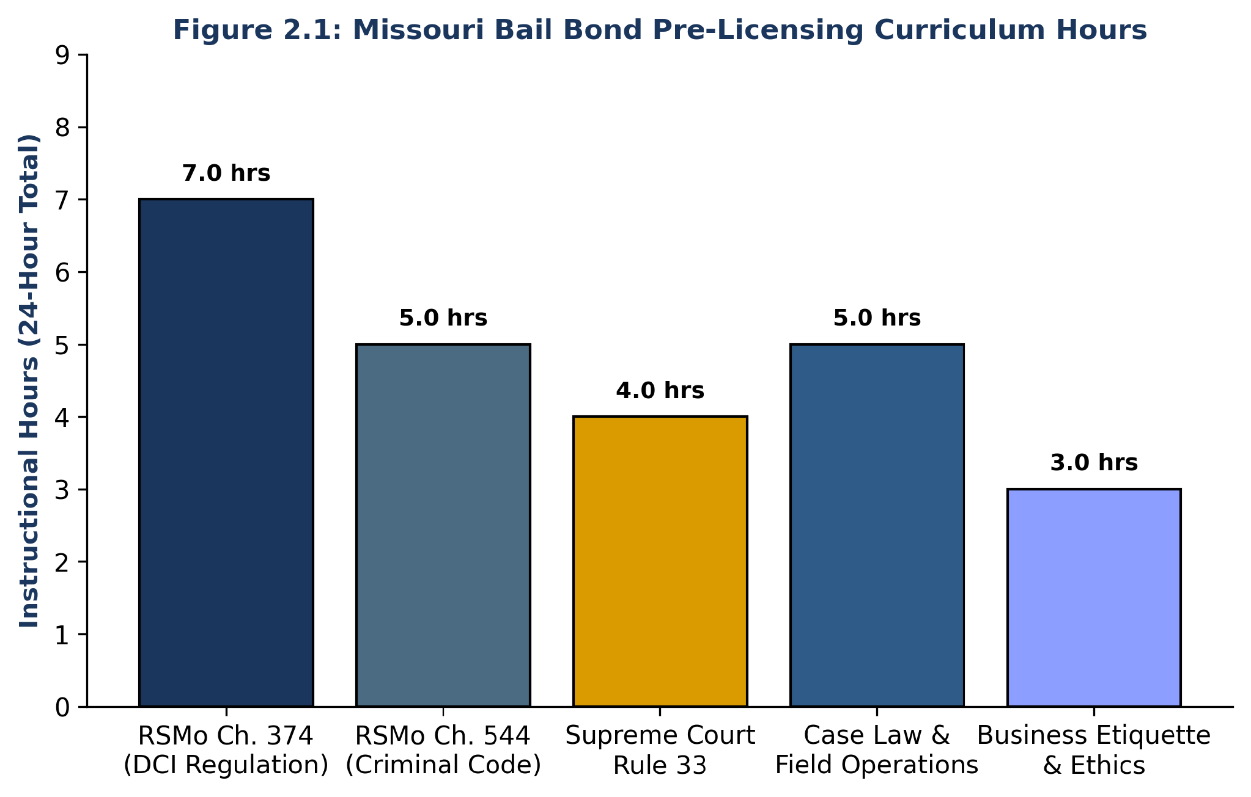
Figure 2.1: Missouri Bail Bond Pre-Licensing Curriculum Subject Hour Distribution
2.2 Unabridged Statutory Commentary: RSMo Chapter 374 Highlights
Practitioners must maintain complete working mastery over the following core statutory provisions of RSMo Chapter 374:
• RSMo 374.715 (Licensing Qualifications & Asset Assignment): Applicants must be at least 21 years old, a US citizen, a Missouri resident for 1 year, possess a high school diploma/GED, pass the state exam, complete 24 hours of basic training (20 CSR 700-6.150), and submit a fingerprint background check. General agents must post a $10,000 assignment of savings certificate with the DCI.
• RSMo 374.716 (Accounting & 3-Year Record Retention): Agents must maintain detailed books, records, contracts, receipts, and powers of attorney for a minimum of 3 years. Records must be open to immediate DCI audit upon request.
• RSMo 374.717 (Prohibited Acts): Agents are strictly prohibited from paying kickbacks or fee splits to jailers, police officers, or attorneys; recommending defense attorneys to defendants; entering detention facilities without official business; or writing bonds while under the influence.
• RSMo 374.757 (Mandatory Pre-Apprehension Dispatch Notification): Prior to attempting an apprehension of a fugitive, the recovery agent or bail bond agent MUST notify local law enforcement (police department or county sheriff dispatch) in the jurisdiction where the apprehension will take place. Failure to notify is a Class A misdemeanor and grounds for immediate license revocation.
• RSMo 374.760 (Monthly Unsatisfied Judgment Affidavits): On or before the 15th day of each month, general agents must submit a sworn affidavit to the DCI listing all unsatisfied bond forfeiture judgments. Failure to pay a final judgment within 60 days results in immediate suspension of bond writing authority in all Missouri courts.
📖 CASE STUDY 2.1: The Failed Police Notification Incident
Scenario: A recovery agent tracked a skip to an apartment in Springfield, MO. Operating at 2:00 AM, the agent breached the door without calling local police dispatch. Neighbors reported a burglary in progress. Arriving police officers held the recovery agent at gunpoint.
Outcome: The agent was arrested for criminal trespass and failing to notify local law enforcement under RSMo 374.757. The DCI revoked the agent's license following an Administrative Hearing Commission complaint under RSMo 374.787.
Key Takeaway: Dispatch notifications under RSMo 374.757 are legally mandatory and protect agent safety.

📌 SECTION 2.2 KNOWLEDGE CHECK
Question: Under RSMo 374.757, what must a recovery agent do PRIOR to attempting a fugitive apprehension?
A) Obtain a search warrant from a county judge
B) Notify local law enforcement dispatch in that jurisdiction
C) Publish a notice in the local newspaper
D) File a motion with the circuit court clerk
✓ CORRECT ANSWER: B. Local law enforcement dispatch notification is mandatory prior to apprehension.

UNIT 2: CRIMINAL PROCEDURE, JUDICIAL RULES & BOND FORFEITURES
CHAPTER 3
Criminal Code Mechanics — RSMo Chapter 544
Recognizance, Public Safety Bail Denials & Surrender Procedures
🎯 CHAPTER 3 LEARNING OBJECTIVES
1. Understand judicial authority to grant bail under RSMo 544.040 and recognizance execution under RSMo 544.050.
2. Analyze non-monetary conditions of release under RSMo 544.455 and public safety bail exclusions under RSMo 544.457 and 544.676.
3. Master statutory prisoner conveyance rules (544.220) and posse comitatus immunity (544.230).
4. Execute legal surrender of principal and discharge of liability under RSMo 544.600 through 544.620.
5. Understand the criminal penalties for Failure to Appear under RSMo 544.665 (Class E Felony vs. Misdemeanor).

3.1 Recognizance & Pretrial Release Conditions (RSMo 544.455 / 544.457)
RSMo Chapter 544 provides the statutory framework governing criminal procedure, arrest warrants, recognizance, and bail settings in Missouri court proceedings.
CONDITIONS OF RELEASE (RSMo 544.455):
When setting bail, associate circuit and circuit judges are statutorily required to impose the least restrictive conditions necessary to ensure court appearance and public safety. Conditions may include: electronic GPS monitoring, travel restrictions, drug/alcohol testing, house arrest, or no-contact orders with alleged victims.
PUBLIC SAFETY BAIL DENIALS (RSMo 544.457 & 544.676):
Under RSMo 544.457 and Article I, Section 20 of the Missouri Constitution, courts possess explicit authority to deny bail entirely if the court finds by clear and convincing evidence that the defendant poses a substantial danger to the victim, witnesses, or the community, or if the defendant is charged with a dangerous felony.
3.2 Statutory Surrender & Discharge of Liability (RSMo 544.600–544.620)
One of the most vital legal tools available to a bail bond agent is the statutory right to surrender the principal and discharge contractual liability before a forfeiture judgment becomes final.
SURRENDER MECHANICS (RSMo 544.600):
A bail bond agent or surety may surrender the principal at any time before final judgment of forfeiture. Surrender is accomplished by delivering a certified copy of the bail bond instrument along with the physical defendant to the sheriff or jailer of the county where the charge is pending.
LEGAL DISCHARGE OF LIABILITY (RSMo 544.610):
Upon taking physical custody of the principal and receiving the certified copy of the bond, the sheriff MUST accept the prisoner and issue a written receipt of surrender to the agent. Upon filing this receipt with the court clerk, the bail agent's financial liability on the bond is statutorily discharged as a matter of law.
📌 SECTION 3.2 KNOWLEDGE CHECK
Question: Under RSMo 544.600, what official document must an agent present to the county sheriff when surrendering a principal to custody?
A) Original application form
B) Certified copy of the bail bond instrument
C) DCI agent license card
D) Unsworn affidavit of revocation
✓ CORRECT ANSWER: B. RSMo 544.600 mandates delivering a certified copy of the bail bond to the sheriff.

CHAPTER 4
Judicial Release Rules — Supreme Court Rule 33
Arrest Warrants, Forfeitures, Writs of Scire Facias & Rule 33.16
🎯 CHAPTER 4 LEARNING OBJECTIVES
1. Master procedural rules governing misdemeanors and felonies under Missouri Supreme Court Rules 33.01 through 33.20.
2. Understand arrest warrant release condition settings under Rule 33.02 and review procedures under Rule 33.05.
3. Navigate the 4-step bond forfeiture process, Writs of Scire Facias, and the 180-day cure window under Rule 33.14.
4. Comply strictly with mandatory 10-day address change notification requirements under Rule 33.16.
5. Complete compensated surety justification affidavits under Rule 33.18.

4.1 Supreme Court Rule 33 Overview & Key Provisions
While RSMo Chapter 544 establishes statutory criminal law, Missouri Supreme Court Rule 33 dictates the procedural rules of court administration that judges, court clerks, sheriffs, and bail bond agents must follow in all circuit and municipal courts.
KEY RULE 33 PROVISIONS:
• Rule 33.01: Right to release and mandatory imposition of least restrictive conditions.
• Rule 33.13: Surrender of principal by surety. Parallels RSMo 544.600.
• Rule 33.14: Forfeiture proceedings, procedural notice, Writs of Scire Facias, setting aside forfeitures, and entry of final judgment.
• Rule 33.16: Mandatory 10-Day Change of Address Filing. Any licensed bail agent or general agent who changes their business or residential address MUST file written notice with the court clerk in EVERY jurisdiction where qualified within 10 days.
• Rule 33.18: Affidavit of Justification. Compensated sureties must file a sworn qualification affidavit certifying net assets equal to or exceeding bond liabilities.
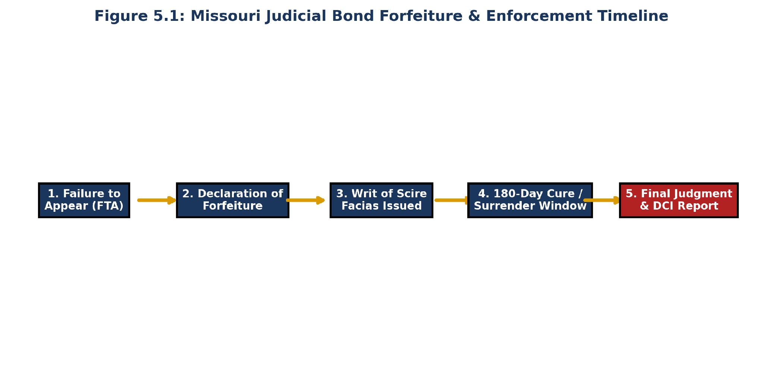
Figure 4.1: Judicial Bond Forfeiture & Enforcement Timeline under Rule 33.14
4.2 The 4-Step Bond Forfeiture Lifecycle (Rule 33.14)
When a defendant fails to appear in court, Rule 33.14 triggers a formal 4-stage judicial forfeiture process:
Stage 1: Declaration of Forfeiture. Upon the defendant's non-appearance, the court notes the default on the record and declares the bond conditionally forfeited.
Stage 2: Issuance of Writ of Scire Facias. The court clerk issues a Writ of Scire Facias (show cause order) served upon the bail agent and general agent, directing them to appear on a date certain to show cause why final judgment should not be entered.
Stage 3: 180-Day Cure / Surrender Window. The agents have up to 180 days to locate, apprehend, and surrender the defendant to custody, or demonstrate legal defense (e.g., defendant incarcerated elsewhere in US under RSMo 374.770).
Stage 4: Entry of Final Judgment & Execution. If the default is not cured, the court enters final judgment against the surety. The general agent has 60 days to pay the judgment before being suspended statewide under RSMo 374.760.
📖 CASE STUDY 4.1: The Default Judgment from Missed Address Change
Scenario: An agent relocated his office across town but failed to notify the county court clerk. Two months later, a client missed court. The clerk mailed a Writ of Scire Facias to the old address. The mail was returned undeliverable. The agent never received notice, missed the 180-day window, and a $15,000 final judgment was entered.
Outcome: The court refused to set aside the judgment because the agent violated Rule 33.16 by failing to file a written address change within 10 days.
Key Takeaway: Rule 33.16 compliance is mandatory to protect your right to notice.

📌 SECTION 4.2 KNOWLEDGE CHECK
Question: Under Supreme Court Rule 33.16, within how many days must an agent file notice of an address change with court clerks?
A) 30 days
B) 10 days
C) 60 days
D) At annual renewal
✓ CORRECT ANSWER: B. Rule 33.16 mandates written notification within 10 days.

UNIT 3: FUGITIVE RECOVERY, FIELD TACTICS & LEGAL LIABILITY
CHAPTER 5
Legal Rights & Constitutional Limits
Taylor v. Taintor Common Law Rights vs. Fourth Amendment Restrictions
🎯 CHAPTER 5 LEARNING OBJECTIVES
1. Analyze the landmark US Supreme Court common law doctrine established in Taylor v. Taintor (1872).
2. Understand Fourth Amendment constitutional limits prohibiting unconsented third-party residence entry (Payton v. New York).
3. Navigate interstate fugitive extraditions and state pre-notification mandates.
4. Differentiate common law arrest authority from statutory law enforcement powers.

5.1 Common Law Authority: Taylor v. Taintor (1872)
The historical authority of bail sureties to apprehend fugitives originates from the landmark US Supreme Court decision in Taylor v. Taintor, 83 U.S. 366 (1872). The Supreme Court famously articulated:
'When bail is given, the principal is regarded as delivered to the custody of his sureties. Their dominion is a continuance of the original imprisonment. Whenever they choose to do so, they may seize him and deliver him up in their discharge; and if that cannot be done at once, they may imprison him until it can be done. They may exercise their rights in person or by agent. They may pursue him into another State...'
MODERN CONSTITUTIONAL LIMITATIONS:
While Taylor v. Taintor provides broad common law authority regarding the principal, modern federal constitutional law and Missouri state statutes strictly restrict field execution:
1. Third-Party Residences (Payton v. New York): A recovery agent CANNOT forcibly enter the residence of a third party (friend, relative, employer) to search for or apprehend a fugitive without voluntary consent or an independent judicial search warrant.
2. Mandatory Police Notification (RSMo 374.757): Agents MUST notify local law enforcement dispatch prior to executing an apprehension.
CHAPTER 6
Field Apprehension Tactics, OSINT & Safety Equipment
Digital Skip Tracing, LE Pre-Notification & Tactical Field Gear
🎯 CHAPTER 6 LEARNING OBJECTIVES
1. Master Open Source Intelligence (OSINT) digital skip tracing techniques (social media, public databases).
2. Execute mandatory police dispatch notifications under RSMo 374.757.
3. Inspect and utilize NIJ Level IIIA ballistic body armor, tactical restraints, and body-worn cameras.
4. Perform safe tactical handcuffing (wall, prone, standing) and systematic outer garment searches.

6.1 Digital OSINT Skip Tracing & Dispatch Notification
Modern skip tracing combines physical surveillance with Open Source Intelligence (OSINT). Agents must analyze social media check-ins, utility records, vehicle registrations, and employment databases.
DISPATCH LOGGING PROTOCOL (RSMo 374.757):
When calling police/sheriff dispatch prior to an apprehension, record: (1) Dispatcher ID/Name, (2) Call Timestamp, (3) Target Address, (4) Agent License Numbers, and (5) Vehicle Descriptions. Retain this log in the permanent file.
CHAPTER 7
Use of Force, Custody Logistics & Legal Liability
Graham v. Connor Standards, Transport Safety & Risk Management
🎯 CHAPTER 7 LEARNING OBJECTIVES
1. Apply the 'objectively reasonable force' standard under Graham v. Connor (490 U.S. 386).
2. Differentiate the 5 tiers of the Tactical Use of Force Continuum Pyramid.
3. Enforce safe custody transport protocols, restraint checks, and medical screening.
4. Document incidents immediately to mitigate civil liability for false arrest or property damage.

7.1 Use of Force Standards: Graham v. Connor
Under the landmark US Supreme Court decision in Graham v. Connor, 490 U.S. 386 (1989), any physical force applied during a seizure or apprehension must be 'objectively reasonable' under the totality of circumstances evaluated from the perspective of a reasonable agent on the scene.
FORCE CONTINUUM TIERS:
• Level 1: Professional Presence & Badges / Vests
• Level 2: Verbal Commands & Tactical Communication
• Level 3: Soft Physical Controls (Empty-hand guidance, wrist locks, handcuffing)
• Level 4: Less-Than-Lethal Gear (OC Pepper Spray, Taser, Impact Batons)
• Level 5: Deadly Force (Authorized strictly in defense of human life against imminent death or serious bodily harm)
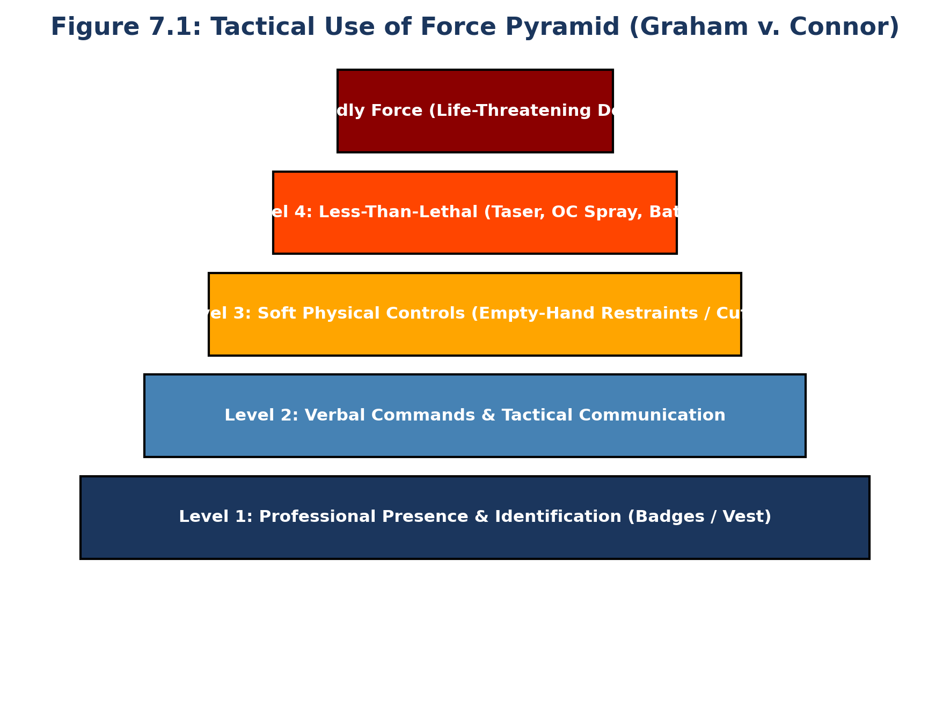
Figure 7.1: Tactical Use of Force Pyramid under Graham v. Connor Standards
UNIT 4: END-TO-END BUSINESS OPERATIONS & PRACTICE
CHAPTER 8
The Complete Life Cycle of a Bail Bond Transaction
8-Stage Operational Life Cycle Roadmap, Workflow Mechanics & Real-World Synthesis
🎯 CHAPTER 8 LEARNING OBJECTIVES
1. Master the 8 sequential operational stages of a commercial bail bond transaction in Missouri.
2. Synthesize statutory compliance, court rules, and field operations into a unified workflow.
3. Execute proper post-surrender exoneration motions and 10-day collateral return protocols.

8.1 Master 8-Stage Operational Life Cycle Roadmap
Stage # | Operational Phase | Primary Tasks & Statutory Requirements
Stage 1 | Arrest & Intake Call | Verify booking charges, warrant status on Missouri Casenet, bail amount, court jurisdiction.
Stage 2 | Underwriting & Vetting | Gather 10-year residency/employment history, evaluate flight risk, vet co-signor asset stability.
Stage 3 | Contract & Collateral | Execute Master Indemnity Contract, Deeds of Trust (all owners), issue numbered receipts (RSMo 374.719).
Stage 4 | POA & Jail Delivery | Attach single qualifying POA, deliver bond to jailer, obtain written receipt of delivery.
Stage 5 | Pretrial Compliance | Enforce check-in schedule, monitor court calendar, file written address changes within 10 days (Rule 33.16).
Stage 6 | Forfeiture Response | Receive Writ of Scire Facias (Rule 33.14), file Motion to Set Aside, utilize 180-day cure window.
Stage 7 | Skip Tracing & LE Notice | Execute OSINT database searches, social media tracking, execute mandatory police dispatch call (RSMo 374.757).
Stage 8 | Surrender & Exoneration | Surrender fugitive with certified bond copy (RSMo 544.600), obtain sheriff receipt, file discharge motion, return collateral in 10 days.

BACK MATTER & APPENDICES
APPENDIX A: COMPREHENSIVE GLOSSARY OF STATUTORY & BAIL TERMINOLOGY
• Affidavit of Justification: A sworn written statement filed under Supreme Court Rule 33.18 by a compensated surety certifying net financial assets equal to or exceeding bond liabilities.
• Bail Bond: A financial guarantee and penal contract submitted to a court to secure a defendant's release while guaranteeing court appearance.
• Bail Bond Agent: An individual licensed under RSMo Chapter 374 to write, execute, and solicit bail bonds under a General Agent.
• Collateral Security: Money, real estate Deeds of Trust, or personal property pledged to a bail agent to secure an indemnity agreement under RSMo 374.719.
• General Bail Bond Agent: An individual or corporation licensed under RSMo Chapter 374 who maintains a $10,000 assignment of savings and supervises bond agents.
• Indemnitor: A co-signor who executes a contract agreeing to reimburse the bail agent for all losses, fees, and recovery costs upon default.
• Obligee: The Court or State of Missouri holding criminal jurisdiction and receiving the bond guarantee.
• Obligor / Surety: The licensed bail bond agent or general agent guaranteeing the appearance.
• Principal: The criminal defendant released from custody upon execution of the bond.
• Scire Facias: A judicial writ ordering a surety to appear and show cause why final forfeiture judgment should not be entered.
• Surety Recovery Agent: An individual licensed under RSMo 374.783 strictly to track, detain, and apprehend fugitives who have breached bail agreements.
APPENDIX B: EXTRA REFERENCE MATERIALS & SAMPLE FORMS
SAMPLE FORM B1: MISSOURI UNIFORM BAIL BOND LICENSE APPLICATION (EXCERPT)
Form B1 — Missouri Department of Commerce & Insurance (DCI)
Applicant Full Legal Name: __________________________________________________
SSN: XXX-XX-____ DOB: __/__/____ MO Resident for 1+ Year? [ ] Yes [ ] No
Fingerprint Background Check Completed via MSHP? [ ] Yes [ ] No
24-Hour Basic Education Course Certificate #: ________________________________

APPENDIX C: BIBLIOGRAPHY & ACADEMIC REFERENCES
1. Missouri Revised Statutes (RSMo) Chapter 374 — Department of Commerce and Insurance (Sections 374.695 – 374.789).
2. Missouri Revised Statutes (RSMo) Chapter 544 — Criminal Procedure & Recognizance (Sections 544.040 – 544.676).
3. Missouri Supreme Court Rules of Criminal Procedure — Rule 33: Misdemeanors or Felonies — Right to Release & Conditions.
4. Missouri Code of State Regulations — Title 20 CSR 700-6.100 through 20 CSR 700-6.250 (Bail Bond Licensing Rules).
5. Taylor v. Taintor, 83 U.S. 366 (1872) — Landmark US Supreme Court Decision on Common Law Surety Rights.
6. Graham v. Connor, 490 U.S. 386 (1989) — Fourth Amendment Objective Reasonableness Standard for Use of Force.
7. Payton v. New York, 445 U.S. 573 (1980) — Fourth Amendment Warrant Requirements for Residential Entry.
APPENDIX D: ALPHABETICAL SUBJECT & STATUTORY INDEX
• Address Change Notification (Rule 33.16) — Section 4.1, Case Study 4.1
• Assignment of Savings ($10,000) — RSMo 374.715, Section 2.2
• Collateral Receipts & Fiduciary Duty — RSMo 374.719, Section 1.3
• Dispatch Notification (Pre-Apprehension) — RSMo 374.757, Section 2.2, Case Study 2.1
• Graham v. Connor (Use of Force) — Section 7.1, Figure 7.1
• Law Enforcement Kickbacks Prohibited — RSMo 374.717, Section 2.2
• Payton v. New York (Third-Party Entries) — Section 5.1
• Scire Facias Writs & Forfeiture Timeline — Rule 33.14, Section 4.2, Figure 4.1
• Surrender of Principal & Certified Bond Copy — RSMo 544.600, Rule 33.13, Section 3.2
• Taylor v. Taintor (Common Law Authority) — Section 5.1
• Unsatisfied Judgment Affidavits (Monthly) — RSMo 374.760, Section 2.2
APPENDIX E: MASTER ASSESSMENT SOLUTION KEY & STATUTORY RATIONALES
FACILITATOR MASTER ANSWER KEY & DEBRIEFING GUIDE:
Section 1.3 Knowledge Check: B (RSMo 374.719 mandates non-technical descriptions and defect notes).
Section 2.2 Knowledge Check: B (RSMo 374.757 mandates dispatch notification prior to apprehension).
Section 3.2 Knowledge Check: B (RSMo 544.600 requires delivering a certified copy of the bail bond).
Section 4.2 Knowledge Check: B (Rule 33.16 mandates written address change filing within 10 days).

MISSOURI BAIL BOND & SURETY RECOVERY AGENT MASTER TEXTBOOK
Comprehensive Pre-Licensing Curriculum, Statutory Commentary & Field Operations Manual
ABOUT THIS MASTER TEXTBOOK
The Missouri Bail Bond & Surety Recovery Agent Master Textbook (Edition 1, 2026) provides un-abridged, comprehensive educational coverage for candidate agents, general agents, and fugitive recovery professionals. Fully aligned with 20 CSR 700-6.150, RSMo Chapters 374 and 544, and Supreme Court Rule 33, this textbook delivers deep legal analysis, workflow roadmaps, practitioner warnings, case studies, and field apprehension safety guidelines.

AUTHORS & SUBJECT MATTER EXPERTS
Krystal Allen & Travis Griffin bring extensive expertise in law enforcement, criminal procedure, DCI statutory compliance, bail bond administration, public administration, and vocational curriculum development. Designed for Missouri pre-licensing education and professional reference.


