Comparing Regression and Machine Learning Models for Predicting Abalone Age

Yuri Griffin
National University - DDS-8555
Dr. Mohamed Nabeel
Date: 04/05/2026

Abstract
The assignment focuses on building predictive models using the Abalone dataset from Kaggle. The goal of the analysis was to predict the number of rings in an abalone shell, which is commonly used to estimate the age of the organism. Three models were tested in this study: Linear Regression, Lasso Regression, and Random Forest. Before building the models, the dataset was prepared by encoding the categorical sex variable and splitting the data into training and testing sets. Model performance was evaluated using R² and mean squared error (MSE). After comparing the results, the Random Forest model produced the best predictions with the highest R² value and the lowest error. That shows that machine learning approaches can sometimes perform better than traditional regression models when the data contains more complex relationships.

Regularization methods such as ridge regression and lasso regression are used to control model complexity and reduce overfitting. These techniques add a penalty to the regression coefficients, which shrinks large values and prevents the model from fitting noise in the data. By balancing bias and variance, regularization methods can improve prediction performance when many predictors are included in a regression model. I used the Abalone dataset to build and compare several predictive models. The goal was to estimate the number of rings in an abalone shell using the physical measurements provided in the dataset. The number of rings is often used as a rough estimate of the age of the abalone. The dataset includes variables such as length, diameter, height, and several weight measurements. There is also a categorical variable called “Sex,” which had to be converted into dummy variables so the regression models could use it. I performed the analysis in Python using Google Colab and the scikit-learn library.
After preparing the data, the dataset was split into training and testing sets, which allowed the models to be trained on one portion of the data and then evaluated on another portion that the model had not seen before. I tested three models: Linear Regression, Lasso Regression, and Random Forest. In addition, principal components regression (PCR) is another technique often used in regression analysis to address multicollinearity by transforming predictors into principal components before fitting the model.
Linear regression is one of the most common statistical methods used to model relationships between variables. Lasso regression is similar, but it adds a penalty that can shrink coefficients and sometimes reduce overfitting. Random Forest is a machine learning algorithm that works by building many decision trees and combining their predictions. Ensemble methods like this are often able to capture more complicated patterns in the data (Che et al., 2011).
To compare the models, I calculated mean squared error (MSE) and the R² value. These metrics are commonly used to evaluate regression models because they measure how well the model explains variation in the data and how large the prediction errors are.
Table 1. Model Performance Comparison
Model | R² | Mean Squared Error
Linear Regression | 0.601 | 4.095
Lasso Regression | 0.396 | 6.207
Random Forest | 0.647 | 3.622

The Linear Regression model produced a mean squared error of 4.095 and an R² value of 0.601. That means the model explains a little over 60% of the variation in the number of rings. The Lasso model did not perform as well for this dataset. It had a mean squared error of 6.207 and an R² value of 0.396 which suggests that the regularization penalty may have reduced the importance of some predictors that were still useful for prediction (Nathans et al.). I also examined diagnostic plots, including a residuals versus fitted plot and a normal Q-Q plot, to evaluate whether the regression assumptions were reasonably satisfied.
Figure 1. Residuals vs Fitted Plot
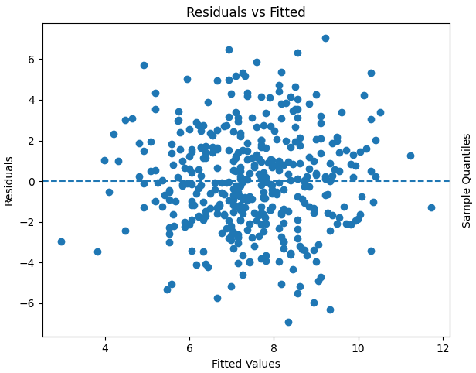
The plot shows the residuals scattered around zero, suggesting the model errors do not follow a strong pattern.
Figure 2. Normal Q-Q Plot of Residuals
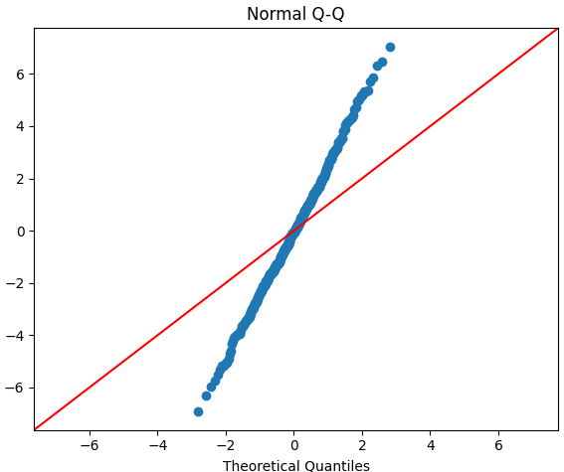
Most points follow the diagonal line, indicating that the residuals are approximately normally distributed.
The Random Forest model produced the strongest results among the models that were tested. It had a mean squared error of 3.622 and an R² value of 0.647, which was the best performance out of the three models. That indicates that the Random Forest model captured the relationships between the variables more effectively. The results suggest that the relationship between the measurements and the number of rings is not perfectly linear. Machine learning models such as Random Forest can often handle these types of relationships better because they allow more flexibility in how variables interact with each other. Similar approaches have been used in other research areas that apply machine learning to predictive modeling problems (Hosseinpour et al., 2025).
Overall, this exercise showed how different modeling approaches can produce different levels of predictive accuracy. Linear regression provided a reasonable baseline model, but the Random Forest model produced the best overall results based on both the R² value and the prediction error. Comparing multiple models is an important step in predictive analytics because it helps determine which technique works best for the data being analyzed. The Python notebook used to perform the analysis and generate the models is available in the GitHub repository submitted with this assignment.

References
Che, D., Liu, Q., Rasheed, K., & Tao, X. (2011). Decision Tree and Ensemble Learning Algorithms with Their Applications in Bioinformatics. Advances in Experimental Medicine and Biology, 696, 191–199. https://doi.org/10.1007/978-1-4419-7046-6_19
Hosseinpour, S., Rezagholizade-Shirvan, A., Golaki, M., Mohammadi, A., Sheikhmohammadi, A., & Atafar, Z. (2025). Advanced removal of butylparaben from aqueous solutions using magnetic molybdenum disulfide nanocomposite modified with chitosan/beta-cyclodextrin and parametric evaluation through sequential multi-objective machine learning algorithms. Results in Engineering, 26, 105247. https://doi.org/10.1016/j.rineng.2025.105247
Nathans, L. L., Oswald, F. L., & Nimon, K. (n.d.). Interpreting Multiple Linear Regression: A Guidebook of variable importance. https://eric.ed.gov/?id=EJ977607

