Supplementary Materials: Genes involved in histone modification are frequently mutated in non-Hodgkin lymphoma.

Ryan D. Morin*, Maria Mendez-Lago*, Andrew J. Mungall, Rodrigo Goya, Karen L. Mungall, Richard Corbett, Nathalie A. Johnson, Tesa M. Severson, Readman Chiu, Matthew Field, Shaun Jackman, Martin Krzywinski, David W. Scott, Diane L. Trinh, Jessica Tamura-Wells, Sa Li, Marlo Firme, Sanja Rogic, Malachi Griffith, Susanna Chan, Oleksandr Yakovenko, Irmtraud Meyer, Eric Y. Zhao, Duane Smailus, Michelle Moksa, Suganthi Chittaranjan, Lisa Rimsza, Angela Brooks-Wilson, John J. Spinelli, Susana Ben-Neriah, Barbara Meissner, Bruce Woolcock, Merrill Boyle, Helen McDonald, Angela Tam, Yongjun Zhao, Allen Delaney, Thomas Zeng, Kane Tse, Yaron Butterfield, Inanc Birol, Rob Holt, Jacqueline Schein, Douglas E. Horsman, Richard Moore, Steven J.M. Jones, Joseph M. Connors, Martin Hirst, Randy D. Gascoyne and Marco A. Marra.

Supplementary Figures
Figure S1: Overview of strategy.
Figure S2: N-terminal truncation of FOXO1 protein with mutation affecting initial codon.

Figure S3: Recurrent mutations affecting the HAT domain of CREBBP and EP300.
Figure S4: The effect of GNA13 mutations at the protein level.
Figure S5: Potential impact of recurrently mutated genes on BCR signalling and downstream messengers.
Figure S6: No detectable prognostic impact of EZH2 or MEF2B mutations in DLBCL.
Figure S7: Confirmation of alternative splicing events resulting from MLL2 splice site mutations.
Figure S8: Visualization of MEF2B mutations in the solved crystal structure.

Supplementary Tables

Table S1: Clinical details for all samples profiled by genome/exome sequencing.

Table S2: Summary and coverage for all samples sequenced by RNA-seq.
Table S3: Gene fusions identified by RNA-seq and genome sequencing.

Table S4: Recurrence of mutations in extension set identified by RNA-seq.
Table S5: Complete list of somatic mutations and validation status from exome and genome sequencing.

Table S6: Mutation hot spots in genes identified using RNA-seq.

Table S7: Genes/patients with significant allelic imbalance favouring mutant or wild-type allele.

Table S8: Selection values for repeatedly and recurrently mutated genes.

Table S9: Mutations affecting CREBBP or EP300 detected using RNA-seq data.

Table S10: All MLL2 Mutations detected by deep re-sequencing.
Table S11: All MEF2B mutations and cSNVs detected.
Table S12: Catalogue of MEF2B cSNVs in FL and DLBCL

Table S13: All cSNVs detected in 10 DLBCL cell lines using RNA-seq data.

Table S14: All oligonucleotides used in the study.

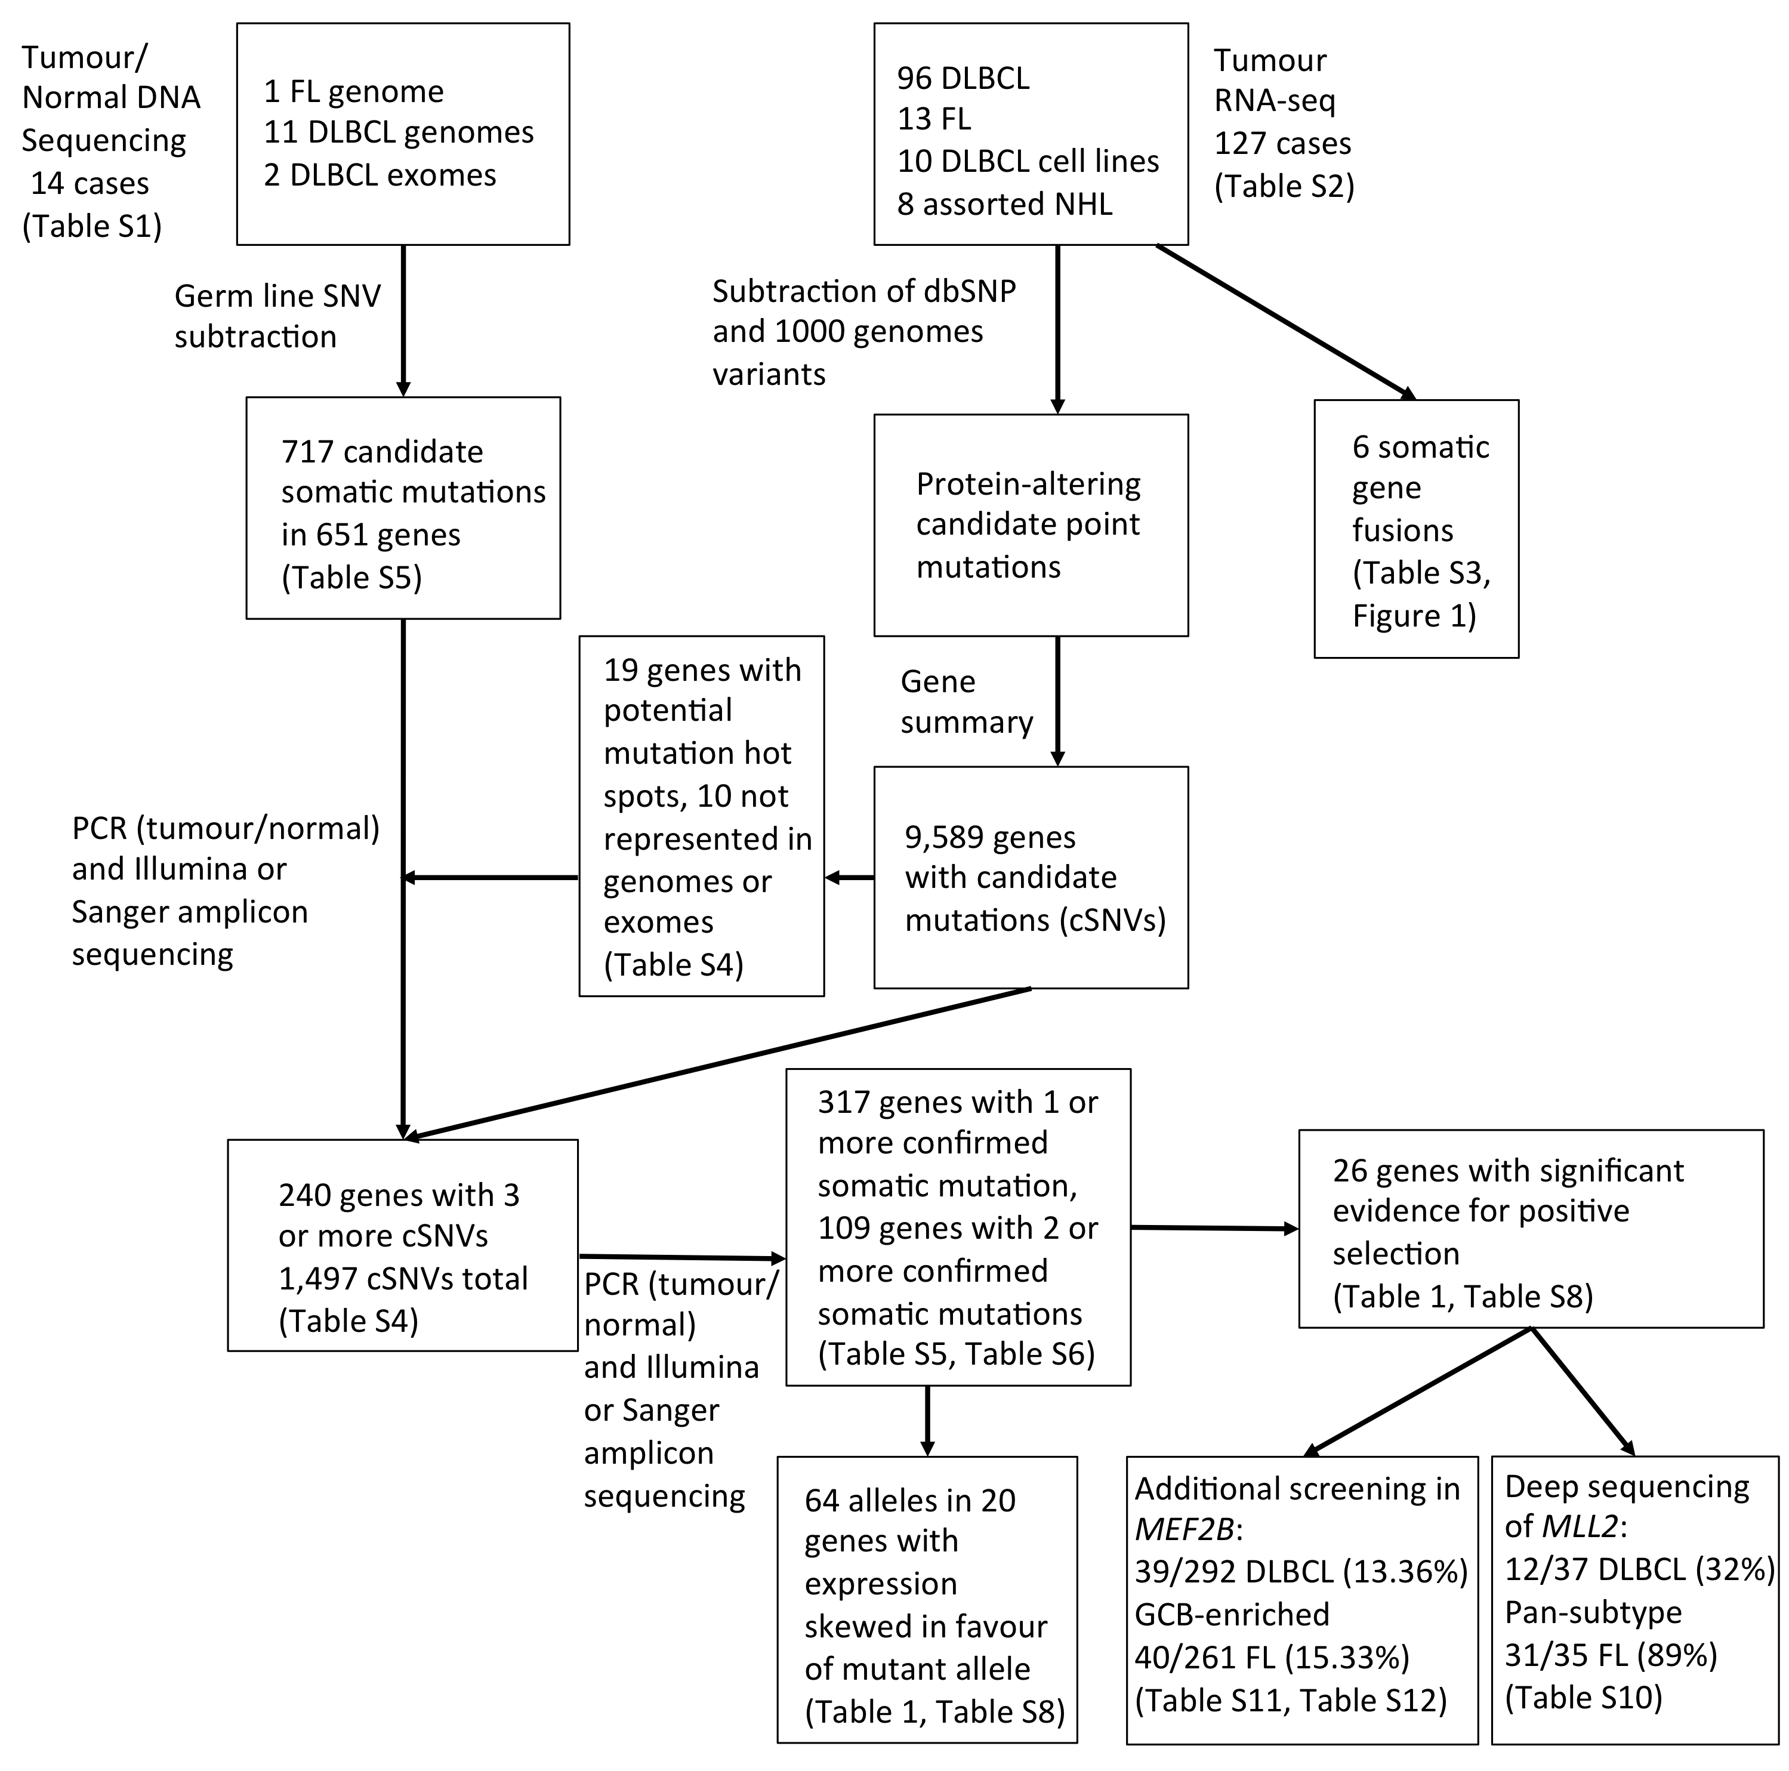
Figure S1: Overview of strategy. The samples analysed, experiments performed and an overview of the results. 717 nonsynonymous candidate somatic mutations in 651 genes were identified from the genomes/exomes of 14 NHL patient samples with matched constitutional DNA. Ten genes with hot spots were identified directly from the RNA-seq and nine of these genes were not among the 651 (661 total genes). We determined that 230 of these genes contained 3 or more cSNVs when genome and RNA-seq data were combined. We also attempted validation of all cSNVs identified in the FL genome and two DLBCL exomes. We validated at least one somatic cSNV in 317 genes (Table S5) and identified two or more somatic mutations in 109 genes using PCR amplification and Sanger sequencing in tumour and normal DNA. Of the successfully re-sequenced cSNVs predicted from the genomes, 171 (94.5%) were confirmed somatic, 7 were false calls and 3 were present in the germ line (Table S5). The entire MLL2 locus was screened for additional mutations in 37 DLBCL and 35 FL samples. MEF2B was similarly sequenced in an extension cohort of 292 DLBCLs and 261 FLs.

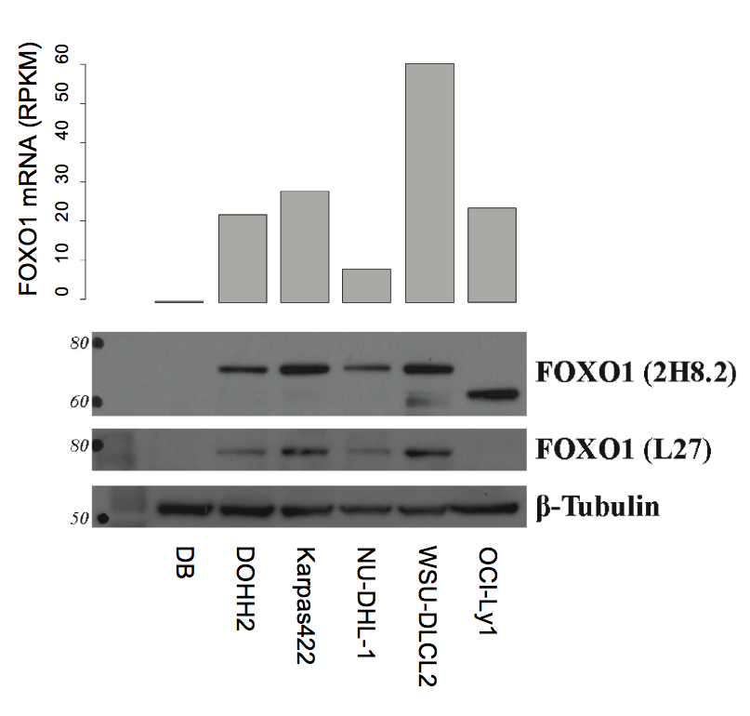

Figure S2: N-terminal truncation of FOXO1 protein with mutation affecting initial codon. (A) The RNA-seq data of cell lines and patient samples revealed mutations in 3 samples affecting the initial codon of FOXO1. To determine the effect of such mutations on FOXO1 protein, we assayed FOXO1 by Western blot in DLBCL cell lines using an antibody raised against full-length FOXO1 (2H8.2). In the cell line containing a mutation at the initiator methionine (OCI-Ly1), we observed a FOXO1 band of reduced molecular weight, compared to FOXO1 wild-type cell lines (size indicated in Kilodaltons on the left). The reduced size is consistent with the use of a second methionine codon in the FOXO1 gene, producing a protein shortened at the amino terminus by 70 amino acids. The same blot was also probed with an antibody that recognizes an N-terminal epitope (L27) and lack of a band in OCI-Ly1 cells is consistent with the notion that the lower band in this cell line corresponds to FOXO1 protein lacking its N-terminus. We also noted absence of the protein in the DB cell line, which showed significantly reduced mRNA levels as measured by RNA-seq (upper bar chart; RPKM = Reads Per Kilobase of gene model per Million mapped reads).

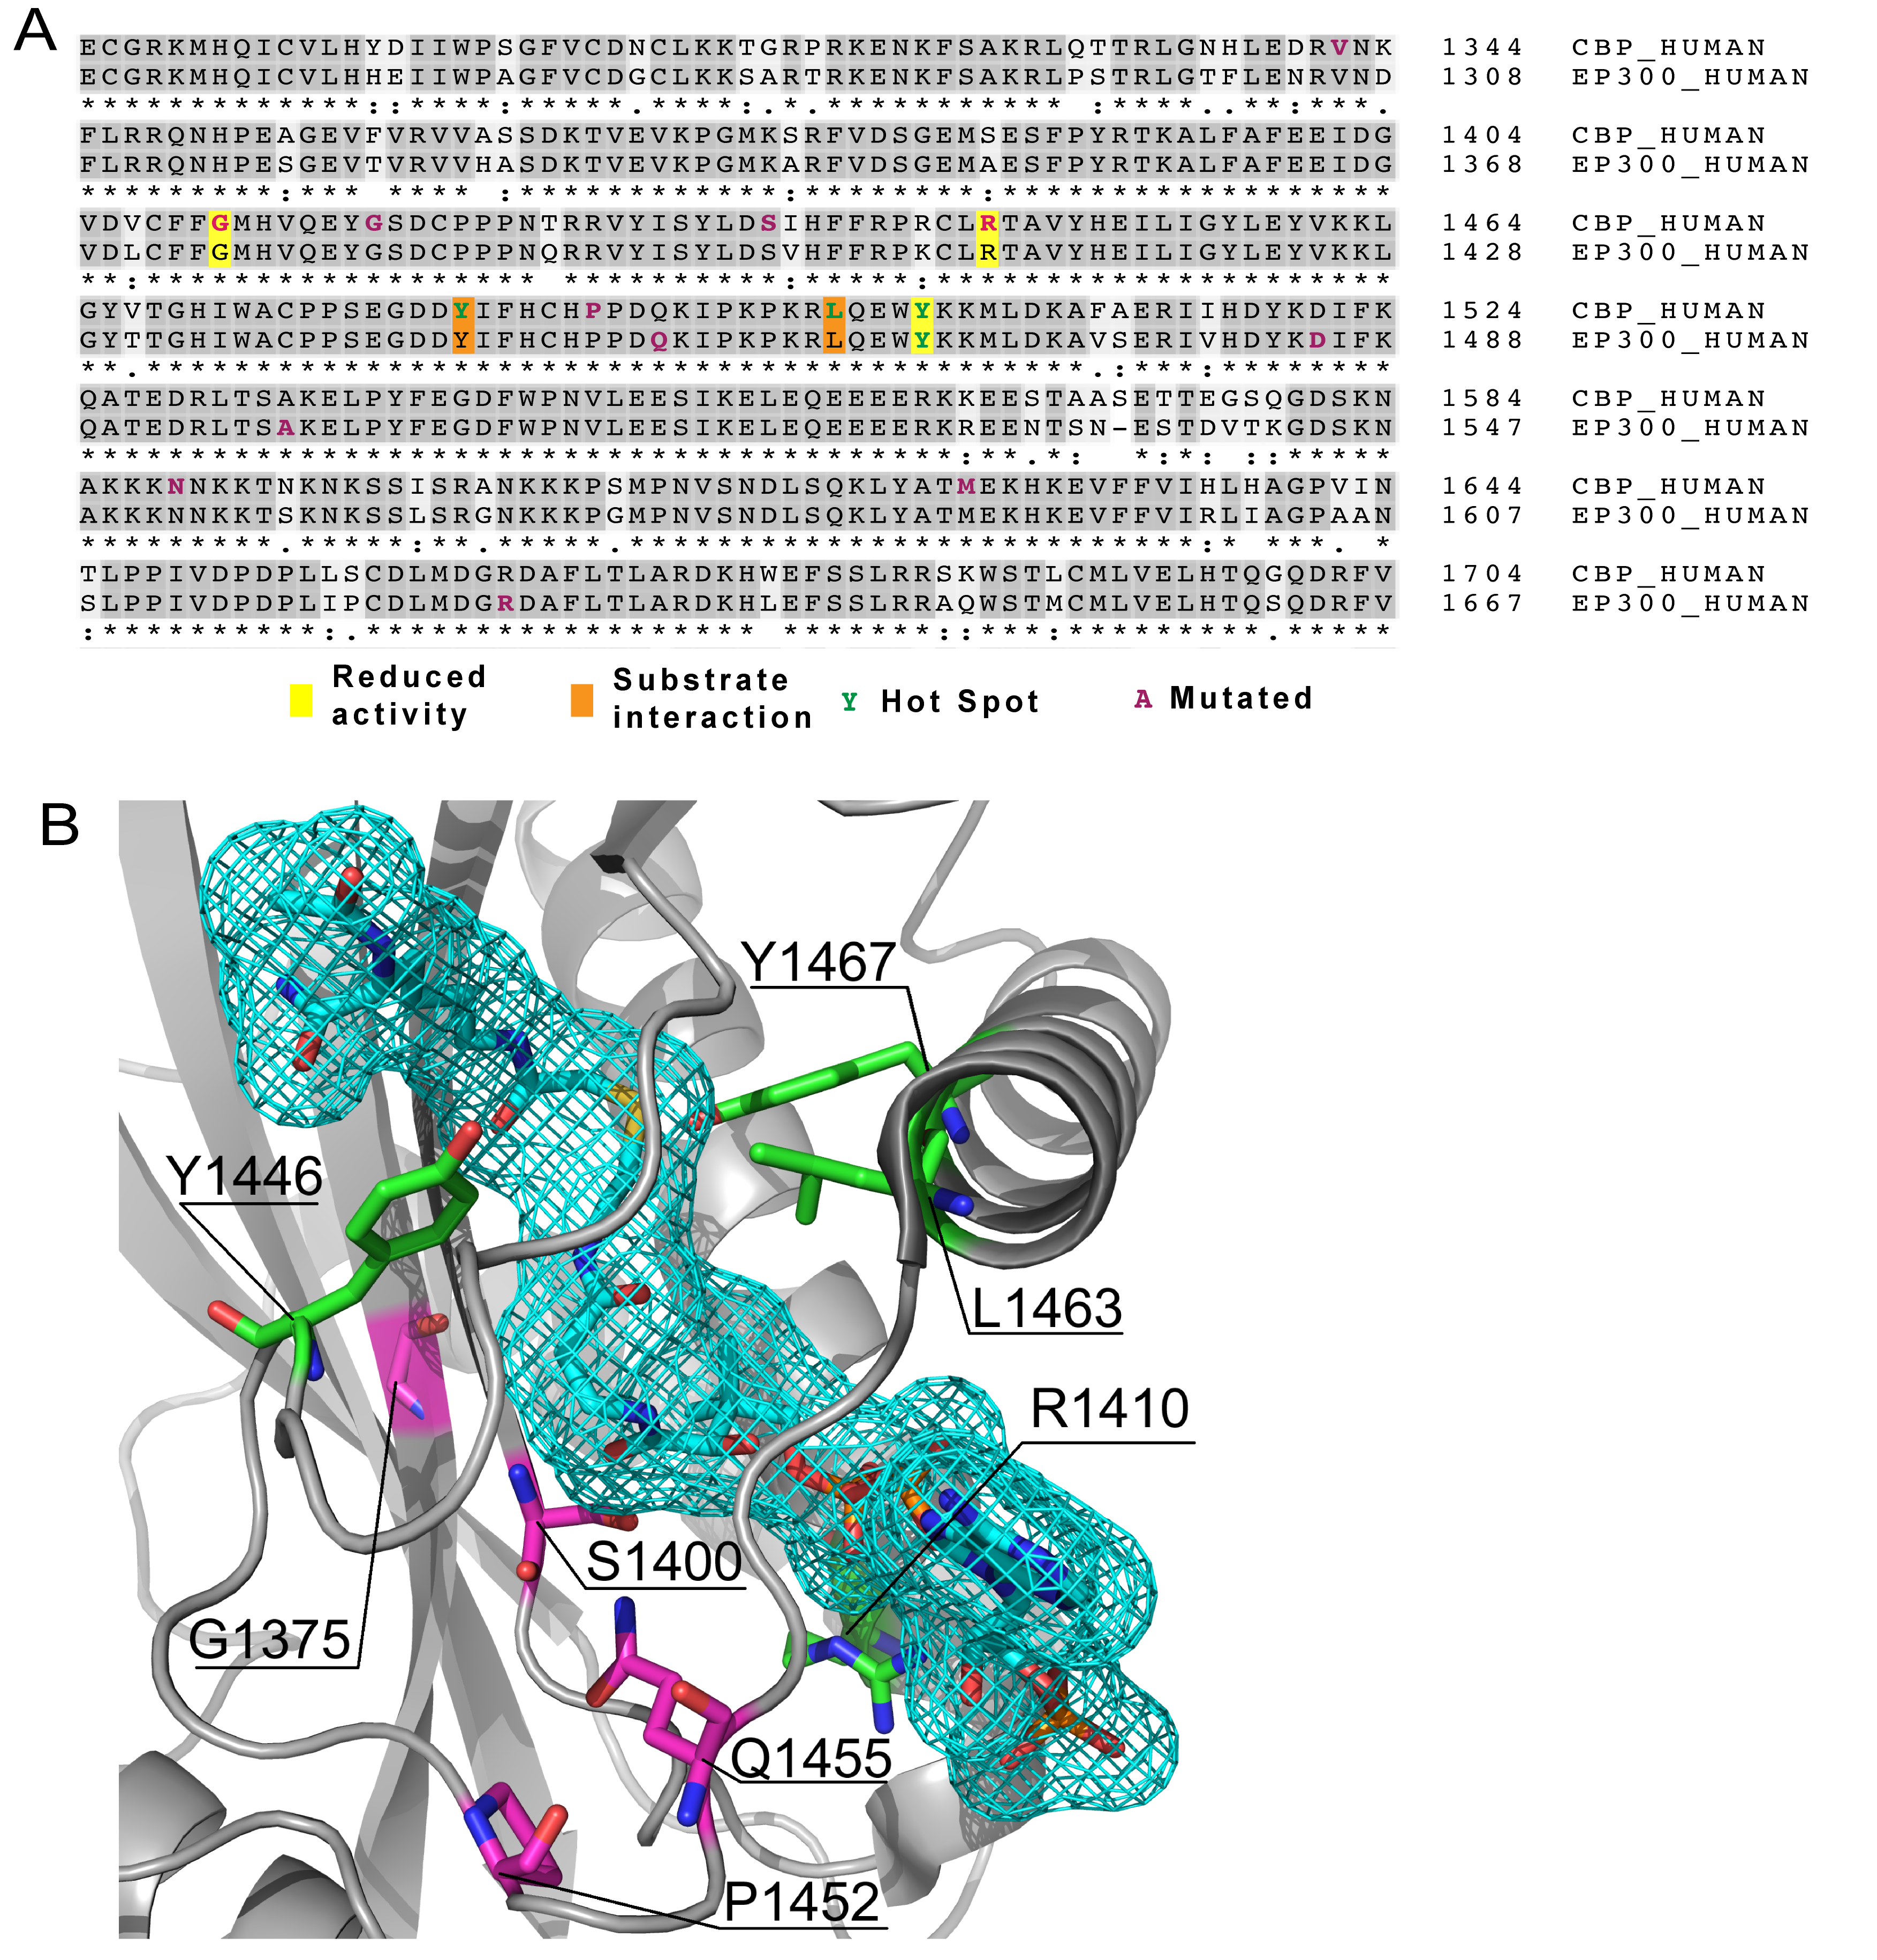
Figure S3: Recurrent mutations affecting the HAT domain of CREBBP and EP300.
Mutations affecting both CREBBP and EP300 were detected. (A) Alignment shows the histone acetyltransferase (HAT) domain of both CREBBP and EP300 proteins. Residues with cSNVs in either CREBBP or EP300 are coloured pink if affected in a single sample or green if affected in multiple samples (i.e. hot spots). Yellow indicates that mutation of the highlighted residue has been shown to reduce HAT activity in vitro and orange indicates that the residue interacts with the substrate analogue utilized in solving the crystal structure (Lys-CoA)¹ (B) The three dimensional structure of the HAT domain of CREBBP and EP300 based on the solved structure of EP300¹. Mutated residues in the HAT domain of both CREBBP and EP300 are highlighted with the same colouring as (A) with positions numbered relative to EP300. Many of the mutated residues are in close proximity to the substrate (shown here is the substrate analogue and inhibitor Lys-CoA, blue-caged molecule).

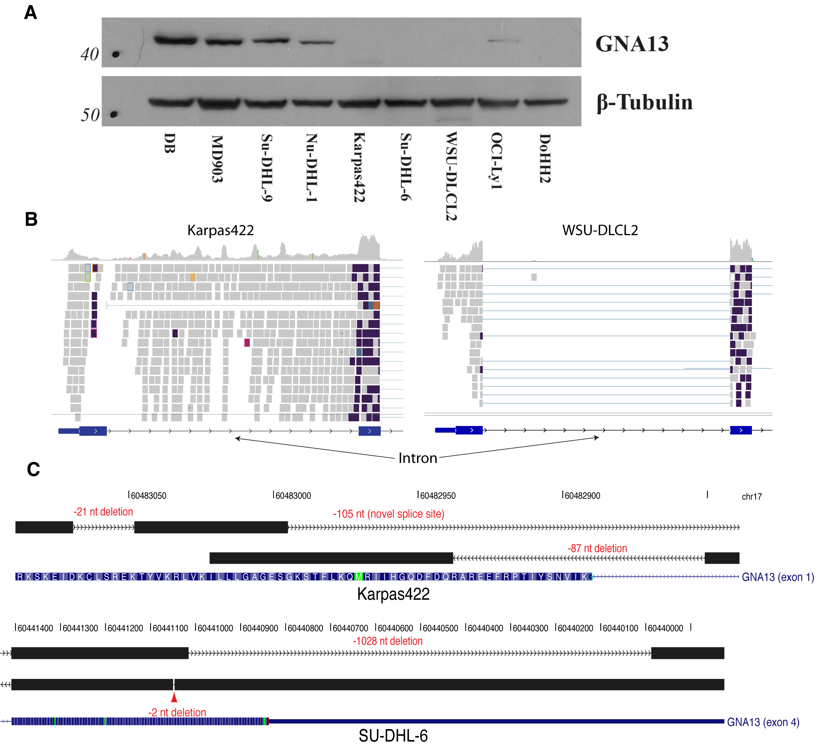

Figure S4: The effect of GNA13 mutations at the protein level.

(A) A western blot revealed the expected lack of GNA13 protein in DOHH2, the cell line with a truncating point mutation detected in the RNA-seq data. The lack of protein in Karpas422, SU-DHL-6 and WSU-DLCL2 was surprising, as we had not detected protein-truncating mutations in these cells. (B) Further analysis of the aligned sequence from these three cell lines and additional analysis utilizing a de-novo transcript assembly approach (Trans-ABySS; Methods), revealed multiple aberrations that may explain the lack of protein. Firstly, in Karpas422 reads were observed to map the first intron, suggesting that the intron is retained in a significant proportion of GNA13 transcripts (compare Karpas422 on the left to WSU-DLCL2 on the right). Inspection of sequence contigs from this case revealed the likely cause of intron reads to be a deletion of 87 nt that removes the canonical splicing donor from this exon (Panel C, top). Splicing still appears to occur to a lesser extent using a non-GT donor. Assembled reads from SU-DHL-6 revealed a 2 nt deletion and a large 1028 nt deletion. The former would affect the reading frame and the latter removes the terminal stop codon. Finally, in WSU-DLCL2, the splicing donor after the third exon was apparently mutated, converting the GT donor to a GC sequence (not shown). As in the Karpas422 case, there was clear evidence for retention of this intron in GNA13 transcripts in WSU-DLCL2. Intron retention has previously been linked to nonsense-mediated transcript degradation² and if that is the case here, could explain the lack of GNA13 protein in these cells.

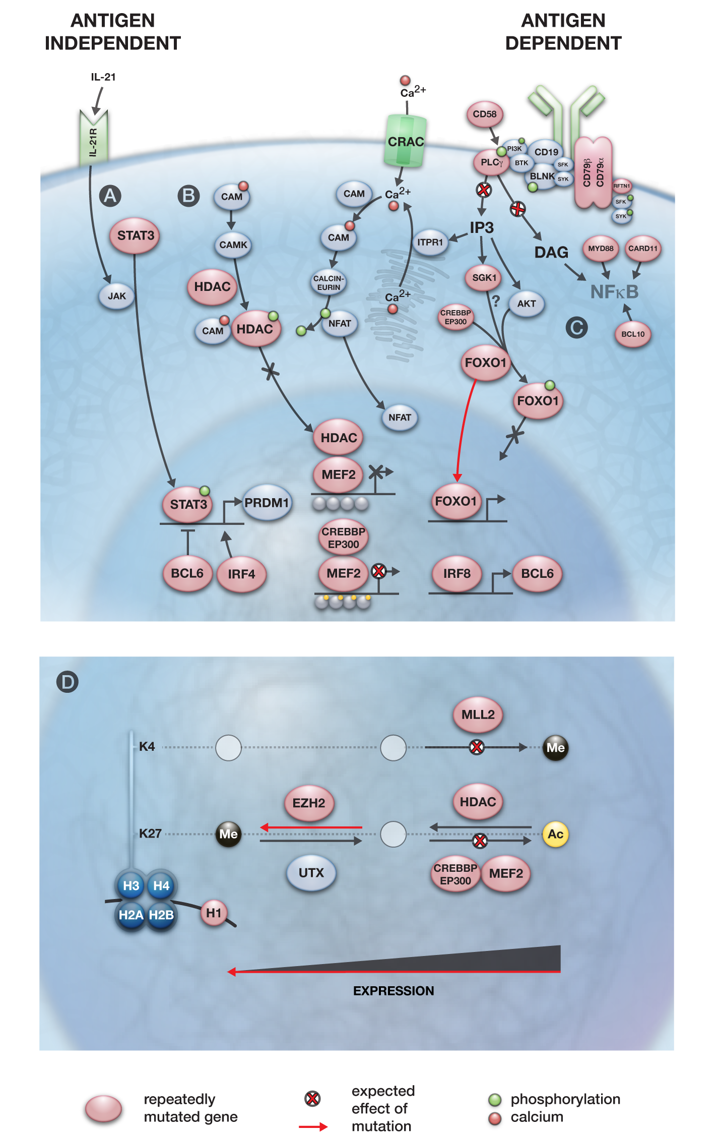
Figure S5: Potential impact of recurrently mutated genes on BCR signalling and downstream messengers.
(A) Autocrine and paracrine stimulation of IL-21R induces the dimerization and activation of STAT3, a positive regulator of PRDM1 expression³. Mutations affecting the DNA binding domain of STAT3 are known to act as dominant negatives, which would predict the inability to induce PRDM1 expression following IL-21 stimulation. (B) Multiple mutations predicted to directly alter BCR signalling or alter the normal events subsequent to BCR-induced influx of the secondary messenger Ca²⁺. Cross-linking of CD58 has been shown to result in the phosphorylation of BLNK, Syk and PLC-gamma and lead to Akt activation⁴. Various mutations are expected to alter the ability of B cells to induce the expression of MEF2 target genes in response to the Ca²⁺ influx. The role of MEF2 gene family members in mediating epigenetic alterations downstream of the BCR has been inferred from a knockout study in which MEF2C was shown to be required for mediating calcium-dependent response to BCR signalling⁵ and the involvement of CREBBP/EP300 in this process has been inferred from MEF2-mediated transcriptional regulation in other cell types including T cells⁶. This model predicts that influx of Ca²⁺ after BCR stimulation would result in the displacement of HATs by activated Calmodulin-dependent protein kinase (CAMK), allowing HDAC activity via CREBBP/EP300 thus enabling transcription at MEF2 target loci. In this model, mutation of any of these three genes and potentially the S155F mutation in HDAC7 would diminish this effect and suppress the induction of MEF2 target loci after BCR stimulation. (C) Multiple mutations may affect the regulation of the activity of FOXO proteins following BCR stimulation. FOXO1 is a downstream target of the kinase AKT, which is activated during BCR signalling. SGK, a related kinase (commonly mutated in this study), is known to phosphorylate FOXO3a in a similar way⁷ and we predict it may also phosphorylate FOXO1. Thus, mutations affecting the FOXO1 phosphorylation site or SGK1 could affect the regulation of FOXO1 nuclear localization and hence, its transactivation activity. The shortened FOXO1 protein produced by mutation of the initial codon (Figure S2) would not contain this phosphorylation site and hence those mutations may also result in altered subcellular localization. Various mutations affecting NF-B activity, which have been previously described, were also observed here^{8,9,10,11}. (D) Many of the recurrently mutated genes in B-NHL are involved in histone modification or themselves encode histone proteins (i.e. HIST1H1C, one of multiple genes that encode histone protein H1). CREBBP/EP300 and MLL2 each produce activating chromatin marks (H3K27Ac and H3K4me3, respectively). HDAC (e.g. HDAC7) and EZH2 produce inactivating marks by removing acetyl groups and trimethylating H3K27, respectively. As heterozygous EZH2 Y641 mutations are known to effectively enhance PRC2 activity¹², then each of the individual mutations may result in suppression of gene expression. Importantly, it is not known whether EZH2 and MLL2 regulate the expression of the same genes as MEF2B/CREBBP/EP300.

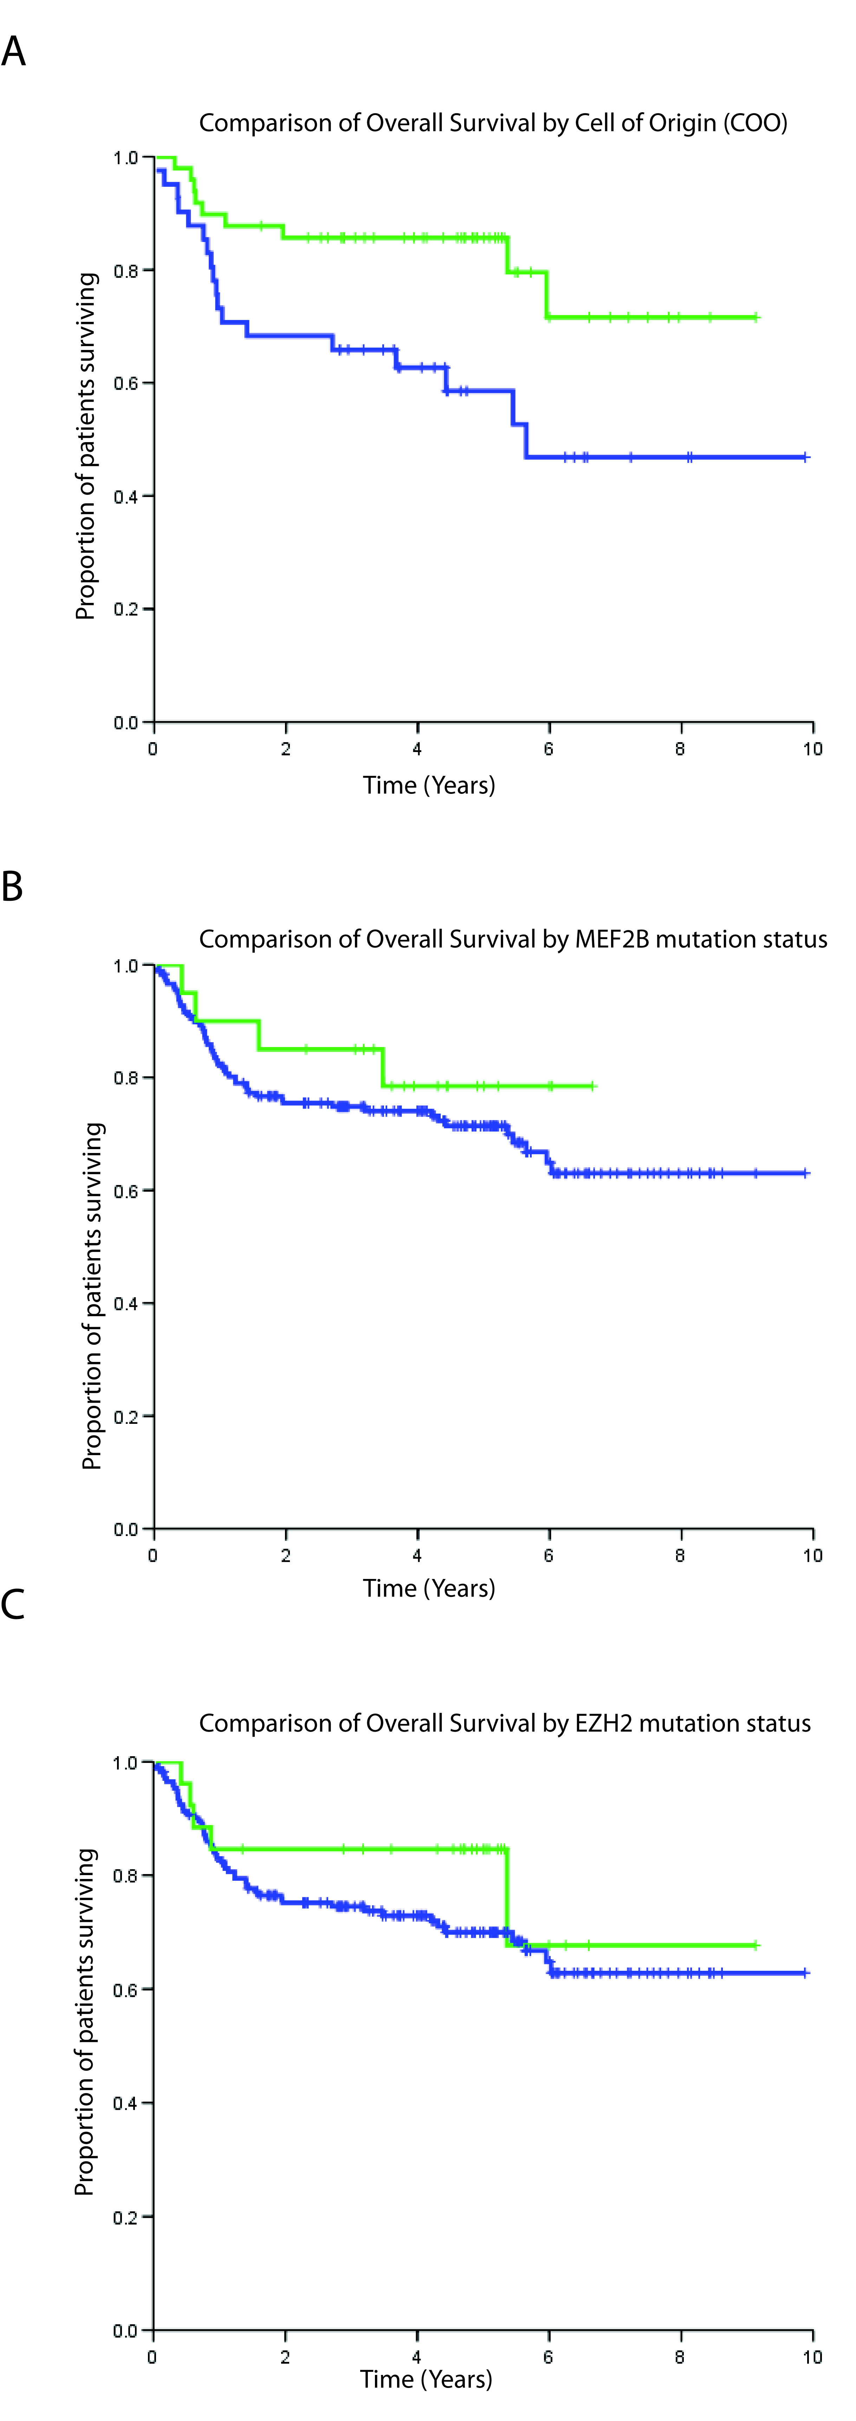
Figure S6: No detectable prognostic impact of EZH2 or MEF2B mutations in DLBCL.
The presence of MEF2B mutations (in exon 1 or 2) and EZH2 hot spot (Y641) mutations was determined in a cohort of 199 DLBCL patients, the subset of the 259 DLBCL cases that were uniformly treated with R-CHOP. (A) The overall survival times (OS) were compared between the uniformly treated patients in this cohort for the cases with known COO subtype, as defined by gene expression profiling (GEP)¹³(Methods). The GCB cases (green, n=49) showed superior OS when compared to the ABC cases (blue, n=41)(P=0.012, Log-rank test). (B) Cases found to have mutations in MEF2B (green) were compared to those lacking mutations (blue) and no significant difference in OS was found (p = 0.399, Log-rank test). (C) Analysis of DLBCL patients with (green) and without (blue) mutations affecting Y641 in EZH2 also showed no significant difference (p = 0.279, Log-rank test). Hence, although these mutations appear to be strongly enriched in GCB cases, they do not appear enriched among cases with particularly good (or poor) outcomes.
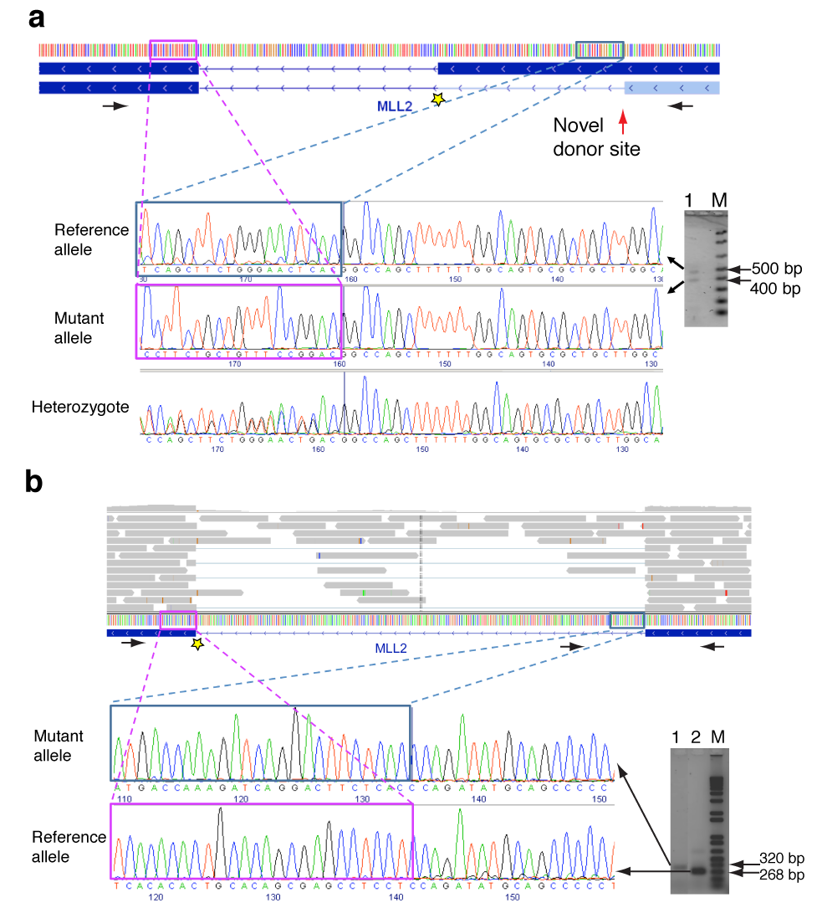
Figure S7: Confirmation of alternative splicing events resulting from MLL2 splice site mutations.
Shown are two examples of the effect of somatic splice site mutations in the MLL2 gene (reverse strand) determined from RNA-seq data and verified by Sanger sequencing (Supplementary Table S10; 05-25439).(A) Point mutation affecting a splice donor site (GT>GA) at chr12:47,714,115 (yellow star). RT-PCR primers for exons 38 and 39 (blue rectangles) are indicated by black arrows. Sequence from the upper gel band represents the reference allele or, from the lower band, the alternative transcript which uses an alternative donor site within exon 38. (B) Point mutation that disrupts a splice acceptor site (AG>CG) at chr12:47,733,692 (yellow star). Intron retention is inferred due to enrichment of intronic sequence reads (top, grey bars). Black arrows depict PCR primers. Primers for exons 5 and 6 (lane 2 of gel on right) produced an amplicon of 267bp and an amplicon of 602bp. The difference in these sizes is the size of the intron (335bp). Primers for exon 5 and the intron (lane 1) produced a single amplicon of 318bp. Amplicon sequencing confirmed the present of the reference splicing pattern and the intron retention event.

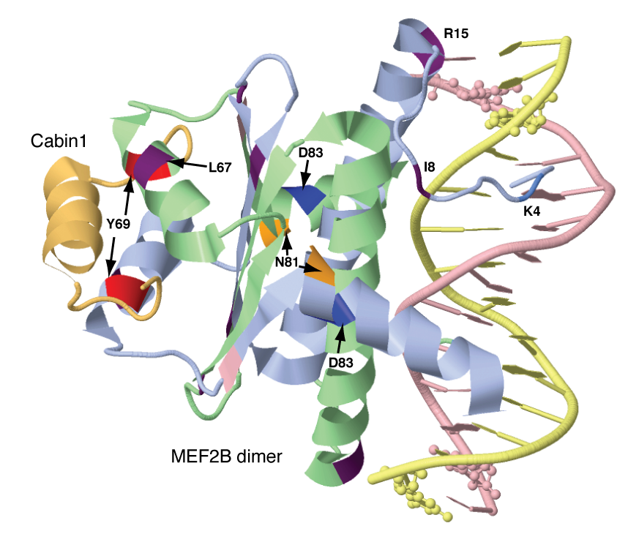
Figure S8: Visualization of MEF2B mutations in the solved crystal structure.
The crystal structure of MEF2B bound to one of its co-repressors (Cabin1) is shown with the mutated residues indicated¹⁴. Some of the mutations affect regions of the protein that interact with co-activators and co-repressors (e.g. Y69, L67) and regions that are likely to interact with DNA (e.g. K4). The crystal structure of MEF2A bound to EP300 has also recently been solved and supports that L67 and Y69 are also important in that interaction¹⁵.
Supplementary Tables

Table S3: Gene fusions identified using RNA-seq and genome sequencing
Patient | Gene fusion(s) | Observed in* | Origin | Breakpoint 1 | Breakpoint 2
DLBCL-PatientC | KIAA1532/ POLR2E | Transcriptome only | Unknown | chr19:2254040 | chr19:1040471
DLBCL-PatientD | BCL2/ IGH | Both | Somatic | chr18:58944471 | chr14:105401497
DLBCL-PatientD | C15orf57/ CBX3 | Both | Germ line** | chr15:38641486 | chr7:26219496
DLBCL-PatientE | None | NA | NA | NA | NA
DLBCL-PatientF | None | NA | NA | NA | NA
DLBCL-PatientG | BCL2/ IGH | Both | Somatic | chr18:58945022 | chr14:105453733
DLBCL-PatientH | MAPKBP1/MGA | Both | Germ line | chr15:39837967 | chr15:39903511
DLBCL-PatientH | SMEK1/ CCDC88C | Both | Germ line | chr14:90867139 | chr14:91005988
DLBCL-PatientI | None | NA | NA | NA | NA
DLBCL-PatientJ | IGH/ DUSP22 | Both | Somatic | chr14:105396245 | chr6:295806
DLBCL-PatientK | C15orf57/ CBX3 | Both | Germ line** | chr15:38641486 | chr7:26219496
DLBCL-PatientK | GIT1/ SHMT1 | Both | Somatic | chr17:18177820 | chr17:24935050
DLBCL-PatientK | YES1/ ENOSF1 | Transcriptome only | Unknown | chr18:714633 | chr18:696468
DLBCL-PatientL | BCL2/ IGH | Both | Somatic | chr18:58915791 | chr14:105400505
DLBCL-PatientM | BCL6/ FBX018 | Both | Somatic | chr3:188945185 | chr10:6018457
DLBCL-PatientM | C15orf57/ CBX3 | Both | Germ line** | chr15:38641486 | chr7:26219496
DLBCL-PatientM | C4orf18/ TMEM144 | Both | Germ line | chr4:159303043 | chr4:159380815

*Events observed only in the transcriptome are potential false positive events or the result of trans-splicing;**Genome sequencing reveals that this germ line derived event is not the result of a genomic translocation but rather the approximately 7 Kb insertion of chr7 sequence (harbouring CBX3) into the chr15 region containing C15orf57.

Table S6: Mutation hotspots in genes identified using RNA-seq.

Codon | Number of Samples | Distinct mutations | Gene Name
602;646 | 30 | 4 | EZH2
83§ | 9 | 2 | MEF2B
69§ | 4 | 2 | MEF2B
81§ | 2 | 2 | MEF2B
1482§ | 3 | 2 | CREBBP
1499§ | 2 | 2 | CREBBP
1467§ | 2 | 2 | EP300
287§ | 2 | 1 | HLA-C
1 | 8 | 5 | BCL7A‡
206§ | 4 | 1 | MYD88‡
230§ | 2 | 1 | MYD88‡
252§ | 6 | 1 | MYD88‡
59 | 7 | 3 | BCL2*
92;196;197 | 5 | 4 | CD79B‡
73;160§ | 4 | 2 | IKZF3‡
164;255§ | 3 | 2 | PIM1‡
97;188 | 3 | 2 | PIM1‡
18§ | 3 | 2 | IRF4‡
587§ | 3 | 2 | BCL6
45§ | 3 | 2 | BTG2‡
141;234 | 3 | 2 | TP53‡
24§ | 2 | 2 | FOXO1‡
1§ | 3 | 3 | FOXO1‡
12§ | 2 | 1 | TNFRSF14
226§ | 2 | 2 | CCND3‡
233§ | 2 | 2 | CCND3‡
1§ | 3 | 3 | B2M‡
§This mutation was proven to be somatic in at least one case; that is, present in tumour DNA but absent in matched constitutional DNA. ‡Not mutated in any of the fourteen genomes or exomes sequenced. *Additional hot spots in BCL2 were excluded to simplify the table. Genes indicated in bold are previously described targets of somatic mutation in lymphoma. Although known to be mutated, hot spots have not, to our knowledge, been described in BCL7A. Note that Tyr641 as previously described¹⁶ is based on the Uniprot sequence Q15910, whereas this site corresponds to residue 602 and 646 in the Refseq annotations.

Table S9: Mutations affecting CREBBP or EP300 detected using RNA-seq data.

Library | Disease | Gene | Annotation | EP300 position
HS0841 | DLBCL line | CREBBP | E1238*;E1268* | E1202
HS0842 | DLBCL line | CREBBP | A436V | A420
HS0842 | DLBCL line | CREBBP | Q170*;Q238* | not conserved
HS0806 | FL | CREBBP | Y71H;Y1482H;Y1512H§ | Y1446
HS1185 | FL | CREBBP | G1411E;G1441E | G1375
HS1200 | FL | CREBBP | Y92F;Y1503F;Y1533F | Y1467
HS1360 | FL | CREBBP | R35C;R1446C;R1476C | R1410
HS1361 | FL | CREBBP | S25N;S1436N;S1466N§ | S1400
HS0637 | DLBCL | CREBBP | Q1104*;Q1134* | Q1068
HS0641 | DLBCL | CREBBP | L88Q;L1499Q;L1529Q§ | L1463
HS0649 | DLBCL | CREBBP | P77R;P1488R;P1518R§ | P1452
HS0649 | DLBCL | CREBBP | A687V;A717V | not conserved
HS0749 | DLBCL | CREBBP | N1589K;N1619K | N1552
HS0933 | DLBCL | CREBBP | R370*;R438* | R354
HS0939 | DLBCL | CREBBP | M1625V;M1655V§ | M1588
HS1135 | DLBCL | CREBBP | V1342E;V1372E | V1306
HS1460 | DLBCL | CREBBP | L88P;L1499P;L1529P§ | L1463
HS1977 | DLBCL | CREBBP | C1283R;C1313R | C1247
HS1979 | DLBCL | CREBBP | N513S;N1978S;N2008S | not conserved
HS2059 | DLBCL | CREBBP | Y71N;Y1482N;Y1512N§ | Y1446
HS2249 | DLBCL | CREBBP | A442T;A1907T;A1937T | not conserved
HS2249 | DLBCL | CREBBP | Y92H;Y1503H;Y1533H§ | Y1467
HS2606 | DLBCL | CREBBP | R35C;R1446C;R1476C§ | R1410
HS0653 | DLBCL | EP300 | Q1904* | -
HS0939 | DLBCL | EP300 | A1498T§ | -
HS1133 | DLBCL | EP300 | L415P | -
HS1462 | DLBCL | EP300 | Y1467H§ | -
HS2049 | DLBCL | EP300 | P925T‡ | -
HS2607 | DLBCL | EP300 | P925T‡ | -
HS1199 | FL | EP300 | D1485V | -
HS1201 | FL | EP300 | Q1455L | -
HS1202 | FL | EP300 | Y1467N§ | -
HS0841 | DLBCL line | EP300 | Q160* | -
HS0900 | DLBCL line | EP300 | R1627W | -

§mutation was proven to be somatic (absent in matched constitutional DNA); ‡was also found in the matched constitutional DNA (inherited variant); bold indicates mutation hot spots.

Table S11: All MEF2B mutations detected.
Case (res_id) | Position (chromosome) | Change (DNA) | Change (protein) | Diagnosis and subtype (subtyping method)
03-31934 | chr19:19122543 | A > T | M1K | FL
02-17440 | chr19:19122535 | T > C | K4E | GCB DLBCL (GEP)
98-17403 | chr19:19122535 | T > C | K4E | DLBCL
06-20044 | chr19:19122535§ | T > C | K4E | FL
06-23741 | chr19:19122535§ | T > C | K4E | FL
07-14540 | chr19:19122535 | T > C | K4E | FL
98-14740 | chr19:19122535 | T > C | K4E | FL
05-15463 | chr19:19122532 | T > C | K5E | FL
03-28045 | chr19:19122523 | T > C | I8V | DLBCL
92-59893 | chr19:19122502 | T > C | R15G | DLBCL
02-28712 | chr19:19122493 | G > A | Q18* | DLBCL
05-22052 | chr19:19121225 | T > C | K23R | DLBCL
07-10201 | chr19:19121222 | C > T | R24Q | FL
SPEC1187 | chr19:19121217 | A > C | F26V | GCB DLBCL (GEP)
06-20952 | chr19:19121195 | T > G | Y33S | FL
03-18669 | chr19:19121153 | A > G | I47T | DLBCL
03-33888 | chr19:19121135 | C > T | R53H | DLBCL
01-16433 | chr19:19121093§ | A > C | L67R | FL
00-15694 | chr19:19121088§ | A > G | Y69H | GCB DLBCL (GEP)
05-11328 | chr19:19121088 | A > G | Y69H | GCB DLBCL (GEP)
06-12968 | chr19:19121087§ | T > C | Y69C | FL
06-18193 | chr19:19121087 | T > C | Y69C | FL
08-10448 | chr19:19121087 | T > C | Y69C | FL
99-30068 | chr19:19121087 | T > C | Y69C | FL
05-11369 | chr19:19121066 | -GGGGCT | E74-P75-H76 > D | FL
06-23851 | chr19:19121066 | T > C | H76R | FL
07-21828 | chr19:19121064 | C > T | E77K | DLBCL
07-30109 | chr19:19121063 | T > C | E77G | Composite FL
06-30145 | chr19:19121052§ | T > A | N81Y | GCB DLBCL (GEP)
05-23110 | chr19:19121050§ | G > T | N81K | GCB DLBCL (GEP)
00-13940 | chr19:19121045 | T > G | D83A | GCB DLBCL (IHC)
06-15922 | chr19:19121045§ | T > G | D83A | GCB DLBCL (GEP)
07-23804 | chr19:19121045 | T > G | D83A | GCB DLBCL (GEP)
00-22287 | chr19:19121045 | T > A | D83V | GCB DLBCL (IHC)
01-18672 | chr19:19121045 | T > A | D83V | GCB DLBCL (IHC)
02-30647 | chr19:19121045§ | T > A | D83V | GCB DLBCL (GEP)
03-11110 | chr19:19121045 | T > A | D83V | DLBCL
03-26817 | chr19:19121045 | T > A | D83V | GCB DLBCL (GEP)
03-30438 | chr19:19121045 | T > A | D83V | GCB DLBCL (GEP)
05-24666 | chr19:19121045 | T > A | D83V | GCB DLBCL (GEP)
06-30025 | chr19:19121045§ | T > A | D83V | GCB DLBCL (GEP)
06-33777 | chr19:19121045§ | T > A | D83V | GCB DLBCL (GEP)
78-60284 | chr19:19121045 | T > A | D83V | GCB DLBCL (IHC)
95-32814 | chr19:19121045§ | T > A | D83V | GCB DLBCL (GEP)
97-10270 | chr19:19121045 | T > A | D83V | DLBCL
DB (cell line) | chr19:19121045 | T > A | D83V | GCB DLBCL (GEP)
06-11109 | chr19:19121045 | T > G | D83A | FL
07-20462 | chr19:19121045 | T > G | D83A | FL
91-34915 | chr19:19121045 | T > G | D83A | FL
03-16286 | chr19:19121045 | T > C | D83G | FL
05-12024 | chr19:19121045 | T > A | D83V | FL
06-22766 | chr19:19121045 | T > A | D83V | FL
06-33903 | chr19:19121045 | T > A | D83V | FL
89-30159 | chr19:19121045 | T > A | D83V | FL
91-53679 | chr19:19121045 | T > A | D83V | FL
97-23234 | chr19:19121045 | T > A | D83V | FL
99-21548 | chr19:19121045 | T > A | D83V | FL
01-24821 | chr19:19119600 | +A | L100 Frameshift | FL
85-31959 | chr19:19119578 | C > A | E108* | FL
06-16716 | chr19:19119559‡ | C > T | R114Q | ABC DLBCL (GEP)
02-18484 | chr19:19119539 | 10bp del | G121 Frameshift | FL
91-53679 | chr19:19118877 | -GGAA | F170 Frameshift | FL
08-15460 | chr19:19118875 | -AAGG | P169 Frameshift | DLBCL
06-10398 | chr19:19118406 | +GG | G242 Frameshift | ABC DLBCL (GEP)
06-30389 | chr19:19118365 | -C | P256 Frameshift | FL
07-18609 | chr19:19117831 | A > C | S294R† | FL
05-20543 | chr19:19117794 | G > T | R307S† | ABC DLBCL (GEP)
05-14545 | chr19:19117608 | A > G | *369G† | FL
06-23851 | chr19:19117608 | A > C | *369E† | FL
06-12557 | chr19:19117606 | C > G | *369Y† | FL

†annotation is unique to NM_001145785, representing the longest MEF2B isoform; §was proven to be somatic (absent in matched constitutional DNA); ‡was also found in the matched constitutional DNA (inherited variant)

Table S12: Catalogue of MEF2B cSNVs in FL and DLBCL.
Amino Acid Change | FL | DLBCL | Total | % variants
M1K | 1 | 0 | 1 | 1.4
K4E§ | 4 | 2 | 6 | 8.7
K5E | 1 | 0 | 1 | 1.4
I8V | 0 | 1 | 1 | 1.4
R15G | 0 | 1 | 1 | 1.4
K23R | 0 | 1 | 1 | 1.4
R24Q | 1 | 0 | 1 | 1.4
F26V | 0 | 1 | 1 | 1.4
Y33S | 1 | 0 | 1 | 1.4
I47T | 0 | 1 | 1 | 1.4
R53H | 0 | 1 | 1 | 1.4
L67R | 1 | 0 | 1 | 1.4
Y69C/H§ | 4 | 2 | 6 | 8.7
E74-P75-H76 > D | 1 | 0 | 1 | 1.4
H76R | 1 | 0 | 1 | 1.4
E77K | 0 | 1 | 1 | 1.4
N81K/Y§ | 0 | 2 | 2 | 2.9
D83A/G/V§ | 11 | 16 | 27 | 39.1
R114Q | 0 | 1 | 1 | 1.4
S294Y | 1 | 0 | 1 | 1.4
R307S | 0 | 1 | 1 | 1.4
*369Y/E/G | 3 | 0 | 3 | 4.3
Truncation | 5 | 3 | 8 | 11.6
Any mutation | 35 | 34 | 69 | 100.0
Total cases sequenced | 261 | 292
Prevalence | 13.41% | 11.64%

§at least one representative mutation at this position has been confirmed as a somatic mutation.
Supplementary Discussion

It is thought that GCB and ABC DLBCLs arise due to distinct genetic events¹⁷ and it is widely accepted that the aggressive nature of the latter results from the acquisition of mutations that mimic stimulation of the B cell receptor by antigen or those that more directly induce constitutive activation of NF-B¹⁸. Here we report other important modulators or components of BCR signalling and regulators of B cell differentiation or survival as targets of repeated and recurrent mutation, including MEF2B/C⁵, SGK1⁷, IRF4¹⁹, STAT3³, STAT6²⁰, RFTN1²¹, CCND3²², PLCG2, FOXO1²³, CARD11⁸, CD79B⁹ and MYD88¹⁰ and IKZF3²⁴. There were notable differences in mutation patterns among these genes. For example, MEF2B/C and STAT3, each of which function as dimers, showed strong evidence for selectively acquiring nonsynonymous (rather than truncating) mutations, whereas SGK1 and CCND3 appeared to be preferentially truncated in NHL. The previously characterized CARD11⁸, CD79B⁹ and MYD88¹⁰ all act upstream of NF-B, leading to its deregulation, typically in ABC DLBCLs. In our data, only CD79B and MYD88 (in addition to structural rearrangements involving BCL6) showed a significant enrichment for mutations in ABC cases (Figure 2) and the point mutations we observed largely corresponded to the known hot spots in these two genes^{9,10}(Table S6).
The remaining genes listed above encode proteins that are either activated or inhibited as a result of BCR stimulation, but not directly involved in regulating NF-B. PRDM1 has been termed the plasma cell master differentiation gene as it orchestrates terminal differentiation of germinal centre B cells into plasma cells²⁵. Importantly STAT3³, found here to be commonly mutated in DLBCL, regulates the activity or expression of PRDM1 in response to IL-21 stimulation. Of interest, inherited mutations in STAT3 are the primary cause of an immune disorder known as hyper IgE syndrome and it has been shown that in these cases mutant STAT3 acts in a dominant negative manner²⁶. Strikingly, some of the somatic mutations we report here affect the same residues found mutated in the constitutional DNA of hyper IgE patients. This leads us to predict that mutant cells may be unable to induce PRDM1 transcription following IL-21 stimulation (Figure S5A). In particular, as many of these mutations were found in both GCB DLBCL and FL, our data suggest that malignant transformation of germinal centre B cells relies on components of BCR signalling separate from those utilized in ABC DLBCL (i.e. NF-B) but also that altered regulation of PRDM1, previously thought to be a feature unique to ABC DLBCL, may be of general importance in NHL.
Mutations affecting CREBBP and EP300 were recently reported in DLBCL²⁷, and ALL²⁸. Similar to the observations reported in these studies, our data show a preference for accumulation of truncating SNVs (n=4, 16.7% of mutated cases) but also include non-synonymous SNVs in many cases (20 cases with cSNVs, Table S9). EP300 also contained multiple cSNVs (8 cases total). We confirmed that 3 EP300 cSNVs and 9 CREBBP cSNVs were somatic mutations. Cases with multiple cSNVs in either gene were rarely observed (one cell line and three patients) consistent with the commonly held notion that both genes are haploinsufficient²⁹. The cSNVs that were not predicted to result in protein truncation were mainly found within the HAT domain of these two proteins. These included four codons that are apparent mutation hot spots (Tables S6 and S9). Of these, three correspond to residues that have been reported to be homologous between the two proteins¹ (Figure S3; Table S9). Representative cSNVs corresponding to three of these hot spots in CREBBP and one in EP300 were confirmed as somatic. Three of the EP300 somatic non-synonymous mutations we observed affected residues previously shown to reduce acetyltransferase activity in an in vitro acetyltransferase assay (Figure S3)¹. We also confirmed that CREBBP (but not EP300) has a significant signature of selective pressure to acquire both truncating and missense mutations (Table 1), but the lack of significance for the latter may owe to limited statistical power due to its reduced mutation prevalence relative to CREBBP. Taken together, these data suggest that reduction or loss of either CREBBP or EP300 may promote lymphomagenesis. Of note, in contrast to a recent report²⁷, we did not observe a significant difference in CREBBP or EP300 mutation frequency in the two subtypes (P = 0.5656 for CREBBP and 0.6607 for EP300; Fisher exact test).
MEF2 proteins can act as transcriptional co-activators or co-repressors by recruiting two classes of enzymes that alter the acetylation state of histone tails, namely HATs and HDACs. MEF2 dimers are known to associate with the two HATs CREBBP and EP300³⁰ and it has been suggested that HDACs and CREBBP/EP300 compete for the same binding site on MEF2³¹. Under normal levels of intracellular Ca²⁺, MEF2 is bound by one of several type IIa HDACs, which maintain the tails of histone proteins in a deacetylated repressive chromatin state³². Increased cytoplasmic Ca²⁺ levels induce the nuclear export of the bound HDAC, thus enabling MEF2 dimers to recruit a HAT enzyme such as CREBBP/EP300, which facilitate transcription at MEF2 target genes by catalysing the addition of acetyl groups to the tails of core histone proteins including lysine 27 on histone H3 (H3K27)^{30,31}(Figure S5D).
Ca²⁺-mediated induction of MEF2 target genes is utilised in diverse developmental processes including muscle and neuronal cell differentiation³³ as well as the maturation of B and T cells⁶. For example, during negative selection, upon T-cell-receptor (TCR) stimulation, the resulting Ca²⁺ influx results in MEF2-mediated induction of the pro-apoptosis NR4A1 (NUR77), which, in turn drives apoptosis of self-reactive T cells⁶. It has also been shown in T cells that MEF2D interacts directly with nuclear NFAT, another Ca²⁺/CaM-regulated protein, and recruits EP300 to MEF2 target genes³⁴. In murine B cells, it was recently demonstrated that MEF2C is required to mediate gene expression events following BCR stimulation, but this study did not discuss a possible overlapping role of MEF2B in this process nor was there a conclusive identification of the MEF2C-regulated genes important to this process⁵. That we also observed mutations in MEF2C at a lower frequency in NHL samples supports the interpretation that these proteins share a related function in this cellular context. The MEF2B dimer has previously been co-crystallized with three of its interacting partners, namely Cabin1¹⁴, HDAC9³¹ and EP300¹⁵ and, informed by these structures, we predict that many of the recurrent mutations would negatively impact the function of MEF2B. For example, at least three of the mutated residues (K5, K23 and R24) are required for mediating the binding of MEF2 to DNA³⁵. Because MEF2 proteins can heterodimerize³⁶, mutations that impact the function of MEF2 are known to produce a dominant effect on the overall function of any MEF2-family protein by occupying a significant proportion of MEF2-containing complexes³⁷. In fact one of the residues found mutated in this study (K24) was previously demonstrated to act as a dominant negative when ectopically expressed³⁷. Further, we also note that the mutation hot spot Y69 was recently shown to be involved in multiple interactions in a solved crystal structure of MEF2B bound to EP300¹⁵, suggesting the possibility that this mutation may impact the ability of these two proteins to interact. Although the impact of the individual MEF2B mutations on MEF2 function requires further study, the recurrence of these mutations among a limited set of residues suggests the action of positive selection for these mutations during cancer progression.
When one considers the high frequency of mutations we detected that affect genes encoding MEF2 proteins, it is striking but perhaps not surprising that inactivating mutations affecting both CREBBP and EP300 are common in NHL, as these are both known effectors of the induction of MEF2-regulated genes. Notably, with one exception, all of the truncation-inducing mutations identified in CREBBP and EP300 are predicted to remove the histone acetyltransferase (HAT) domain of the protein¹⁴. Moreover, comparison of the positions mutated in CREBBP to those mutated in EP300 reveals that some homologous residues within the HAT domains are affected in both proteins (Figure S3). Based on the crystal structure of EP300, five of these recurrently mutated residues were previously identified as important for mediating substrate interaction¹. In that study, three of these residues were mutated and showed loss (or reduction) of HAT activity in vitro, suggesting that many of the cSNVs we observed in these two proteins also negatively impact their function in vivo. Further, CREBBP/EP300 are both known to regulate the function of FOXO1³⁸, another gene found recurrently mutated in this study. Thus it is also possible that the mutation of these genes in addition their potential effect on MEF2-mediated transactivation, could impact the normal AKT-mediated nuclear exclusion of FOXO1 (Figure S5C).
Our data are consistent with a model wherein the induction of MEF2 target genes in response to BCR stimulation is inhibited by mutations that reduce the function of MEF2 complexes, potentially in a dominant negative fashion, or mutations that inactivate either of their transcriptional co-activators CREBBP or EP300 (Figure S5D). Another mutation identified in this study in a single case is also consistent with our model, namely the mutation of S155 to phenylalanine in HDAC7. This serine residue is known to be phosphorylated by CAMK following TCR stimulation, facilitating nuclear export of HDAC7 in response to Ca²⁺ influx³⁹. In the cited study, mutation of this residue resulted in impaired export of HDAC7 following TCR stimulation thereby inhibiting MEF2-mediated induction of NUR77 expression and hence, inhibiting NUR77-mediated apoptosis. Thus, this mutant could potentially produce a nuclear-restricted protein that leads to constitutive suppression of MEF2 target genes regardless of intracellular Ca²⁺ levels. This would be a similar effect that would be expected for loss-of-function mutations of MEF2B, CREBBP or EP300. Though an increase in cytoplasmic Ca²⁺ is one downstream signal following BCR stimulation, the NFAT transcription factors, key downstream mediators of this signal that promote survival, were not mutated and thus are expected to function normally. Also, pathways such as NF-B and events modulated by AKT do not rely on the Ca²⁺ messenger and should therefore be unaffected by these mutations. Interestingly, a recent report suggests that SGK1 (found here to be commonly inactivated in DLBCL) may also play a role in modulating Ca²⁺ levels by regulating the turnover of the Ca²⁺ channel protein Orai⁴⁰. Thus, this model predicts that mutations directly affecting MEF2 function (i.e. those in MEF2B, MEF2C, HDAC7, CREBBP or EP300) or other genes involved in regulating cytoplasmic calcium levels would diminish the cell’s ability to induce MEF2 target genes in response to BCR stimulation while leaving other downstream signals intact.
References
1. Liu, X. et al. The structural basis of protein acetylation by the p300/CBP transcriptional coactivator. Nature 451, 846–850 (2008).
2. Lewis, B.P., Green, R.E. & Brenner, S.E. Evidence for the widespread coupling of alternative splicing and nonsense-mediated mRNA decay in humans. Proc Natl Acad Sci USA 100, 189–192 (2003).
3. Diehl, S. et al. STAT3-mediated up-regulation of BLIMP1 Is coordinated with BCL6 down-regulation to control human plasma cell differentiation. J Immunol 180, 4805–4815 (2008).
4. Ariel, O., Levi, Y. & Hollander, N. Signal transduction by CD58: The transmembrane isoform transmits signals outside lipid rafts independently of the GPI-anchored isoform. Cell Signal 21, 1100–1108 (2009).
5. Wilker, P. et al. Transcription factor Mef2c is required for B cell proliferation and survival after antigen receptor stimulation. Nat Immunol 9, 603–612 (2008).
6. Youn, H., Sun, L., Prywes, R. & Liu, J. Apoptosis of T cells mediated by Ca2+-induced release of the transcription factor MEF2. Science 286, 790–793 (1999).
7. Brunet, A. et al. Protein Kinase SGK Mediates Survival Signals by Phosphorylating the Forkhead Transcription Factor FKHRL1 (FOXO3a). Mol Cell Biol 21, 952–965 (2001).
8. Lenz, G. et al. Oncogenic CARD11 mutations in human diffuse large B cell lymphoma. Science 319, 1676–1679 (2008).
9. Davis, R.E. et al. Chronic active B-cell-receptor signalling in diffuse large B-cell lymphoma. Nature 463, 88–92 (2010).
10. Ngo, V.N. et al. Oncogenically active MYD88 mutations in human lymphoma. Nature 470, 115–119 (2011).
11. Du, M.Q. et al. BCL10 gene mutation in lymphoma. Blood 95, 3885–3890 (2000).
12. Yap, D.B. et al. Somatic mutations at EZH2 Y641 act dominantly through a mechanism of selectively altered PRC2 catalytic activity, to increase H3K27 trimethylation. Blood 117, 2451–2459 (2011).
13. Wright, G. et al. A gene expression-based method to diagnose clinically distinct subgroups of diffuse large B cell lymphoma. Proc Natl Acad Sci USA 100, 9991–9996 (2003).
14. Han, A. et al. Sequence-specific recruitment of transcriptional co-repressor Cabin1 by myocyte enhancer factor-2. Nature 422, 730–734 (2003).
15. He, J. et al. Structure of p300 bound to MEF2 on DNA reveals a mechanism of enhanceosome assembly. Nucleic Acids Res (2011).doi:10.1093/nar/gkr030
16. Morin, R.D. et al. Somatic mutations altering EZH2 (Tyr641) in follicular and diffuse large B-cell lymphomas of germinal-center origin. Nat Genet 42, 181–185 (2010).
17. Lenz, G. et al. Molecular subtypes of diffuse large B-cell lymphoma arise by distinct genetic pathways. Proc Natl Acad Sci USA 105, 13520–13525 (2008).
18. Lenz, G. & Staudt, L.M. Aggressive lymphomas. N Engl J Med 362, 1417–1429 (2010).
19. Hunt, K.E., Hall, B. & Reichard, K.K. Translocations involving MUM1 are rare in diffuse large B-cell lymphoma. Appl Immunohistochem Mol Morphol 18, 109–112 (2010).
20. Linehan, L.A., Warren, W.D., Thompson, P.A., Grusby, M.J. & Berton, M.T. STAT6 is required for IL-4-induced germline Ig gene transcription and switch recombination. J Immunol 161, 302–310 (1998).
21. Saeki, K., Miura, Y., Aki, D., Kurosaki, T. & Yoshimura, A. The B cell-specific major raft protein, Raftlin, is necessary for the integrity of lipid raft and BCR signal transduction. EMBO J 22, 3015–3026 (2003).
22. Peled, J.U. et al. Requirement for cyclin D3 in germinal center formation and function. Cell Res 20, 631–646 (2010).
23. Srinivasan, L. et al. PI3 kinase signals BCR-dependent mature B cell survival. Cell 139, 573–586 (2009).
24. Cortés, M. & Georgopoulos, K. Aiolos is required for the generation of high affinity bone marrow plasma cells responsible for long-term immunity. J Exp Med 199, 209–219 (2004).
25. Shaffer, A.L. et al. Blimp-1 orchestrates plasma cell differentiation by extinguishing the mature B cell gene expression program. Immunity 17, 51–62 (2002).
26. Minegishi, Y. et al. Dominant-negative mutations in the DNA-binding domain of STAT3 cause hyper-IgE syndrome. Nature 448, 1058–1062 (2007).
27. Pasqualucci, L. et al. Inactivating mutations of acetyltransferase genes in B-cell lymphoma. Nature 471, 189–195 (2011).
28. Mullighan, C.G. et al. CREBBP mutations in relapsed acute lymphoblastic leukaemia. Nature 471, 235–239 (2011).
29. Janknecht, R. The versatile functions of the transcriptional coactivators p300 and CBP and their roles in disease. Histol. Histopathol 17, 657–668 (2002).
30. Giordano, A. & Avantaggiati, M. p300 and CBP: partners for life and death. J Cell Physiol 181, 218–230 (1999).
31. Han, A., He, J., Wu, Y., Liu, J.O. & Chen, L. Mechanism of recruitment of class II histone deacetylases by myocyte enhancer factor-2. J Mol Biol 345, 91–102 (2005).
32. Youn, H. & Liu, J. Cabin1 represses MEF2-dependent Nur77 expression and T cell apoptosis by controlling association of histone deacetylases and acetylases with MEF2. Immunity 13, 85–94 (2000).
33. Potthoff, M. & Olson, E. MEF2: a central regulator of diverse developmental programs. Development 134, 4131–4140 (2007).
34. Youn, H.D., Chatila, T.A. & Liu, J.O. Integration of calcineurin and MEF2 signals by the coactivator p300 during T-cell apoptosis. EMBO J 19, 4323–4331 (2000).
35. Wu, W. et al. Conservation and evolution in and among SRF- and MEF2-type MADS domains and their binding sites. Molecular biology and evolution (2010).doi:10.1093/molbev/msq214
36. Martin, J. et al. A Mef2 gene that generates a muscle-specific isoform via alternative mRNA splicing. Mol Cell Biol 14, 1647–1656 (1994).
37. Molkentin, J.D., Black, B.L., Martin, J.F. & Olson, E.N. Mutational analysis of the DNA binding, dimerization, and transcriptional activation domains of MEF2C. Mol Cell Biol 16, 2627–2636 (1996).
38. van der Heide, L.P. & Smidt, M.P. Regulation of FoxO activity by CBP/p300-mediated acetylation. Trends Biochem. Sci. 30, 81–86 (2005).
39. Dequiedt, F. et al. HDAC7, a thymus-specific class II histone deacetylase, regulates Nur77 transcription and TCR-mediated apoptosis. Immunity 18, 687–698 (2003).
40. Eylenstein, A. et al. Stimulation of Ca2+-channel Orai1/STIM1 by serum- and glucocorticoid-inducible kinase 1 (SGK1). FASEB J 25, 2012–2021 (2011).

