Integrated Assignment : April 2015

Day1: Parts 1-2
Day2: Parts 3-4

Background: PCA3 gene plays a role in Prostate Cancer detection due to its localized expression in prostate tissues and its over-expression in tumour tissues. This gene's expression profile makes it a useful marker that can complement the most frequently used biomarker for prostate cancer, PSA. There are cancer assays available that tests the presence of PCA3 in urine.

Objectives: In this assignment, we will be using a subset of the GSE22260 dataset, which consists of 30 RNA-seq tumour normal pairs, to assess the prostate cancer specific expression of the PCA3 gene.

Things to keep in mind:

- The libraries are polyA selected.
- The libraries are prepared as paired end.
- The samples are sequenced on Illumina's Genome Analyzer II.
- Each read is 36 bp long
- The average insert size is 150 bp with standard deviation of 38bp.
- We will only look at chromosome 9 in this exercise.
- Dataset is located here: http://www.ncbi.nlm.nih.gov/geo/query/acc.cgi?acc=GSE22260
- 20 tumour and 10 normal samples are available
- For this exercise we will pick 3 matched pairs (C02,C03,C06 for tumour and N02,N03,N06 for normal). We can do more if we have time.

PART 1 ------Obtaining Data and References --------

Goals:
- Obtain the files necessary for data processing
- Familiarize yourself with reference and annotation file format
- Familiarize yourself with sequence FASTQ format

#set your working directory

mkdir -p ~/workspace/rnaseq/integrated_assignment/
export RNA_HOME=~/workspace/rnaseq/integrated_assignment

#copy the necessary reference and annotation files. Note, when initiating an environment variable, we don't need the $; however, everytime we call the variable, it needs to be preceeded by a $.

#make sure that the environment variable is set correctly

echo $RNA_HOME
cp -r ~/CourseData/RNA_data/integrated_assignment_files/* $RNA_HOME
cd $RNA_HOME

Q1) How many directories are there under the “refs” directory?

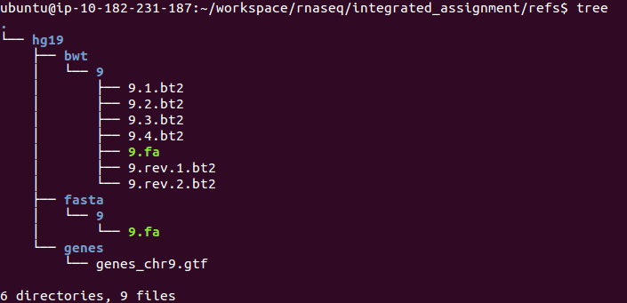

Q2) How many exons does the gene PCA3 have?

Q3) How many cancer/normal samples do you see under the data directory?

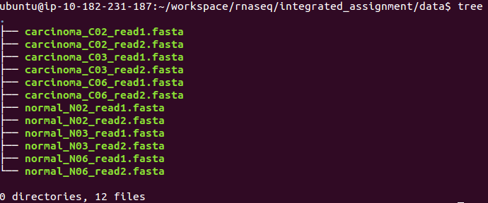

NOTE: The fasta files you have copied above contain sequences for chr9 only. I have pre-processed those fasta files to obtain chr9 and also matched read1/read2 sequences for each of the samples. You do not need to redo this; However, I will explain below the process I went through to get them to this point.

########################### FYI ###############################
- Access the following link: http://www.ncbi.nlm.nih.gov/geo/query/acc.cgi?acc=GSE22260. Scroll down to select the files you want to download.

-The raw data in GEO is provided as _map.txt. After you download the files, you can run the following command to convert them to FASTA:

‪cat GSM554076_C02_read1_map.txt | grep chr9 | cut -f1,2 | awk '{print ">"$1"\n"$2}' > GSM554076_C02_read1_map.chr9.fasta‬

‪cat GSM554076_C02_read2_map.txt | grep chr9 | cut -f1,2 | awk '{print ">"$1"\n"$2}' > GSM554076_C02_read2_map.chr9.fasta‬

-The second challenge was to match the reads for both read1 and read2, since the two FASTA files have different number of records.

‪for i in `cat GSM554076_C02_read2_map.chr9.fasta | grep ">"`;do R1=`echo ${i} | sed 's/0\/2/0\/1/g'`; grep -A1 $R1 GSM554076_C02_read1_map.chr9.fasta >> carcinoma_C02_read1.fasta;done;‬

‪for i in `cat carcinoma_C02._read1.fasta | grep ">"`;do R2=`echo ${i} | sed 's/0\/1/0\/2/g'`; grep -A1 $R2 GSM554076_C02_read2_map.chr9.fasta >> carcinoma_C02_read2.fasta;done;‬

- Now you have two FASTA files with the same number of reads at the each end
########################### FYI ###############################

Q4) What sample has the highest number of reads?

PART 2 ----- Data alignment -----

Goals:
- Familiarize yourself with Tophat/Bowtie alignment options
- Perform alignments
- Obtain alignment summary

Q5) What is the value of --mate-inner-dist? What calculation did you do to get that answer?

Q6) Considering that the read length in this exercise is 36bp, what should you set the --segment-length to (default is 25bp)?

cd $RNA_HOME/
export RNA_DATA_DIR=$RNA_HOME/data/
echo $RNA_DATA_DIR
mkdir -p alignments/tophat/trans_idx
cd alignments/tophat
export TRANS_IDX_DIR=$RNA_HOME/alignments/tophat/trans_idx/
echo $TRANS_IDX_DIR

#take a minute and try to figure out what each parameter means and how we go the numbers.

tophat2 -p 8 --mate-inner-dist 80 --mate-std-dev 38 --segment-length 18 --rg-id=normal --rg-sample=normal_N02 -o normal_N02 -G $RNA_HOME/refs/hg19/genes/genes_chr9.gtf --transcriptome-index $TRANS_IDX_DIR/ENSG_Genes $RNA_HOME/refs/hg19/bwt/9/9 $RNA_DATA_DIR/normal_N02_read1.fasta $RNA_DATA_DIR/normal_N02_read2.fasta

tophat2 -p 8 --mate-inner-dist 80 --mate-std-dev 38 --segment-length 18 --rg-id=normal --rg-sample=normal_N03 -o normal_N03 -G $RNA_HOME/refs/hg19/genes/genes_chr9.gtf --transcriptome-index $TRANS_IDX_DIR/ENSG_Genes $RNA_HOME/refs/hg19/bwt/9/9 $RNA_DATA_DIR/normal_N03_read1.fasta $RNA_DATA_DIR/normal_N03_read2.fasta

tophat2 -p 8 --mate-inner-dist 80 --mate-std-dev 38 --segment-length 18 --rg-id=normal --rg-sample=normal_N06 -o normal_N06 -G $RNA_HOME/refs/hg19/genes/genes_chr9.gtf --transcriptome-index $TRANS_IDX_DIR/ENSG_Genes $RNA_HOME/refs/hg19/bwt/9/9 $RNA_DATA_DIR/normal_N06_read1.fasta $RNA_DATA_DIR/normal_N06_read2.fasta

tophat2 -p 8 --mate-inner-dist 80 --mate-std-dev 38 --segment-length 18 --rg-id=carcinoma --rg-sample=carcinoma_C02 -o carcinoma_C02 -G $RNA_HOME/refs/hg19/genes/genes_chr9.gtf --transcriptome-index $TRANS_IDX_DIR/ENSG_Genes $RNA_HOME/refs/hg19/bwt/9/9 $RNA_DATA_DIR/carcinoma_C02_read1.fasta $RNA_DATA_DIR/carcinoma_C02_read2.fasta

tophat2 -p 8 --mate-inner-dist 80 --mate-std-dev 38 --segment-length 18 --rg-id=carcinoma --rg-sample=carcinoma_C03 -o carcinoma_C03 -G $RNA_HOME/refs/hg19/genes/genes_chr9.gtf --transcriptome-index $TRANS_IDX_DIR/ENSG_Genes $RNA_HOME/refs/hg19/bwt/9/9 $RNA_DATA_DIR/carcinoma_C03_read1.fasta $RNA_DATA_DIR/carcinoma_C03_read2.fasta

tophat2 -p 8 --mate-inner-dist 80 --mate-std-dev 38 --segment-length 18 --rg-id=carcinoma --rg-sample=carcinoma_C06 -o carcinoma_C06 -G $RNA_HOME/refs/hg19/genes/genes_chr9.gtf --transcriptome-index $TRANS_IDX_DIR/ENSG_Genes $RNA_HOME/refs/hg19/bwt/9/9 $RNA_DATA_DIR/carcinoma_C06_read1.fasta $RNA_DATA_DIR/carcinoma_C06_read2.fasta

At this point, each one of your samples should have the following files:

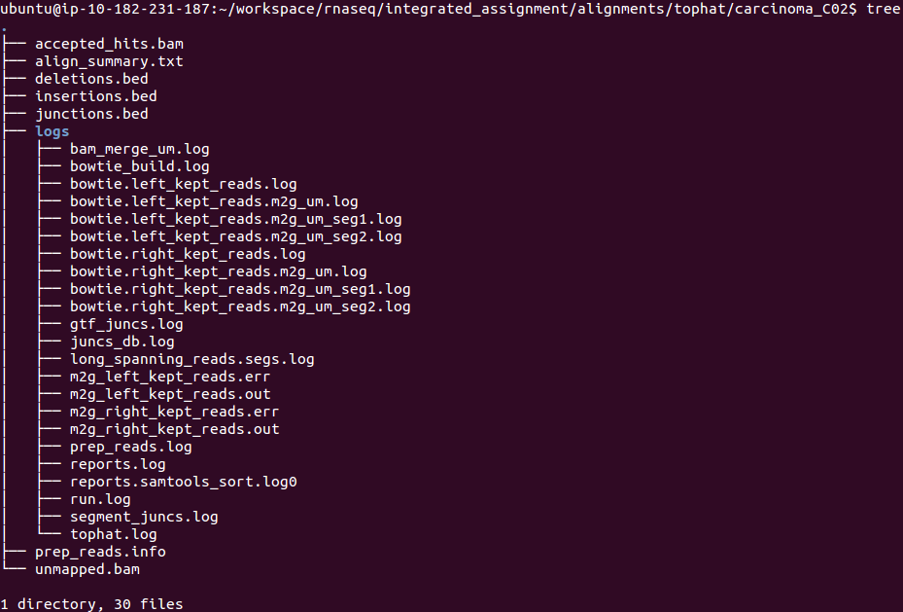

Q7) How would you obtain summary statistics for each aligned file?

PART 3 ---- Expression Estimation ---------

Goals:
- Familiarize yourself with Cufflinks options
- Run Cufflinks to obtain expression values
- Obtain expression values for the gene PCA3

cd $RNA_HOME/
mkdir expression
cd expression

example (how to run cufflinks for one sample):

cufflinks -p 8 -o normal_N02 --GTF $RNA_HOME/refs/hg19/genes/genes_chr9.gtf --no-update-check $RNA_HOME/alignments/tophat/normal_N02/accepted_hits.bam
cufflinks -p 8 -o normal_N03 --GTF $RNA_HOME/refs/hg19/genes/genes_chr9.gtf --no-update-check $RNA_HOME/alignments/tophat/normal_N03/accepted_hits.bam
cufflinks -p 8 -o normal_N06 --GTF $RNA_HOME/refs/hg19/genes/genes_chr9.gtf --no-update-check $RNA_HOME/alignments/tophat/normal_N06/accepted_hits.bam

cufflinks -p 8 -o carcinoma_C02 --GTF $RNA_HOME/refs/hg19/genes/genes_chr9.gtf --no-update-check $RNA_HOME/alignments/tophat/carcinoma_C02/accepted_hits.bam
cufflinks -p 8 -o carcinoma_C03 --GTF $RNA_HOME/refs/hg19/genes/genes_chr9.gtf --no-update-check $RNA_HOME/alignments/tophat/carcinoma_C03/accepted_hits.bam
cufflinks -p 8 -o carcinoma_C06 --GTF $RNA_HOME/refs/hg19/genes/genes_chr9.gtf --no-update-check $RNA_HOME/alignments/tophat/carcinoma_C06/accepted_hits.bam

At this point, you should have the following files in your “expression” directory:

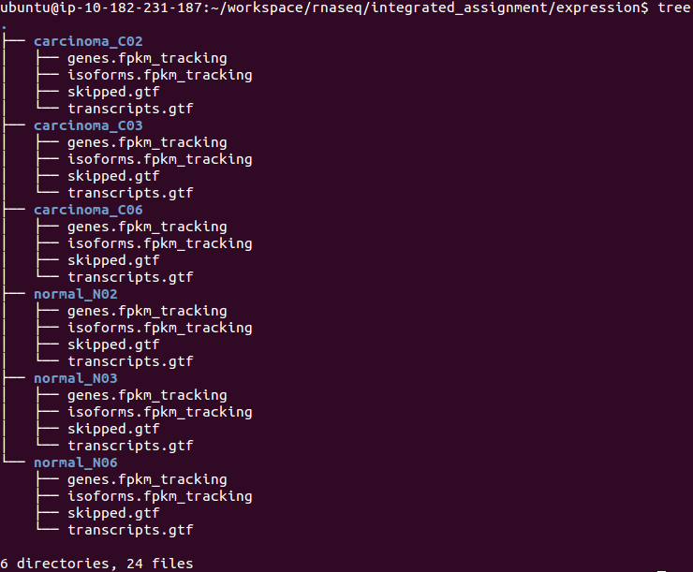
Q8) How do you get the expression of PCA3 across the normal and carcinoma samples?

PART 4 -- Differential Expression Analysis ---

Goals:
- Perform differential analysis between tumor and normal samples
- Check if PCA3 is differentially expressed

cd $RNA_HOME/expression

ls -1 */transcripts.gtf > assembly_GTF_list.txt

cuffmerge -p 8 -o merged -g $RNA_HOME/refs/hg19/genes/genes_chr9.gtf -s $RNA_HOME/refs/hg19/bwt/9/ assembly_GTF_list.txt

cd $RNA_HOME/
mkdir de
mkdir de/reference_only
cd $RNA_HOME/alignments/tophat

#run cuffdiff to perform comparison

cuffdiff -p 8 -L Normal,Carcinoma -o $RNA_HOME/de/reference_only/ --no-update-check $RNA_HOME/expression/merged/merged.gtf normal_N02/accepted_hits.bam,normal_N03/accepted_hits.bam,normal_N06/accepted_hits.bam carcinoma_C02/accepted_hits.bam,carcinoma_C03/accepted_hits.bam,carcinoma_C06/accepted_hits.bam

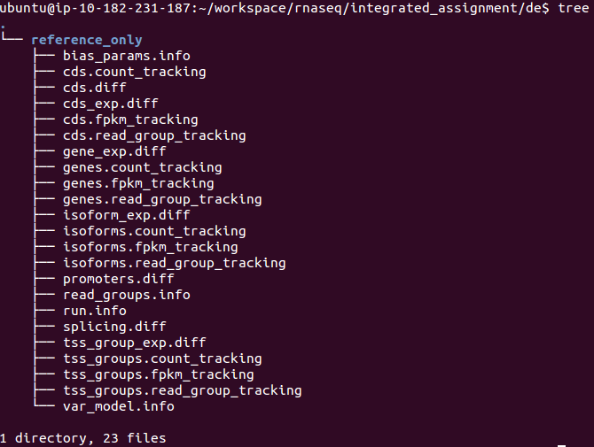
At this point, you should have the following files under your “de” directory:

Q9) any significant genes that are differentially expressed? what about PCA3?

NOTE: Make a copy of the data to use in generateCummerbund plots generation

cd $RNA_HOME/
mkdir final_results
cd $RNA_HOME/final_results
mkdir reference_only
cp $RNA_HOME/de/reference_only/isoform* reference_only/
cp $RNA_HOME/de/reference_only/read_groups.info reference_only/

NOTE: Rerun Obi's CummerBund Script focusing on PCA3 genes.

Q10) What plots can you generate to help you visualize this gene's expression profile?

