**Appendix-B**

**AUC Confidence Interval and Delong Test for each theoretical model across both stages presented in the paper.**

**Figure 1: AUC with 95% Confidence Intervals for State 1: Conflict Onset**

**Figure 2: Results of Delong Test for Stage 1: Conflict Onset**

**Figure 3: AUC with 95% Confidence Intervals for State 2: Conflict Escalation**

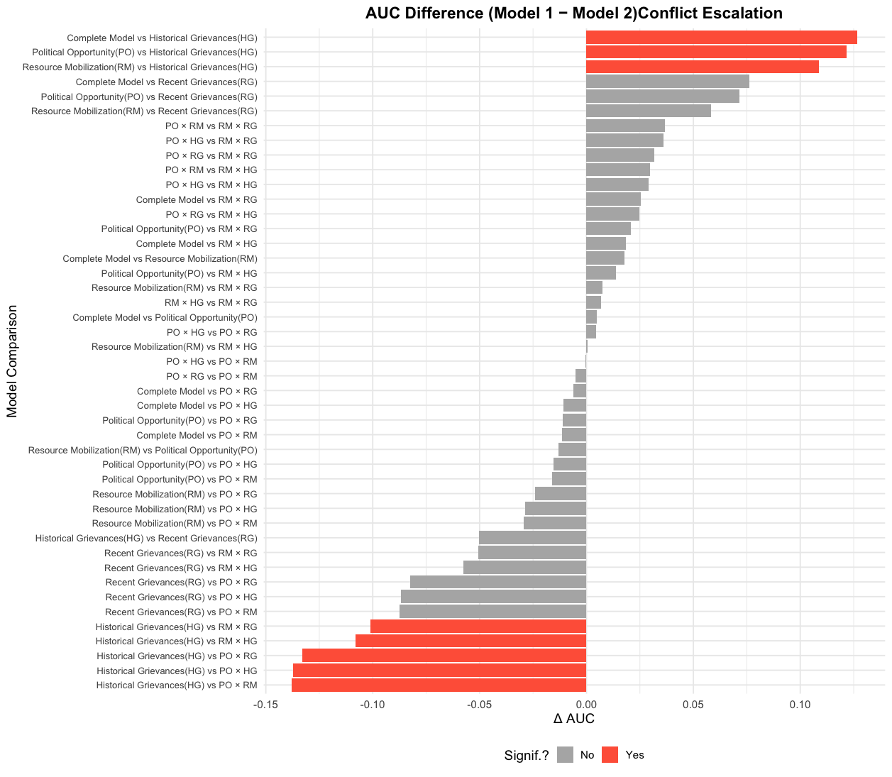**Figure 4: Results of Delong Test for Stage 2: Conflict Escalation**