**Adjudicating Theories of Self-Determination Conflict with Machine Learning: A Stage-Specific Predictive Evaluation**

**Abstract:** This letter introduces a theory-driven machine learning framework to adjudicate between competing explanations for the onset and escalation of self-determination conflicts. Drawing on global group-level data (1945–2012), we evaluate four leading theoretical models—historical grievances, recent grievances, political opportunity, and resource mobilization—alongside their interactions, using Random Forest classifiers and logistic regression across two distinct stages: (1) the nonviolent onset of separatist claims, and (2) their escalation into violence. Substantively, our findings reveal that while out-of-sample predictive performances among these four theoretical models and their interactions do not vary substantially within and across stages, political opportunity and resources mobilization models alone or in combination with each other performs better than others in both predicting nonviolent onset and conflict escalation of self-determination conflicts. By contrast, both historical and recent grievance models—despite recent scholarly attention—perform comparatively poorly. Through variable importance and partial dependence analyses, we show that while higher levels of democracy and economic development are positively associated with nonviolent mobilization, their lower levels are predictive of violent escalation—underscoring the stage-specific nature of these mechanisms. This stage-specific framework shows that the mechanisms driving conflict onset differ from those driving escalation—an often-overlooked distinction in the literature. Methodologically, Random Forest models offer superior predictive accuracy and reveal key nonlinear and interactive dynamics that traditional logistic regression models miss. By treating predictive performance as a tool for theory refinement, we offer a replicable approach for evaluating the generalizability and substantive relevance of conflict theories.

**Word count: ~2500 (without title, abstract and references; some text around figures will be removed after completion)**

***Political Analysis* (letter format, up to 2500 words)**

**Introduction**

Why do some self-determination movements escalate into violent conflict while others remain nonviolent or dissipate altogether? A large literature offers competing explanations, invoking historical and recent grievances, opportunity structures, resource mobilization, or their interactions. Yet few studies systematically adjudicate these theories across distinct stages of conflict—onset and escalation—or test their generalizability across cases.[1] Even fewer evaluate and adjudicate among these theories using predictive metrics that reward generalization rather than in-sample fit, an essential step for advancing theory in this area.

This letter proposes a new strategy for theory adjudication and applies it to the study of self-determination conflict—using supervised machine learning to assess competing theoretical models based on their out-of-sample predictive accuracy at different stages of conflict development. The approach is applicable not only to other forms of conflict but also to a wide range of political relevant phenomena. By leveraging machine learning techniques, this framework pushes beyond traditional approaches and provides a novel lens for appraising the mechanisms driving conflict. We train both Random Forest classifiers and logistic regression estimator on global data from 1946 to 2012 to predict (1) which ethnic groups initiate nonviolent self-determination claims and (2) which ethnic group claims later escalate into violence. Each model operationalizes a distinct theory and uses specific indicators. Performance is evaluated based on out-of-sample predictive accuracy, and interpretative attention is devoted to variable importance, partial dependence plots, and interaction structure. Although machine learning approaches have been increasingly exploited for prediction problems, our usage to adjudicate between theories marks a methodological departure from traditional *theory testing* by focusing on out-of-sample generalizability, thus addressing the problem of overfitting that often undermines regression-based studies.

First, our findings reveal machine learning classifiers outperform traditional regression-based approaches. They also enhancing interpretability, revealing non-additive interactions and nonlinear effects that illuminate stage-specific causal mechanisms. Second, our results show that while predictive performances of these models do not vary substantially within and across stages, both nonviolent mobilization and violent escalation is best predicted by political opportunity and resources mobilization models alone or in combination with each other. By comparison, models emphasizing historical and recent grievances perform weak, raising doubts about their explanatory power. Third, through variable importance and partial dependence analyses, we show that while higher levels of democracy and economic development are positively associated with nonviolent mobilization, their lower levels are predictive of violent escalation—underscoring the stage-specific nature of these mechanisms.

By using predictive accuracy as a criterion for theory adjudication, this approach complements existing explanatory work and helps clarify which mechanisms matter, when, and under what conditions. This provides a critical bridge between empirical analysis and theoretical development in the study of contentious politics by offering new insights into the dynamics of self-determination conflicts. The results provide a framework for evaluating generalizable theories of contentious politics and suggest a path forward for integrating machine learning into substantive theory testing. This letter advances an approach to adjudicating between political science theories that enables us to detect and interpret key interactions, which speak directly to the stage-specific causal mechanisms that motivate our theories.

**Theoretical Background**

Theories of self-determination conflict tend to fall into one of four broad schools: historical grievances, recent grievances, political opportunity, and resource mobilization. Some argue that deep-rooted historical injustices, such as lost autonomy, colonial subjugation or the imposition of direct rule, generate long-term identity-based claims (Hechter 2000; Mamdani 2001; Toft 2003; Wimmer 2013; Siroky and Cuffe 2015). Other scholars emphasize more proximate grievances—such as repression, economic exclusion, or political marginalization—as triggers for collective action (Gurr 1993; Petersen 2002; Wood 2003; Stewart 2008; Chenoweth and Stephan 2011; Cederman et al. 2010).Opportunity-based accounts argue that mobilization occurs when political openings, such as democratization or federalism, lower the cost of dissent (Tarrow 1998; Goodwin and Jasper 1999; McAdam et al. 2001). Finally, resource mobilization theories highlight organizational capacity and elite leadership as prerequisites for sustained contention (Olson 1965; Tilly 1978; Fearon and Laitin 2003; Staniland 2014).

These theories are often invoked to explain either the onset *or* escalation of self-determination movements. Some studies find that grievances—recent ethnic exclusion—predict mobilization violence (Cederman et al. 2010), while others emphasize how federalism and democratization as indicators of political opportunity model create incentives for rebellion and escalation (Chapman et al. 2007). Yet no study systematically compares the predictive performance of these theories across both stages using out-of-sample accuracy to adjudicate between them.

Moreover, traditional regression-based studies face two widely recognized challenges. First, they rely on in-sample significance tests, which reward overfitting and obscure generalizability. Second, they assume linear and additive effects, disregarding the very interaction structures that many theories posit. Machine learning classifiers, particularly tree-based models, offer a potential solution (Montgomery and Olivella 2018). They can test competing theoretical models within a uniform predictive framework, recover complex interaction structures, and evaluate generalizability using cross-validation and out of sample tests. This allows scholars to rigorously adjudicate between theories—not based on statistical significance, but on their ability to generalize across cases and stages in the causal process.

**Data and Methods**

The analysis draws on the Ethnic Power Relations – Self-Determination Movement (EPR-SDM) merged dataset, which identifies all politically relevant ethnic groups from 1946 to 2012 and codes the onset and escalation of self-determination claims (Sambanis et all 2018;Germann & Sambanis 2021; Vogt et al. 2015). The unit of analysis is the self-determination movement-year, nested within countries.

We model two binary outcomes:[2]

1. *Onset:* coded 1 in the first year an organization of a self-determination movement made a nonviolent claim on behalf of an ethnic group; and 0 otherwise; dropping cases of SDMs that started violently.[3]
2. *Escalation*: coded 1 if a group transitions from a nonviolent claim to violence conditional on prior nonviolent claim; and 0 otherwise; dropping all observations without a prior nonviolent claim.[4]

We use Random Forest classifiers and logistic regression models. We split the data into training and testing parts. To ensure this split does not lead to data leakage and bias, we use a group-wise sampling split approach based on the group id variable. Models are trained using repeated 10-fold cross-validation. We randomly selected 20% of these groups to form the test set, while the remaining 80% were assigned to the training set. This approach ensures that entire groups appear exclusively in either the training or test set, preventing data leakage. For assessing the predictive accuracy of both Random Forest and logistic regression models, we use the Receiver Operating Characteristic (ROC). We also examine variable importance scores (using the permutation method) and partial dependence plots to identify and visualize how predictors influence onset and escalation.

To evaluate theories, we construct four parsimonious theoretical model families as well as the resulting interaction models.[5]

|  |  |
| --- | --- |
| Models | Predictors |
| Complete Model | Population (log), GDP per capita (log) Democracy, Group Size, Separatist Kin, Regional Autonomy, Federal System, Cold War (Dummy), Lost Autonomy (Since 1800), Historically Excluded from Politics, Lost Autonomy (Past 2 Years), Political Exclusion (Past 2 Years), Noncontiguity, Number of Relevant Groups, Hydrocarbon Reserves(log), Mountainous Terrain |
| Historical Grievances (HG) | Lost Autonomy (Since 1800), Historically Excluded from Politics |
| Recent Grievances (RG) | Political Exclusion (Past 2 Years), Lost Autonomy (Past 2 Years) |
| Political Opportunity (PO) | Democracy, Regional Autonomy, Federal System, Cold War (Dummy),Noncontiguity*,* Number of Relevant Groups |
| Resource Mobilization (RM) | Group Size, Separatist Kin, Hydrocarbon Reserves(log), Mountainous Terrain |
| PO × HG | All PO and HG Predictors |
| PO × RG | All PO and RG Predictors |
| PO × RM | All PO and RM Predictors |
| RM × HG | All RM and HG Predictors |
| RM × RG | All RM and RG Predictors |
| Controls | Population (log), GDP per capita (log) both are included in all models |

**Results and Discussions**

Figure 1.1 and Figure 1.2 shows the out-of-sample predictive performance of each theoretical model using the Area Under the Curve (AUC) metric, for both conflict onset and conflict escalation. Panel A shows results from logistic regression models, and Panel B presents results from Random Forest (RF) classifiers.Table 2 summarizes AUC scores for all models across both stages. To evaluate predictive performance, we rely on AUC scores and then use DeLong test**[6]** — a nonparametric method for comparing statistical significance of ROC curves (DeLong et all, 1988) within stages—and report them in our discussion of the findings below. Delong test assesses whether the observed differences in AUC scores of different models are statistically significant. Overall, random forest models consistently outperform logistic regression models in predicting conflict onset and conflict escalation as well. The following sections provide more details on predictive performance of each model across both stages.

**Stage 1: Predicting the Nonviolent Onset of Self-Determination Claims**

In predicting the nonviolent onset of separatist claims, our Complete Random Forest model significantly outperforms its logistic regression counterpart, achieving an AUC of 0.84 compared to 0.68 of logistic regression. This complete model thus serves as our benchmark for evaluating more parsimonious models. As presented in Table 2, Random Forest models consistently surpasses logistic regression ones across individual and interaction models, highlighting its superior predictive capability.

Regarding theoretical frameworks, our individual models exhibit modest and comparable predictive performance, with Resource Mobilization slightly ahead (AUC = 0.81), followed by Political Opportunity (0.79), Recent Grievances (0.78), and Historical Grievances (0.75). However, DeLong tests reveal these differences are not statistically significant. Interaction models generally perform similarly to single models, except for the combination of Political Opportunity and Resource Mobilization, which achieves a notable AUC of 0.84 (the highest among all models). DeLong tests confirm this interaction model significantly outperforms both the standalone Political Opportunity and Grievances models. This indicates that interaction of political opportunity and resources mobilization better predicts nonviolent mobilization than others.

Two key insights emerge from our findings for onset stage. First, despite distinctive assumptions and their explanatory power established in the existing literature, our individual structural models yield remarkably similar predictive power for conflict onset. Second, not all interaction models do consistently and substantially outperform single-theory models, though the combination of Political Opportunity and Resource Mobilization proves a valuable exception.

**Figure 1.1: Out-of-Sample Predictive Accuracy of Theoretical Models: Conflict Onset**

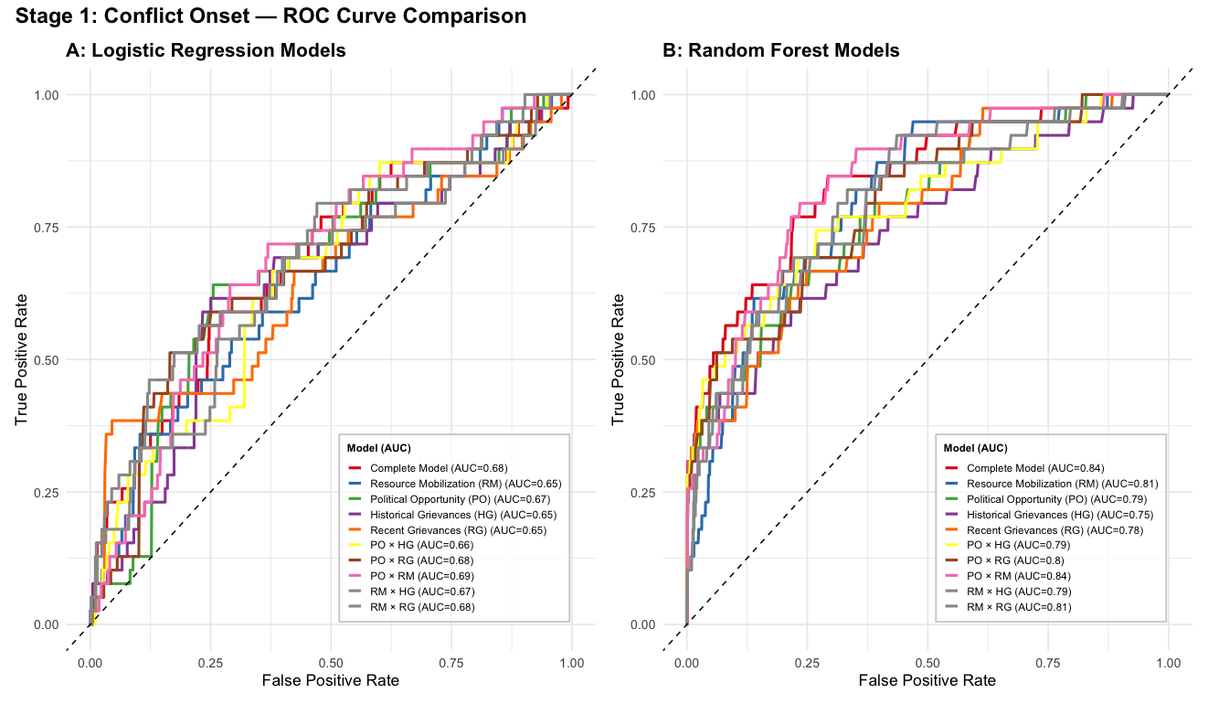

**Stage 2: Predicting the Violent Escalation of Self-Determination Claims**

Consistently and similar to Stage 1 models, Random Forest models exhibit superior predictive accuracy over their logistic regression counterparts in Stage 2 too, except for the Historical and Recent Grievances models. The Complete Model notably achieves an AUC of 0.79, significantly outperforming its logistic regression equivalent (AUC = 0.67). Individual and interaction models maintain performance patterns similar to those observed in Stage 1. Delong tests indicates that the differences in AUC scores are only significant between the Historical Grievances model and the interaction models, meaning that interaction models performed better compared to Historical Grievances. Largely, a striking observation is the consistency in predictive performance within and across both onset and escalation stages.

Collectively, these Stage 2 findings underscore two important insights. Firstly, neither Historical nor Recent Grievances models surpass the predictive performance of alternative individual or interaction models, suggesting that grievance-based explanations, historical or recent, do not provide superior predictive power compared to Political Opportunity and Resource Mobilization models. Secondly, models exhibit stable predictive power across both conflict onset and escalation stages, reinforcing their utility in consistently anticipating both types of outcomes.

**Figure 1.2: Out-of-Sample Predictive Accuracy of Theoretical Models: Conflict Escalation**

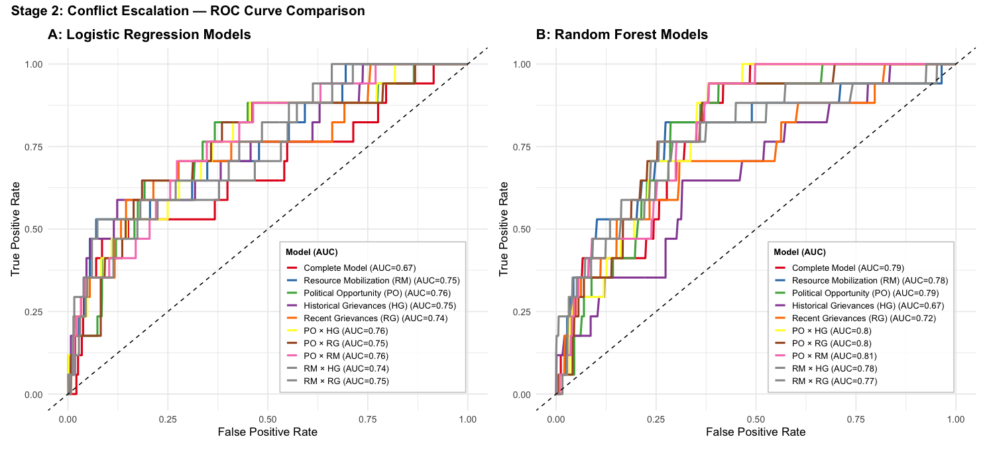

**Table 2. AUC Scores: Onset and Escalation**

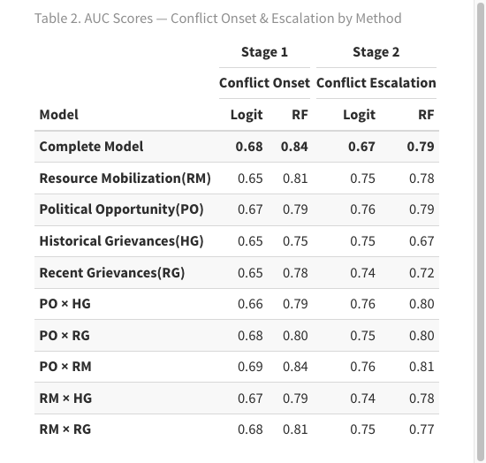

### **Variable Importance and Top Predictors of Self-Determination Conflict Onset and Escalation**

Another important dimension of model performance lies in examining variable importance—specifically, identifying which predictors contribute most to the model’s accuracy. To assess this, we employ the permutation importance method, a widely used technique in machine learning that measures the decrease in model accuracy when the values of a given predictor are randomly shuffled (Altmann et al 2010). If shuffling a variable substantially reduces accuracy, it implies that the variable is highly influential for prediction.Figure 2 illustrates the permutation-based variable importance scores for the Complete Random Forest models across both stages of conflict onset and conflict escalation.

### **Figure 2.  Top Predictors of Self-Determination Conflict Onset and Escalation**

In the Conflict Onset stage, the most influential predictors are primarily state level factors. Country population size, GDP per capita, and the number of relevant groups in the country emerge as the top three variables driving conflict onset. While population and GDP per capita are not components of the theoretical models under consideration, their consistent inclusion as control variables stresses the foundational role of macro-structural conditions in shaping separatist mobilization. The number of relevant groups—an indicator aligned with the Political Opportunity model—further reinforces the significance of structural opportunities for mobilization

Notably, federalism and democracy, also classified under the Political Opportunity framework, rank highly in importance. Following these are group size, which serves as one of the indicators for the Resource Mobilization model. Meanwhile, indicators associated with Historical Grievances—namely, political exclusion and lost autonomy—appear lower in the variable importance rankings. Taken together, these findings suggest that the predictive power in predicting the onset of nonviolent separatist movements is *largely* driven by variables associated with the Political Opportunity and Resource Mobilization models, rather than grievance-based explanations.

Similarly, in the Conflict Escalation stage, the most influential predictors remain largely state-centered and structurally rooted. The top three variables—GDP per capita, democracy, and the number of relevant groups—emphasize the continued salience of political and economic structures in conditioning the likelihood of conflict escalation. While GDP per capita serves as a control variable, both democracy and the number of relevant groups are central indicators of the Political Opportunity model. These are followed by population (another control) and the Cold War indicator, which is also part of the Political Opportunity framework. Notably, four out of the five most important predictors for conflict escalation originate from the Political Opportunity model. Grievance-based factors, including historically lost autonomy and recent autonomy downgrades, appear only after these core political opportunity model predictors.

Taken together, the variable importance results from both stages—conflict onset and escalation—suggest a consistent pattern: political opportunity structures, rather than grievance-based explanations, play a more dominant role in predicting the dynamics of separatist mobilization and its escalation into conflict.

Turning to the partial dependence plots, Figures 3.1 and 3.2 illustrate how the top five predictors at each stage influence the predicted probability of conflict onset and escalation. These plots reveal the marginal effect of each variable while holding others constant, offering insight into their substantive predictive contributions. In the Conflict Onset stage, four of the top five predictors are continuous variables and exhibit pronounced nonlinear relationships. Higher levels of GDP per capita are associated with an increased probability of nonviolent onset. This coupled with fact that democracy, given that it is among the top, suggest that nonviolent mobilization is more likely in economically developed and politically open contexts. Similarly, increases in population size and the number of relevant groups correspond to higher probabilities of onset. The only categorical variable among the top predictors is federalism, which shows a clear positive association: groups situated within federal systems are more likely to initiate nonviolent separatist claims.

### **Figure 3.1 Partial Dependence of Top 5 Predictors-Conflict Onset**

In the Conflict Escalation stage, the partial dependence plots in Figure 3.2 illustrate that the most influential predictors tend to exhibit declining effects on the probability of escalation. Both GDP per capita and democracy display a negative relationship with escalation: as economic development and democracy scores increase; the predicted likelihood of conflict escalation decreases. This suggests that violent escalation is more likely to occur in contexts characterized by weak democratic institutions and low levels of economic development. When compared to the Conflict Onset stage—where higher GDP per capita and stronger democracy scores were associated with a greater likelihood of nonviolent mobilization—an important distinction emerges, that is, nonviolent onset is more likely in developed settings, while violent escalation tends to occur in more autocratic and economically underdeveloped environments. Population remains relatively stable in its effect until reaching very high levels, at which point the probability of escalation increases. The number of relevant groups exhibits a non-linear and inconclusive pattern, making its role less straightforward to interpret. Finally, the Cold War era shows a strong association with increased escalation risk, suggesting that separatist movements were more prone to turn violent during that post-Cold War period. As these partial plots shows, both prediction of onset and escalation are driven by different mechanisms.

### **Figure 3.2 Partial Dependence of Top 5 Predictors-Conflict Escalation**

**Discussion**

These findings address three persistent ambiguities in the study of many political phenomena: the stage-specificity of mechanisms, the role of machine learning in theory testing, and the gap between statistical significance and predictive generalization.

First, applied to the problem of self-determination conflict, the results underscore a critical insight: conflict onset and conflict escalation might be driven by distinct underlying mechanisms. While the findings reveal that the predictive power of individual theoretical models do not vary substantially within and across stages, the interaction models and variable importances shows different mechanisms in predicting the onset of nonviolent conflict and its escalation into violence. Overall, a consistent pattern of the findings is that political opportunity and resources mobilization models along or in combination with each other performs better in predicting both stages than grievance-based models that recently has been empathized more (German & Sambanis 2021). This asymmetry is largely underexplored in the literature, where such theoretical frameworks are rarely evaluated in terms of their stage-specific predictive capacity. Most prior studies either treat conflict as a singular, undifferentiated process, or focus on isolated indicators rather than testing the combined predictive validity of more complete theoretical models.

Second, this study demonstrates that machine learning can enhance theory testing. The application of Random Forest, a sophisticated ensemble learning method, not only delivers superior predictive accuracy but also reveals important nonlinear patterns and interaction effects. Compared to traditional approaches such as logistic regression, Random Forest is better equipped to capture the complex, conditional dynamics that characterize real-world conflict processes. Crucially, this approach moves us beyond testing whether individual variables are statistically significant to a deeper understanding of theory based on an evaluation of combinations of hypothesized indicators of our theories. In doing so, machine learning becomes a powerful tool for theory refinement, helping to identify which constructs are substantively meaningful and which may fall short when subjected to rigorous, data-driven scrutiny of multi-stage processes. It provides a more robust evaluation of self-determination theories by not merely identifying correlations in past data but also assessing their ability to generalize to future cases. This shift is crucial because it moves the field beyond data-driven *post hoc* explanations, aligning theory with prediction and offering stronger external validity.

Third, the distinction between in-sample fit and out-of-sample predictive performance is not merely technical—it is epistemologically consequential. Theories that exhibit strong associations within the training data but fail to generalize beyond it may be capturing correlates or symptoms of conflict, rather than identifying underlying causal mechanisms. In contrast, models that maintain high predictive accuracy in out-of-sample contexts are more likely to reflect structural regularities that transcend specific samples of cases, thereby offering stronger claims to causal inference. We call for a higher standard of theory evaluation—one that moves beyond retrospective data fit and toward forward-looking, generalizable insights. Importantly, this approach enables stage-specific predictive adjudication, clarifying which theoretical models travel across conflict phases, and which do not. This not only deepens substantive understanding of conflict dynamics but also highlights the critical importance of model selection for both empirical strategy and theoretical development.

**Conclusion**

This study advances a predictive, stage-specific framework for adjudicating competing theories of self-determination conflict. Leveraging Random Forest classifiers trained on global data, it reveals that the mechanisms driving the onset of nonviolent separatist claims are distinct from those fueling their escalation into violence. While most of individual and interaction models perform similarly within and across both stages, political opportunity and resources mobilization models alone, their interactions, or their indicators in complete models as shown in variable importance and partial dependence analysis best predict nonviolent mobilization and violent escalations too. However, different values and direction of indicators of both political opportunity and resources mobilization models predict nonviolent and violent escalation differently. For example, higher numbers of the group in the country, federalism, and democracy scores predicts nonviolent onset, and lowers values of democracy predicts violent escalations. Notably, the interaction between political opportunity and resources mobilizations consistently outperforms individual and other interaction models across both stages such as historical and recent grievances.

These findings challenge the predictive utility of several prominent frameworks. The contributions are twofold. Methodologically, the study offers a replicable, generalizable approach for theory testing that integrates machine learning with social science theory, moving beyond conventional in-sample associations to assess true out-of-sample performance across stages of political phenomena. Substantively, it provides sharper insight into the conditions under which self-determination movements escalate, and under which they remain nonviolent.

**References**

Altmann, André, Laura Toloşi, Oliver Sander, and Thomas Lengauer. "Permutation importance: a corrected feature importance measure." Bioinformatics 26, no. 10 (2010): 1340-1347.

Cederman, Lars-Erik, Andreas Wimmer, and Brian Min. 2010. Why Do Ethnic Groups Rebel? New Data and Analysis. World Politics 62 (1):87–119.

Chapman, Thomas, and Philip G. Roeder. 2007. "Partition as a solution to wars of nationalism: The importance of institutions." American Political Science Review 101, no. 4: 677-691.

Chenoweth, Erica, and Maria J. Stephan. 2011.Why civil resistance works: The strategic logic of nonviolent conflict. Columbia University Press.

DeLong, E. R., DeLong, D. M., & Clarke-Pearson, D. L. (1988). Comparing the areas under two or more correlated receiver operating characteristic curves: a nonparametric approach. *Biometrics*, 837-845.

Fearon, James D., and David D. Laitin. 2003. Ethnicity, Insurgency, and Civil War. American Political Science Review 97 (1):75–90.

Germann, Micha, and Nicholas Sambanis. 2021."Political exclusion, lost autonomy, and escalating conflict over self-determination." International Organization 75, no. 1: 178-203.

Goodwin, Jeff, and James M. Jasper. 1999. "Caught in a winding, snarling vine: The structural bias of political process theory." In Sociological forum, vol. 14, pp. 27-54. Kluwer Academic Publishers-Plenum Publishers.

Gurr, R. Ted. 1993. Why minorities rebel: A global analysis of communal mobilization and conflict since 1945. International political science review, 14(2), 161-201.

Hechter, Michael. 2000. Containing Nationalism. Oxford University Press.

McAdam, Doug, Sidney G. Tarrow, and Charles Tilly. 2001. Dynamics of Contention. Cambridge University Press.

Meyer, David S., and Sidney G. Tarrow, eds. 1998. The social movement society: Contentious politics for a new century. Rowman & Littlefield.

Montgomery, Jacob M., and Santiago Olivella. 2018. “Tree-Based Models for Political Science Data.” *Political Analysis* 26(3): 312–330.

Olson, Mancur.1965. "The logic of collective action." Contemporary sociological theory 124:62-63.

Petersen, Roger Dale. 2002. Understanding Ethnic Violence: Fear, Hatred, and Resentment in Twentieth- Century Eastern Europe. Cambridge University Press.

Sambanis, Nicholas, Micha Germann, and Andreas Schädel. 2018. "SDM: A new data set on self-determination movements with an application to the reputational theory of conflict." *Journal of Conflict Resolution* 62, no. 3 : 656-686.

Siroky, S. David, & Cuffe, John. 2015. Lost autonomy, nationalism and separatism. Comparative Political Studies, 48(1), 3-34.

Staniland, Paul.2014. "Violence and democracy." Comparative Politics 47, no.1: 99-118.

Tilly, Charles. 1978. From Mobilization to Revolution. Addison-Wesley.

Vogt, Manuel, Nils-Christian Bormann, Seraina Rüegger, Lars-Erik Cederman, Philipp Hunziker, and Luc Girardin. "Integrating data on ethnicity, geography, and conflict: The ethnic power relations data set family." Journal of Conflict Resolution 59, no. 7 (2015): 1327-1342.

Wimmer, Andrews. 2013. Waves of war: Nationalism, state formation, and ethnic exclusion in the modern world. Cambridge University Press.

Wood, Elisabeth Jean. 2003. Insurgent Collective Action and Civil War in El Salvador. Cambridge University Press.

1. A relevant study is by Chenoweth and Ulfelder (2017). They evaluate the predictive power of several prominent theoretical models in explaining the emergence nonviolent extra-institutional protest campaigns. While our study builds on their valuable effort, it moves beyond their limitations by analyzing two conflict stages, employing both supervised machine learning and logistic regression, and offering broader, more systematic coverage of self-determination movements.
2. We follow the framework established by Germann and Sambanis (2021), “Political Exclusion, Lost Autonomy, and Escalating Conflict over Self-Determination,” to distinguish between the two stages and guide their operationalization.
3. The total nonviolent claims in the dataset are 182.
4. The total cases of firs-time escalations are 76.
5. For a comprehensive discussion and justification on how we choose each indicator for each theoretical model, please see Appendix-A in the supplementary documents. Some of the indicators are country level characteristics and the rest are group specific ones. We analyze the sample of geographically concentrated groups for both stages since they are more likely to mobilize and escalate.
6. Please see Appendix B to have a detailed and visualization of AUC confidence interval and **DeLong** test on all models.