Requirements
Application is designed to calculate camshaft profile (practical and theoretical) and print it to end user.
Supports two follower types: translating (with roller) and rotating (with roller).
Input: camshaft geometry parameters and follower motion law.

System requirements
JRE8 need to have been installed.

Workflow
Contains 3 stages:
- input of geometry parameters
- input of follower motion law
- output of camshaft profile

1. Input of geometry parameters
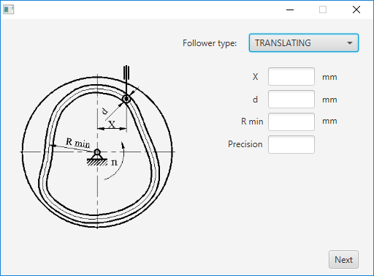
Geometry parameters window
To run application need to execute file run.bat
On start up will be shown window to set camshaft geometry parameters.
Switching between follower types can be done by selector on window right top corner.
Switching between stages performed by Next/Prev button on window right bottom corner.
To proceed to next stage need to fill out all input fields.

2. Input of follower motion law
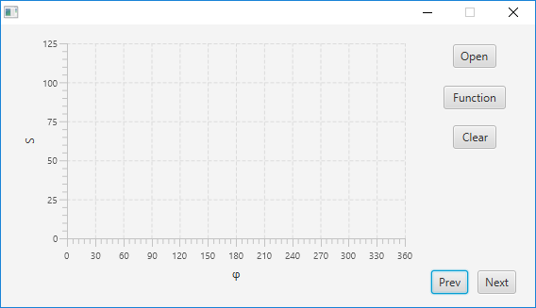
Follower motion law window
Follower motion law window contain XY chart to represent S(φ) function.
S – follower transition value; φ – camshaft rotation angle
Follower motion law can be set using: file, mathematical expression or interactive.

2.1. Loading follower motion law from file
To load follower motion law from file need to press Open button and select file using dialog window. Each file line should contain point x and y coordinates separated by space.

2.2. Setting motion law using mathematical expression
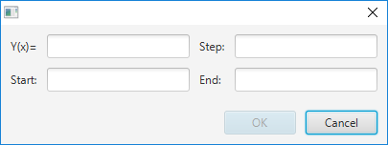
Dialog window to set motion law using mathematical expression
To set motion law using mathematical expression need to press Function button.

Following operators are supported:
- Addition: 2 + 2
- Subtraction: 2 – 2
- Multiplication: 2 * 2
- Division: 2 / 2
- Exponential: 2 ^ 2
- Unary Minus, Plus (Sign Operators): +2 - (-2)
- Modulo: 2 % 2
Following functions are supported: abs, acos, asin, atan, ceil, cos, exp, floor, log, log2, log10, sin, sqrt, tan, signum
2.3. Interactive follower motion law modification
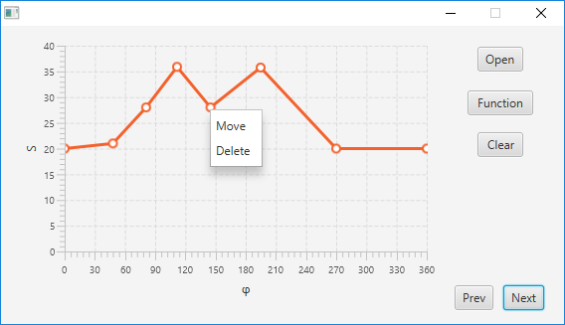
Edit point context menu
To add point need to call context menu on chart and select Add.

To move or delete point need to call context menu on existing point and select appropriate menu item. Points also can be moved by mouse dragging.
To proceed to camshaft profile stage need to complete follower motion law. Follower motion law considered to be completed if it has at least 2 points with (0;y) and (360;y) coordinates.

3. Output of camshaft profile
As a result of calculation, camshaft practical and theoretical profiles will be printed.
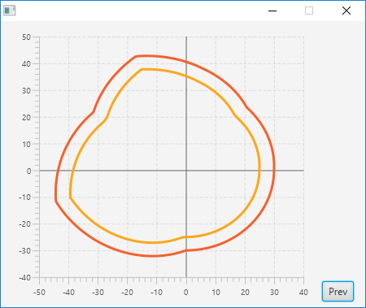
Camshaft profile window

Architecture/Design
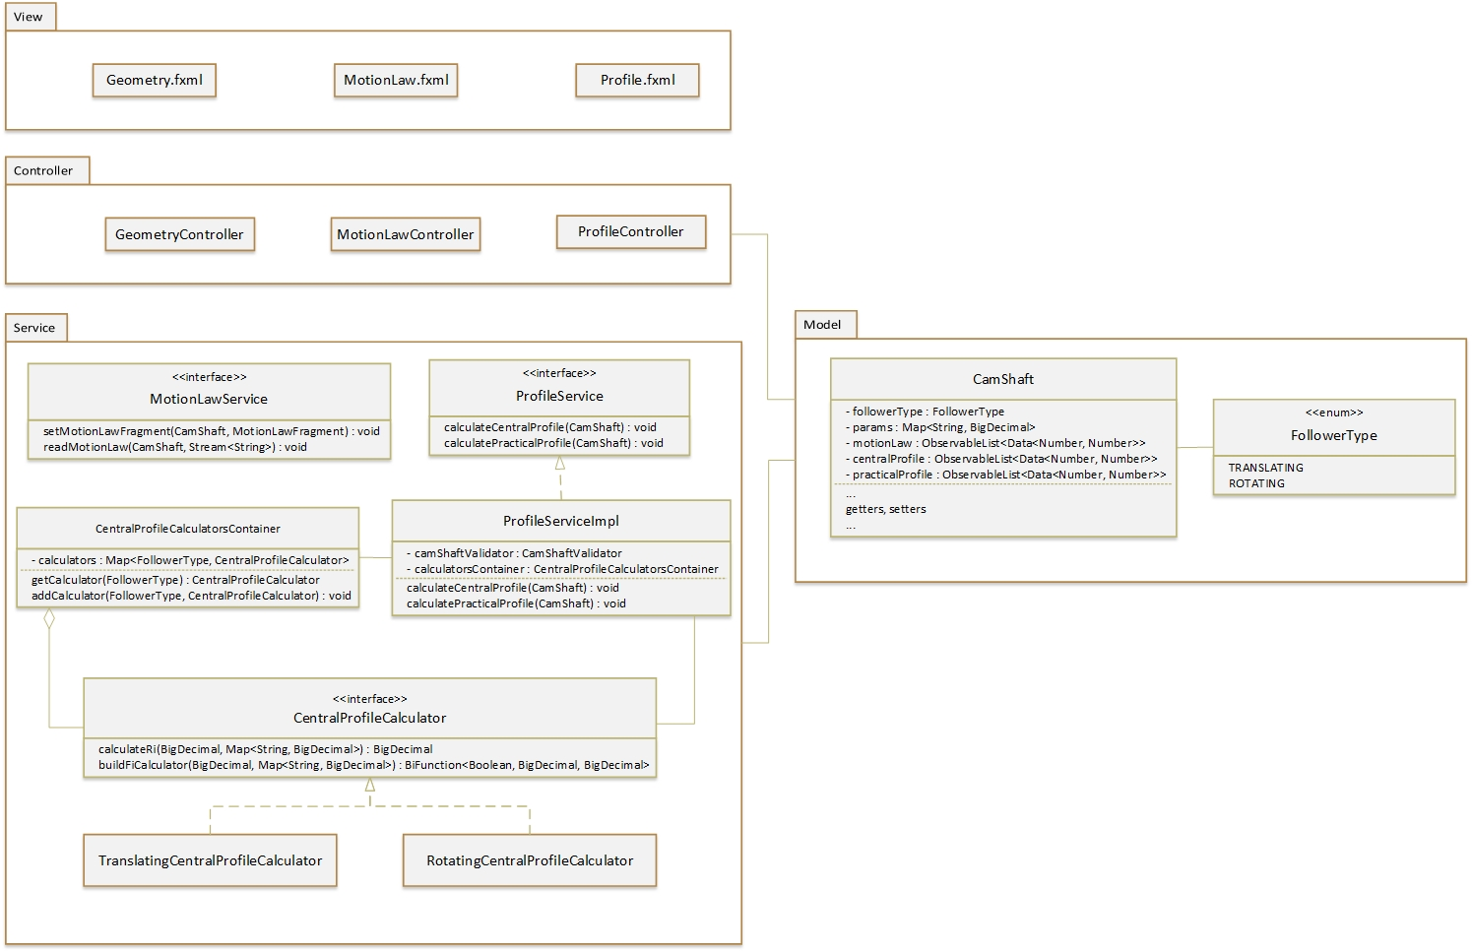
Technical
Calculations of theoretical(central) profile
1. Camshaft with translating roller follower
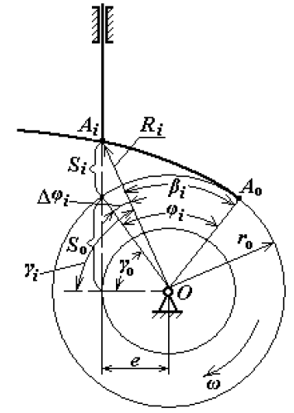

2. Camshaft with rotating roller follower

