# Angular Frontend Developer

* Please make sure to read this WHOLE file before you start

## The setup

* Please provide an Angular 8(latest) application

* The app will be built using node:11

* The application needs to support i18n and should be provided in 2 languages of your choice

* You do not need to translate, just prepare tech wise

* The application is supposed to be a SPA

* It's your decision how the app is being served, feel free to include any Docker file or npm command you want

* If you are not able to provide this step please describe exactly what is needed

## Documents to provide

* Your sourceode(.ts, assets, configs, ...)

* A Readme.md file that holds the following information

* How to build your project

**- installed v11.15.0 using nvm**

**- installed @angular/cli - v8.3.2**

- each component (in this case Bmw) is build with the following: **ng generate component Bmw**

* How to serve your project

Within the project folder type:

**- ng serve**

Then the application is served on - [http://localhost:4200/](http://localhost:4200/webpack-dev-server/)

If new port is needed it can be changed (ex for **4201**) by:

**- ng serve --host 0.0.0.0 --port 4201**

- the brands are shown on <http://localhost:4200/brand_name>;

- all other navigation on [http://localhost:4200/](http://localhost:4200/webpack-dev-server/) will redirect to Home Page

I have made implementation of the application by deploying it with **Firebase**

In order to deploy it I made the following:

- Configured **angular.json** configurations for **DE** and **EN** build:

"configurations": {  
 "de": {  
 "aot": true,  
 "outputPath": "dist/de/",  
 "i18nFile": "src/locale/messages.de.xlf",  
 "i18nFormat": "xlf",  
 "i18nLocale": "de",  
 "i18nMissingTranslation": "error",  
 "baseHref": "/de/"  
 },  
 "en": {  
 "aot": true,  
 "outputPath": "dist/en/",  
 "i18nFile": "src/locale/messages.en.xlf",  
 "i18nFormat": "xlf",  
 "i18nLocale": "en",  
 "i18nMissingTranslation": "error",  
 "baseHref": "/en/"  
 },

* Also the configurations for serve:
* "configurations": {  
   "de": {  
   "browserTarget": "traffic:build:de"  
   },  
   "en": {  
   "browserTarget": "traffic:build:en"  
   },

By those configurations it is possible to serve the application on one of the following languages **DE** and **EN**:

**ng serve --configuration=de**

**ng serve --configuration=en**

Also Build of the application (DE and EN) could be made by the following

**ng build --configuration=de**

**ng build --configuration=en**

In my case the build is configured to created **dist** folder under main project directory

Those two folders will be the ones that will be deployed later on.

After configuration of Firebase account and Firebase project (in my case **traffic-grp**) and install on my machine globally (**npm install -g firebase-tools**) the project is initiated by **firebase init**

Selected app is **Hosting: Configure and deploy Firebase Hosting sites**. Make sure that the

? What do you want to use as your public directory? **dist**

? Configure as a single-page app (rewrite all urls to /index.html)? **No**

After the initialization the application is ready to be deployed as follows: **firebase deploy**

Afterwards the application is available on <https://traffic-grp.firebaseapp.com/en/> and <https://traffic-grp.firebaseapp.com/de/> for both EN and DE.

Each time when changes are made in the App the user can redeploy it simply by: **firebase deploy**

**Note**: That is possible only after executing commands for build, collect translations etc.

* Changes needed in case of branching out a car brand

* 4-5 sentences should be enough, just make sure your idea is clear, not too many details needed

It needs to be removed the component from **app.module.ts** as shown on the figure bellow and then the component itself in the project folder;

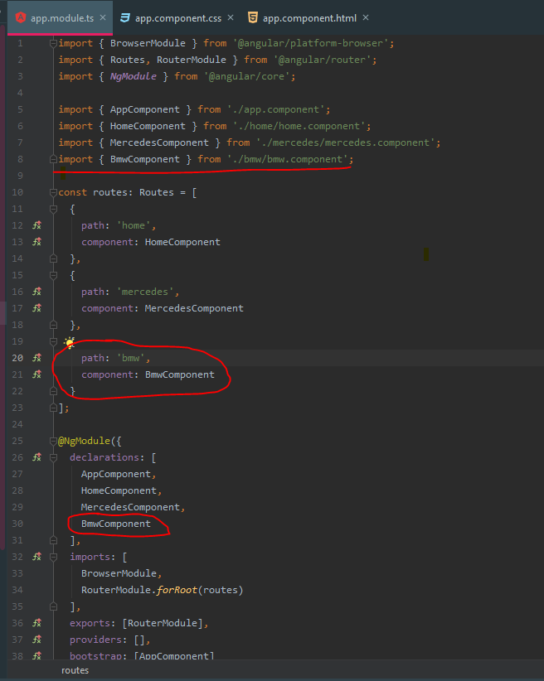

**DO NOT FORGET** to remove also the navigation link in **app.component.ts**, this will reflect on the navigation list

brandsList = [  
 { code: 'mercedes', label: 'Mercedes' },  
 { code: 'bmw', label: 'BMW' }  
];

* Changes to add brand specfic content pages

* ~ Number of hours this task took you, preferably per step/part

## The actual task

* The following app is supposed to be a car dealer's website

* The root page(/) should redirect to the default locale

### On the main page /:locale

* Please provide a layout according to Screenshot1.jpg, feel free to improve the design, just include the given components at the spots mentioned

* Top left - navigation

* Top right - language selector

* Bottom - footer

* Center - text

* Bottom right - InfoBox

### Mercedes sub page /:locale/mercedes

* The layout stays the same, please just adjust the text to

* Headline: Mercedes

* Subline: The best or nothing

### Mercedes sub page /:locale/bmw

* The layout stays the same, please just adjust the text to

* Headline: BWM

* Subline: The ultimate driving machine

### Cookie Disclaimer

* On the bottom right is a floating box that is displayed until it's closed via the red "X"

* Once closed the box will not reopen for the user

* Further more the box holds the users IP

* Use https://api.ipify.org?format=json to determine it, the result shall be cached for the session

## Important notes

* The company may at some point branch out all their Mercedes/BMW cars

* therefore they will need a new website that only holds the subjected part of the application, consider that in your app design

* Please describe what would needed to be done

* The brands may get additional pages that are brand specific, the navi would in that case need to adjust

* Please describe what would needed to be done