1.

Start Morning:

if Saturday:

if time < 13:00:

going in fishing:

else if time = 18:00

watch football:

else if Sunday:

while time < 15:00:

read a book:

else:

watch TV:

else:

going work:

End:

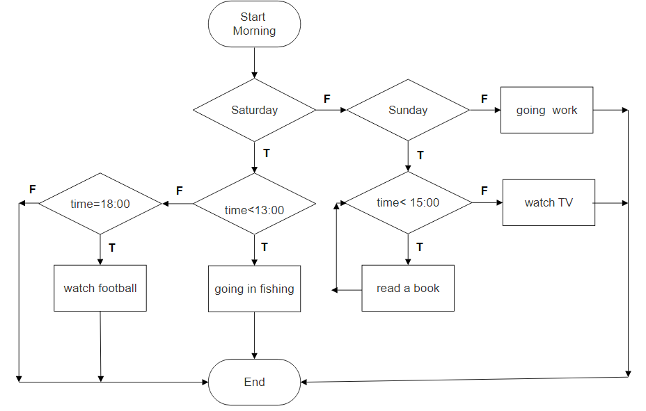

2.

Start:

if time=13:00:

start lunch:

else if time = 14:00:

end lunch:

else:

while time<18:00

if time = 16:00:

meeting:

else:

work:

else:

home:

End:

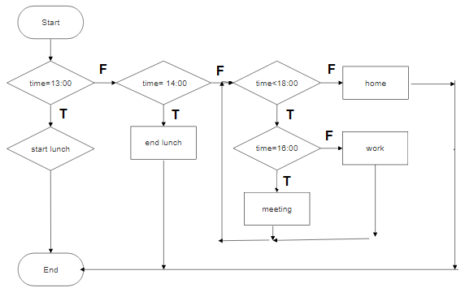

3. Start:

Read A, B, C

if A+B\*C>100

A=B:

C=10:

while A > 0:

A = A - 1:

else:

C = B + 1:

End:

