**Creator:**  Grigor M. Zotov  *Computer Science Student @Sofia University (FMI)*

**Theme:** Meme Generator **Date:** 2018-01-24

**E-mail: grigorzotov@gmail.com**

## Theme: Meme Generator

## 1. Introduction

## During my web course, we were given the task of making a paper on a given topic and then presenting it. It was necessary to make an invitation for the presentation and is there a more entertaining and more intriguing invitation than a favorite meme.

## My project realizes a website where after entering a faculty number and password, the user has the opportunity to see the theme of his project, generate a meme on his subject and keep it.

## The "Meme" generator uses several tools to create the desired invitation. We have the ability to enter text at the top and bottom of our meme. The text may be in a few lines, which will also affect the picture itself.

## 2. Theory

## "Meme" is an idea, behavior, or style that spreads from person to person in a given culture. It was introduced by Richard Dawkins in his book, The Selfish Gene (1976), discussing the evolutionary nature of the spread of ideas and cultural phenomena. Memes are spread by jumping from brain to brain by a process that in the broadest sense can be called imitation. According to Richard Dawkins, the spread of memes is a manifestation of Darwin's theory in another form.

## 3. Technologies used

When creating my project, I used the webpage description and design languages: ***HTML*** and ***CSS***, interpretable programming language: ***JavaScript***, scripting language on the server side language: ***PHP*** and structured queries language: ***SQL***.

*HTML* and *CSS* served to create the **Log In** design, as well as to style the page to generate meme.

JavaScript is used to create and configure our meme. Through him:

* Retrieves user-defined information;
* Generates the original image as an example;
* Retrieves predefined "memes";
* Loads custom meme that is uploaded by the user;
* Create "CanvasElement" and draw on it;
* A built-in feature to save the created by meme as images on our computer;
* The function of updating the text of the "meme" when changing the values;

PHP / SQL serve to create, validate, and retrieve data from a database. Integrated e LogIn system, which by faculty number and password, to check if there really is such a student. Positive responsible gives access to the site.

## 4. Installation and settings

The project does not need additional libraries. All functionality is written to work autonomously.

The only preliminary action we need to do to access a functioning "meme" generator is to create a database with a table called "users" with attributes:

* user_id int(20) : AUTO_INCREMENT;
* user_first varchar(256);
* user_uid varchar(256);
* user_topic varchar(256);
* user_pwd varchar(256);

After creating the table, we need to enter students with their names, faculty number, referral theme, and password for each one.

Once we've completed these steps, we can log in and use the meme generator.

## 5. Quick User Guide

To take advantage of the functionality of the project, we need to take the following steps:

1. At the start of the project, we get a Log In page where we need to enter our faculty number and password. (provided by admin or if we have created our own account).
   1. If we do not have a registration, we can do it by choosing "Create an Account";

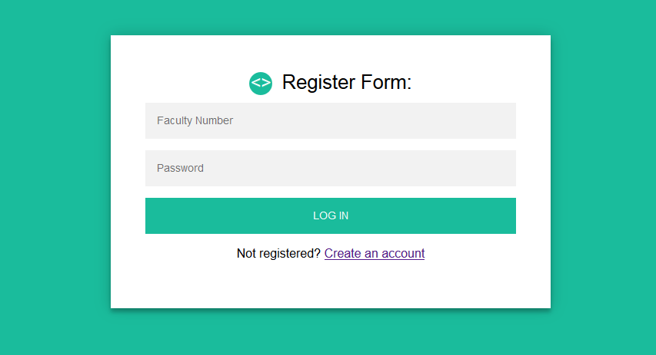

1. Once we have entered the data, click on the "LOG IN" button.
2. Upon successful entry, you will receive information about your name, project topic, and the tools you need to create your "meme".

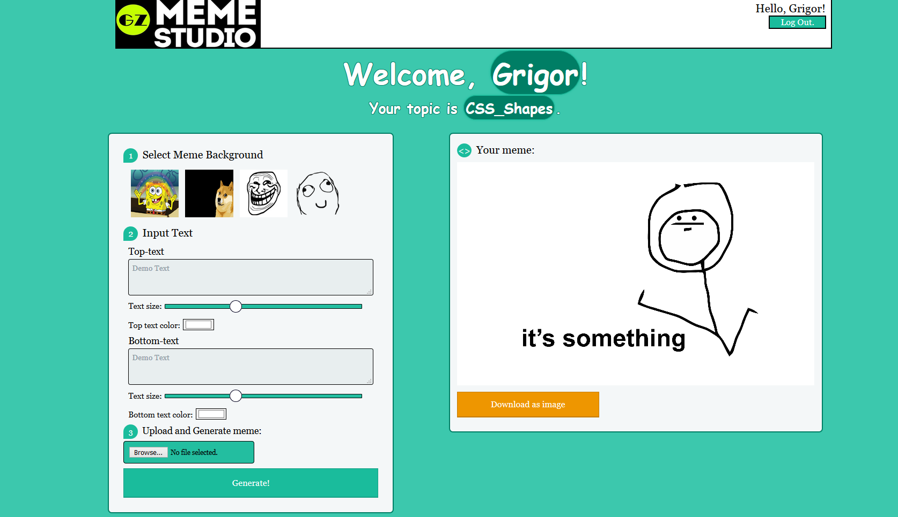

1. We have several choices for creating our image:
   1. We can choose some of the already existing "memes".
   2. We define the text for the top and bottom of the meme. We can write on miltiple lines as this will also affect our image instantly.
   3. We can adjust the size and color of the text.
   4. We have the ability to load an image from our computer and create it on it. To do so, we chose "Browse" - the button with which we upload our background, and then choose "Generate!". A meme will be generated with your background and an example text on it.
2. Once we are happy with our creation, we can keep it on our computer. We have to select the button "Download as image”.

## 6. Описание на програмния код

* init() : an initialization function that sets the starting values ​​of all the elements in the page. We keep in the variable values ​​of the background, the upper and lower text, as well as their color and size. Here are EventListeners who track for a change in value. When available, they perform the UpdateText() function;
* UpdadeText() : a function that processes the text on the image. It has information about the values ​​of the text (what is written so far, size, position, line, color) and draws it on canvas;
* generateMeme() : creates the original meme as an example.
* downloadCanvas() : a feature to save our meme on the local machine.

## 7. Contributions, limitations and opportunities for future expansion

The code used to create, configure, manipulate, and save the image uses only features provided by the JavaScript language. We work with the Canvas API by drawing an image and plotting it against the parameters you entered.

I succeeded in realizing the functionality of writing multiple lines on canvas, both on top and bottom. I used variables to keep my current background and so easy to move from one meme to another. We can choose from some of the templates you have set. The project has the functionality to update the text of the meme immediately after it is entered and so we do not need to press the update button every time we make changes. The size and color of the text also changes dynamically by specifying it. We have a working button to save the image on the computer.

Restrictions and opportunities for future development:

* We can not adjust the position of the text fields. We can only put a new line or tabs.
* A tool can be implemented to add an extra text field or an element of another "meme".
* The project does not work with video or audio resources.
* Random generating button that creates random "memes".
* Ability to share in a a social media/group.

## 8. Sources used

[1] Canvas API, <https://developer.mozilla.org/en-US/docs/Web/API/Canvas_API>

[2] HTML5 Canvas, <https://www.w3schools.com/html/html5_canvas.asp>

[3] SaveButton, Ken,AbdiasSoftware, <https://jsfiddle.net/AbdiasSoftware/7PRNN/>

[4] PHP MySQL Database, <https://www.w3schools.com/php/php_mysql_intro.asp>